NAME:…………………………………………………………………………………...…………
SCHOOL:…………………………………………………………………………………………..
A.D.M NO:……………………………………….. DATE:………………………………………
SIGNATURE:……………………………………

565/1
BUSINESS
PAPER 1
2022

BUSINESS P1

INSTRUCTIONS TO CANDIDATES:
- Answer ALL the questions in the spaces provided.

FOR EXAMINERS USE ONLY
Question | 1 |  | 2 |  | 3 |  | 4 |  | 5 |  | 6 |  | 7 |  | 8 |  | 9 |  | 10 |  | 11 |  | 12 |  | 13 | 14
Marks
Question |  | 15 |  | 16 |  | 17 |  | 18 |  | 19 |  | 20 |  | 21 |  | 22 |  | 23 |  | 24 |  | 25
Marks

TOTAL MARKS

1. Identify four factors that influence the level of capital of a business enterprise. (4 marks)
………………………………………………………………………………………………………………………………………………………………………………………………………………………………………………………………………………………………………………………………………………………………………………………………………………………………………………………………………………………………………………………………………
2. Give four features of economic resources (4 marks)
………………………………………………………………………………………………………………………………………………………………………………………………………………………………………………………………………………………………………………………………………………………………………………………………………………………………………………………………………………………………………………………………………………………………………………………………………………………………………………
3. Indicate with a tick(✓) in the appropriate column the business environment associated with each of the factors mentioned below. (4 marks)
 | FACTOR | INTERNAL | EXTERNAL
i) | Government policy
ii) | Technological environment
iii) | Financial resources
iv) | Firm structure

4. State four reasons why people engage in business activities. (4 marks)
………………………………………………………………………………………………………………………………………………………………………………………………………………………………………………………………………………………………………………………………………………………………………………………………………………………………………………………………………………………………………………………………………………………………………………………………………………………………………………
5. Outline four tools used by the government to influence the quantity of a product supplied in a market. (4 marks)
………………………………………………………………………………………………………………………………………………………………………………………………………………………………………………………………………………………………………………………………………………………………………………………………………………………………………………………………………………………………………………………………………………………………………………………………………………………………………………
6. Highlight four factors that may be used to determine the size of a firm. (4 marks)
………………………………………………………………………………………………………………………………………………………………………………………………………………………………………………………………………………………………………………………………………………………………………………………………………………………………………………………………………………………………………………………………………………………………………………………………………………………………………………
7. Indicate by writing the word “TRUE” or “FALSE” against the statement describing characteristics for goods and services. (3 marks)
 | STATEMENT | TRUE or FALSE
a) | Goods are inseparable from their producers
b) | Services can be standardized in form of size, appearance or quality
c) | Services are experienced not owned
d) | Goods are not always perishable
e) | Services are highly perishable
f) | Goods can change in value overtime

8. The central bank is a banker to the government. Outline four banking services it provides to the Kenya government. (4 marks)
………………………………………………………………………………………………………………………………………………………………………………………………………………………………………………………………………………………………………………………………………………………………………………………………………………………………………………………………………………………………………………………………………
9. The following are types of advertising: Product advertising, competitive advertising, informative advertising and institutional advertising. In the table below, match each type with its appropriate description. (4 marks)
 | TYPE OF ADVERTISING | DESCRIPTION
a) |  | Promotes the name of the manufacturer
b) |  | Persuades the consumers to buy a product
c) |  | Creates awareness about a product
d) |  | Promotes a particular brand of a product

10, Outline four barriers to written communication. (4 marks)
………………………………………………………………………………………………………………………………………………………………………………………………………………………………………………………………………………………………………………………………………………………………………………………………………………………………
………………………………………………………………………………………………………………………………………………………………………………………………………………
11. For each of the following cases, name the motive for holding money. (4 marks)
 | CAES | MOTIVE
a) | To meet daily bus fare expenses
b) | To meet unexpected medical emergencies
c) | To stock maize when prices fall
d) | To meet daily food requirements

12. The diagram below shows the current demands for petrol.
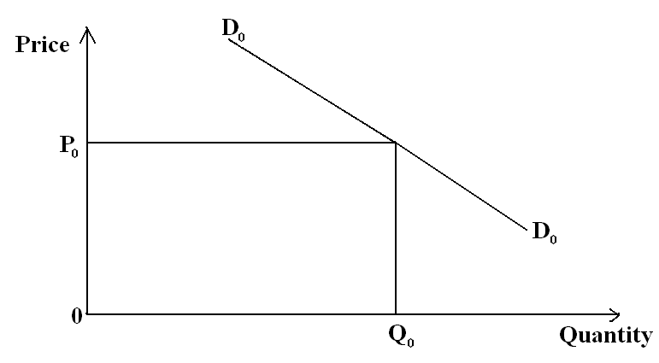
- What is the effect of an increase in the price of cars on demand for petrol. (2 marks)
………………………………………………………………………………………………………………………………………………………………………………………………………………………………………………………………………………………………
- Draw a new demand curve on the diagram above to show the effect of an increase in price of cars. (2 marks)
…………………………………………………………………………………………………………………………………………………………………………………………………………………………………………………………………………………………………………………………………………………………………………
13. State four reasons why few Kenyans take out life assurance policies. (4 marks)
………………………………………………………………………………………………………………………………………………………………………………………………………………………………………………………………………………………………………………………………………………………………………………………………………………………………………………………………………………………………………………………………………………………………………………………………………………………………………………
14. For each of the transactions given below, indicate in the appropriate column, the source documents and the book of original entry in which the transaction is recorded. (4 marks)
 | Transaction | Book of original entry | Source document
a) | Sale of tables on credit
b) | Purchase of stock on credit
c) | Goods returned by a customer
d) | Payment to a creditor

15. Outline four sources of a business idea. (4 marks)
………………………………………………………………………………………………………………………………………………………………………………………………………………………………………………………………………………………………………………………………………………………………………………………………………………………………………………………………………………………………………………………………………………………………………………………………………………………………………………
16 Write down the international trade document that relate to each of the following statements
 | STATEMENT | DOCUMENT
a) | Indicate the country of origin of the imported goods
b) | A document of title to the goods traded in international trade
c) | Used to demand for payment before delivery of goods
d) | Facilitated an importer to obtain credit

17. The financial period of Buteba Traders ends on 31st December every year. On 31st December 2011 the business had the following assets and capital.
Item Sh.
Capital 24,000
Stock of goods 1,500
Debtors 2,000
Machinery 20,000
Cash 4,000
Required:
Calculate the total liabilities and prepare a balance sheet as at 31st December 2011. (4 marks)

18. Highlight four circumstances under which a country may be classified as underdeveloped. (4 marks)
………………………………………………………………………………………………………………………………………………………………………………………………………………………………………………………………………………………………………………………………………………………………………………………………………………………………………………………………………………………………………………………………………………………………………………………………………………………………………………………………………………………………………………………………………………………………………………………………………………………………………………………………
19. Record the following transactions in the cash book of Jerussa Entreprises for the month of January 2011 and balance it off.
2011
Jan. 1: Cash in hand sh. 10,000, cash at bank sh. 20,000
Jan. 10:Paid Luke Sh. 8,800 and Joan sh. 11,000 after deducting 12% cash discount in each case by
cheque
Jan. 30:Banked all the cash leaving sh. 1,200 in the cash box. (5 marks)

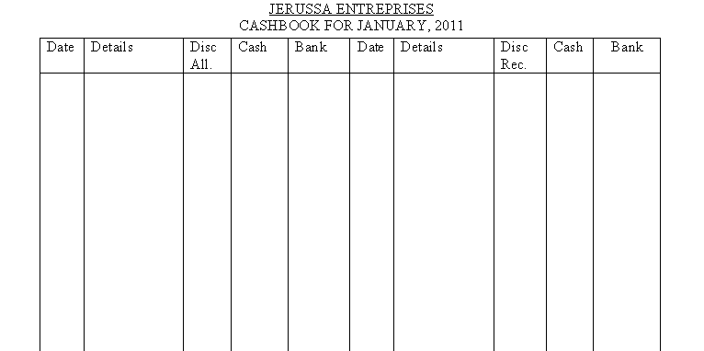

20. State four benefits that consumers get from small scale retailers. (4 marks)
………………………………………………………………………………………………………………………………………………………………………………………………………………………………………………………………………………………………………………………………………………………………………………………………………………………………………………………………………………………………………………………………………………………………………………………………………………………………………………………………………………………………………………………………………………………………………………………………………………………………………………………………
21. The following information was obtained from the books of Okame Traders on 30th June 2011.
Opening stock 8,000

Purchases 53,000
Sales 62,900
Returns outwards 2,700
Closing stock 12,700

Prepare Okame Trading Accounts for the year ended 30th June 2011. (4 marks)

22. The following balances were extracted from the books of Mwambo wholesalers for the year ended 31st December,2005.
END
END
Sales 500,000
Purchases 320,000
Opening stock 80,000
Closing stock 40,000
Debtors 140,000
Creditors 90,000
Calculate
- Margin
- Current ratio
- Rate of stock turn over (4 marks)

23. The following statistics refer to a hypothetical economy. Use it to calculate the per capita income using the income approach. (4 marks)
(Ksh in millions)
Total profits by entrepreneurs 80,0000
Total rent received by landlords 130,000
Total interests earned by financial institutions 40,000
Total salaries paid by employees -50,000
Total population 40

24. Give four features that differentiate a public corporation from a public limited company. (4 marks)
………………………………………………………………………………………………………………………………………………………………………………………………………………………………………………………………………………………………………………………………………………………………………………………………………………………………………………………………………………………………………………………………………………………………………………………………………………………………………………
25. Highlight four undesirable effects of inflation to the Kenyan economy (4 marks)
………………………………………………………………………………………………………………………………………………………………………………………………………………………………………………………………………………………………………………………………………………………………………………………………………………………………………………………………………………………………………………………………………………………………………………………………………………………………………………
END

