MARKING SCHEME

Name………………………………………………………. Adm No………………
Stream …………………… Date ………………………….…
Candidate’s Signature………………………

MAGS JOINT EXAM
Kenya Certificate of secondary Education (KCSE)

565/2
BUSINESS STUDIES
PAPER 2
TERM I 2020
2 HOURS.

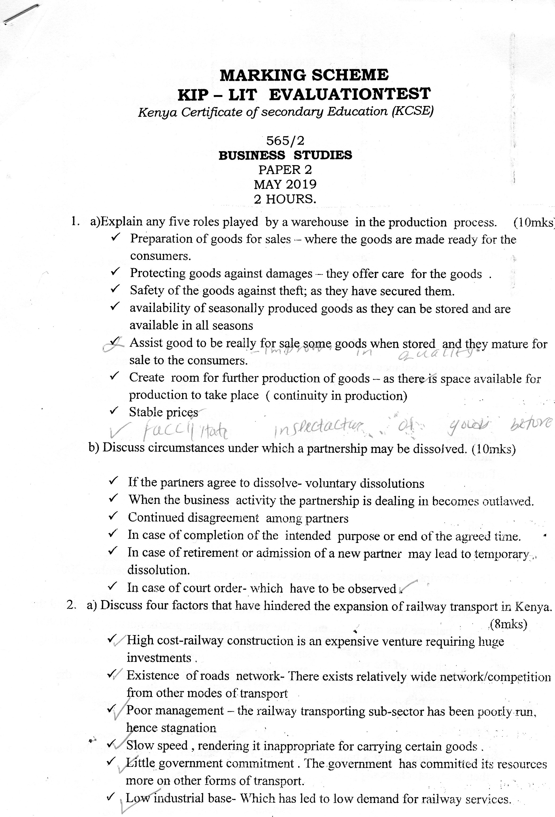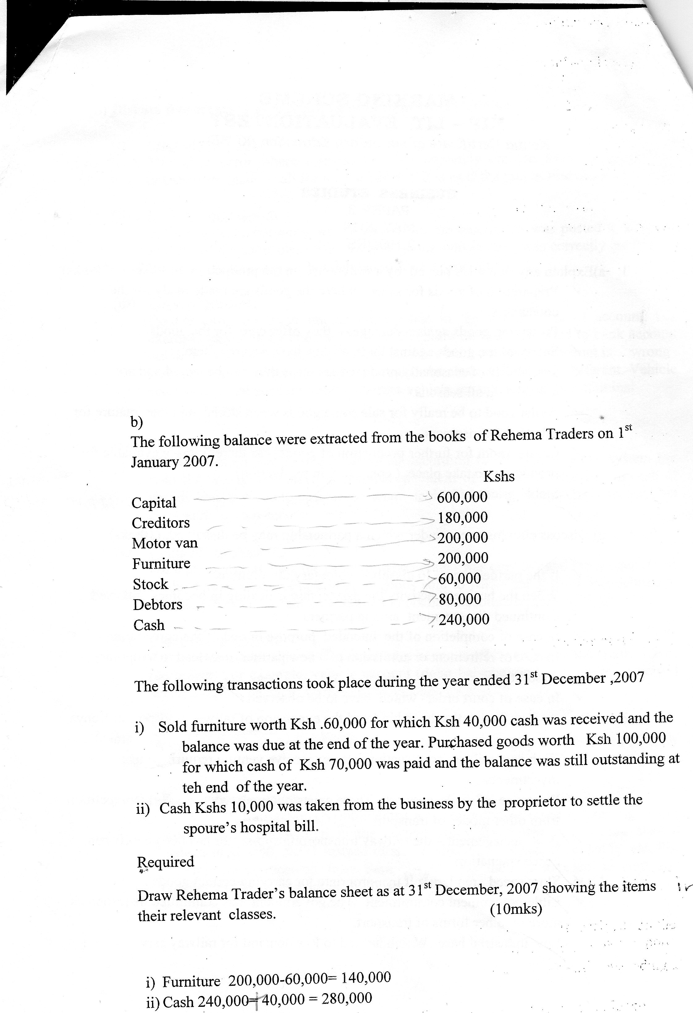

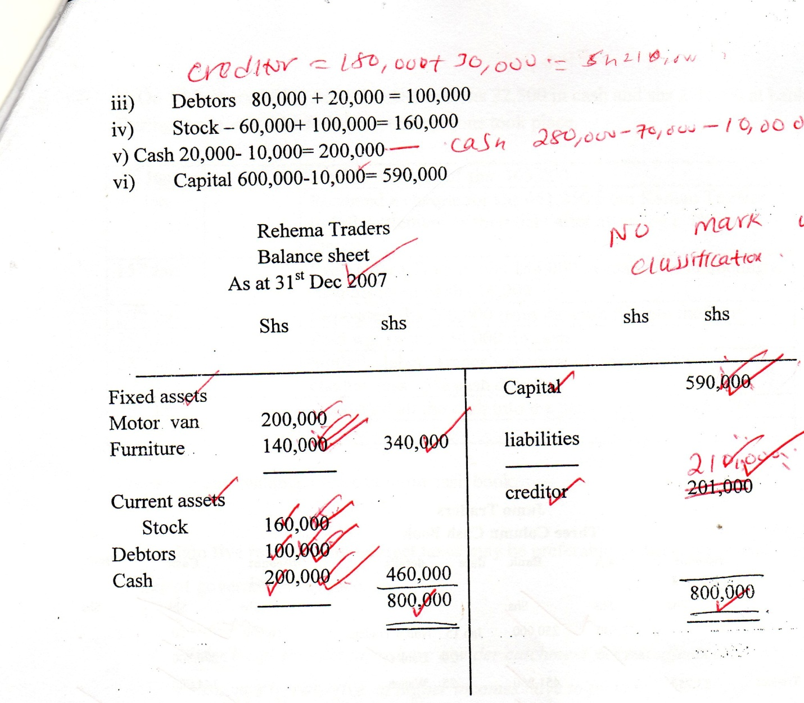

3.(a) Explain five guidelines used by government in spending public resources.
- Sanction – before public resources are used, government must get approval from a relevant authority (e.g parchment)
- Proper financial management – proper accounting records should be kept and be audited for accountability /transparency .
- Maximum social benefit – it should be spent in such a manner that majority of the citizens benefits.
- Economy – public finance should be spent in a way to minimize waste
- Productivity - more of the resources should go towards development expenditure as opposed to recurrent expenditure.
- Flexibility – public resources should be use in non-right manner so that its possible to re-direct the resources to more urgent areas when need arises.
- Elasticity – It should be possible to increase or decrease the amount of public finance depending on economic situations e.g during inflation.

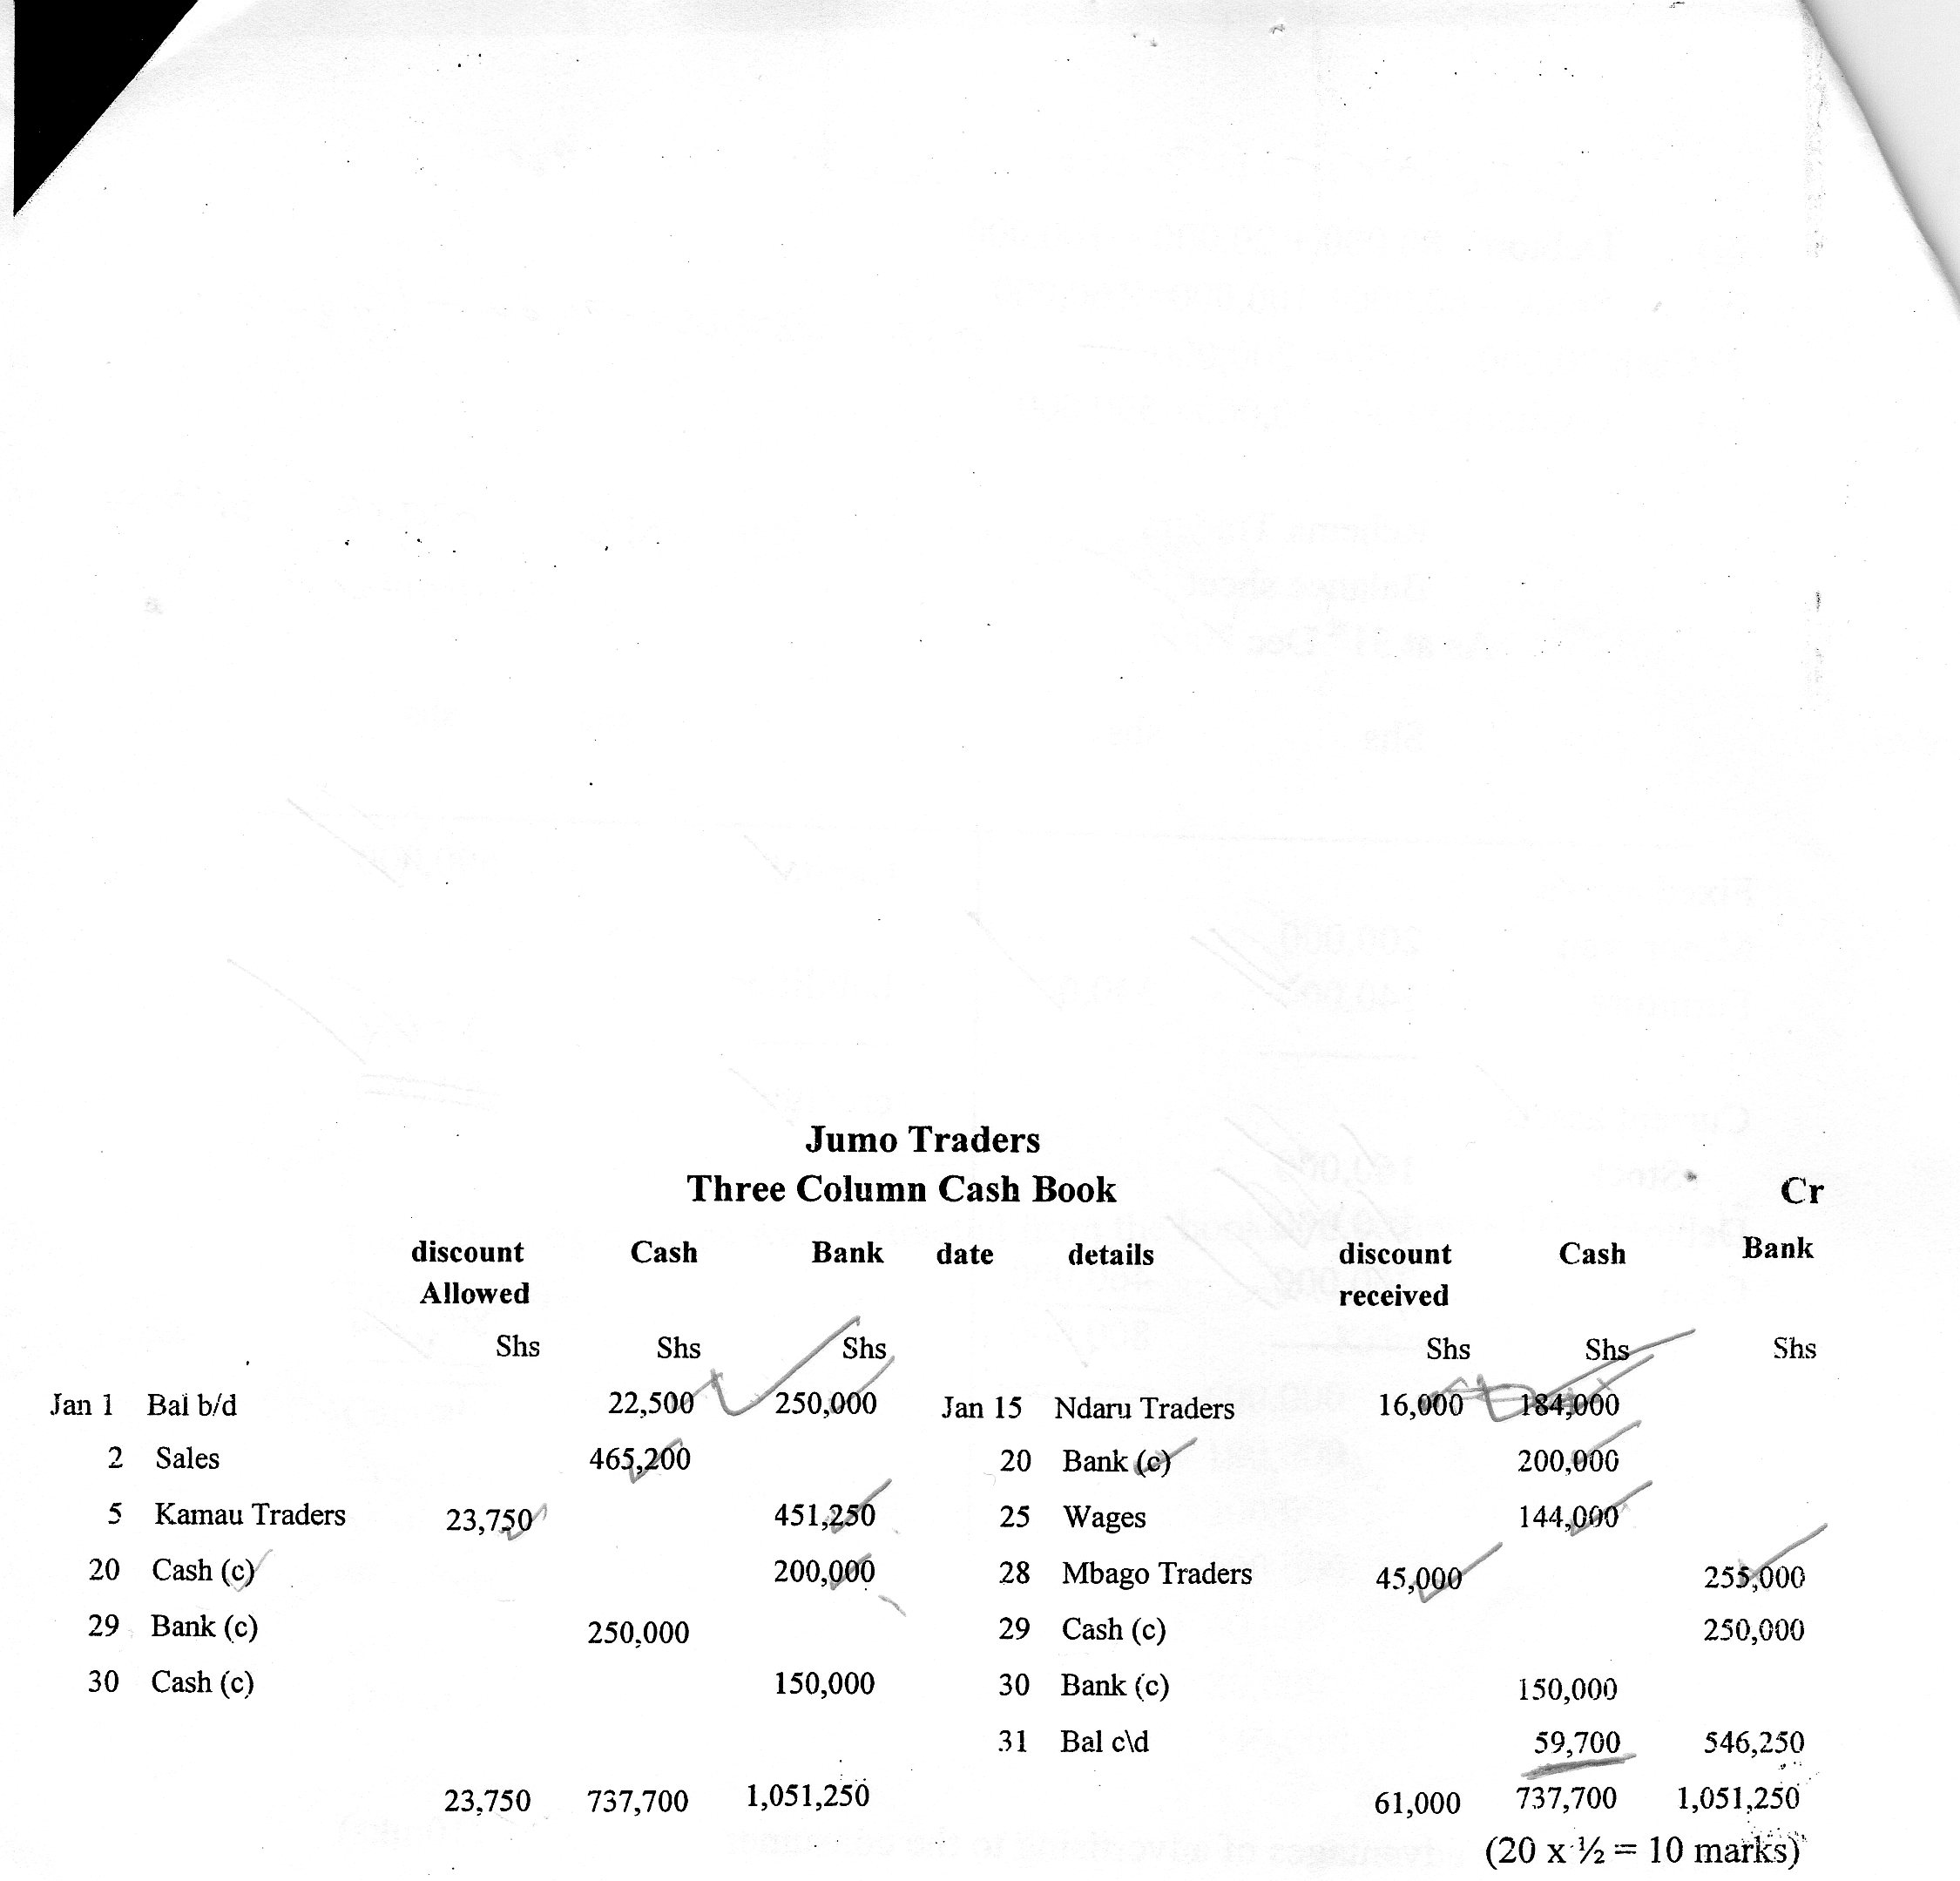
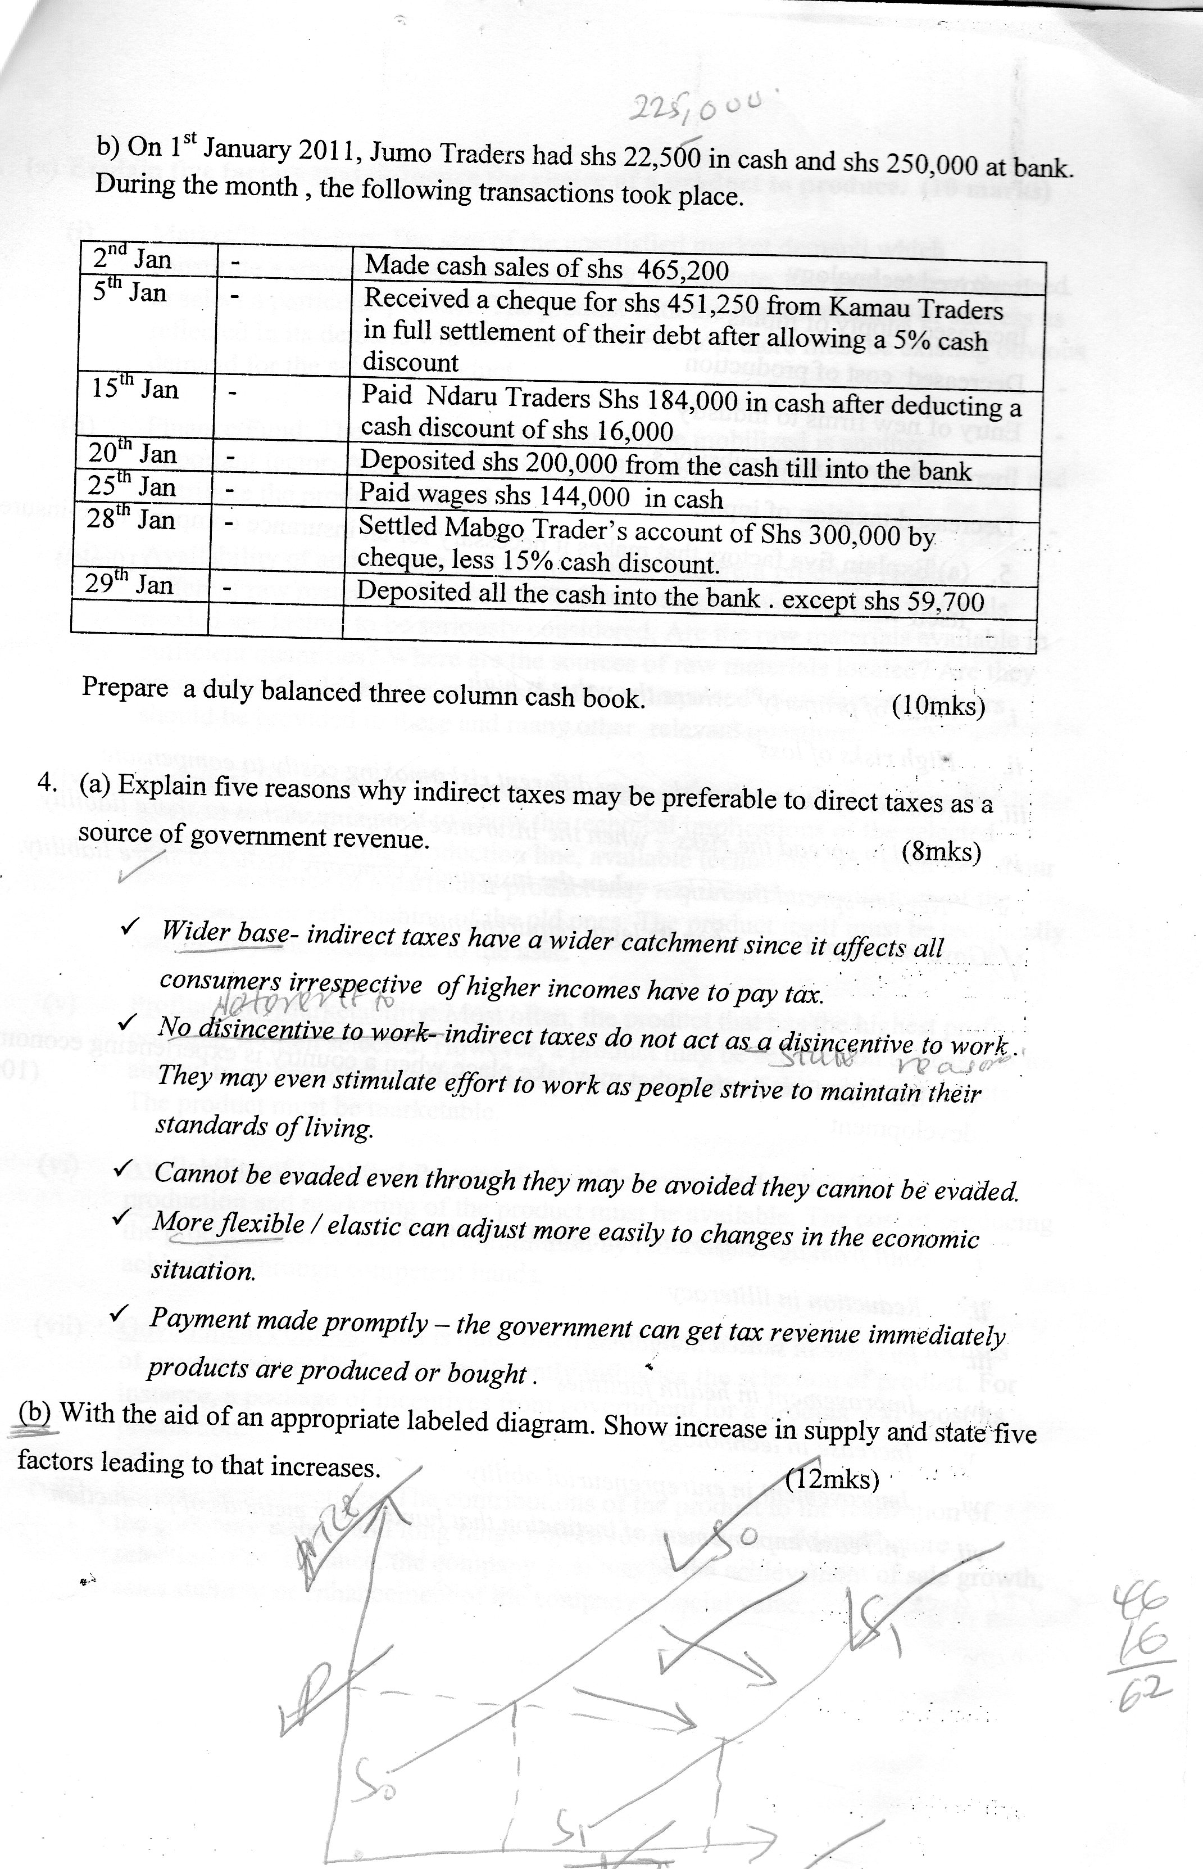

4. (a) Explain five ways in which the price of a product may e determined. (10mks
- Price-mechanism – the interplay of demand and supply curves(forces) provides a prevailing price.
- Tendering – where buyers of a product are invited to quote price independently- the one quoting favourable terms and price forms the price for the product.
- Auction – determination of a price through bidding, the highest bidder form the price.
- Price control – where government set a price ceiling where sellers are not supposed to sell beyond.
- Bargaining/haggling – price is decided through negotiation
- Taxation – tax imposed may raise or reduced in price.
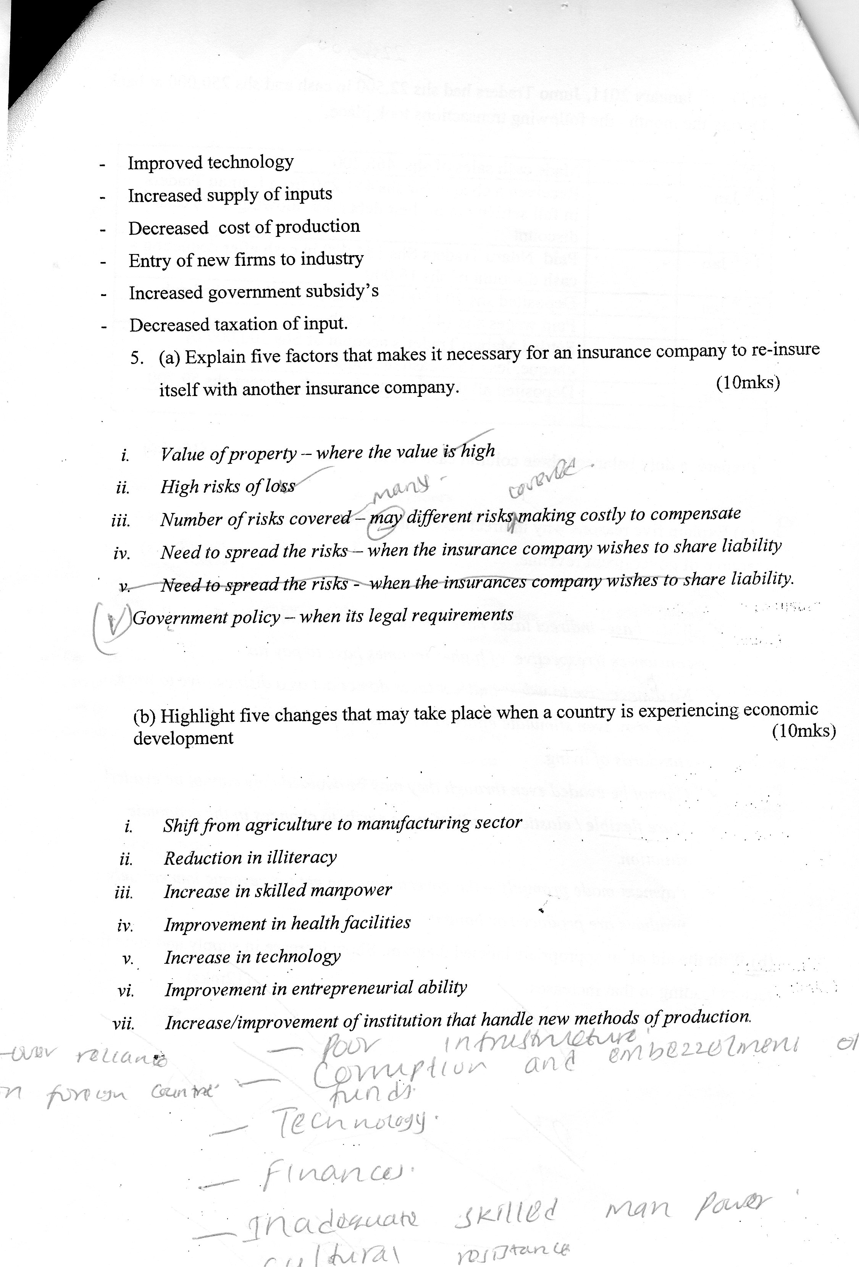

5. (a) Explain five differences between a perfect competition and monopoly (10mks)

Perfect completion | Monopoly
Many sellers  Commodities are homogeneous  There is a free entry and exit into the market by suppliers  Prices determined by the forces of demand and supply  No price discrimination  No government interference | Single seller many buyers  Commodities have no close substitutes  There are barriers to entering the market  There exists price discrimination  There may be government interferences

(b) Explain five circumstances where hire-purchase is desirable. (10mks)

- When there is not down payment needed like in hire purchase
- Where the buyer wants to own the goods immediately unlike where in hire purchase ownership is delayed.
- Where the buyer wants to resell the goods immediately unlike in hire purchase
- Where the buyer wants to buy both durable and non-durable goods unlike in hire purchase where durable goods are accessed
- Where the buyer doesn’t want the goods to be re-possessed unlike in hire purchase.
- Where the buyer wants simple proceedings unlike in hire purchase where the procedures are lengthy and time consuming.

