Name...……………………………………………………….. Index Number...…………………..
Candidate’s Signature ……….………………… Date…………………………….

233/1
CHEMISTRY (THEORY)
PAPER 1
2 HOURS

SMARTPASS EXAMINATION
Kenya Certificate of Secondary Education (KCSE)
MODEL ONE 2019

INSTRUCTIONS TO CANDIDATES
- Write your name and index number in the spaces provided above.
- Sign and write the date of examination in the spaces provided above.
- Answer ALL the questions in the spaces provided in the question paper.
- KNEC Mathematical tables and silent non-programmable electronic calculators may be used.
- All working MUST be clearly shown where necessary
- This paper consists of 13 printed pages.
- Candidates should check the question paper to ensure that all pages are printed as indicated and no questions are missing.
- Candidates should answer all the questions in English.

For Examiner’s Use Only
Question | Maximum Score | Candidate’s Score
1 – 29 | 80

1. The electrical conductivity of barium hydroxide solution was measured after each addition of
1.0 cm³ of dilute sulphuric (VI) acid from a burette. The graph below was obtained.
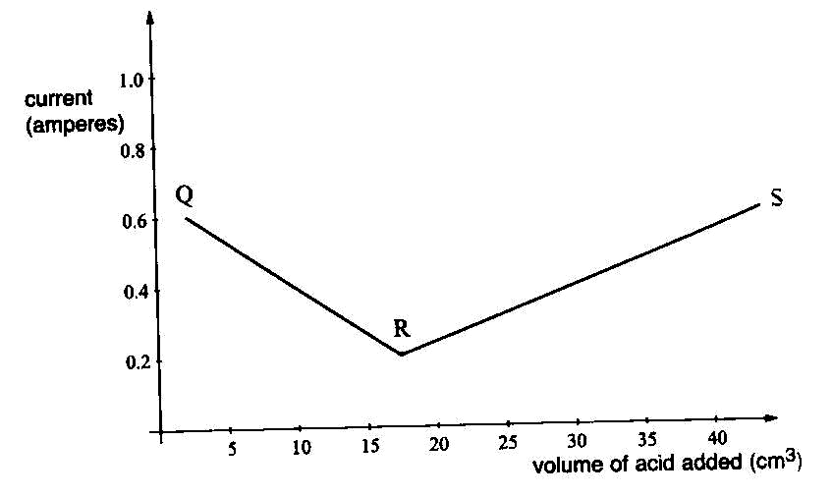
(a) Write the chemical equation of the reaction that took place. (1 mark)
………………………………………………………………………………………………………
………………………………………………………………………………………………………
(b) Explain the graph between,
(i) Q and R (1 mark)
………………………………………………………………………………………………………
………………………………………………………………………………………………………
………………………………………………………………………………………………………
(ii) R and S (1 mark)
………………………………………………………………………………………………………
………………………………………………………………………………………………………
………………………………………………………………………………………………………
2. A mass of 14.2 g sodium nitrate saturated 32.1 cm³ of water at 32 ºC. Determine the solubility
of sodium nitrate at 32 ºC. (Density of water = 1g/cm³). (2 marks)
………………………………………………………………………………………………………
………………………………………………………………………………………………………
………………………………………………………………………………………………………
………………………………………………………………………………………………………
3. Explain why sulphur is a solid while oxygen is a gas at room temperature. (2 marks)
………………………………………………………………………………………………………
………………………………………………………………………………………………………
………………………………………………………………………………………………………
………………………………………………………………………………………………………
4. Study the electrode potential in the table below and answer the questions that follow.
E volts
Cu²⁺ _{(aq)} + 2e- → Cu_{(s)} +0.34
Mg²⁺ _{(aq)} + 2e- → Mg_{(s)} -2.38
Ag⁺ _{(aq)} + e- → Ag _{(s)} +0.80
Ca²⁺ _{(aq)} + 2e- → Ca _{(s)} -2.87
(a) Identify the strongest reducing agent. (1 mark)
………………………………………………………………………………………………………
(b) What would be observed when magnesium ribbon is dipped in solution of copper (II)
sulphate. Explain. (2 marks)
………………………………………………………………………………………………………
………………………………………………………………………………………………………
………………………………………………………………………………………………………
………………………………………………………………………………………………………
5. In a reaction, 0.65 g of impure zinc oxide reacted with 100 cm³ of 0.15 M nitric (V) acid.
(a) Write equation of the reaction. (1 mark)
………………………………………………………………………………………………………
(b) Calculate percentage purity of the zinc oxide sample. (2 marks)
(Zn = 65, O = 16)
………………………………………………………………………………………………………
………………………………………………………………………………………………………
………………………………………………………………………………………………………
………………………………………………………………………………………………………
………………………………………………………………………………………………………
………………………………………………………………………………………………………
………………………………………………………………………………………………………
6. The set up below can be used for the laboratory preparation of product W.
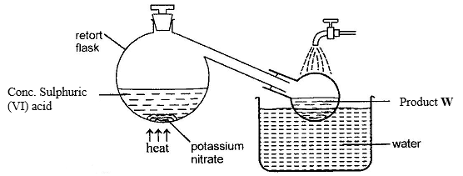
(a) Write chemical equation for the reaction that takes place in the retort flask. (1 mark)
………………………………………………………………………………………………………
(b) Explain why product W appears yellow in colour. How is the colour removed? (2 marks)
………………………………………………………………………………………………………
………………………………………………………………………………………………………
………………………………………………………………………………………………………
………………………………………………………………………………………………………
7. The table below shows information of four elements A, B, C and D. Study it and answer the
questions that follow. The letters do not represent the actual symbols of the elements.
Element | Electronic arrangement | Atomic radius | Ionic radius
A | 2.8.2 | 0.136 | 0.065
B | 2.8.7 | 0.99 | 0.181
C | 2.8.8.1 | 0.203 | 0.133
D | 2.8.8.2 | 0.174 | 0.099

(a) Which two elements have similar properties? (1 mark)
………………………………………………………………………………………………………
(b) Explain why B ionic radius is larger than its atomic radius. (2 marks)
………………………………………………………………………………………………………
………………………………………………………………………………………………………
………………………………………………………………………………………………………
………………………………………………………………………………………………………

8. The production of ammonia gas involves a reversible reaction as shown.
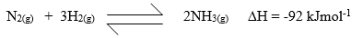
(a) What condition is necessary for the chemical equilibrium to be established? (1 mark)
………………………………………………………………………………………………………
………………………………………………………………………………………………………
(b) Suggest two conditions that are likely to shift the equilibrium from right to left.
(2 marks)
………………………………………………………………………………………………………
………………………………………………………………………………………………………
9. Describe how chloride ions are tested in a solution. (2 marks)
………………………………………………………………………………………………………
………………………………………………………………………………………………………
………………………………………………………………………………………………………
………………………………………………………………………………………………………
………………………………………………………………………………………………………
………………………………………………………………………………………………………
10. The empirical formula of X is CH₂Br. Given that 0.235 g of X occupies a volume of 56 cm³
at 546 K and 1 atmosphere pressure, determine its molecular formula.
(H = 1.0, C = 12.0, Br = 80.0, molar gas volume at STP = 22.4 dm³) (3marks)
………………………………………………………………………………………………………
………………………………………………………………………………………………………
………………………………………………………………………………………………………
………………………………………………………………………………………………………
………………………………………………………………………………………………………
………………………………………………………………………………………………………
………………………………………………………………………………………………………

11. When a piece of sodium metal is place in cold water in a beaker it melts producing a hissing
sound, as it moves on the surface of the water. Explain these observations. (3 marks)
………………………………………………………………………………………………………
………………………………………………………………………………………………………
………………………………………………………………………………………………………
………………………………………………………………………………………………………
………………………………………………………………………………………………………
………………………………………………………………………………………………………
………………………………………………………………………………………………………
………………………………………………………………………………………………………
12. The set-up below was used to prepare a hydrocarbon. Study it and answer the questions that
follow.
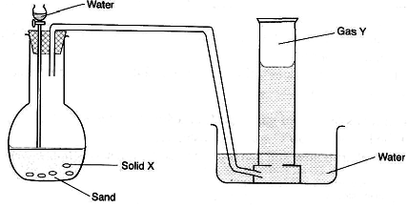
(a) Identify solid X and gas Y.
Solid X………………………………………………………………..... (1 mark)
Gas Y………………………………………………………………….... (1 mark)
(b) Write a chemical equation for the complete reaction between gas Y and bromine
vapour. (1 mark)
………………………………………………………………………………………………………
13. (a) When excess chlorine gas is bubbled through cold, dilute sodium hydroxide solution, the
resulting solution acts as a bleaching agent. Using an equation, explain how the resulting
solution acts as a bleaching agent. (1 mark)
………………………………………………………………………………………………………
(b). What is observed when chlorine gas is bubbled through a solution of potassium
bromide? Explain. (2 marks)
………………………………………………………………………………………………………
………………………………………………………………………………………………………
………………………………………………………………………………………………………
………………………………………………………………………………………………………
14. (a) Explain why the pH of 1.0 M hydrochloric acid is 1 while that of 1.0 M ethanoic acid is
5.0. (1 mark)
………………………………………………………………………………………………………
………………………………………………………………………………………………………
………………………………………………………………………………………………………
………………………………………………………………………………………………………
(b) How can a precipitate of barium sulphate be distinguished from that of barium sulphite?
(2 marks)
………………………………………………………………………………………………………
………………………………………………………………………………………………………
………………………………………………………………………………………………………
………………………………………………………………………………………………………

15. A, B, C and D are dyes present in a mixture. In a given solvent, C is more soluble than B and A is more soluble than C. D is the least soluble. Draw an ascending paper chromatogram showing how they would appear when separated using the solvent. (2 marks)
………………………………………………………………………………………………………
………………………………………………………………………………………………………
………………………………………………………………………………………………………
………………………………………………………………………………………………………
………………………………………………………………………………………………………
………………………………………………………………………………………………………
………………………………………………………………………………………………………
………………………………………………………………………………………………………
16. The reaction below refers to the preparation of lead (II) sulphate starting with lead metal.

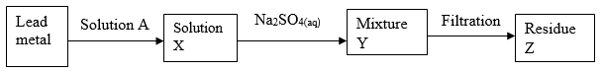

(a) Name solution A…………………………………………………………….. (1 mark)
(b) Write an ionic equation for the reaction in (a) above. (1 mark)
………………………………………………………………………………………………………
(c) Explain why it is not possible to prepare residue Z using lead metal and dilute sulphuric
acid. (1 mark)
………………………………………………………………………………………………………
………………………………………………………………………………………………………
………………………………………………………………………………………………………
………………………………………………………………………………………………………
17. The diagram below represents a Bunsen burner flame. Study it and answer the questions that
follow.
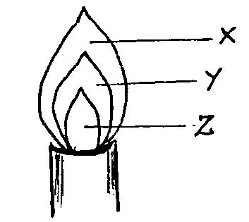
(a) Under what condition is the represented flame produced? (1 mark)
………………………………………………………………………………………………………
………………………………………………………………………………………………………
(b) Which of the regions shown represents the hottest part of the flame? (1 mark)
………………………………………………………………………………………………………
(c) Name region Y (1 mark)
………………………………………………………………………………………………………
18. A typical electrolysis cell uses a current of 40,000 amperes. Calculate the mass in kilograms
of aluminium produced in one hour. (Al = 27, 1 Faraday = 96,500 coulombs) (3 marks)

………………………………………………………………………………………………………
………………………………………………………………………………………………………
………………………………………………………………………………………………………
………………………………………………………………………………………………………
………………………………………………………………………………………………………
………………………………………………………………………………………………………
………………………………………………………………………………………………………
………………………………………………………………………………………………………

19. (a) Distinguish between endothermic and exothermic reaction. (1 mark)
………………………………………………………………………………………………………
………………………………………………………………………………………………………
………………………………………………………………………………………………………
………………………………………………………………………………………………………
(b) Nitrogen reacts with oxygen to form nitrogen (II) oxide according to the following
reaction
N_{2(g)} + O_{2(g)} → 2NO_{(g)} ∆H = +180 kJmol⁻¹
Draw an energy level diagram for this reaction including the activation energy. (2 marks)
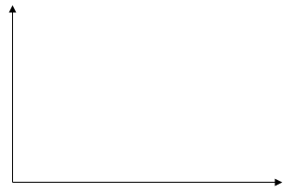

20. (a) When a compound T was heated, a brown gas and a residue which was yellow when hot
and white when cold were formed. Identify the:
(i) Brown gas…………………………………………………………….. (1 mark)
(ii) Residue………………………………………………………………… (1 mark)
(b) Name a suitable drying agent for ammonia gas. (1 mark)
………………………………………………………………………………………………………
21. Give the structural formula of the following organic compounds.
(a) 2-Methylbutane
………………………………………………………………………………………………………
………………………………………………………………………………………………………
(b) Pent-2-ene
………………………………………………………………………………………………………
………………………………………………………………………………………………………
(c) Ethylpropanoate
………………………………………………………………………………………………………
………………………………………………………………………………………………………
22. When iron and steam are heated in a closed container, a dynamic equilibrium is reached.
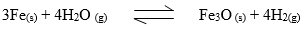
(a) Define the dynamic equilibrium. (1 mark)
………………………………………………………………………………………………………
………………………………………………………………………………………………………
………………………………………………………………………………………………………
………………………………………………………………………………………………………
(b) What is the effect on equilibrium if magnesium is added? Explain. (2 marks)
………………………………………………………………………………………………………
………………………………………………………………………………………………………
………………………………………………………………………………………………………
………………………………………………………………………………………………………
23. State and explain the observations that would be made when burning magnesium is lowered
into a gas jar of sulphur (IV) oxide. (3 marks)
………………………………………………………………………………………………………
………………………………………………………………………………………………………
………………………………………………………………………………………………………
………………………………………………………………………………………………………
24. A mixture contains barium sulphate, calcium chloride and dry ice. Describe how the
components can be separated. (3 marks)
………………………………………………………………………………………………………
………………………………………………………………………………………………………
………………………………………………………………………………………………………
………………………………………………………………………………………………………
………………………………………………………………………………………………………
………………………………………………………………………………………………………
25. In the redox reaction below:
2H⁺_{(aq)} + Cr₂O₇²⁻_{(aq)} + 3SO_{2(aq)} → 2Cr³⁺_{(aq)} + 3SO₄²⁻_{(aq)} + H₂O_{(l)}
Identify the reducing agent. Explain. (2 marks)
………………………………………………………………………………………………………
………………………………………………………………………………………………………
………………………………………………………………………………………………………
………………………………………………………………………………………………………
26 (a) Explain why aluminium utensils do not corrode as easily as iron utensils although
aluminium is higher than iron in the reactivity series. (1 mark)
………………………………………………………………………………………………………
………………………………………………………………………………………………………
………………………………………………………………………………………………………
………………………………………………………………………………………………………
(b) State two uses of aluminium other than utensils making. (2 marks)
………………………………………………………………………………………………………
………………………………………………………………………………………………………
27. The diagram below represents a set up that was used to react lithium with steam. Study and
answer the question that follows.
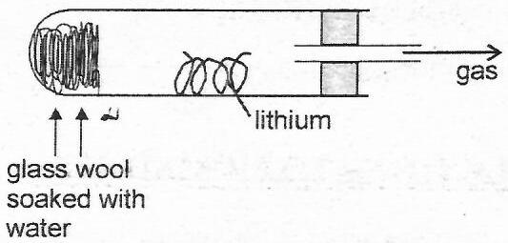
a) Write an equation for the reaction that takes place. (1 mark)
………………………………………………………………………………………………………
b) Why is it not advisable to use potassium metal in place of lithium in the above set-up? (1 mark)
………………………………………………………………………………………………………
………………………………………………………………………………………………………
c) The gas produced above is used for welding. Which other gas is combined with it? (1 mark)
………………………………………………………………………………………………………
28. Using dots (.) and crosses (×) to represent valence electrons, show bonding in:
(a) Nitrogen trifluoride (N = 7, F = 9) (1 mark)
………………………………………………………………………………………………………
………………………………………………………………………………………………………
………………………………………………………………………………………………………
………………………………………………………………………………………………………
………………………………………………………………………………………………………
………………………………………………………………………………………………………
(b) Sodium oxide (Na = 11, O = 8) (1 mark)
………………………………………………………………………………………………………
………………………………………………………………………………………………………
………………………………………………………………………………………………………
………………………………………………………………………………………………………
………………………………………………………………………………………………………
………………………………………………………………………………………………………
29. The graphs below were drawn by measuring the volume of hydrogen produced with time
when excess zinc metal in different physical states were reacted with 50 cm³ of 2 M
hydrochloric acid.

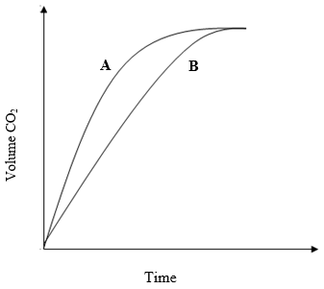
(a) Which curve corresponds to the reactions involving powdered zinc? (1 mark)
………………………………………………………………………………………………………
(b) Both curves eventually flatten out at the same level of hydrogen. Explain. (1 mark)
………………………………………………………………………………………………………
………………………………………………………………………………………………………
………………………………………………………………………………………………………
………………………………………………………………………………………………………

