SMARTPASS 233/1 CHEMISTRY PAPER 1 MODEL ONE 2019 MARKING SCHEME
1. (a) H₂SO_{4(aq)} + Ba(OH)_{2(aq)} → BaSO_{4(s)} + H₂O_{(l)}
(b) (i) Conductivity decreases because Ba²⁺ and OH⁻ ions are converted to insoluble
BaSO_{4(s)} and H₂O_{(l)} which do not conduct electricity.
(ii) Conductivity increases due to the increase of H₂SO_{4(aq)} beyond the neutralization
point or equivalence point.
2. Mass of water = 32.1 cm³ × 1 g/cm³ = 32.1 g √
32.1 g of water = 14.2 sodium nitrate
100 g of water = 100 × 14.2 = 44.24 g √
32.1
3. Oxygen is above sulphur in group six, √ the intermolecular force of attraction between
molecules increases down the group with increases in size of the molecule. √
4. (a) Ca / calcium √
(b) The blue colour of copper (II) sulphate will fade; √½ brown solid will be deposited on
magnesium ribbon.√½
Magnesium reduces the copper (II) ions (blue) to copper metal (brown) and itself
oxidised to colourless magnesium ions √ or
Mg_{(s)} + Cu²⁺_{(aq)} → Mg²⁺_{(aq)} + Cu_{(s)}
5. (a) ZnO_{(s)} + 2HNO_{3(aq)} → Zn(NO₃)_{2(aq)} + H₂O_{(l)} √
(b) mol HNO₃ = 0.15 × 100/1000 = 0.015 √½
mol ZnO 0.015/2 = 0.0075 √½
g ZnO = 0.0075 × 76 = 0.57 √½
% ZnO = 0.57/65 = 87.7 √½
6. (a) KNO_{3(s)} + H₂SO_{4(l)} → KHSO_{4(s)} + HNO_{3(l)} √
(b) Because of dissolved NO_{2 (g)} √ (formed from thermal decomposition of HNO₃); the
colour can be removed by bubbling air through the acid. √
7. (a) A and D √
(b) B ion has an extra electron√ which reduces the overall nuclear attraction.√
8. (a) Reaction be carried out in a closed system or vessel √
(b) -Increase in temperature √
-Reduction in pressure √
9. To the solution, add a few drops of lead nitrate solution. √ A white ppt that dissolves on
heating confirms Cl⁻ ions √ or add a few drops of silver nitrate and a white ppt is
formed.
10. (1 × 56)/546 = (1 × V₂)/273
V₂ = 28 cm³ √
28 cm³ = 0.235 g
22400 cm³ = (22400 ×0.235)/28 = 188 g √
n = 188/94 = 2
MF = (CH₂Br)₂ or C₂H₄Br₂ √
11. - Melting: reaction is exothermic. √1
- Hissing sound: due to hydrogen gas evolved. √1
- Moving on the surface: sodium is less dense than water and gets propelled by
escaping H₂ gas. √1

12. (a) Solid X-Calcium carbide / CaC₂ √, Gas Y-Ethyne / C₂H₂ / CH≡CH √
(b) CH≡CH_{(g)} + 2Br_{2(g)} → CHBr₂CHBr_{2(l)} √
13. (a) NaOCl_{(aq)} + dye → NaCl_{(aq)} + dye-O (colourless compound) √
(b) Colourless solution turns brown √; Chlorine being more reactive than bromine
oxidises bromide ions to bromine.√
14. (a) As a strong acid, hydrochloric acid is completely dissociated giving a high
concentration of H⁺ ions while ethanoic acid is a weak acid and is partially
dissociated. √1
(b) Sulphite dissolves in dilute hydrochloric acid or nitric acid with evolution of sulphur
(IV) oxide √ while the sulphate does not dissolve.√
15.
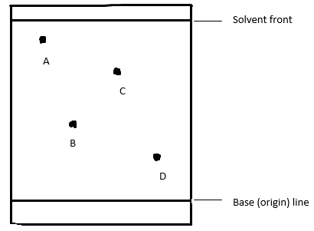
Diagram = 1 mark, Labelling = 1 mark
16. (a) Nitric (V) acid √
(b) Pb²⁺_{(aq)} + SO₄²⁻_{(aq)} → PbSO_{4(s)} √
(c) An insoluble coating of PbSO_{4(s)} would prevent contact of the metal with the acid
and stop further reaction. √
17. (a) Produced when air-hole is open √
(b) X √
(c) Green-blue region√
18. Quantity of electricity = 40,000 × 60 × 60 √
3 × 96,500 coulombs produce 27 g of Al √
= 13.43 kg √
19. (a) Endothermic reaction- absorbs heat from the surrounding √½
Exothermic reaction- releases heat to the surrounding √½
(b)
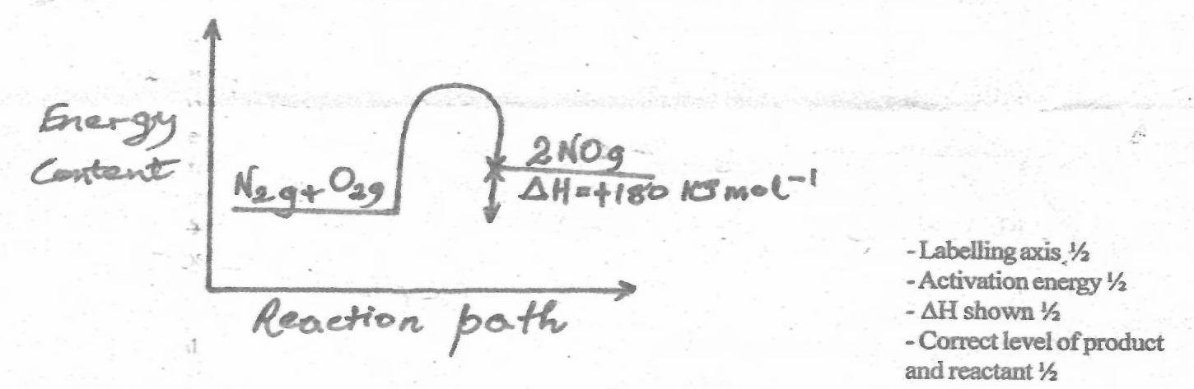
20. (a) (i) Nitrogen (IV) oxide /NO₂ √
(ii) Zinc oxide/ZnO √
(b) Calcium oxide √
21. (a) CH₃─CH₂CHCH₃ √
│
CH₃

(b) CH₃CH₂CH═CHCH₃ √

(c) O
║
CH₃CH₂C─O─CH₂CH₃ √
22. (a) The forward and backward reactions takes place at the same rate.√
(b) Backward reaction is favoured or equilibrium shift to the left √; Magnesium reacts
with steam lowering the concentration which is replaced through backward
reaction.√
23. Magnesium continues to burn for some time, √½ white fumes √½ and yellow specks or
solid are formed√½.
Heat produced by burning magnesium decomposes sulphur (IV) oxide to sulphur
(yellow solid) and oxygen √½. Magnesium burns in the oxygen √ ½ to form magnesium
oxide (white fumes). √½
24. Heat the mixture √½, dry ice sublimes √½, add water to the mixture √½, filter √½, and
filtrate is calcium chloride, residue is barium sulphate √½, heat the filtrate to saturation
and then cool to allow crystals of calcium chloride to form. √½
25. Reducing agent SO₂ √
Oxidation number of S has increased from +4 in SO₂ to +6 in SO₄²⁻.
OS of S in SO₂
S + 2(-2) = 0
S = +4 √½
OS of S in SO₄²⁻
S + 4(-2) = -2
S= +6 √½

26. (a) Aluminium form a protective layer of aluminium oxide on the surface which
prevents further oxidation whereas iron does not.√
(b) Food packaging
Head lamp reflectors
Overhead electrical cables
Construction of aircrafts and ships (Duralumin alloy)
Reducing agent in thermite process
Abrasive (corundum or emery)
Any two = 2mks
27. (a) 2Li_{(s)} + H₂O_{(g)} → Li₂O_{(s)} +H_{2(s)} √
(b) K is highly reactive and the reaction would be more vigorous and explosive.√
(c) Oxygen gas√
28.
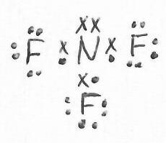√
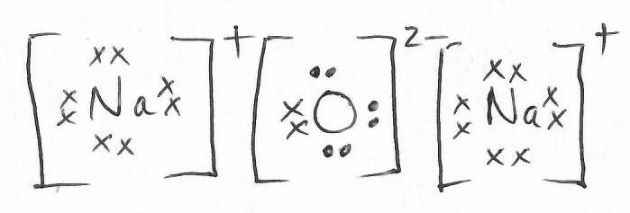√
29. (a) Curve A
(b) In both cases, hydrochloric acid has been used up in the reaction and the total
amount of hydrogen produced is the same. √

