Name………………………………………………………......... Index number…………………..
Candidate’s signature.………………….. Date……………………

233/2
CHEMISTRY (THEORY)
PAPER 2
2 HOURS

SMARTPASS EXAMINATION
Kenya Certificate of Secondary Education (KCSE)

MODEL ONE 2019

INSTRUCTION TO CANDIDATES

- Write your name and index number in the spaces provided above.
- Sign and write the date of examination in the spaces provided above.
- Answer ALL the questions in the spaces provided in the question paper.
- KNEC Mathematical tables and silent non-programmable electronic calculators may be used.
- All working MUST be clearly shown where necessary
- This paper consists of 12 printed pages.
- Candidates should check the question paper to ensure that all pages are printed as indicated and no questions are missing.
- Candidates should answer all the questions in English.

For Examiner’s Use Only

Question | Maximum Score | Candidate’s Score
1 | 10
2 | 12
3 | 13
4 | 12
5 | 11
6 | 11
7 | 11
TOTAL SCORE | 80

1. A few drops of sulphuric acid were added to four test-tubes containing cations as shown
below.
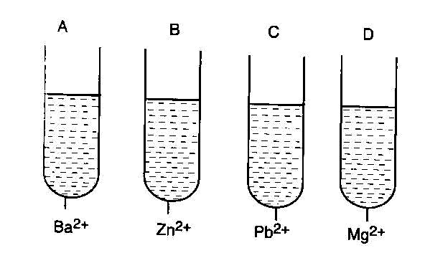
(a) (i) In which test-tubes were white precipitate formed? (1 mark)
………………………………………………………………………………………………………
(ii) Write the chemical formula of the precipitate formed. (1 mark)
………………………………………………………………………………………………………
(iii) State and explain the observations that would be made in test-tube B when aqueous
ammonia is added drop-wise until in excess. (2 marks)
………………………………………………………………………………………………………
………………………………………………………………………………………………………
………………………………………………………………………………………………………
………………………………………………………………………………………………………
(iv) State and explain the observation that would be made when little amount of sodium
stearate solution are added in test-tube D. (2 marks)
………………………………………………………………………………………………………
………………………………………………………………………………………………………
………………………………………………………………………………………………………
………………………………………………………………………………………………………
(b) Study the flow chart below and answer the questions that follow.
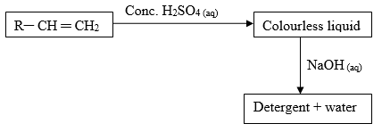
(i) What is the type of detergent prepared in this process? (1 mark)
………………………………………………………………………………………………………
(ii) Explain the cleaning of action of the detergent. (2 marks)
………………………………………………………………………………………………………
………………………………………………………………………………………………………
………………………………………………………………………………………………………
………………………………………………………………………………………………………
(c) Using an ion equation show how sodium carbonate removes water hardness. (1 mark)
………………………………………………………………………………………………………
2. The table below gives formulae and volumes occupied by 1 g of some gases at s.t.p. Study it
carefully to answer the questions that follow.
Formula of gas | Ne | C₂H₂ | O₂ | Ar | NO₂ | SO₂ | SO₃
Relative Molecular Mass | 20 | 26 | 32 | 40 | 46 | 64 | 80
Volume (cm³) | 1120 | 862 | 700 | 560 | 487 | 350 | 280
(a) Plot a graph of volume of gas (y-axis) against the relative molecular mass. (3 marks)

(b) Use the graph to predict the volume occupied at s.t.p by
(i) 1g of hydrogen chloride gas (Cl=35.5, H=1) (1 mark)
………………………………………………………………………………………………………
(ii) 1g of carbon (II) oxide. (C=12, O=16) (1 mark)
………………………………………………………………………………………………………
(iii) Relative molecular mass of a gas which occupies 508 cm³ per gram at s.t.p. (1 mark)
………………………………………………………………………………………………………
(c) (i) State the Graham’s law of diffusion. (1 mark)
………………………………………………………………………………………………………
………………………………………………………………………………………………………
………………………………………………………………………………………………………
………………………………………………………………………………………………………
(ii) A gas X diffuses through a porous plug in 60 seconds. Gas Y which is a quarter the
volume of gas X diffuses through the same plug in 22.5 seconds. Calculate the relative
molecular mass of gas Y. (Relative Molecular Mass of X = 34) (3 marks)
………………………………………………………………………………………………………
………………………………………………………………………………………………………
………………………………………………………………………………………………………
………………………………………………………………………………………………………
………………………………………………………………………………………………………
………………………………………………………………………………………………………
………………………………………………………………………………………………………
………………………………………………………………………………………………………
(d) A gas occupies 100 cm³ at 0 ⁰C and 1 atmosphere pressure. Calculate the temperature
at which the volume is double and the pressure is halved. (2 marks)
………………………………………………………………………………………………………
………………………………………………………………………………………………………
………………………………………………………………………………………………………
3. The set up below was used to prepare hydrogen chloride gas and salt T.
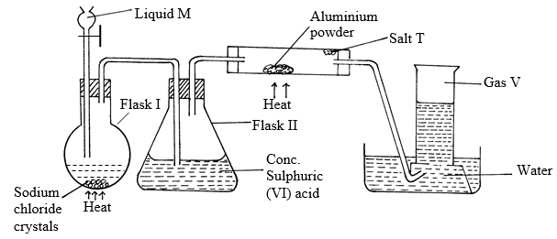
(a) Identify the following
(i) Liquid M……………………………………………………………………. (1 mark)
(ii) Gas V………………………………………………………………………. (1 mark)
(iii) Salt T……………………………………………………………………… (1 mark)
(b)Write balanced chemical equations for reactions that occur at:
(i) Flask I (1 mark)
………………………………………………………………………………………………………
(ii) Combustion tube. (1 mark)
………………………………………………………………………………………………………
(c) Name the process that formed salt T as shown in the diagram. (1 mark)
………………………………………………………………………………………………………
(d) Sulphuric (VI) acid is used as a drying agent in this experiment. Explain why calcium
oxide is unsuitable for the same purpose in this reaction. (1 mark)
………………………………………………………………………………………………………
………………………………………………………………………………………………………
(e) The water in the beaker was found to have a pH of 2.0 at the end of the experiment.
Explain. (1 mark)
………………………………………………………………………………………………………
………………………………………………………………………………………………………
………………………………………………………………………………………………………
(f) Calculate the mass of salt T formed if 480 cm³ of hydrogen chloride gas measured at
r.t.p was reacted with aluminium powder. (Al = 27, Cl = 35.5, MGV = 24 dm³) (2 marks)
………………………………………………………………………………………………………
………………………………………………………………………………………………………
………………………………………………………………………………………………………
………………………………………………………………………………………………………
(g) In the space provided below, draw a well labelled diagram showing how you would
dissolve hydrogen chloride gas in water. (1 mark)
………………………………………………………………………………………………………
………………………………………………………………………………………………………
………………………………………………………………………………………………………
………………………………………………………………………………………………………
………………………………………………………………………………………………………
(h) Explain why hydrogen chloride gas dissolved in methylbenzene does not react with
calcium carbonate. (1 mark)
………………………………………………………………………………………………………
………………………………………………………………………………………………………
………………………………………………………………………………………………………
………………………………………………………………………………………………………
(i) Using equation, state the observation made when a gas jar containing hydrogen chloride
gas is opened near an open bottle of liquid ammonia. (1 mark)
………………………………………………………………………………………………………
………………………………………………………………………………………………………
4. (a) The grid given represents part of the periodic table. Study it and answer the questions that
follow. (The letters do not represent the actual symbol of the elements)

 |  |  |  |  |  |  |  | A
 |  |  |  | B
 | C |  | D |  |  | E
 | F
(i) What name is given to the group of elements to which C and F belong? (1 mark)
………………………………………………………………………………………………………
(ii) Which letter represents the element that is least reactive? (1 mark)
………………………………………………………………………………………………………
(iii) What type of bond is formed when B and E react? Explain. (2 marks)
………………………………………………………………………………………………………
………………………………………………………………………………………………………
………………………………………………………………………………………………………
………………………………………………………………………………………………………
(iv) Write the formula of the compound formed when element D and oxygen gas react.
(1 mark)
………………………………………………………………………………………………………
(v) On the grid, indicate with a tick (√) the position of element G which is in
the third period of the periodic table and forms G³⁻ ions. (1 mark)

(vi) Compare the atomic sizes of elements C and D. Explain. (2 marks)
………………………………………………………………………………………………………
………………………………………………………………………………………………………
………………………………………………………………………………………………………
………………………………………………………………………………………………………
(b) Study the information in the table below and answer the questions that follow.
(The letters do not represent the actual symbols of the substances).

Substance | Melting point  (ºC) | Boiling point (ºC) | Solubilty in water | Density at room temperature g/cm³
H | -117 | 78.5 | Very soluble | 0.8
J | -78 | -33 | Very soluble | 0.77 × 10⁻³
K | -23 | 77 | Insoluble | 1.6
L | -219 | -183 | Slightly soluble | 1.33 × 10⁻³

(i) Which substance is a liquid at room temperature and when mixed with water two layers
would be formed? (1 mark)
………………………………………………………………………………………………………
(ii) Determine the melting point of H in Kelvin? (1 mark)
………………………………………………………………………………………………………
(iii) Which letter represents a substance that is a gas at room temperature and which can be
Collected by downward displacement of air? (Density of air is 1.29 × 10⁻³ g/cm³ at room
temperature). Explain. (2 marks)
………………………………………………………………………………………………………
………………………………………………………………………………………………………
………………………………………………………………………………………………………
5. (a) The table below gives standard electrode potentials for the metals represented by the letters
A, B, C and D. Study it and answer the questions that follow.
Metal | Standard electrode potential, E⁰ (Volts)
A  B  C  D | -0.13  +0.85  +0.34  -0.76
(i) Arrange the metals in a decreasing order of reactivity. (1 mark)
………………………………………………………………………………………………………
Metals C and D were connected to form a cell as shown in the diagram below.
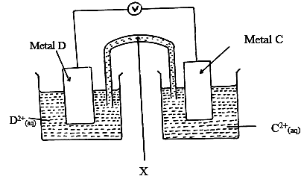
(ii) Write the equations for the reactions that occur at electrodes.
C (1 mark)
………………………………………………………………………………………………………
D (1 mark)
………………………………………………………………………………………………………
(iii) On the diagram, indicate with an arrow the direction in which electrons would flow.
(1 mark)
(iv) What is the function of the part labelled X. (1 mark)
………………………………………………………………………………………………………
………………………………………………………………………………………………………
………………………………………………………………………………………………………
………………………………………………………………………………………………………
(v) Calculate the e.m.f of the cell formed in the diagram. (1 mark)
………………………………………………………………………………………………………
………………………………………………………………………………………………………
………………………………………………………………………………………………………
………………………………………………………………………………………………………
(b) An electric current was passed through a concentrated solution of copper (II) chloride
as shown in the diagram below.
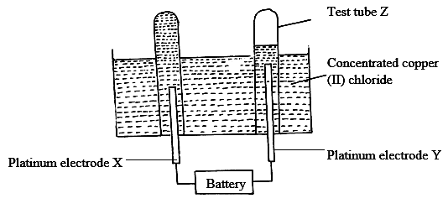
(i) Write the chemical equation of reaction at cathode? (1 mark) ………………………………………………………………………………………………………
(ii) After sometime test-tube Z was found to contain a mixture of two gases. Explain
this observation. (2 marks)
………………………………………………………………………………………………………
………………………………………………………………………………………………………
………………………………………………………………………………………………………
………………………………………………………………………………………………………
(iii) State the observations that would be made at the anode if the platinum electrodes are
replaced with copper electrodes. (2 marks)
………………………………………………………………………………………………………
………………………………………………………………………………………………………
………………………………………………………………………………………………………
………………………………………………………………………………………………………
6. The list below shows the formula of some organic compounds. Use it to answer the questions
that follow. Use the letters T₁ to T₆.
T₁ – CH₃CH₂CH₂CH₃
T₂ – CH₃CH₂CH₂COOC₂H₅
T₃ – CH₃CH₂CH₂CH₂OH
T₄ – CH₃CH₂CH₂COOH
T₅ – CH₃CH₂CHCH₂
T₆ – CH₃CCCH₃
(a) Select a compound which.
(i) Will produce bubbles of a gas when reacted with sodium carbonate. (1 mark)
………………………………………………………………………………………………………
(ii) Will decolourise both bromine water and acidified potassium permanganate. (1 mark)
………………………………………………………………………………………………………
(iii) Will produce hydrogen gas when reacted with sodium metal. (1 mark)
………………………………………………………………………………………………………
(iv) Represents a saturated hydrocarbon. (1 mark)
………………………………………………………………………………………………………
(v) Is likely to undergo polymerization. (1 mark)
………………………………………………………………………………………………………
(b) Using two molecules show how polymerization in T₅ occurs. (1 mark)
………………………………………………………………………………………………………
………………………………………………………………………………………………………
………………………………………………………………………………………………………
………………………………………………………………………………………………………
(c) Name the process by which compound T₂ is formed and identify the compounds that
were used to form it.
Process (1 mark)
………………………………………………………………………………………………………
Compounds (1 mark)
………………………………………………………………………………………………………
………………………………………………………………………………………………………
(d) Compound T₃ can be converted to T₄ as shown by the equation below.
C₃H₉OH + O₂ → C₃H₇COOH + H₂O
Given the following information
∆H_{c} C₃H₉OH = -4910 kJmol⁻¹
∆H_{c} C₃H₇COOH = -4090 kJmol⁻¹
Determine the heat change for the reaction above. (3 marks)
………………………………………………………………………………………………………
………………………………………………………………………………………………………
………………………………………………………………………………………………………
………………………………………………………………………………………………………
………………………………………………………………………………………………………
………………………………………………………………………………………………………
………………………………………………………………………………………………………
………………………………………………………………………………………………………
7. The set-up below can be used to generate a gas.
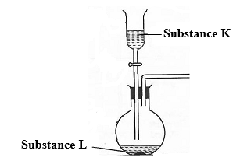
(a) (i) Complete the table below giving the names of substance K and L if the gases generated
are carbon (IV) oxide and carbon (II) oxide. (2marks)
Substance | Carbon (IV) oxide | Carbon (II) oxide
K
L
(ii) Complete the diagram to show how a sample of carbon (II) oxide can be collected.
(2marks)
(iii) State two ways that can be used to distinguish carbon (IV) oxide from carbon (II)
oxide? (2 marks)
………………………………………………………………………………………………………
………………………………………………………………………………………………………
………………………………………………………………………………………………………
………………………………………………………………………………………………………
(b) (i) In an experiment, carbon (IV) oxide gas was passed over heated charcoal held in a
combustion tube. Write a chemical equation for the reaction that took place in the
combustion tube. (1 mark)
………………………………………………………………………………………………………
(ii) State one use of carbon (II) oxide. (1 mark)
………………………………………………………………………………………………………
………………………………………………………………………………………………………
(c) The following set ups were used by Form Two students. Study and use them to answer the
questions that follow.
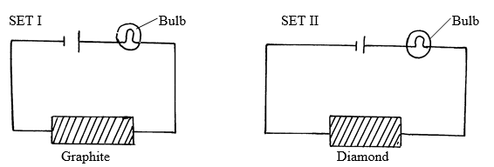
State and explain the difference in observation made in set up I and II above. (3 marks)
………………………………………………………………………………………………………
………………………………………………………………………………………………………
………………………………………………………………………………………………………

