SMARTPASS 233/2 CHEMISTRY PAPER 2 MODEL ONE 2019 MARKING SCHEME
1. (a) (i) A and C
(ii) BaSO₄ and PbSO₄
(iii) White precipitate soluble in excess aqueous ammonia. When a few drops of
aqueous ammonia are added insoluble zinc hydroxide / Zn(OH)_{2(s)} is formed √½
which dissolves in excess aqueous ammonia to form soluble complex of
tetraamine zinc (II) ion / [Zn(NH₃)₄]²⁺_{(aq)}. √½
(iv) White precipitate is formed (scum) due to formation of insoluble magnesium
stearate / Mg(C₁₇H₃₅COO)_{2(s)}.
(b) (i) Soapless detergent √
(ii) The non-polar end of detergent molecule dissolves in the grease while the polar
end dissolves in water √. This loosens grease to form micelle which are carried
away by rinsing water.√
(c) Mg²⁺_{(aq)} + CO₃²⁻_{(aq)} → MgCO_{3(s)} or Ca²⁺_{(aq)} + CO₃²⁻_{(aq)} → CaCO_{3(s)}
2. (a)
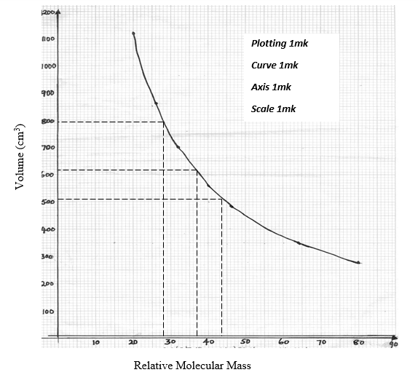
(b) (i) 620 cm³ √ (working must be shown on the graph)
(ii) 790 cm³ √
(iii) 44 √
(c) (i) The rate of diffusion of a gas is inversely proportional to the square root of its
density under the same conditions of temperature and pressure. √
(b) R_{X} = 1/60 = 0.0167 √½
R_{Y} = 0.25/22.5 = 0.0111 √½
0.0167/0.0111 = square root (Y/34) √
(0.0167/0.0111)² = Y/34
Y = (0.0167/0.0111)² × 34 = 76.96 √
(c) P₁V₁ = P₂V₂
T₁ T₂
1 × 100 = 0.5 × 200 √
273 T₂
T₂ = 273 K √
3. (a) (i) Conc. Sulphuric (VI) acid /sulphuric acid √ Acc. formula
(ii) Hydrogen gas // H₂ √
(iii) Aluminium Chloride // AlCl₃ √
(b) (i) NaCl_{(s)} + H₂SO_{4(l)} → Na₂SO_{4(aq)} + 2HCl_{(g)} √ or Deny ½ if state symbols wrong or missing
H₂SO_{4(l)} + Cl⁻_{(aq)} → H₂SO_{4(aq)} + HCl_{(g)}
ii) 2Al_{(s)} + 6HCl_{(g)} → 2AlCl_{3(s)} + 3H_{2(g)} √
(c) Sublimation √
(d) Gas is acidic, therefore reacts with the basic calcium oxide √
(e) Unreacted HCl gas √ dissolves forming a strong acidic solution √ Acceppt correct equation
(f) Moles of HCl = 480 = 0.02 moles √½
24000
Moles ratio HCl:AlCl₃ = 3:1
Moles of AlCl₃ = 0.02 × 1/3 = 0.0066 moles √½
RFM = 133.5½
Mass of T = 0.0066 × 133.5 = 0.8811 g √½
(g)
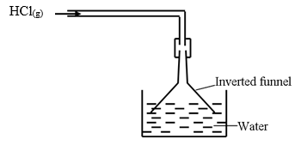
Diagram = √½, Labelling = √½
(h) In methyl / benzene HCl exists in molecular form and there are no H⁺ ions to react
with the carbonate √½
(i) HCl_{(g )} + NH_{3(g)} → NH₄Cl _{(s)} √ ½
White Fumes √ ½
The observation must be mentioned / indicated
4. (a) (i) Alkaline earth metals √
(ii) A√
(iii) Covalent √. They form bond by sharing of electrons since they are both non-
metals √
(iv) D₂O₃ √
(v) Group V and period 3 √
(vi) D has small atomic radius than C √, due to increased nuclear charge across the
period which pull electrons closer to the nucleus. √
(b) (i) K √
(ii) -117 + 273 = 156K √
(iii) J √ because its BP is higher than room temperature and is less denser than air √
5. (a) (i) D > A > C > B √
(ii) C²⁺_{(aq)} + 2e - → C_{(s)} √
D⁺_{(aq)} → D_{(s)} + 2e⁻√
(iii)
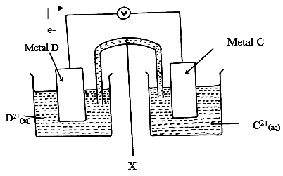
(iv) To complete the circuit / balance the charges
(v) e.m.f = +0.34 – (⁻0.76) √
= + 1.10 volts √
(b) (i) Cu²⁺_{(aq)} + 2e- → Cu_{(s)} √
(ii) Initially the Cl⁻ ions are at higher concentration hence preferentially discharged
to form chlorine gas √ but with time the concentration of Cl⁻ goes down hence
OH⁻ ions are discharged to produce of oxygen gas. √
(iii) No gas will be evolved; √ Anode dissolves. √
6. (a) (i) T₄ √
(ii) T₅ / T₆ for any one √
(iii) T₃ / T₄ for any one √
(iv) T₁ √
(v) T₅ / T₆ for any one √
(b)
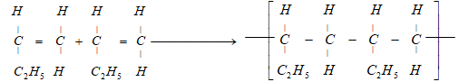 √
(c) Process – Esterification
Compounds - 1
(d)
C₃H₉OH + O₂ → C₃H₇COOH + H₂O ∆H₁ =?
C₃H₇COOH + 5O₂ → 4CO₂ + 4H₂O ∆H₂ = -4090 kJmol⁻¹ √
C₄H₉OH + 6O₂ → 4CO₂ + 5H₂O ∆H₃ = -4910 kJmol⁻¹ √
⸫ ∆H₁ = ∆H₃ - ∆H₂ = -4910 – (-4090) = -820 kJmol⁻¹ √
OR
C₃H₉OH + O₂ ∆H₁ =? C₃H₇COOH
+ 5O₂
+ 6O₂
∆H₃ = -4910 kJmol⁻¹ √ ∆H₂ = -4090 kJmol⁻¹ √
4CO₂ + 5H₂O
⸫ ∆H₁ = ∆H₃ - ∆H₂ = -4910 – (-4090) = -820 kJmol⁻¹ √
7. (a) (i)
Substance | Carbon (IV) oxide | Carbon (II) oxide
K | Dilute hydrochloric acid √½ | Concentrated sulphuric (VI) acid √½
L | Marble chips or calcium carbonate √½ | Sodium methanoate or ethanedioc acid (oxalic acid) √½

(ii)
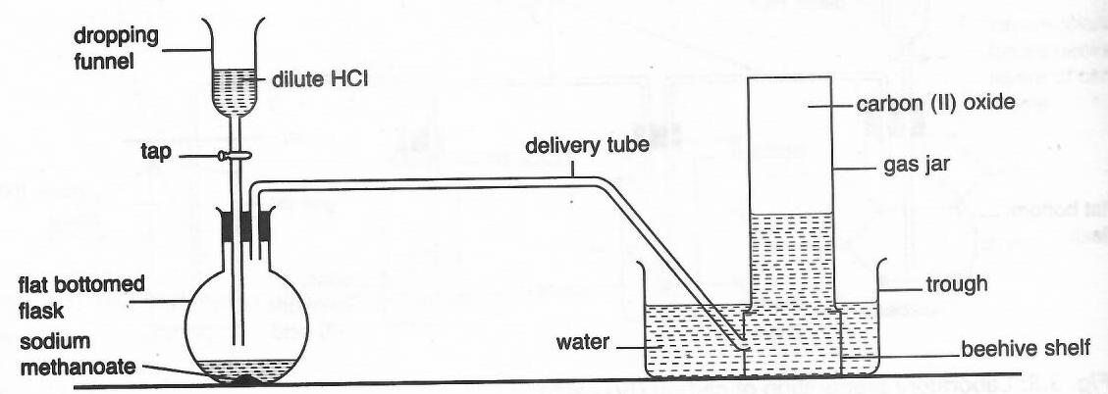
Complete diagram = 1 mark, Labelling = 1 mark
(iii) Carbon (IV) oxide reacts with lime water / calcium hydroxide solution to yield
white precipitate while carbon (II) oxide does not. √
Carbon (II) oxide burns with blue flame while carbon (IV) oxide does not burn. √
(b) (i) CO_{2(g)} + C_{(s)} → 2CO_{(g)} √
(ii) Reducing agent in extraction of some metals from their oxides. √
(c) The bulb lights in set up I or conducts electricity while set up II does not. √
In graphite, three out of four valence electrons of carbon atom are bonded leaving one
delocalised electron thus conducts electricity √ while in diamond, all the four valence
electrons are bonded and is without delocalised electrons. √

