**CHEMISTRY P 2 FORM III**

**TIME: 2 ½ HOURS:**

**NAME:…………………………………………… CLASS:……ADM NO:……SCHOOL: ……………**

**INSTRUCTIONS: Answer all questions in the space provided.**

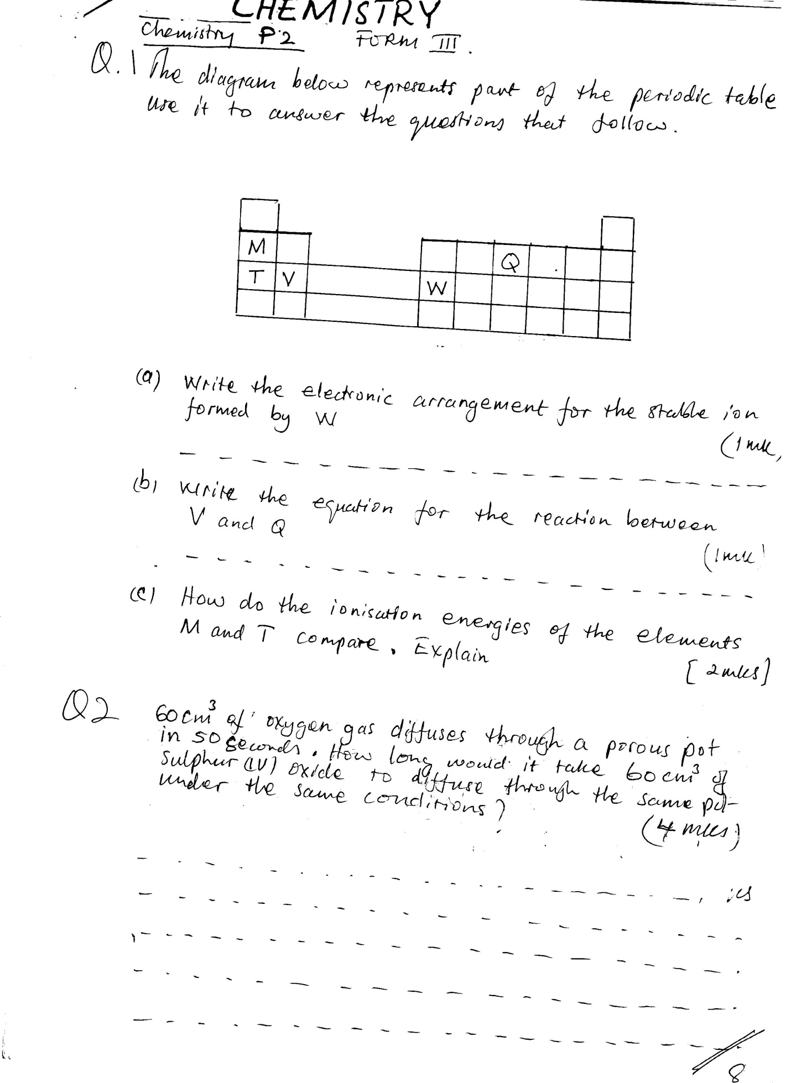Q 1. The diagram below represents part of the periodic table use it to answer the questions that follow.

a) Write the electronic management for the stable ion formed by W (1mk)

..............................................................................................................................................

b) Write the question for the reaction between V and Q ( 1 mk)

…………………………………………………………………………………………………………………………………………

c) How do we ionization energies of the elements M and T compare. Explain (2mks)

……………………………………………………………………………………………………………………………………………………………………………………………………………………………………………………………………………………

Q 2. 60 cm3 of oxygen diffuses through a porous pot in 50 seconds. How long would it take 60 cm3 of oxygen gas diffuses through a porous pot in 50sec.How long would it take 60cm3 of Sulphur (iv) oxide to diffuse through the same pot under the same conditions? (4mks)

……………………………………………………………………………………………………………………………………………………………………………………………………………………………………………………………………………………………………………………………………………………………………………………………………………………………………………………………………………………………………………………………………………………………………………………………………………………………………………………………………………………………………………………

Q 3. Give 2 reasons why helium is used in weathers ballons (2mks)

i)………………………………………………………………………………………………………………………………………

ii)………………………………………………………………………………………………………………………………………

Q 4. State the types of change that take place in each of the following situations

a)Burning a piece of charcoal ………………………………………………………………………………..(1mk)

b) Heating copper (ii) carbonate strongly…………………………………………………….…………(1mk)

c) Heating Zinc oxide strongly …………………………………………………………………………………(1mk)

Q 5. In a experiment to determine the percentage of purity of a sample of sodium carbonate, 2.15g of the sample reached completely with 40cm3 of 0.5m sulphuric (iv) acid

i)Calculate the number of moles of Sodium Carbonate that reacted (2mks)

…………………………………………………………………………………………………………………………………………………………………………………………………………………………………………………………………………………………………………………………………………………………………………………………………………………………………………………………………………………………………………………………………………………………………………

ii)Determine the percentage of Sodium Carbonate in the sample (Na=23,C=12,0=16 (3MK)

…………………………………………………………………………………………………………………………………………………………………………………………………………………………………………………………………………………………………………………………………………………………………………………………………………………………………………………………………………………………………………………………………………………………………………

iii) Name two industrial uses of Sodium Carbonate (2mks)

…………………………………………………………………………………………………………………………………………………………………………………………………………………………………………………………………………………………………………………………………………………………………………………………………………………………………………………………………………………………………………………………………………………………………………

Q 6 A certain mass of gas occupies 0.15dm3 at 20c and 98,648.5pa, Calculate it volume at 101325pa and 00c (3mks)

………………………………………………………………………………………………………………………………………………………………………………………………………………………………………………………………………………………………………………………………………………………………………………………………………………………………………………………………………………………………………………………………………………..……………………..

Q 7 a) Explain why aluminum is a better conductor of electricity than Sodium (2mks)

…………………………………………………………………………………………………………………………………………………………………………………………………………………………………………………………………………………………………………………………………………………………………………………………………………………………………………………………………………………………………………………………………………………………………………

b) State one property of aluminum that makes it suitable for power transmission cables (1mk)

……………………………………………………………………………………………………………………………………………………………………………………………………………………………………………………………………………………………………………………………………………………………………………………………………………………………………………………………………………………………………………………………………………………………………….

Q 8 The diagram below shows set-up for preparing hydrogen gas by a Form 3 Student .

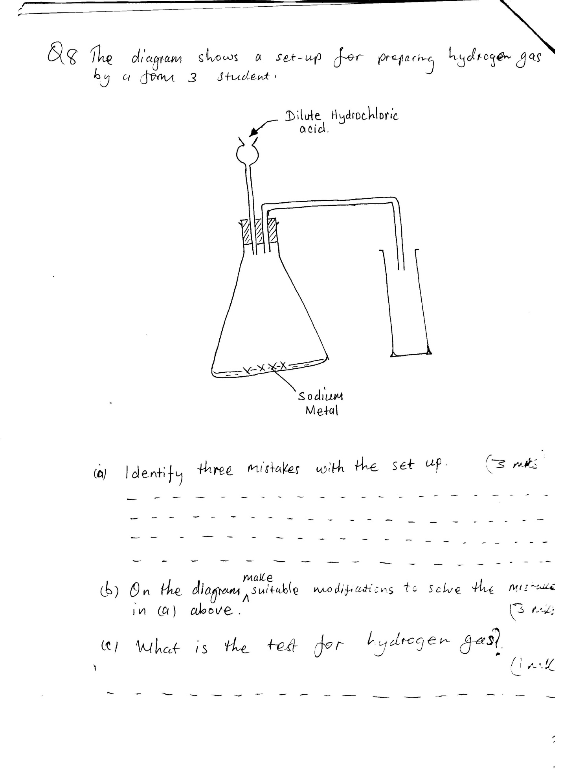

a)Identify three mistakes with the set-up (3mks)

…………………………………………………………………………………………………………………………………………………………………………………………………………………………………………………………………………………………………………………………………………………………………………………………………………………………………………………………………………………………………………………………………………

b) On the diagram make suitable modification to solve the mistakes in( a) above (3mks)

c) What is the test for hydrogen gas (1mk)

…………………………………………………………………………………………………………………………………………

Q 9 Carbon Oxide gas was passed over heated iron III Oxide as shown in the diagram below

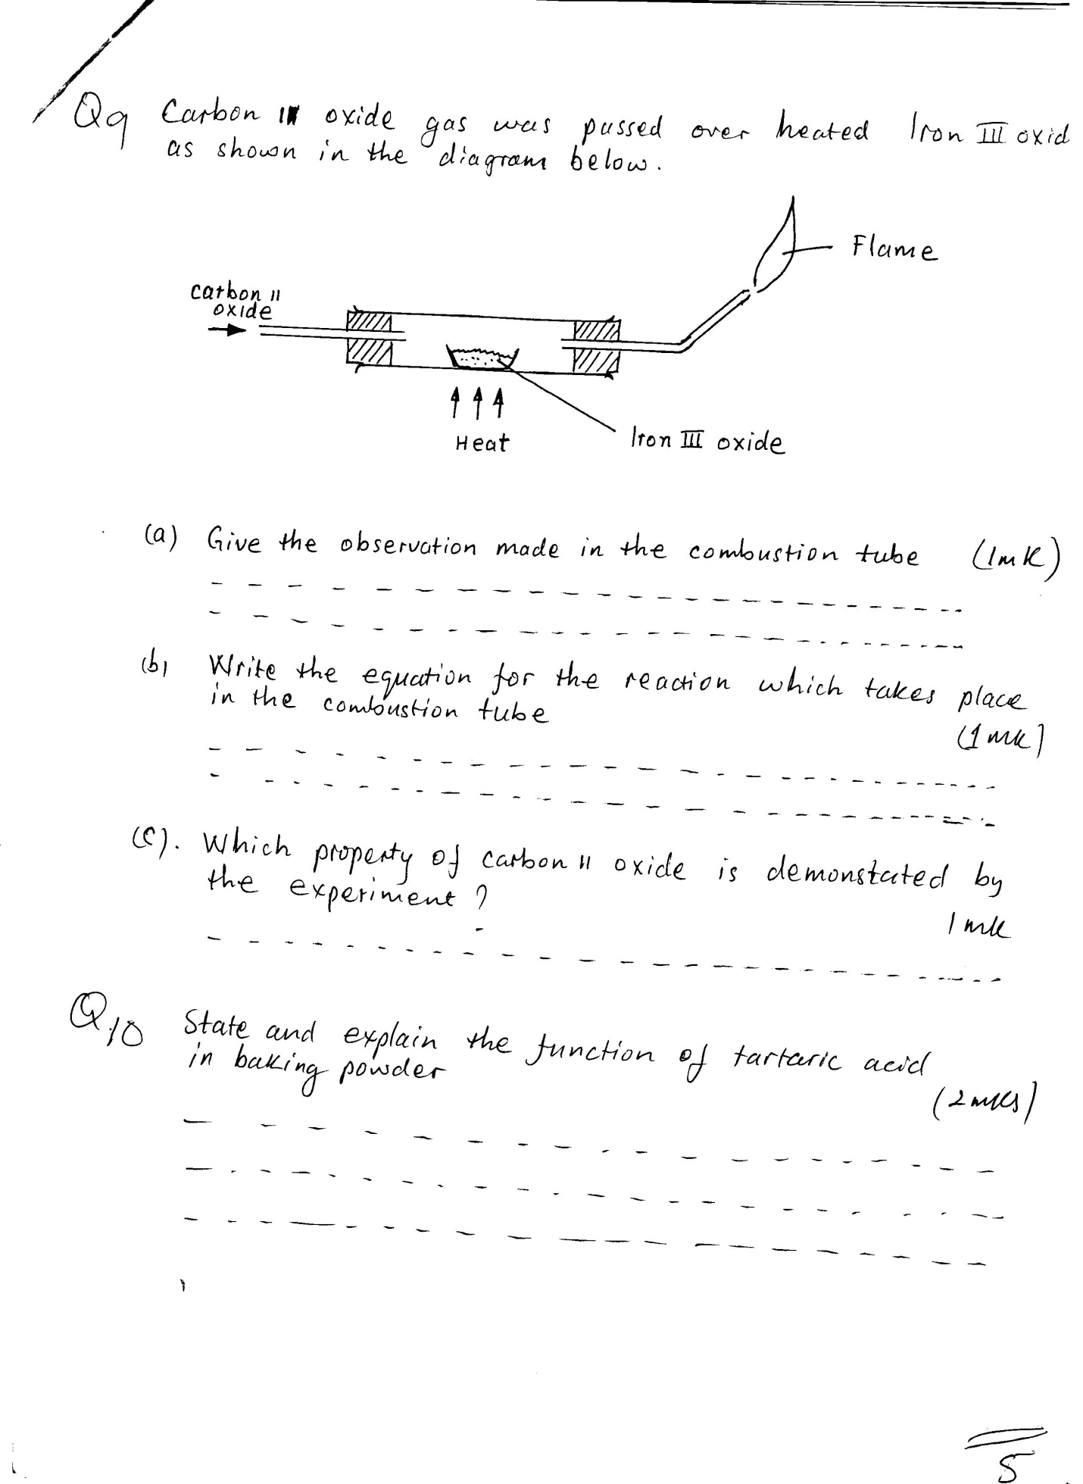

1. Give the observation made in the combustion tube (1mk)

……………………………………………………………………………………………………………………………………………………………………………………………………………………………………………………………………………........

b) Write the equations for the reaction which take place in the combustion tube (1mk)

……………………………………………………………………………………………………………………………………………………………………………………………………………………………………………………………………………………c) Which property of carbon II Oxide as demonstrated by the experiment (1mk)

…………………………………………………………………………………………………………………………………………

Q 10. State and explain the function of tartaric acid in baking powder (2mks)

………………………………………………………………………………………………………………………………………………………………………………………………………………………………………………………………………………………………………………………………………………………………………………………………………………………………

Q 11. a) State Boyle’s Law (1mk)

………………………………………………………………………………………………………………………………………………………………………………………………………………………………………………………………………………………………………………………………………………………………………………………………………………………………

b) 300cm3 of a gas at 800mm Hg was compressed to 200mm Hg pressure at constant temperature. Determine the new volume (2mks)

…………………………………………………………………………………………………………………………………………………………………………………………………………………………………………………………………………………………………………………………………………………………………………………………………………………………………………………………………………………………………………………………………………………………………………

Q 12. Explain why is not suitable to have a

1. Jiko with burning charcoal in a closed room (2mks)

…………………………………………………………………………………………………………………………………………………………………………………………………………………………………………………………………………………………………………………………………………………………………………………………………………………………………………………………………………………………………………………………………………………………………………

1. Which gas is contained in tizzy drinks? 1mk)

……………………………………………………………………………………………………………………………………………………………………………………………………………………………………………………………………………………………………………………………………………………………………………………………………

1. Write an equation for the reactions on the gas contained in dizzy drink and water (1mk)

………………………………………………………………………………………………………………………………………………………………………………………………………………………………………………………………………………………………………………………………………………………………………………………………………

Q 13. Air was passed through several reagents as shown in the flow chart below

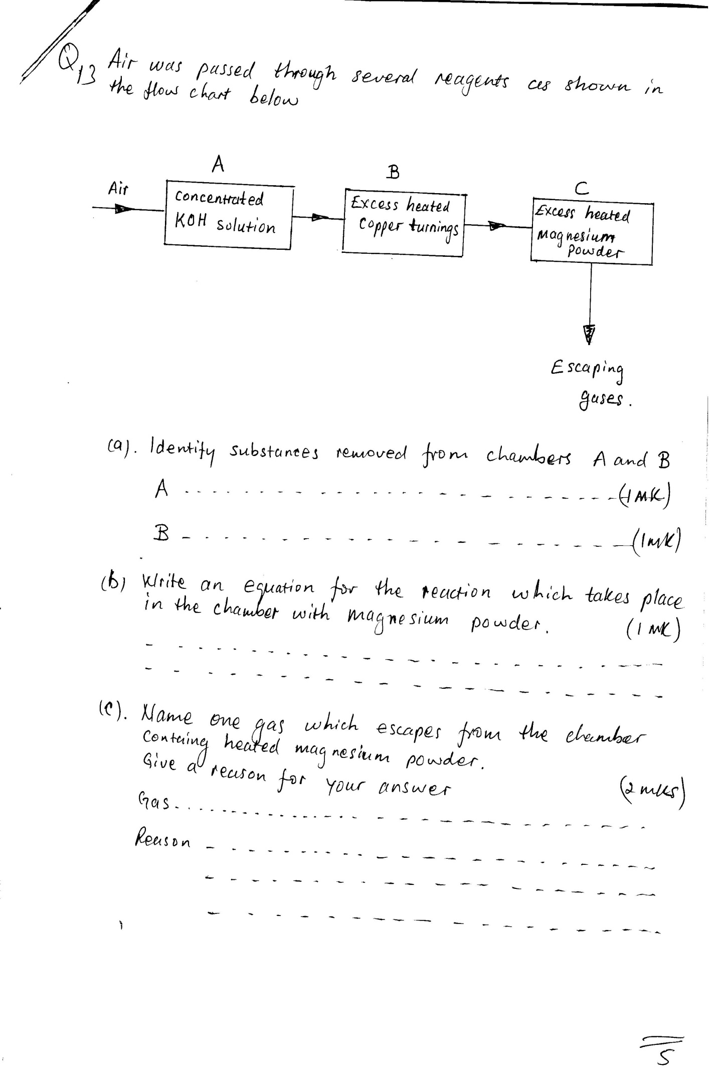

a) Identify substances removed from chambers A and B then

A ………………………………………………………………………………………………………………………… (1mk)

B…………………………………………………………………………………………………………………………… (1mk)

1. Write an equation for the reaction which take place in the chamber with magnesium powder (1mk)

……………………………………………………………………………………………………………………………………………………………………………………………………………………………………………………………………

c)Name one gas which escapes from the chamber containing heated magnesium powder.

Give a reason for your answer (2mks)

Gas ………………………………………………………………………………………………………………………………

Reason ……………………………………………………………………………………………………………………..……

……………………………………………………………………………………………………………………………………………………………………………………………………………………………………………………………………………………

Q 14. When potassium Nitrate is heated, it produces potassium Nitrate and gas X

1. Identify gas X (1mk)

…………………………………………………………….……………………………………………………………………

b) Name the type of reaction undergone by the potassium Nitrate (1mk) …………………………………………………………………………………………………………………..…………………

Q 15. Write a balanced equation for the reaction between Magnesium and Steam (1mk)

……………………………………………………………………………………………………………………..……..………

Q 16. When Chlorine gas was bubbled through water the resulting solution act as a bleaching agent

1. Explain how the resulting solution act as a bleaching agent (2mks)

…………………………………………………………………………………………………………………………………………………………………………………………………………………………………………………………………………………………………………………………………………………………………………………………………………………………………………………………………………………………………………………………………………………………………………

1. Using a neat diagram show how chlorine gas is collected in the laboratory (2mks)

…………………………………………………………………………………………………………………………………………………………………………………………………………………………………………………………………………………………………………………………………………………………………………………………………………………………………………………………………………………………………………………………………………

Q 17. Study the information in the table below and answer the questions that follow: The letters do not represent the actual symbol of the element).

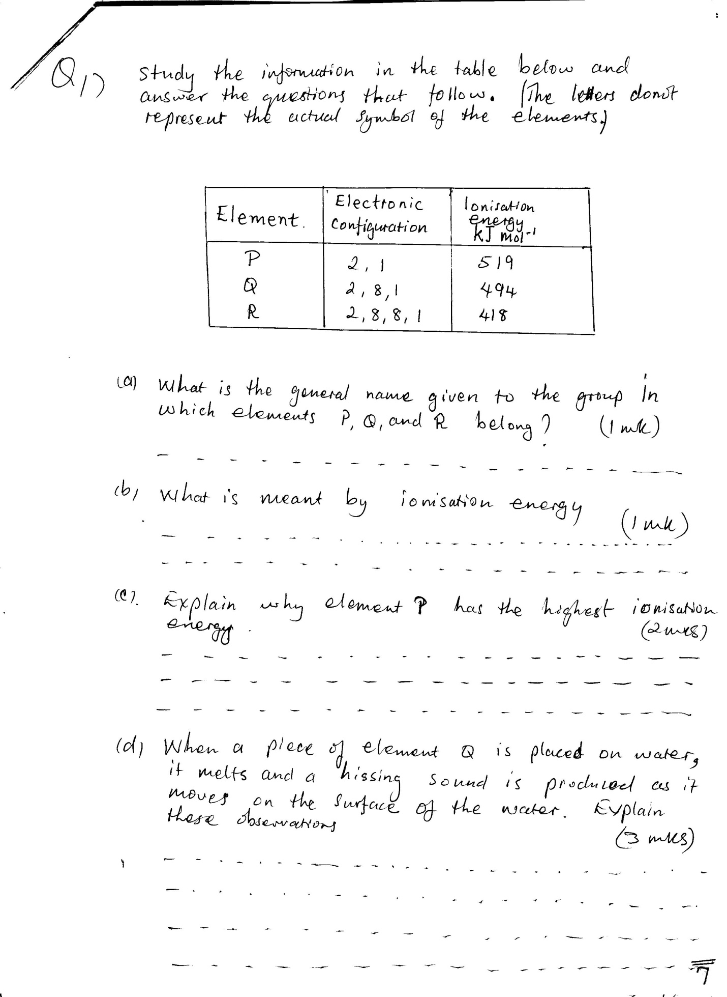

a) What is the general name given to the group in which element P, Q and R belong? (1mk)

…………………………………………………………………………………………………………………………………………

b) What is meant by ionisation energy (1mk)

……………………………………………………………………………………………………………………………………………………………………………………………………………………………………………………………………

c) Explain why Element P has the highest ionisation energy (2mk)

………………………………………………………………………………………………………………………………………………………………………………………………………………………………………………………………………………………………………………………………………………………………………………………………………………………………

d)When a piece of element Q is placed on water it melts and a hissing sound is produced as it moves on the surface of the water .Explain this observation (3mks)

…………………………………………………………………………………………………………………………………………………………………………………………………………………………………………………………………………………………………………………………………………………………………………………………………………………………………………………………………………………………………………………………………………………………………………………………………………………..

e) Write an equation for the reaction between elements Q and water (1mk)

………………………………………………………………………………………………………………………………………………………………………………………………………………………………………………………………………………………………………………………………………………………………………………………………………………………………

Q 18 Some moist iron wool was placed in a test tube and the tube inverted and placed in a beaker containing water. The apparatus was left for one week .It was observed that the iron wool had rusted and the water level had raisen.No further change took place when the set-up was left for more days even though not all the iron rusted.

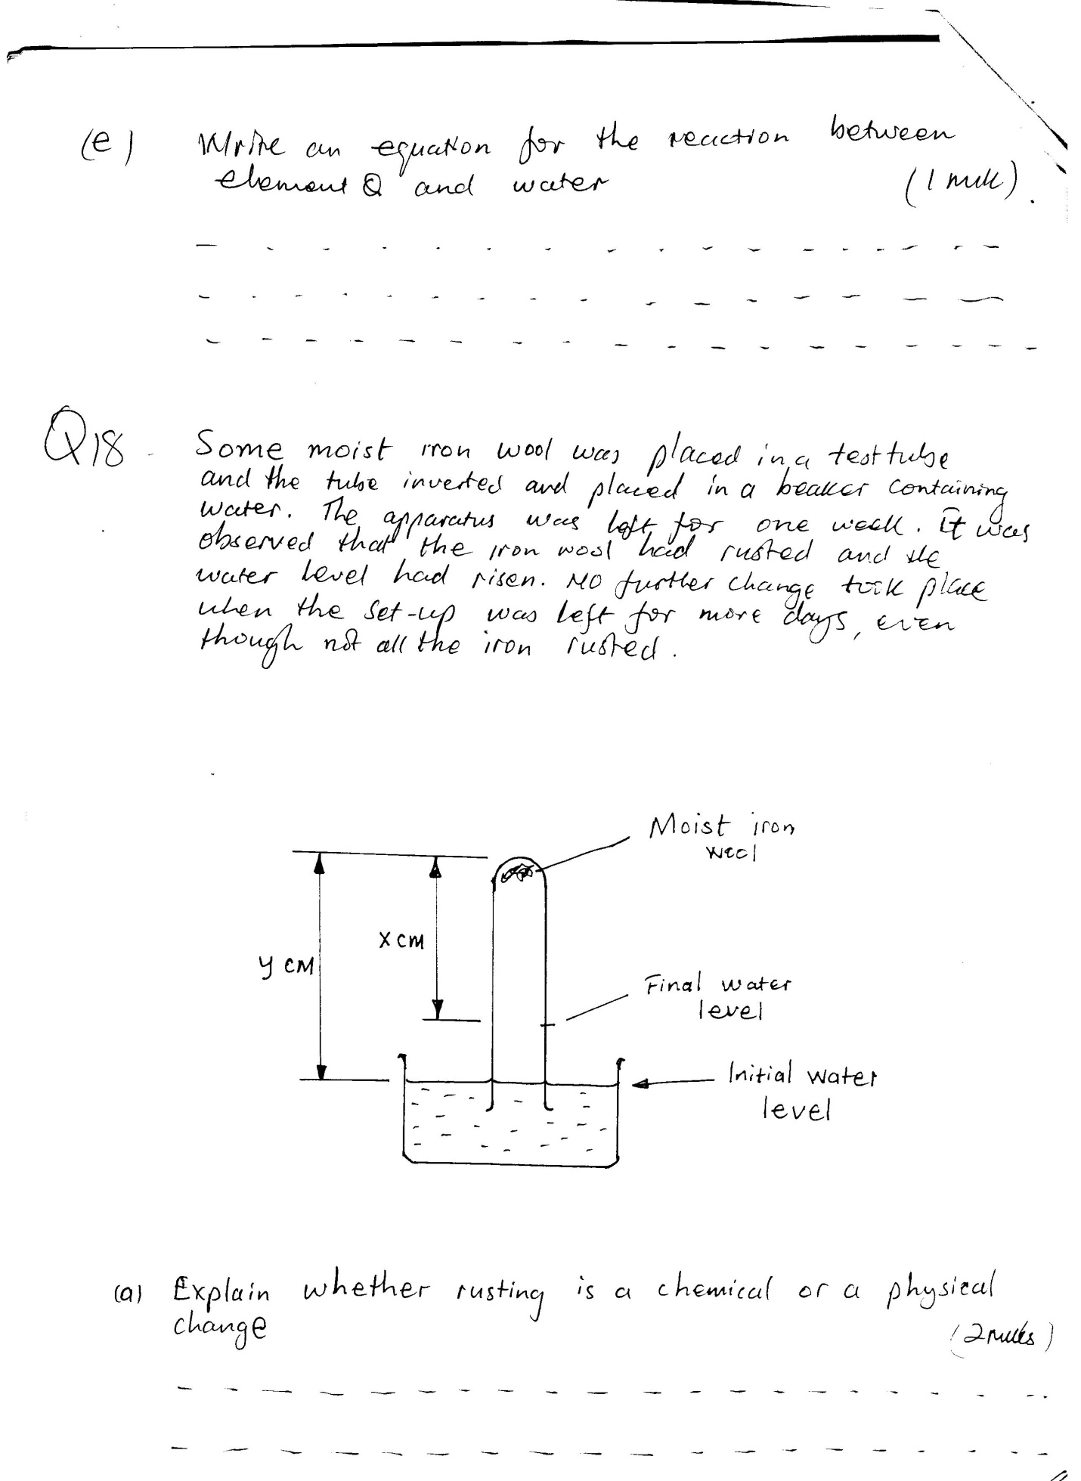

1. Explain whether rusting is a chemical or a physical change (2mks)

……………………………………………………………………………………………………………………………………………………………………………………………………………………………………………………………………………………………………………………………………………………………………………………………………..

1. Write an expression for an approximate percentage of air used up (1mk)

……………………………………………………………………………………………………………………………………………………………………………………………………………………………………………………………………

1. What would be the effect on the level of the water if a larger piece of iron wool was used (2mk)

……………………………………………………………………………………………………………………………………………………………………………………………………………………………………………………………………………………………………………………………………………………………………………………………………..

1. State the similarities between rusting and combustion (2mks)

…………………………………………………………………………………………………………………………………..

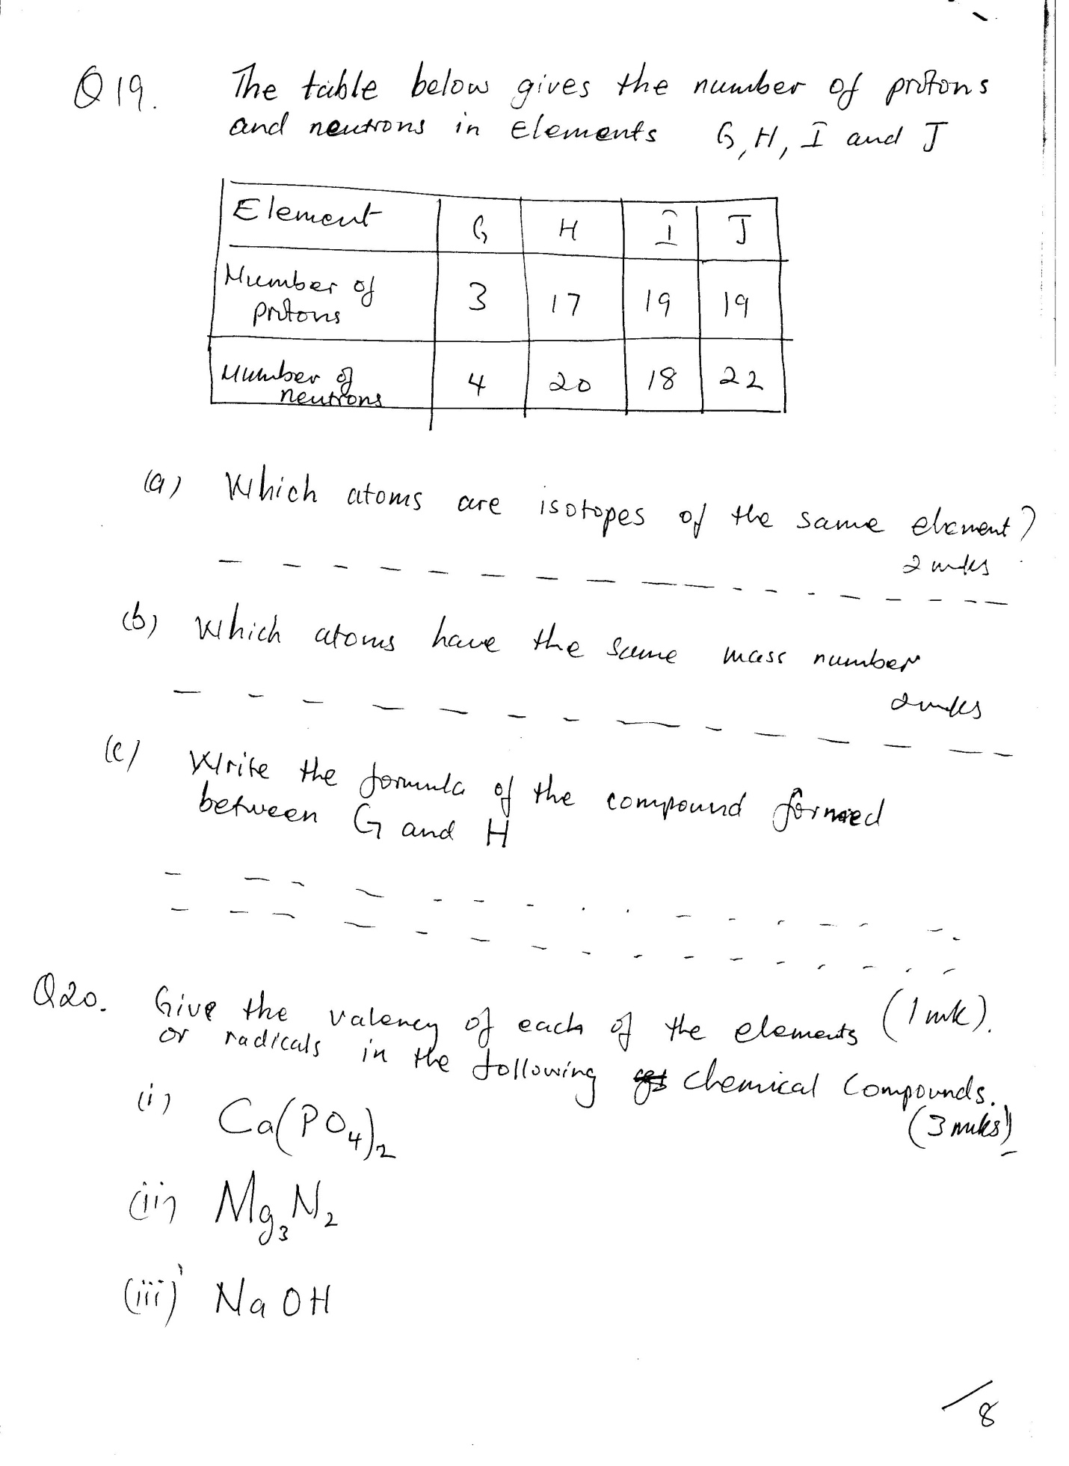Q 19 The table below gives the number of protons and neutrons in element G,H,I and J

1. Which atoms isotopes of the same element? (2mks)

……………………………………………………………………………………………………………………………………….

1. Which atoms have the same mass number (2mks)

……………………………………………………………………………………………………………………………………..

1. Write formula of the compound formed between G and H (1mk)

…………………………………………………………………………………………………………………………………………………………………………………………………………………………………………………………………………………

Q 20 Give the valency of each of the elements (1mk)

or radical in the following chemical compounds. (3mks)

1. Ca(PO4)2
2. Mg3N2
3. NaOH