NAME: ………………………………. ADM NO: ……….. CLASS: …………….
233
FORM THREE
CHEMISTRY
MID TERM 1 EXAMS 2023
TIME: 2 HOURS

Answer all the questions in the spaces provided.
1. What is the temperature on the Kelvin scale for each of the following? (3 marks)
(a) 100ºC –

(b) -100ºC –

(c) 22ºC –

2. State any three differences between luminous and non-luminous flame. (3 marks)
Luminous | Non-Luminous

3. The table below shows liquids that are miscible and those that are immiscible.

Liquid | L₃ | L₄
L₁ | Miscible | Miscible
L₂ | Miscible | Immiscible
(i) Name the method that can be used to separate L₁ and L₃ from a mixture of the two.
(1 mk)

(ii) Describe how a mixture of L₂ and L₄ can be separated. (2 mks)

4. A gas occupies 450cm³ of 27ºC. What volume would the gas occupy at 177ºC if its
pressure remains constant? (3 mks)

5. The electron arrangement of ions X⁺³ and Y²⁻ are 2.8 and 2.8.8
(a) Write the electronic arrangement of the elements X and Y. (2 mks)
X –
Y –

(b) Write the formula of the compound that would be formed between X and Y.(1 mk)

6. Explain why there is general increase in the first ionization energies of the elements in
period 3 of the periodic table from left to right. (2 mks)

7. How would you obtain a sample of pure iodine from a mixture of iodine and lead sulphate?

8. (a) State Gay Lussacs law. (1 mk)

(b) 10cm³ of a gaseous hydrocarbon (C₂H_{x}) required 30cm³ of oxygen for complete
combustion. If 20cm³ steam and 20cm³ of carbon (iv) oxide were produced, what
is the value of X. (3 mks)

9. Explain how conduction of electricity take place in the following: (2 mks)
(a) Iron metal –

(b) Molten lead (II) iodide –
10. Study the set up below and answer the questions that follow.

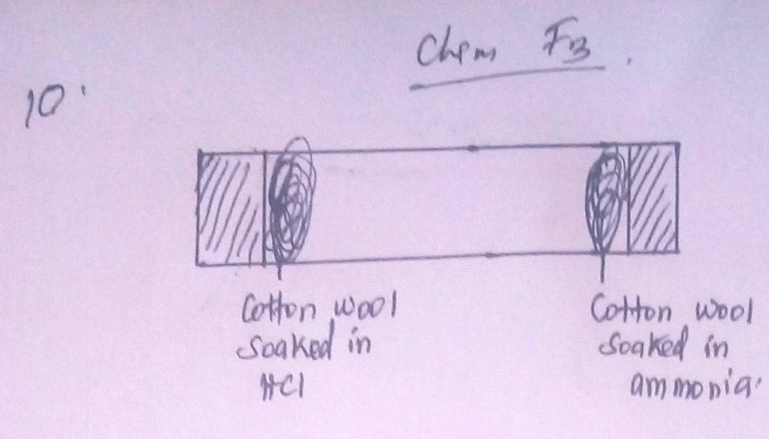

(a) What observation would be made in the tube? (1 mk)

(b) Indicate with a cross (x) on the diagram the likely position where observations
stated in (a) above would be made. (1 mk)

11. An organic compound had the following composition 37.21% carbon, 7.75% hydrogen
and the rest chorine. Determine the molecular formula of the compound given that the
molecular mass of the compound is 65 (C = 12, H = 1), Cl = 35.5) (5 mks)

12. Write an ionic equation for the reaction between an aqeous solution of Sodium hydroxide
and dilute hydrochloric acid. (3 mks)

13. Use the scheme below to answer the questions that follow.
Carbon (iv) Oxide
Solid H
heat
H₂O
Ca(OH)_{2(aq)}
Solid J

(a) Identify the solids H and J. (2 mks)
H –
J –

(b) State one commercial use of solid J. (1 mk)

14. The diagram below shows a ‘Jiko’ when in use. Study it and answer the questions that
follow.

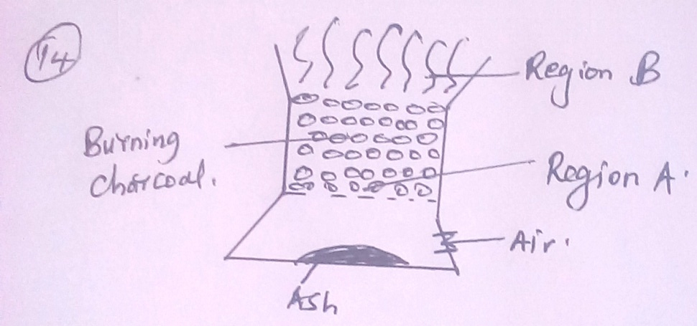

(a) Identify the gas formed at region A. (1 mk)

(b) State and explain the observation made at region B. (2 mks)

15. (a) Diamond and graphite are allotropes of carbon. What is meant by an allotrope?

(b) Explain why graphite can be used as a lubricant while diamond cannot. (2 mks)

16. (a) Distinguish between a covalent bond and co-ordinate bond. (2 mks)

(b) Draw a diagram to show bonding in ammonium ion (N = 7, H = 1) (2 mks)

17. Study the information given in the table below and answer the questions that follow. The
letters do not represent the actual symbols of the elements.
Element | Atomic number | Boiling point(k)
S | 3 | 1603
T | 13 | 2743
U | 16 | 718
V | 18 | 87
W | 19 | 1047

(a) Select the elements which belong to the same;
(i) Group - (1 mk)

(ii) Period - (1 mk)

(b) Which element;
(i) Is in gaseous state at room temperature? Explain. (1 mk)

(ii) does not form an oxide. (1 mk)

(c) Write the;
(i) formula of the nitrate of element T. (1 mk)

(ii) equation for the reaction between element S and U.

(d) What type of bond would exist in the compound formed when U and T react? Give
a reason for your answer. (2 mks)

18. The table below shows the relative atomic masses and the percentage abundances of the
isotopes L₁ and L₂ of element L.
 | Relative atomic mass | % abundance
L1 | 62.93 | 69.09
L2 | 64.93 | 30.91
Calculate the relative atomic mass of element L. (3 mks)

19. When magnesium metal is burnt in air, it reacts with both oxygen and nitrogen gases
giving a white ash. Write two equations for the reactions taking place. (2 mks)

20. The chromatogram below was obtained from a contaminated food sample P.
Contaminants Q, R, S and T are suspected to be in P. Use it to answer the following
questions.

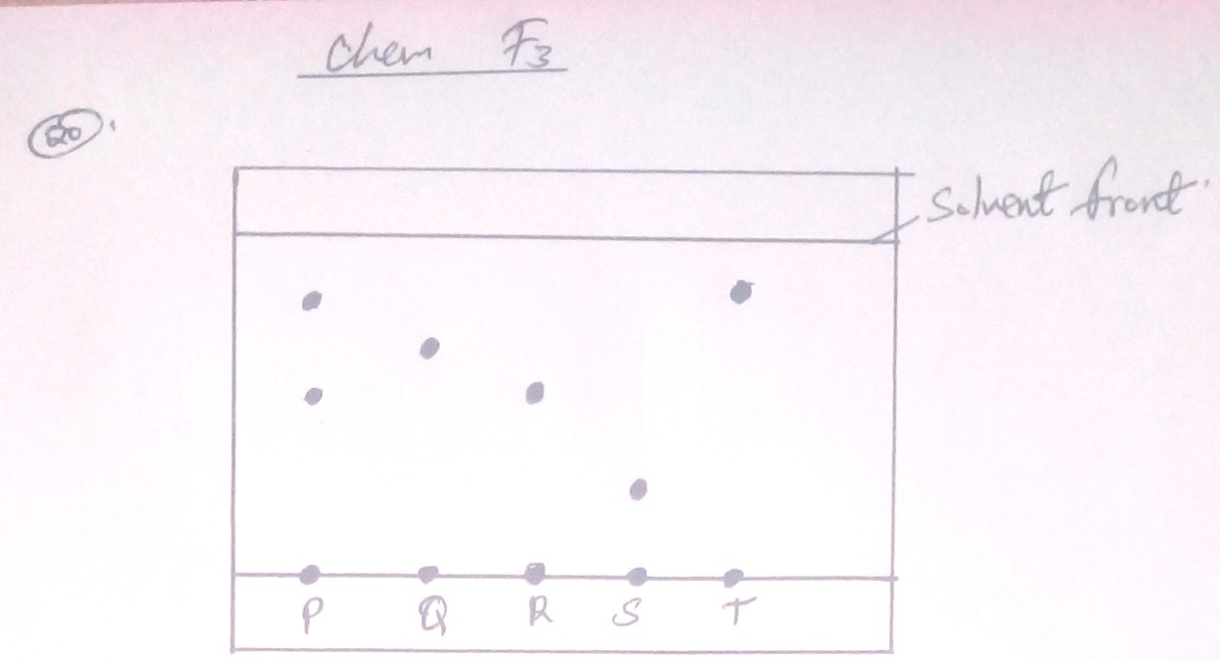

(a) Identify the contaminant in mixture P. (1 mk)

(b) Which is the most soluble contaminant in P? (1 mk)

21. Classify the following processes as either chemical or physical. (3 mks)
Process | Type of change
(a) Heating copper (II) sulphate crystals
(b) Obtaining kerosene from crude oil
(c) Souring of milk

22. Name two amphoteric oxides. (2 mks)

23. (a) What is the chemical name for rust. (1 mk)

(b) State one condition that accelerates rusting. (1 mk)

24. (a) State Charles law. (1 mk)

(b) Draw a sketch graph to illustrate Charles law. (2 mks)

25. (a) Define the term molar solution. (1 mk)

(b) In a class of 30 students, each student requires 100cm3 of 0.1M sodium hydroxide
solution for a tritration experiment. Calculate
(i) The total volume of sodium hydroxide required for the class.
(K = 39, O = 16, H = 1) (2 mks)

(ii) The total mass of sodium hydroxide required to prepare the total volume of solution
for the class. (3 mks)

26. The table below shows the values of solutions A, B, C and D.

Solution | A | B | C | D
pH value | 2 | 7 | 12 | 14

(a) Which solution is likely to be that of magnesium hydroxide? (1 mk)

(b) Select the solution that reacts with calcium carbonate powder. Give a reason. (1 mk)

27. Determine the volume of 2.0M NaOH which when diluted to 250cm³ would produce a
0.8M NaOH solution. (2 mks)

