ANESTAR VICTORY BOYS
FORM ONE CHEMISTRY MARCH/APRIL 2021 HOLIDAY ASSIGNMENT

- The diagram below shows apparatus commonly used in a chemistry laboratory.

(i) What is the name of the above apparatus.
(ii) Label the region PQR.
(iii) What would happen if part B was closed?

(a) Identify the processes represented by the letters A, B, C, D, E and F (3 marks)
(b) Name two substances that undergo the process labelled E and F. (2 marks)
(c) Name a method that can be used to extract the following:-
(i) Common salt from a salt solution. (1 mark)
(ii) Paraffin from crude oil. (1 mark)

(d) A student separated liquid P (B.P 78°C) and liquid Q (B.P 100°C) using the apparatus shown below.
(i) Name the apparatus labelled

(a) M............................................................................................................................. (1 mark)
(b) R.............................................................................................................................. (1 mark)
(ii) State one function of the glass bead in apparatus labelled R (1 mark)
(iii) What is the reading on the thermometer when the first jar drops of the distillate appeared in the beaker

(iv) Which of the liquids remains in the flask. (1 mark)

3. (a) Above is a paper chromatogram of pure substances W, X and Y
The mixture K contains substances W and X only. Indicate on the diagram the chromatogram of K.

(b) State three application of chromatography.
4. The set-up below was used to prepare a sample of oxygen gas. Study it and answer
the questions that follow.
H₂O₂
MnO₂

(i) Complete the diagram to show how Oxygen can be collected
(ii) Write a chemical equation of the reaction to produce oxygen

5 Air was passed through several reagents as shown below:
Concentrated sodium hydroxide solution
Air
Excess copper turnings hydroxide solution
Escaping
gases
Excess heated magnesium powder

(a) Write an equation for the reaction which takes place in the chamber containing
Magnesium powder
(b) Name one gas which escapes from the chamber containing magnesium powder.
Give a reason for your answer

6. (a) What is rust?
(b) Give four methods that can be used to prevent rusting
(c) Name two substance which speeds up the rusting process

7. Oxygen is obtained on large scale by the fractional distillation of air as shown on the flow
chart bellow.

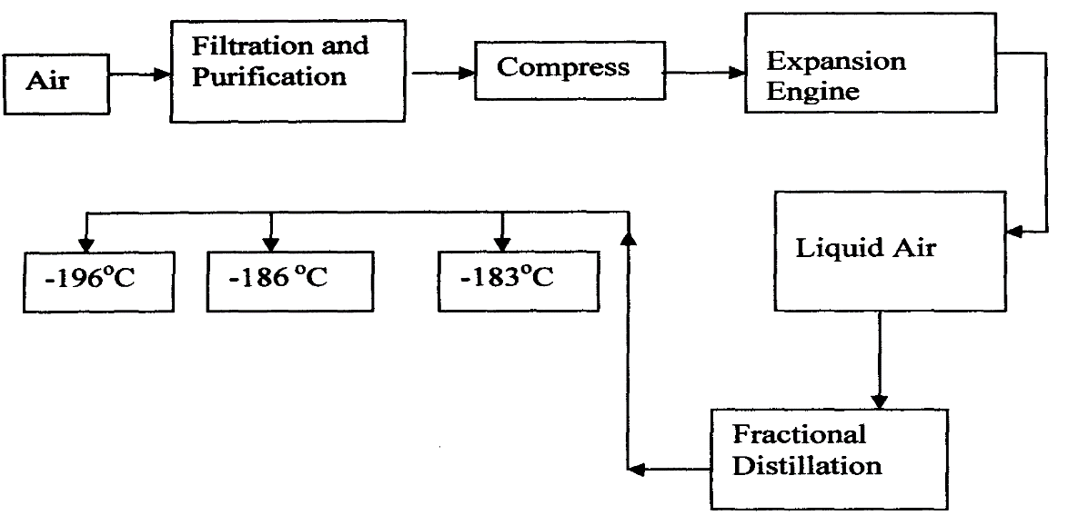

a) Identify the substance that is removed at the filtration stage
b) Explain why Carbon (IV) oxide and water are removed before liquefaction of air
c) Identify the component that is collected at -186°C

8. A form one class carried out an experiment to determine the active part of air. The diagram below shows the set-up of the experiment and also the observation made.
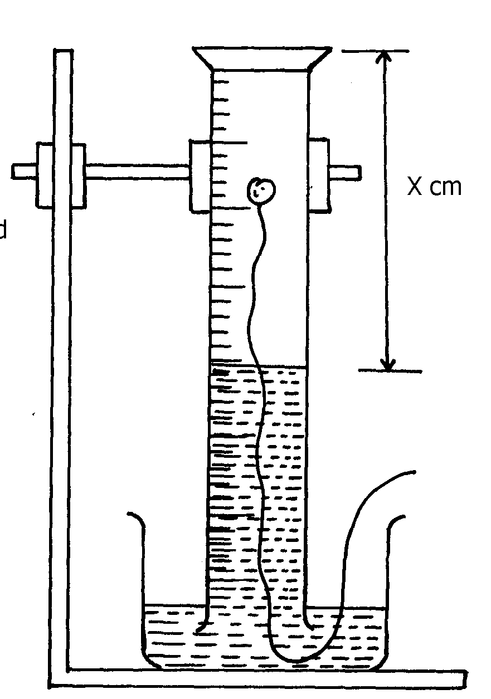
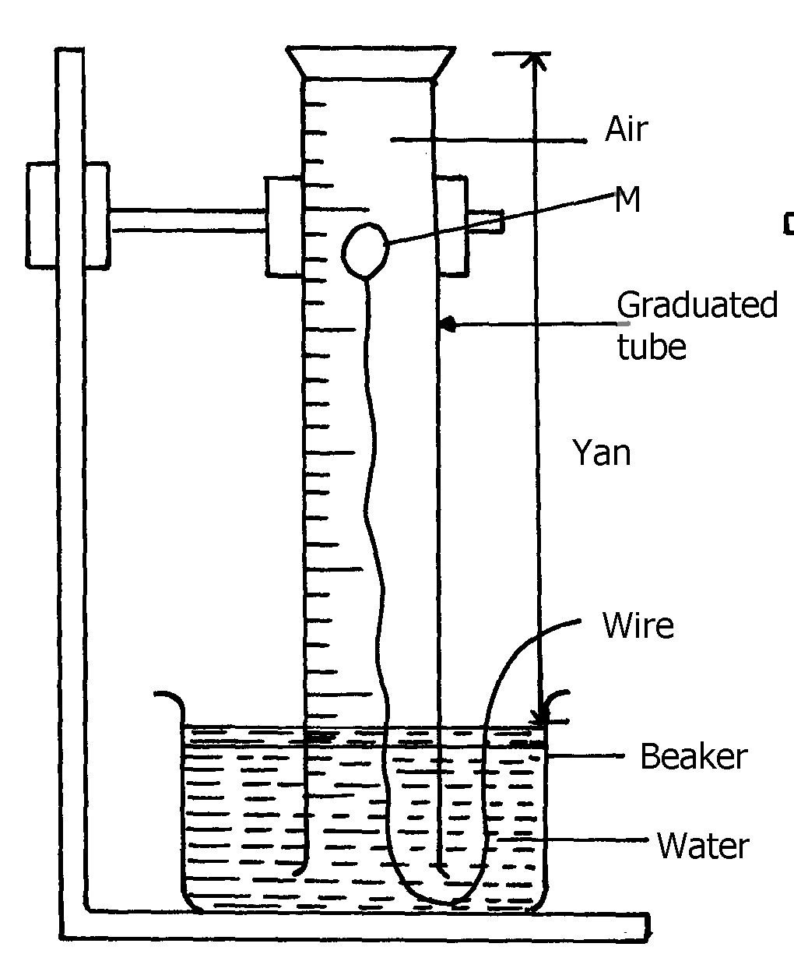
(i) At the beginning (ii) observation at the end of the experiment

Ycm
Air
Solid A

- (i) Identify substance M( 1 mark)

(ii) State two reasons for the suitability of substance M for this experiment (2marks)
(b) Write the equation for the reaction of substance M and the active part of air (1mark)

(c) (i) Using the letters Y and X write an expression for the percentage of the active part of air( 2 marks)

(ii) The expression in (c)(i) above gives lower value than the expected. Explain (2marks)

(d) (i) Explain the observation made when litmus paper is dipped into the beaker at the end of the experiment (2mark)
(ii) Name the active part of air (1 mark)

(iii) Suggest another method that can be used to determine the active part of air (1mark)

