ANESTAR VICTORY BOYS HIGH SCHOOL - LANET
CHEMISTRY HOLIDAY ASSIGNMENT- FORM II (2021)

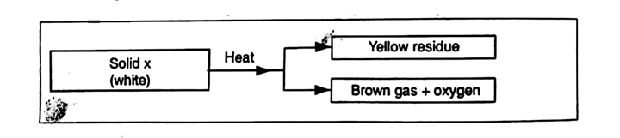
- Study the scheme below and answer the questions that follow.
Name:
- solid X (1mk)
- The yellow residue (1mk)
- Write the chemical equation for the decomposition of substance X (1mk)
- Study the experimental set up of apparatus shown below.
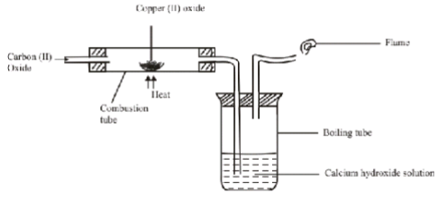
- State two observations made in the set up as the experiment progressed (2mk)
- Using an equation, explain the change that occurred in the boiling tube (1 mark)
- Why was the gas burned in the flame? (1 mark)
- Painting, oiling, galvanizing and tin plating are methods of rust prevention.
- Explain the similarity of these methods in the way they prevent rusting(1 mark)
- Explain why galvanized iron objects are better protected even when scratched (1mark)
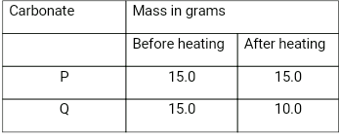
- Two carbonates P and Q are weighed before and after heating. The results are given in the table below.
Which one is likely to be sodium carbonate? Explain. (2 marks)

- The chemical equations below are the main reactions in large scale manufacture of sodium carbonate.
NH_{3(g)} + CO_{2(g)} + H₂O_{(l)} NH₄HCO_{3(aq)}
NH₄HCO_{3(aq)} + NaCl_{(aq)} Nahco_{3(s)} + NH₄Cl_{(aq)}
- Explain how the two products NaHCO₃ and NH₄Cl are separated (1mk)

- How sodium carbonate is finally obtained? (1mk)
- Explain how ammonia is recovered in this process. (1mk)
- Describe how you would separate a solid mixture of lead(II) chloride and copper(II) oxide (3mks)
- The table below shows the relative atomic masses and percentages abundance of the isotopes M₁ and M₂ of element M

Isotope | Relative abundance | % abundance
M₁ | 60.57 | 59.71
M₂ | 62.83 | 40.29

Calculate the relative atomic mass of element M (3mks)
- Distinguish between ionic and covalent metallic and coordinate bonds. (6marks)
- Explain using equations, the changes observed when carbon(iv) oxide is bubbled through calcium hydroxide solution until there is no further change occurs. (3mks)
- State four applications of carbon in real life. (4mks)
- Graphite is a poor conductor of electricity at high temperature. Explain (2mks)
- Diamond and graphite are two allotropes of carbon. Describe an experiment that would show that both substances are allotropes of carbon. (4mks)
- The apparatus illustrated below were used to prepare and collect carbon (ll) oxide in the laboratory
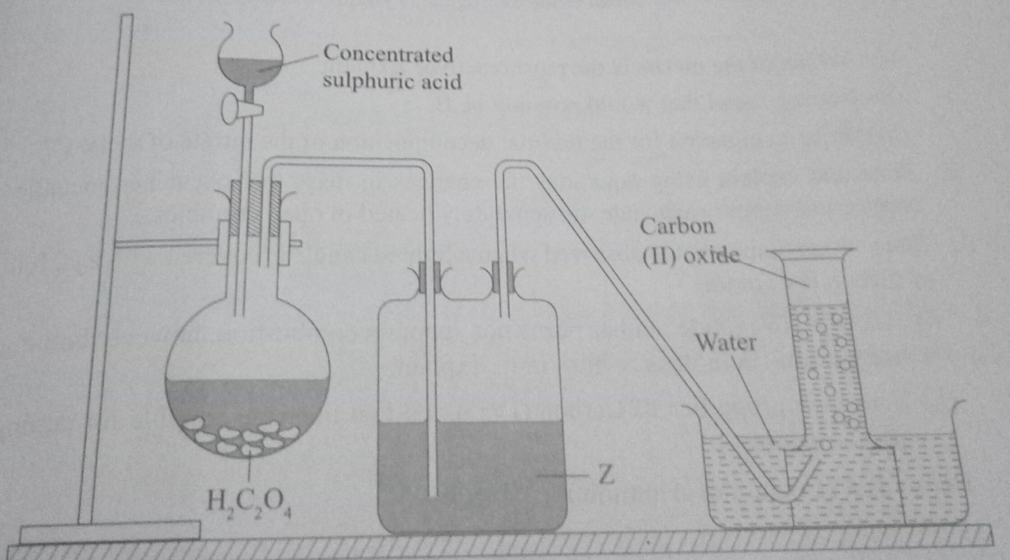

- State the conditions necessary for the reaction to occur. (2mks)
- Identify substance Z and state its role in this reaction (2mks)
- Write an equation for the reaction. (1mk)
- Explain why carbon (ll) oxide is collected over water (1mk)
- Carbon (ll) oxide is not collected by downward delivery. Explain. (2mks)
- What is an electric current? (1mk)
- Suggest a reason for the electrical conductivity in the substances that conduct. (2mks)
- The diagram below represents a set up of apparatus used to investigate the effect of electric current on Lead (ll) oxide. Study it and answer the questions that follow.

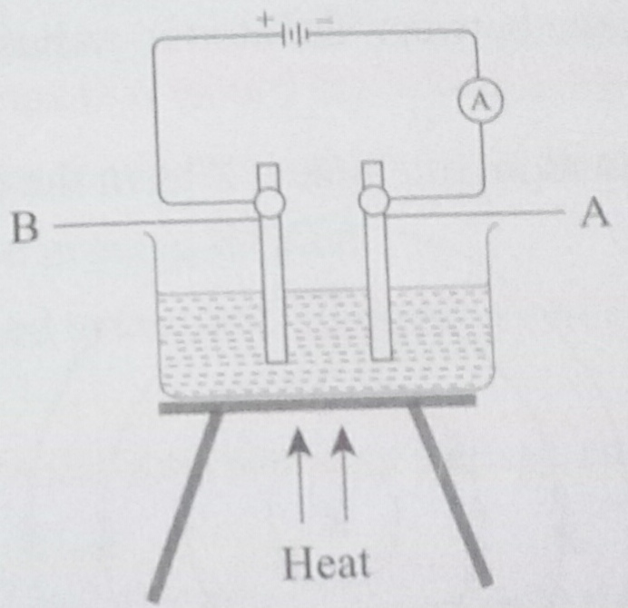
- Identify the cathode and the anode (2mks)
- What is the role of the cell/battery on the set-up? (2mks)
- State and explain the observations made when the swith is closed. (Use equations where possible) (4mks)
- State four applications of electrolysis in real life (4mks)
- What are salts? (1mk)
- State FOUR major methods of preparing salts. (4mks)
- Starting with dilute nitric (v) acid, describe how you can prepare crystals of potassium nitrate (4mks)
- State any FOUR disadvantages of evaporating a solution to dryness during preparation of salts (4mks)
- Differentiate between chemical bond and structure of a substance. (2mks)
- Aluminum chloride behaves as covalent rather than ionic. Explain. (2mks)
- Use dot(s) (•) and crosses (X) to show bonding in dimer aluminum chloride (Al₂Cl₆) (3mks)
- What do you understand by the term "chemical families of elements"? (1mk)
- Briefly explain the following observations.
- Alkaline earth metals are generally less reactive than alkali metals in the same period (2mks)
- Generally, metals reacts by losing electrons while halogens reacts by gaining electrons. (2mks)
- Group (VIII) elements are gases at room temperature (2mks)
- Though sodium and aluminum are in the same period and are both metals, aluminium is better conductor of electricity. (2mks)
- Many cooking pans are made of aluminum although it is a reactive metal. Explain. (2mks)
- Nobles gases are generally ureactive (2mks)
- What are the oxidation numbers and the charges of the following substances?
- Copper (l) ion (2mks)
- Hydrogen in hydrogen peroxide (2mks)
- Potassium in potassium permanganate (KMnO₄) (2mks)
- Sulphur in H₂SO₄ (2mks)

