2020 FORM 4 TERM 1 ENRTY EXAMS
F0RM 4 CHEMISTRY PP2
MARKING SCHEME.
- Q √1
- Sharp/ constant melting point and boiling point.

ii) Melting point – lower the M.P √ 1
Boiling point – raises the b.p√ 1
b) B – Melting √1
D - Condensation√1

ii) Sublimation √1
iii) Iodine √ ½
- Ammonium chloride √ ½ Any two 1mk.
- Solid ice √ ½
- Iron (III) chloride√
- Aluminum chloride √ ½

iv) Exothermic √ ½
Involves heat loss ½
- a) Nitrogen gas√ 1

b) i)Carbon (iv) oxide gas√1
ii)Oxygen gas√1
iii) Nitrogen√1
c) To remove/absorb water vapour or dry / drying agent.

d)i) 2 NaOH_{(Aq)} +CO_{2(g)} Na₂CO_{3(S)+}H₂O _{(L)}√1

ii)3Mg _{(s)} +N_{2 (g)} Mg₃N_{2(S)}√1

Penalize ½ if state symbols miss/wrong
Penalize fully if not balanced.
e) Brown solid changes to black√1
Brown copper metal oxidized/ reacts with oxygen to form copper (II) oxide (black)

f) - Argon
- Neon Any one. (1mk)
- Helium

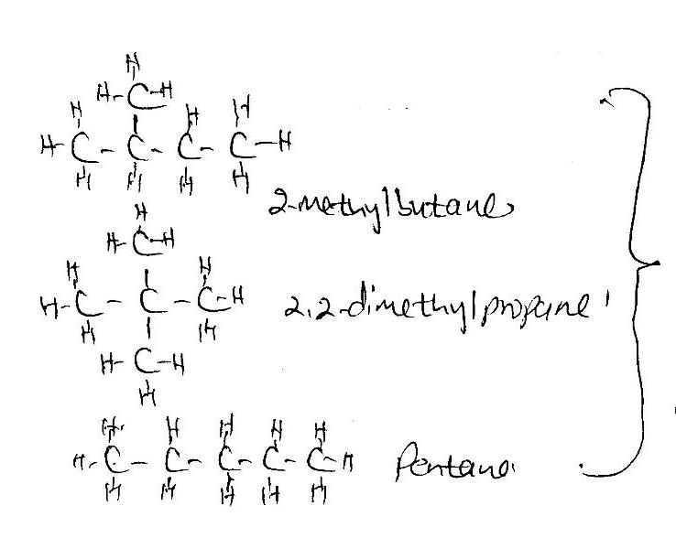
3

Any two
Drawing ½mk
Naming ½mk
Penalize fully if the structure is
wrong

b J- Hydrogenation√1
K –Bromination/Halogenation √1
T-Polymerisation√1

(ii) J-Hydrogen gas √ ½
K- Bromine gas √ ½

(iii) U-carbon (IV) Oxides gas √1
W chloroethane √ 1
S – Polyethene√ 1

Y – Sodium propanoate√ 1

C) CH₂CH₂ √ 1 burns with a yellow sooty flame while CH₃CH₃ √1 burns with a blue non- sooty flame.
4 a) C and T (Mark tied to the two elements)

b) J – has five energy levels/ highest number of energy levels.
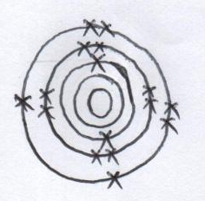
c)

d) i) Y -2,8,8,2 √ 1
W – 2,8,7√1
e) Period 3 should be shown on the grid
Group 5 otherwise penalize fully
f) M √
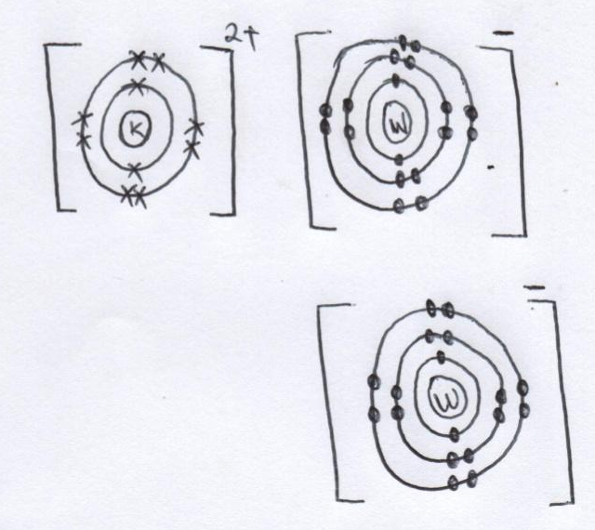
g) K W₂

h. K has a smaller √ ½ atomic radius than X
K has more √ ½ protons in the nucleus which increase the nucleus force of attraction √ ½ (higher nuclear charge) hence the electrons on the energy levels are strongly attracted towards the nucleus.
5 (i) 2 Pb (NO₃)_{2(S)} Heat 2 PbO_{(s)} +4 NO_{2 (g)} + O₂
- Penalize ½ mk if state symbols miss /wrong
- Penalize fully if not balanced
(ii) Sodium nitrite√ ½
Sodium nitrate √ ½
(iii) Charcoal glow red hot √1
(iv) To absorb Carbon (IV) oxide gas formed√1
(v) Carbon (II) oxide gas √1

b) i) Nitrogen gas – fractional distillation of liquid air√ 1
Hydrogen gas – Electrolysis of brine
- Cracking of hydrocarbon
- Water gas√ 1
(ii) Catalyst P platinum/ platinum – rhodium √ 1
b) Gas M – Nitrogen (II) Oxide √ 1
c) Liquid F – water √ 1
(iii) 4NH₃ +5O₂ ^{platinum} 4NO_{(g)} + 6H ₂O (₁₎
iv) 4 NO_{2 (g)} +2H₂O_{(l)+}O_{2(g)} 4 HNO_{3(aq)}
v) – Manufacture of nitrate fertilizers, synthetic fibre, dyes, drugs, explosives,
Purification of metals (Any one 1 mk).

6. (a) (i) solid W – Sodium sulphite
(ii) Dropping funnel
(b)Drying agent
(c)
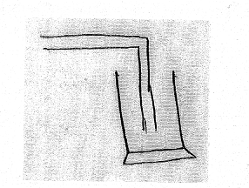

d Yellow iron (III) sulphate solution √1 turned pale green sulphur (IV) oxide gas reduced iron (III) ions to iron (II) ions√1.

e) Na₂SO_{3(S)} + 2HCl_{(aq)} 2 NaCl_{(aq)}+SO_{2(g)} + H₂O_{(l)}
moles of HCl
2 moles 1000 cm³
50 cm³√ (1 mk)
$\frac{2×50}{1000}=\frac{100}{1000}$ = 0.1moles
Mole ratio Hcl : SO₂
2 : 1 √ ½
Moles of SO₂ ₌ $\frac{1}{2}$= 0.05moles
1Mole 24dm³
  - oles ? = 1.2dm³√ ½
- $\frac{0.05×24}{1}√$½

j) - to make calcium hydrogen sulphite used to bleach wood pulp in the manufacture of paper
- as a fumigant
- as a preservative in jam and fruit juices
(Any two)

7(a) (i) A-Concentrated hydrochloric acid (1mk)
B-water (1mk)
(ii) Calcium oxide/CaO (1mk)
(iii) to absorb unreacted/excess chlorine (1mk)
(iv) 2KMnO_{4(S)}+ 16HCl (_{aq)} 2KCl _{(aq)}+ 2MnCl_{(aq)} + 8H₂O_{(l)} + 5Cl_{2(g)} (1mk)
(v) Solid C sublimes (1mk) hence collects on the cooler place away from heating.
(vi)
Elements present | _{Al} | _{Cl2}
Mass/volume  R.A.M/M.G.V  No of moles  Mole ratio | 0.675  27  $\frac{0.675}{27}$ = 0.025  $\frac{0.025}{0.025}$= 1  EF=AlCl₃ ½mk | 1800cm³  24000cm³  $\frac{1800}{24000}$= 0.075 ½mk  $\frac{0.075}{0.025}$ = 3 ½mk

(AlCl₃)_{n}=267 ½mk
(27 + 35.5 x 3)_{n} = 267
n = $\frac{267}{133.5}$ = 2
M.F. = (AlCl₃)₂ = Al₂Cl₆ ½mk

(b)(i) - bleaching agent in pulp
-Used as herbicides Any one (1mk)
(ii)chlorine bleaches by addition of oxygen while sulphur iv oxide
C) Hydrogen chloride gas dissociates in water to form an acidic solution which produces gas with zinc carbonate (1mk) while in methylbenzene the gas remains molecular hence the solution has no acidic properties and does not react with zinc carbonate (1mk)
Bleaches by reduction ( 1mk)

