CHEMISTRY PAPER 1 FORM FOUR
MARKING SCHEME.

- It is very hot.
Does not from soot each ½ mks

- R.A.M=35.5
35.5= ¾ ×35 + ¼ × x (1mk)
142=105 + x (1mk)

X = 37 (1mk)

- (a) ChloroHorocarbon (1mk)

(b) When ozone layer is depleted high energy radiation reach the earth and may cause cancer to human beings. (1mk)

(c) Global warming. (1mk)

- (a) NH₄NO_{3(S)} heat N₂O₍₃₎+2H₂O₍₃₎ (1mk)

(b) Over warm water, it’s fairly soluble in cold water (1mk)

(c) Both red blue litmus paper were not affected / did not change. (1mk)

- RS0₂ = M_{G} 1mk
R_{G} M SO₂

25 = MG
26.26 64

M_{G} = 25 64 1mk
26.26
= 7.6166

M_{G} = 58 1mk

- (a) Group I ( ½ mk)

Period 6 (½ mk)

b. 2Y_{(S)} + CL_{2 (g)} 2YCL_{(s)} (1mk

- C₂H₃CL₃

H CL H H
H C C CL CL C C H
H CL CL CL
(Each 1mk)
- H₂SO_{4(aq)} + 2NaOH_{(aq)} Na₂SO_{4(aq)} +2H₂O_{(l)}

Moles of KOH 30×0.2
1000
= 6/1000
=0.006 MOLES (1MK)

Moles of H₂SO₄ reacting ratio 1:2

= moles of H₂SO₄ =0.006
2
= 0.003 moles (1MK)

0.003 = 0.6×V
0.6
= 3/0.6 = 5cm³ (1MK)

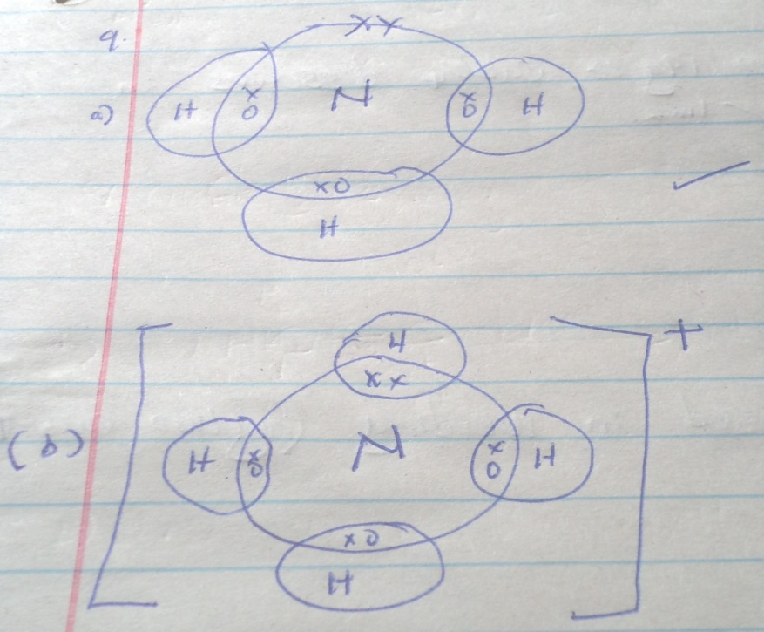
C H O
- % Composition 69.42 4.13 26.45 ½ MK
R.A.M 12 1 16
MOLES 5.785 4.13 1.653 ½ MK
MOLES RATIO 5.785 4.13 1.653 = 1
1.653 1.653 1.653
3.5 2.5
Whole number ratio 3.5×2=7 2.5×2=5 1×2=2 ½ mk

EF C₇H₅O₂ ½ MK

(C₇H₅O₂)_{n} =242

(84+5+32)_{n}=242

121n=242

n =2 (½ mk)

MF= (C₇H₅O₂)₂

= C₁₄H₁₀O₄ ½ MK

- It means that a maximum of 19g of cuso₄ dissolves in 100g of water at 15⁰c. 1mk

- - Manufacture of O₂Hcl_{(aq)}
- Manufacture of ammonia
- Hardening of oils into fats.
- In hydrogen flame which is used in welding (any two 1mk)

- Add water to the mixture potassium chloride dissolves it is ionic while sulphure is molecular. Filter the mixture to obtain sulphure as residue and potassium chloride as filtrate. Evaporate the filtrate to obtain solid KCL.

- Pale blue precipitate is formed. 1mk
b. Deep blue solution will be formed. 1mk
- with water
Mg_{(s)} +2H₂O _{(l)} Mg (OH)_{2 (aq)} + H_{2 (g)} 1mk
With steam
Mg_{(s)} + H₂O_{(g)} M_{g}O _{(S)} + H_{2 (g)} 1mk
- (a) Y 1mk

(b) Y and Z (1mk) because they have the same (1mk) number of protons but different number of neutrons.

- (i) An element is a substance made of one kind of atom and cannot be split into simpler substance by chemical means. 1mk

(ii) Atomic number is the number of protons in an atom of an element.

(b) Ti₂ (SO₄)₃

- Anion SO₄²⁻ 1MK
Cation Zn²⁺ 1mk

Ba²⁺_{(aq)} SO²⁺_{4 (aq)} BaSO_{4 (S)} 1mk

- Sublimation 1mk

- Ca (OH)₂ + CO_{2 (g)} CaCO_{3 (S)} +H₂O
The white precipitate would dissolve due to formation of soluble calcium hydrogen carbonate. 1mk

- 2, 2 –dimethylpropane.
Pent-2-yne

- Burning magnesium produces a lot of heat which breaks the bond between sulphur and oxygen in SO₂. Magnesium then uses the oxygen which was broken from sulphure to continue burning; a burning splint does not produce a lot of heat.

- Yellow solid (sulphur) is deposited. 1mk
H₂s ₍₃₎ +2FeCl_{3 (aq)} 2Fecl_{2 (aq)} + S _{(S)} +2Hcl _{(aq)}
H₂s is oxidized to sulphur 1mk

- This existence of an element in more than one form in the same physical state. 1mk
Diamond 1mk
Graphite 1mk

- 2NH_{3 (s)} +H_{2(l)}SO₄ (NH₄)₂ SO_{4 (aq)}
R.M.M of (NH₄)₂ SO₄ = 28+8+32+64
=132
Moles required to produce 25kg
25000g
Moles =25000g =189.39 moles 14mks
132
Moles of H₂SO₄ required =189.39 moles
R.M.M of H₂SO₄ =98
Mass = 98× 189.39 1mk
=18560g
=18.56kg 1mk

- 6NaOH_{(aq)} 3Cl_{2 (g)} NaClO₃ + 5Nacl_{(aq)} +3H₂O_{(l)}
Manufacture of bleaching agents.

- Methylbenzene is a non- polar compound hence hydrogen chloride in it does not ionize but exist as a molecule substance but in water hydrogen chloride ionizes to give H⁺ and cl⁻ ions that’s why it conduct electricity in water.

- It is endothermic 1mk . This is because the products are heavy more than energy than the reactants. 1mk.

- These are oxides which react with both acids and alkalis. 1mk
Al₂O₃, ZnO and Pbo. Any two

- It would react with HCl_{(g)} since it is basic and Hcl is acidic to form calcium chloride and water.
Concentrated H₂SO₄
Anhydrous calcium chloride.

- (a) Propanoic acid 1mk

H H O
H C C C OH 1mk
H H

(b) Esters

- (a) X²⁺ 2.8.8
Y²⁻ 2.8

(b) XY

