
FORM FOUR TRIAL 2, 2019
Kenya Certificate of Secondary Education
233/1 CHEMISTRY (Theory)
PAPER ONE
TIME: 2HRS

INSTRUCTIONS TO CANDIDATES
- Write your name and admission number in the spaces provided above
- Sign and write the date of examination in the spaces provided
- Electronic calculators may be used.
- All working must be clearly shown where necessary

FOR EXAMINERS USE ONLY

QUESTION | MAXIMUM SCORE | CANDIDATE SCORE
 | 81-280

- The table below shows pH values of solutions ABC and D
Solution | A | B | C | D
pH value | 1 | 7 | 10 | 13

- Give solution that is;
- Acidic (1mk)
……………………………………………………………………………………………………………………………………
- Weak base (1mk)
……………………………………………………………………………………………………………………………………
- Neutral (1mk)
……………………………………………………………………………………………………………………………………
- Give the product formed when solution A react with a carbonate salt (1mk)
……………………………………………………………………………………………………………………………………
- The set up below was used to collect gas K produced by the reaction between water and calcium metal
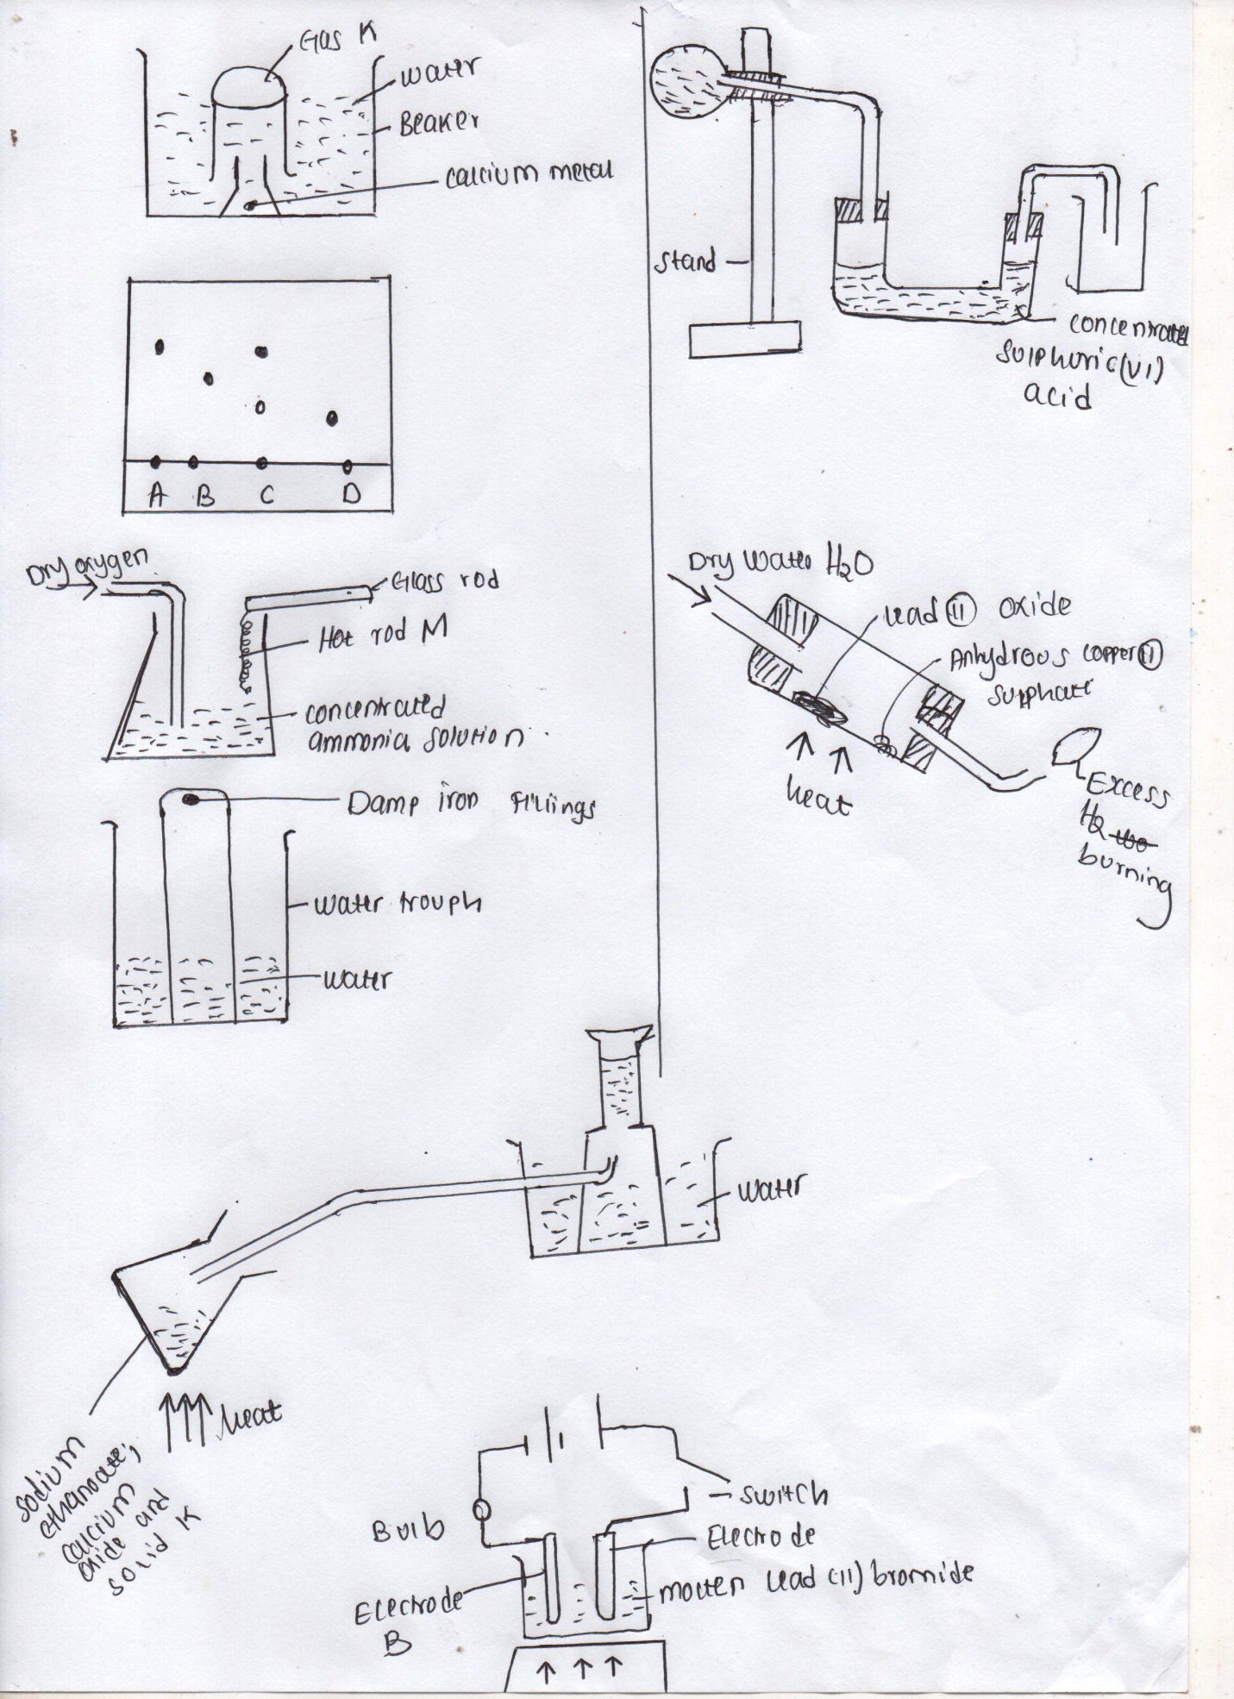

- Name gas K (1mk)
…………………………………………………………………………………………………………………………………
- An organic compound P contains 64.9% carbon, 13.5 Hydrogen and the rest of the % is oxygen.
- Determine empirical formula of the compound (3mks)

- Determine the molecular formula given that the relative formula mass of P is 74 (1mk)
- The diagram below shows spots of pure substances A, B and D on a chromatography paper. Spot C is that of the mixture.

- On the diagram show the following
- Baseline (½mk)
- Solvent front (½mk)
- Which substances are present in C (2mks)
……………………………………………………………………………………………………………………………………
……………………………………………………………………………………………………………………………………
- In a reaction 20cm³ of 0.1m sodium carbonate completely reacted with 13cm³ of dilute sulphuric (V) acid. Find h concentration of suphuric acid in moles per litres (3mks)

- Using dots (·) and crosses (X) draw the structure of hydroxonium ion (H₃O⁺) (2mks)

- Study the information below and answer the questions that follows. Letters do not represent the actual symbol of element.
Element | Atomic No | Ionization energy kJmol
P | 4 | 1800
Q | 12 | 1450
R | 20 | 1150

- What is the general name given to the group in which element P, Q and R belong? (1mk)
……………………………………………………………………………………………………………………………………
- Explain why P has highest ionization energy (2mks)
……………………………………………………………………………………………………………………………………
……………………………………………………………………………………………………………………………………
……………………………………………………………………………………………………………………………………
- Write a balanced chemical equation for the reaction between element Q and water
(1mk)
……………………………………………………………………………………………………………………………………
- The diagram below shows catalytic oxidation of ammonia gas. Use it to answer the questions that follows.

- Name metal M (1mk)
……………………………………………………………………………………………………………………………………
- State and explain two observations made inside the flask (2mks)
……………………………………………………………………………………………………………………………………
……………………………………………………………………………………………………………………………………
…………………………………………………………………………………………………………………………………
- In an experiment a gas jar containing some damp iron fillings was inverted in a trough containing some water and the set up was left for 3 days.
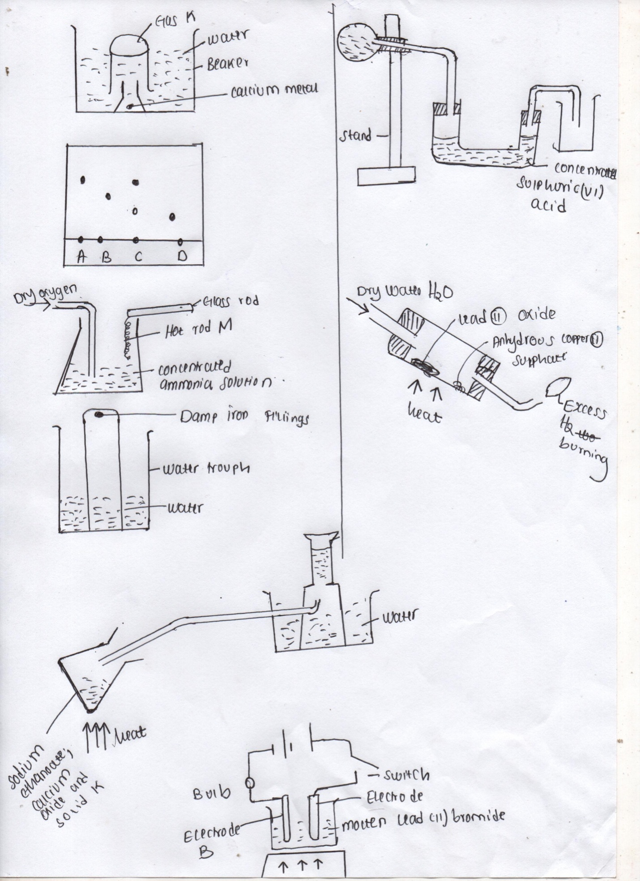

- Why was iron fillings moistened (1mk)
……………………………………………………………………………………………………………………………………
- State and explain observation made after 3 days (2mks)
……………………………………………………………………………………………………………………………………
……………………………………………………………………………………………………………………………………
……………………………………………………………………………………………………………………………………
- a) Distinguish between hygroscopy and efflorescence (2mks)
……………………………………………………………………………………………………………………………………
……………………………………………………………………………………………………………………………………
……………………………………………………………………………………………………………………………………
b) Starting with lead (II) oxide, describe how you would prepare lead (II) sulphute (3mks)
……………………………………………………………………………………………………………………………………
……………………………………………………………………………………………………………………………………
……………………………………………………………………………………………………………………………………
…………………………………………………………………………………………………………………………………
- a) Define the term isotope (1mk)
……………………………………………………………………………………………………………………………………
……………………………………………………………………………………………………………………………………
b) Chlorine gas has a mass of 35.5. It is made up of two isotope ${}_{17}^{35}{Cl}$and${}_{17}^{37}{Cl}$ . Determine the relative abundance of each isotope in the chlorine gas. (2mks)

- Explain the reason why Aluminium is used for making utensils like sufuria (1mk)
……………………………………………………………………………………………………………………………………
……………………………………………………………………………………………………………………………………
- Describe a chemical test to differentiate between carbon (IV) oxide and carbon (II) oxide gas (2mks)
……………………………………………………………………………………………………………………………………
……………………………………………………………………………………………………………………………………
……………………………………………………………………………………………………………………………………
- i) State Graham’s law of diffusion (1mk)
……………………………………………………………………………………………………………………………………
ii) 120cm³ of methane gas takes 30 seconds to diffuse through a certain membrane. Determine the rate of diffusion of surphure (IV) oxide gas through the same membrane (C=12, H=1, S=32, O=16) (3mks)

- Study the set up below and answer the questions that follow
Gas Q

Heat

Sodium ethanoate +calcium oxide +solid K
- Name gas Q (1mk)
……………………………………………………………………………………………………………………………………
- Identify solid K (1mk)
……………………………………………………………………………………………………………………………………

- What is the purpose of calcium oxide in the experiment (1mk)
……………………………………………………………………………………………………………………………………
…………………………………………………………………………………………………………………………………

- Both ions $Y^{2-}$ and $Z^{2+}$ have an electron configuration of 2.8.8
- Write the electron arrangement for:
Y …………………………………………………………………………………. (½mk)
Z …………………………………………………………………………………. (½mk)
- What is the mass number of atom Z given that it has 20 neutrons (1mk)

- Magnesium ribbon was burnt in air;
- State the observation made (1mk)
…………………………………………………………………………………………………………………………………………………………………………………………………………………………………………………………………………
- Write the equations for the reaction (2mks)
……………………………………………………………………………………………………………………………………
- a) Distinguish between a weak acid and a dilute acid (2mks)
……………………………………………………………………………………………………………………………………
……………………………………………………………………………………………………………………………………
……………………………………………………………………………………………………………………………………
b) Giving a reason, identify an acid in the reverse reaction below (2mks)
H₃O+ _{(aq)} + NH_{3(g)} NH₄⁺ + H₂O _{(l)}
Acid ………………………………………………………………………………………………………. (½mk)
Reason …………………………………………………………………………………………………… (½mk)
- What causes water hardness (1mk)
……………………………………………………………………………………………………………………………………
……………………………………………………………………………………………………………………………………
- a)Using ionic equation, explain how sodium carbonate removes permanent hardness (1mk)

b) State one disadvantage of using hardness in the boilers (1mk)
……………………………………………………………………………………………………………………………………
- Study the equation below
CH₃CHClCHClCH₃
- Give the structural formula of Q (1mk)
…………………………………………………………………………………………………………………………………
- Name the type of reaction in the equation above (1mk)
……………………………………………………………………………………………………………………………………
- To which family of hydrocarbons does Q belong? (1mk)
……………………………………………………………………………………………………………………………………
- Consider the scheme below for allotropes of sulphur
Allotrope J Allotrope K
- What is the significance of temperature 96⁰C (1mk)
……………………………………………………………………………………………………………………………………
- Name allotrope J and K (2mks)
……………………………………………………………………………………………………………………………………
…………………………………………………………………………………………………………………………………
- In term of structure and bonding explain why Diamond is used in drilling and graphite used as a lubricant (2mks)

- The table below gives the bond energies of some compounds.
Bond | Bond energy kJ/mole
H-H | 435
Cl-Cl | 244
H-Cl | 431

Calculate the enthalpy change for the reaction H2_{(g)} + Cl2_{(g)} 2HCl_{(g)} (3mks)

The diagram above shows the effect of electric current on lead (II) bromide. Study it and use it to answer the questions that follow.
- On the diagram, Name electrodes A and B (2mks)

- State the observations made at electrode A (1mk)
…………………………………………………………………………………………………………………………………………………………………………………………………………………………………………………………………………
- Write the equation that takes place at electrode B (1mk)
…………………………………………………………………………………………………………………………………………………………………………………………………………………………………………………………………………
- The diagram below represents the apparatus used to prepare and collect dry ammonia gas.

Ammonia chloride and KOH

- State two mistakes in the set up of apparatus (2mks)
………………………………………………………………………………………………………………………………………………………………………………………………………………………………………………………………………..
- Write an equation for the reaction apparatus (2mks)

- The table below gives the solubilities of potassium bromide and potassium sulphate at 0⁰C and 40⁰C.
Substance | Solubility g/100 water at
 | 0⁰C | 40⁰C
Potassium bromide | 55 | 75
Potassium sulphate | 10 | 12

When an aqueous mixture containing 60g of potassium bromide and 7g of potassium sulphate in 100g of water at 80⁰C was cooled to 0⁰C, some crystals were formed.
- Identify the crystals (1mk)
…………………………………………………………………………………………………………………………………
- Determine the mass of crystals formed (1mk)

- Name the method used to obtain the crystals (1mk)
…………………………………………………………………………………………………………………………………

- Study the diagram below

- What is the observation made on anhydrous copper (II) sulphate (1mk)
…………………………………………………………………………………………………………………………………
…………………………………………………………………………………………………………………………………
- Write an aqueous for the reaction ,between hydrogen gas and lead (II) oxide (1mk)

- What is the property of hydrogen gas being investigated above (1mk)
…………………………………………………………………………………………………………………………………
…………………………………………………………………………………………………………………………………

