
CHEMISTRY PAPER 1 233/1
TRIAL 2,2019
FORM 4 PAPER 1
MARKING SCHEME
- a (i) A √1
(ii) C√1
(iii) B√1
(b) Salt, carbon (IV) oxide, water√1 (4mks)
2. Hydrogen gas√1 (1mk)
Elements C H O
- a) % Mass 64.9 √1 13.5 21.6
Molar mass 12 1 16
Moles 5.41 13.5√1 1.35
Ratio 4 10 1
Empirical formula C₄ H₁₀O (3mks)
(b) Molar mass (C₄H₁₀O)n =74
74 n =74 n=1√ ½
74 74
=C₄H₁₀O√ ½ (1mk)
- Solvent front
(a)Base line shown on the diagram (1mk)

(b) A√(1)& 1 √(1) (2mks)

- Na₂ CO₃+ H₂SO₄ Na₂SO₄ + CO_{2 ( g)} + HO_{2 (l)}
Moles of Na₂CO₃ =20x0.1 √(1) = 0.002 moles
1000
Mole ratio 1:1√1 Moles of acid = 0.002√1
Molarity = 0.002 x 1000 =0.15 MH₂ SO₄
13

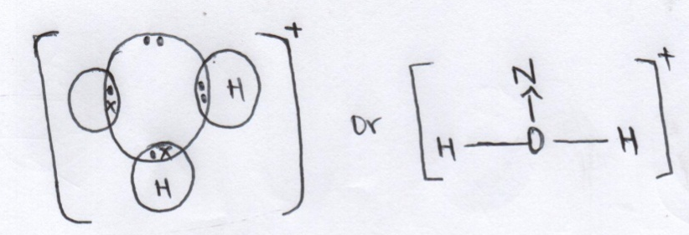

7. (a) Alkaline earth metal √1 (01)
(b) P has smallest√1 atomic radius some electrons of P are closer√1 to nucleus
hence strongly held by the nucleus (02)
(c ) Q_{(s)} + 2 H₂O 26 H₂)√ + H_{2(g)}(01)

8 (a) platinum √1(01)
(b)Brown fumes, hot rod continues to glow (02)
9. (a) ensure iron fillings √1 stick at the top of gas jar (01)
(b) Ironfillings change √ to brown as it combines with water and oxygen to form
Rust .Water rises in gas jar to occupy the space that was left when oxygen was used up.
10. Hygroscopy is the process by which salts
(a) Absorb water when exposed to atmosphere and become damp: while efflorescence is the process by which salts lose their water of crystallization to the at atmosphere. (02)
(b) To a given volume of nitric (v) acid add excess of lead (II) oxide √1 until some residue are left in the beaker.
- Filter to √1 to obtain Lead (II) Nitrate solution and lead (II) oxide residue.
- To the filtrate √1add excess solution of sodium sulphate to ensure complete precipitation.
- Filter to obtain√ lead (II) sulphate as residue and sodium nitrate solution as filtrate.
- Rinse the residue and dry√1 between filter papers.
11. (a) Are atoms of the same element with same atomic number but different mass number. (2mks)
35.5=35xy+ (100-y) 37
100
35.5 =35y + 37000- 37$x$ cl = 100 - 75
3550 = 35x – 37$x$ +3700 = 25 %
3550 – 3700 = -2y
-150 = -2$x$
$x$= 75% (2mks)

12. Aluminum reacts with oxygen forming insoluble aluminum oxide which prevent further corrosion. (1mks)
13. Pass the two gases separately through Ca(OH)₂ Solution. White ppt is observed with carbon (IV) Oxide while no white ppt formed with carbon(II) Oxide (2 mks)
14. i) The rate of diffusion of a gas is inversely proportional to the square root of its density provided physical conditions remain constant. ( 1mk)
ii)
$\frac{RA}{RB}=\sqrt{\frac{MB}{MA}}$ ${RSO}_{2}=\frac{4}{2}$
$= \frac{4}{{RSO}_{2}}=\sqrt{\frac{64}{16}}$ ${RSO}_{2}=$ 2cm³/s

$\frac{4}{{RSO}_{2}}$ $=2$

15. (i) Methane (1mk)
(ii) Sodium hydroxide (1mk)
(iii)Absorb moisture from the air so as to ensure sodium hydroxide remain
in solid state (1mk)
16. (a) Y-2.8.6 ( ½ mk)
Z- 2.8.8.2 ( ½ mk)
b) 40 (1mk)
17 (a) white solid (1mk)
(b) 2Mg(_{s)} + O_{2(g)} 2MgO_{(S)}
(C)6 Mg _{(S)} +2N_{2(g)} 2Mg₃N2 _{(S)} Mg ₃ N₂ white solid (1mk)
18. Weak acid has less hydrogen ion concentration per given volume while dilute acid has higher solvent molecule concentration per given volume (2mks)
(b) Acid – NH₄⁺√(½) reason donate the proton√(½) (H⁺) ( 1mk)
19. (a) ca²⁺ or Mg²⁺ (1mk)
20. (a) Mg²⁺ + CO₃²⁻ Mgco_{3 (s)} (1 mk)
(b) Deposition of fir which is an insulator (1mk)

H cl cl H
21. H C C C C H
H H H H (1mk)

(ii) Addition reaction (1mk)
(iii) Alkenes (1mk)
22. i) Transition temperature (1mk)
ii) J- Rhombic sulphur (α sulphur) ( 1mk)
K-Monoclinic sulphur (β Sulphur) ( 1mk)
23. carbon atoms in diamond are bonded to each other by strong covalent bonds while in graphite it has weak intermolecular forces between the hexagonal layers hence slide over each other (2mks)
24. Bond breaking Bond formation
1x435 = 435 √(1) 2x431 =862√(1)
1x244 = 244
+ 679

Total energy Bond breaking + bond formation
679 +(-862) (1)
= - 183 kJ/Mol (3mks)
25. (a) A- Anode (1mk)
B- Cathode (1mk)
b) Brown fumes are seen (1mk)
(c) pb ²⁺ +2e pb _{(s)} (1mk)
26. – Wrong drying agent
a) Wrong method of gas collection (2mks)
b) NH₄CL_{(s)} + KOH_{(aq)} Kcl_{(S)} +NH_{3 (g)}+HO_{2 (l)} (1mk)
27.(i) potassium Bromide (1mk)
(ii) 60 -55 = 5g (1mk)
iii) Fractional crystallization (1mk)
28. i) it changes from white to blue (1mk)
ii)Pbo_{(s)+}H_{2(g)} Pb _{(s)} +H ₂O _{(l)} (1mk)
iii) Reduction (1mk)

