
NAME: ________________________________________________________________ ADM NO:_________________
CLASS: _________________________________DATE:_______________________ SIGN:_____________________

233/1
CHEMISTRY THEORY
FORM FOUR PAPER 2
TRIAL 2, 2019
TIME: 2HOURS

CHEMISTRY THEORY
TIME: 2HRS

INSTRUCTIONS TO CANDIDATES
- Write your name and admission number in the spaces provided above
- Sign and write the date of examination in the spaces provided
- Electronic calculators may be used.
- All working must be clearly shown where necessary

FOR EXAMINERS USE ONLY
QUESTIONS | MAXIMUM SCORE | CANDIDATES SCORE
1  2  3  4  5  6  7  8 | 8  10  10  12  10  10  09  11
 | 80MARKS

- (a) The curves below represent the variation of temperature with time when pure and impure samples of a solid were heated separately.
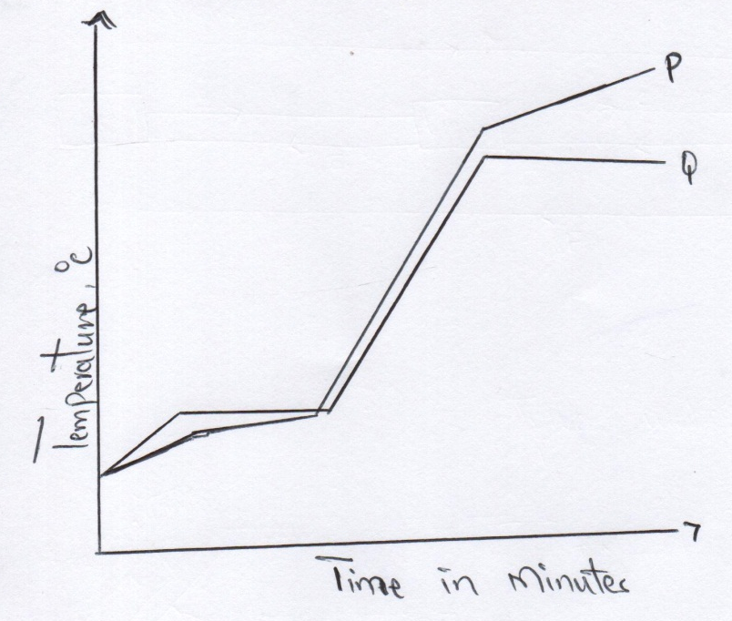

- (a)Which curve shows the variation in temperature for the pure solid? Explain. (2mks)
………………………………………………………………………………………………………………………………………………………………………………………………………………………………………………………………………………………………………………………………………………………………………………………………………..
- State the effect of impurities on the melting and boiling points of a pure substance.
- Melting points (¹/₂ mk)
……………………………………………………………………………………………………………………………………………………………………………………………………………………………………………………….
- Boilling points (¹/₂ mk)
………………………………………………………………………………………………………………………………………………………………………………………………………………………………………………………..
(b)The diagram below shows the relationship between the physical states of matter.
A
Solid
Liquid
Gas
B C

E D

F

- Identify the processes B and D. (2mks)
B………………………………………………
D…………………………………………….
- Name process A (1mk)
………………………………………………………………………………………………………………………………
- State two substances in chemistry that undergo the process A (1mk)
……………………………………………………………………………………………………………………………………………………………………………………………………………………………………………………….
- Is the process E exothermic or endothermic? Explain (1mk)
………………………………………………………………………………………………………………………………………………………………………………………………………………………………………………………..
2.Air was passed through several reagents as shown below
CHAMBER 3
Heated Copper turnings
CHAMBER 2
Concentrated Sulphuric (VI) acid
CHAMBER 1
Concentrated Sodium Hydroxide Solution
Air

CHAMBER 4
Heated magnesium powder

Escaping gases

- Name the main inactive component of air (1mk)
…………………………………………………………………………………………………………………………………
- Name the components of air that are removed in the following chambers (3mks)
- Chamber 1
…………………………………………………………………………………………………………………..
- Chamber 3
………………………………………………………………………………………………………………….
- Chamber 4
…………………………………………………………………………………………………………………..

C) What is the purpose of passing air through concentrated sulphuric (1v) acid. (1mk)
………………………………………………………………………………………………………………………………………………………………………………………………………………………………………………………………………………………
d) Write a chemical equation for thereaction which takes place in :-
- chamber 1 (1mk)

……………………………………………………………………………………………………………………………

- Chamber4 (1mk)
………………………………………………………………………………………………………………………………
e) State and explain the observation made in chamber 3 during reaction (2mks)
…………………………………………………………………………………………………………………………………………………………………………………………………………………………………………………………………………
f) Name one gas which escapes from the scheme above (1mk)
……………………………………………………………………………………………………………………………………..
3. (a) Draw and name two isomers of Pentane (2mks)

(B) Study the flow diagram below and then answer the questions that follow.
U
H₂O
Substance Y

O₂ Heat Sodalime

Process K Process J
CH₂BrCH₂

CH₂CH₂

CH₃CH₃

Nickel Catalyst

Process T Cl₂

H H
C C
H H
Substances S
W + HCl

- Name process J, K and T (3mks)
J- ……………………………………………………………..
K- …………………………………………………………….
T- …………………………………………………………….
- State the reagents necessary for processed J and K (1mk)
…………………………………………………………………………………………………………………………………..
- Name substances U, W, S and Y (2mks)
U ……………………………………………………………….
W ………………………………………………………………
S ………………………………………………………………..
Y ………………………………………………………………..
C) Describe how burning can distinguish CH₂CH₂ from CH₃CH₃ (2mks)
………………………………………………………………………………………………………………………………………………………………………………………………………………………………………………………………………………………………………………………………………………………………………………………………………………………………………
4. The grid below shows a part of the periodic table. The letters do not represent the actual symbols. Study it and answer the questions that follow.
C |  |  |  |  |  |  |  | T
 |  |  |  |  |  | U
X | K |  | M |  |  | Q | W
 | Y |  |  |  |  | P |  | Z
J

- Identify the elements in period 1 (1mk)
………………………………………………………………………………………………………………………………….
- With a reason, identify the element with the largest atomic radius (2mks)
………………………………………………………………………………………………………………………………………………………………………………………………………………………………………………………………….
- Draw the atomic structure of element Q (1mks)

- Write down the electronic configurations of elements Y and W
Y- ……………………………………………………………………….
W- ………………………………………………………………………
- Element G forms an ion G³⁻ and its ionic configuration 2.8.8. indicate its position on the grid above (1mk)

- Identify an element whose oxide reacts with both acids and alkalis (1mk)

………………………………………………………………………………………………………………………………
- i. Write down the chemical formular of the compound formed between elements K and W (1mk)
……………………………………………………………………………………………………………………………………
ii. Draw the bonding in the compound formed in (g) (i) above using dots (.) and crosses (x) to represent electrons (1mk)

- Compare the atomic radius elements X and K. Explain (2mks)
……………………………………………………………………………………………………………………………………………………………………………………………………………………………………………………………………………………………………………………………………………………………………………………………………………..
- (a) Study the diagram below and answer the questions that follow
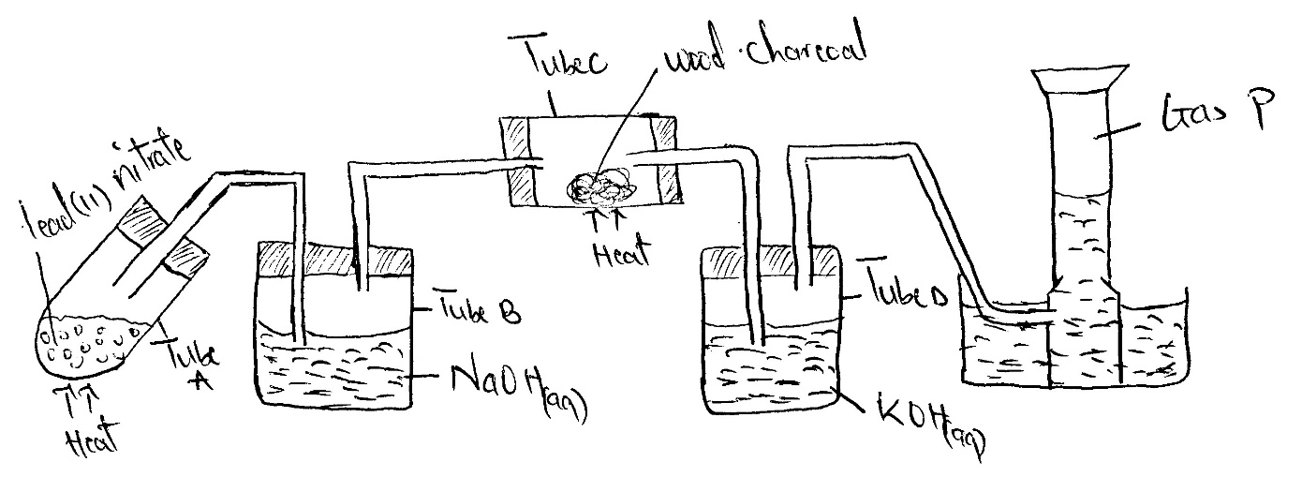

- Write a chemical equation for the reaction in tube A (1mk)
…………………………………………………………………………………………………………………….
- Name the two salts formed in tube B (1mk)
……………………………………………………………………………………………………………………………………………………………………………………………………………………………………………………………..
- State the observation made in tube C (1mk)
……………………………………………………………………………………………………………………….
- What is the purpose of potassium hydroxide in tube D. (1mk)
………………………………………………………………………………………………………………………….
- Name gas P (1mk)
……………………………………………………………………………………………………………………….
(b) The flow chart below shows some industrial processes. Use it to answer the questions that follow
Air
Liquid F
III
Hydrogen
Nitrogen

Gas M
I
Air
II
Absorption rower
Catalyst P
700⁰C
Ammonia
Air
IV

Nitric (V) acid
(i) Give the source of the following raw materials
- Nitrogen gas (½mk)
…………………………………………………………………………………………………………………………………..
- Hydrogen gas (½mk)
…………………………………………………………………………………………………………………………………..
ii) Name the following substances;
- Catalyst P (½ mk)
…………………………………………………………………………………………………………………………………..
- Gas M (½ mk)
……………………………………………………………….…………………………………………………………………
- Liquid F (½mk)
…………………………………………………………………………………………………………………………………..
iii)Write the chemical equations for; formation of gas M. (1mk)
……………………………………………………………………………………………………………………………………

The reaction in the absorption tower (1mk)
………………………………………………………………………………………………………………………………….
iv) State one use of nitric (v) acid (½mk)
…………………………………………………………………………………………………………………………………..
6. Study the reaction scheme below and answer the questions that follow
Sodium
Suplhate
Solution
White precipitate P
NaOH_{(aq)}
Lead (II) nitrate solution
White precipitate
Few drops
Excess NaOH
Process 2
DiluteHCl
White precipitate L
Colourless solution Y
Colourless solution Q

Process 3
Colourlesssolution Z

a) Write the chemical formular of compounds P and Q
i) P ………………………………………….
ii) Q ……………………………………………. (2mks)
b) Write an ionic equation for the process that produces white precipitate P (1mk)
…………………………………………………………………………………………………………………………………………
C) Name process 2 (1mk)
………………………………………………………………………………………………………………………………………
d) Name the process that separated P and Q (1mk)
P ………………………………………..
Q …………………………………………
e) Write a balanced chemical equation for the formation of white precipitate L. (1mk)
………………………………………………………………………………………………………………………………………
f) State the condition required for process 3 (1mk)
…………………………………………………………………………………………………………………………………………
g) What physical process is exhibited in process 3 (1mk)
………………………………………………………………………………………………………………………………………
h) Name the anion present in colourless solution Z (1mk)
………………………………………………………………………………………………………………………………………
i) Write the formula of the complex ion present in colourless solution Y (1mk)
…………………………………………………………………………………………………………………………………………
7. Below is a set of apparatus that was used to obtain a dry sample of sulphur(iv)oxide gas
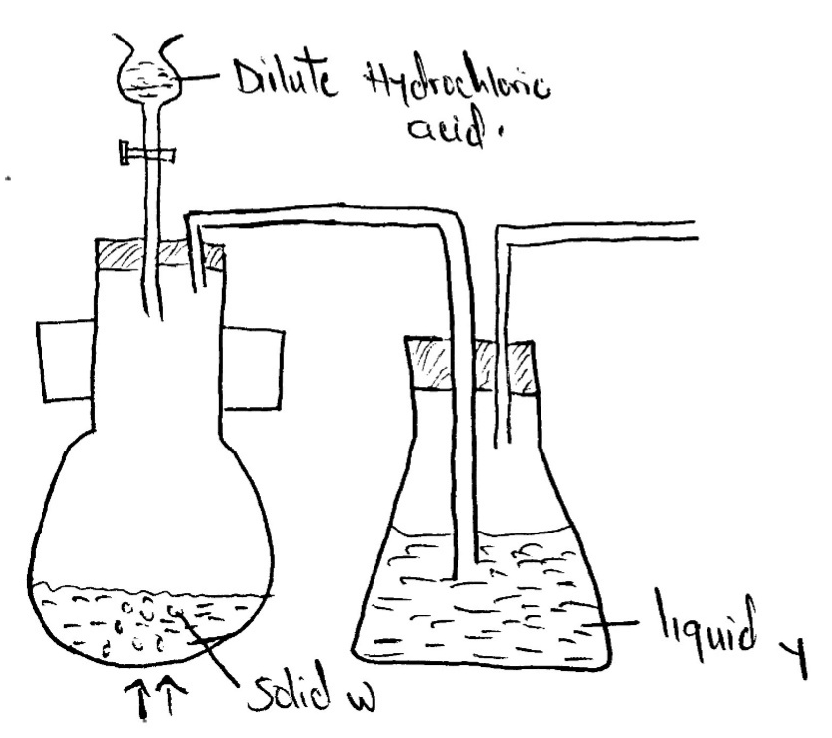

a) Name;
i) Solid W (1mk)
………………………………………………………………………………………………………………………………………
(ii)The apparatus containing dilute hydrochloric acid (1mk)
…………………………………………………………………………………………………………………………………………
b) State the role of Liquid Y (1mk)
………………………………………………………………………………………………………………………………………..
C) Complete the diagram to show how the gas could have been collected (1mk)

d) A sample of sulphur(iv)oxide gas was passed through freshly prepared iron(III)sulphate solution. State and explain the observation made (2mks)
………………………………………………………………………………………………………………………………………………………………………………………………………………………………………………………………………………………………………………………………………………………………………………………………………………………………………………
e) 50cm³ of 2M Hydrochloric acid was used during the above experiment. Determine the volume of sulphur(iv)oxide gas produced at r.t.p (molar gas volume = 24dm³)
…………………………………………………………………………………………………………………………………………
…………………………………………………………………………………………………………………………………………
…………………………………………………………………………………………………………………………………………
8. In an experiment, 40cm³ of 0.1 M sodium hydroxide solution was placed in a suitable apparatus and 5.0cm³ portions of hydrochloric acid were added. The resulting mixture was stirred with a thermometer and the temperature taken after each addition. Both solutions were initially at 20⁰c
Volume of HCL (cm³) | 5 | 10 | 15 | 20 | 25 | 30 | 35 | 40 | 45
Temperature (ºc) | 21.5 | 22.5 | 24.0 | 25.0 | 26.0 | 27.0 | 27.5 | 27.5 | 27.0

- i. Plot a graph of temperature against volume of the acid added (4mks)

- Use the graph to determine the concentration in moles per litre of the hydrochloric acid (2mks)

- i) Calculate the heat change for the reaction (1½mk)

- Molar enthalpy of neutralization of hydrochloric acid by sodium hyndroxide solution (density of solution 1g/cm³ specific heat capacity 4.2 kj/kg) (1½mks)

- Write the thermochemical equation for the reaction (1mks)
…………………………………………………………………………………………………………………………………………………………………………………………………………………………………………………………………………

- Draw an energy level diagram for the reaction (1mk)

