
FORM 4
CHEMISTRY PAPER 2
TRIAL 2, 2019
MARKING SCHEME.
- Q √1
- Sharp/ constant melting point and boiling point.

ii) Melting point – lower the M.P √ ½
Boiling point – raises the b.p√ ½
b) B – Melting √
D - Condensation√1

ii) Sublimation √1
iii) Iodine √ ½
- Ammonium chloride √ ½ Any two 1mk.
- Solid ice √ ½
- Iron (III) chloride√
- Aluminum chloride √ ½

iv) Exothermic √ ½
Involves heat loss ½
- a) Nitrogen gas√ 1

b) i)Carbon (iv) oxide gas√1
ii)Oxygen gas√1
iii) Nitrogen√1
c) To remove/absorb water vapour or dry / drying agent.

d)i) 2 NaOH_{(Aq)} +CO_{2(g)} Na₂CO_{3(S)+}H₂O _{(L)}√1

ii)3Mg _{(s)} +N_{2 (g)} Mg₃N_{2(S)}√1

Penalize ½ if state symbols miss/wrong
Penalize fully if not balanced.
e) Brown solid changes to black√1
Brown copper metal oxidized/ reacts with oxygen to form copper (II) oxide (black)

f) - Argon
- Neon Any one. (1mk)
- Helium

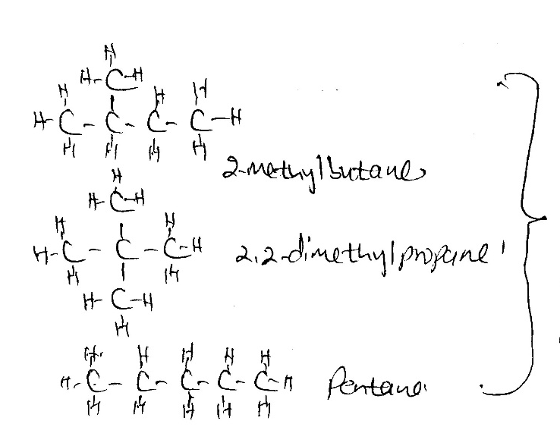

Any two
Drawing ½mk
Naming ½mk
Penalize fully if the structure is
wrong

b J- Hydrogenation√1
K –Bromination/Halogenation √1
T-Polymerisation√1

(ii) J-Hydrogen gas √ ½
K- Bromine gas √ ½

(iii) U-carbon (IV) Oxides gas √1
W – 1- chloroethane √ ½
S – Polyethene√ ½
Y – Sodium propanoate√ ½

C) CH₂CH₂ √ 1 burns with a yellow sooty flame while CH₃CH₃ √1 burns with a blue non- sooty flame.
4 a) C and T (Mark tied to the two elements)

b) J – has five energy levels/ highest number of energy levels.
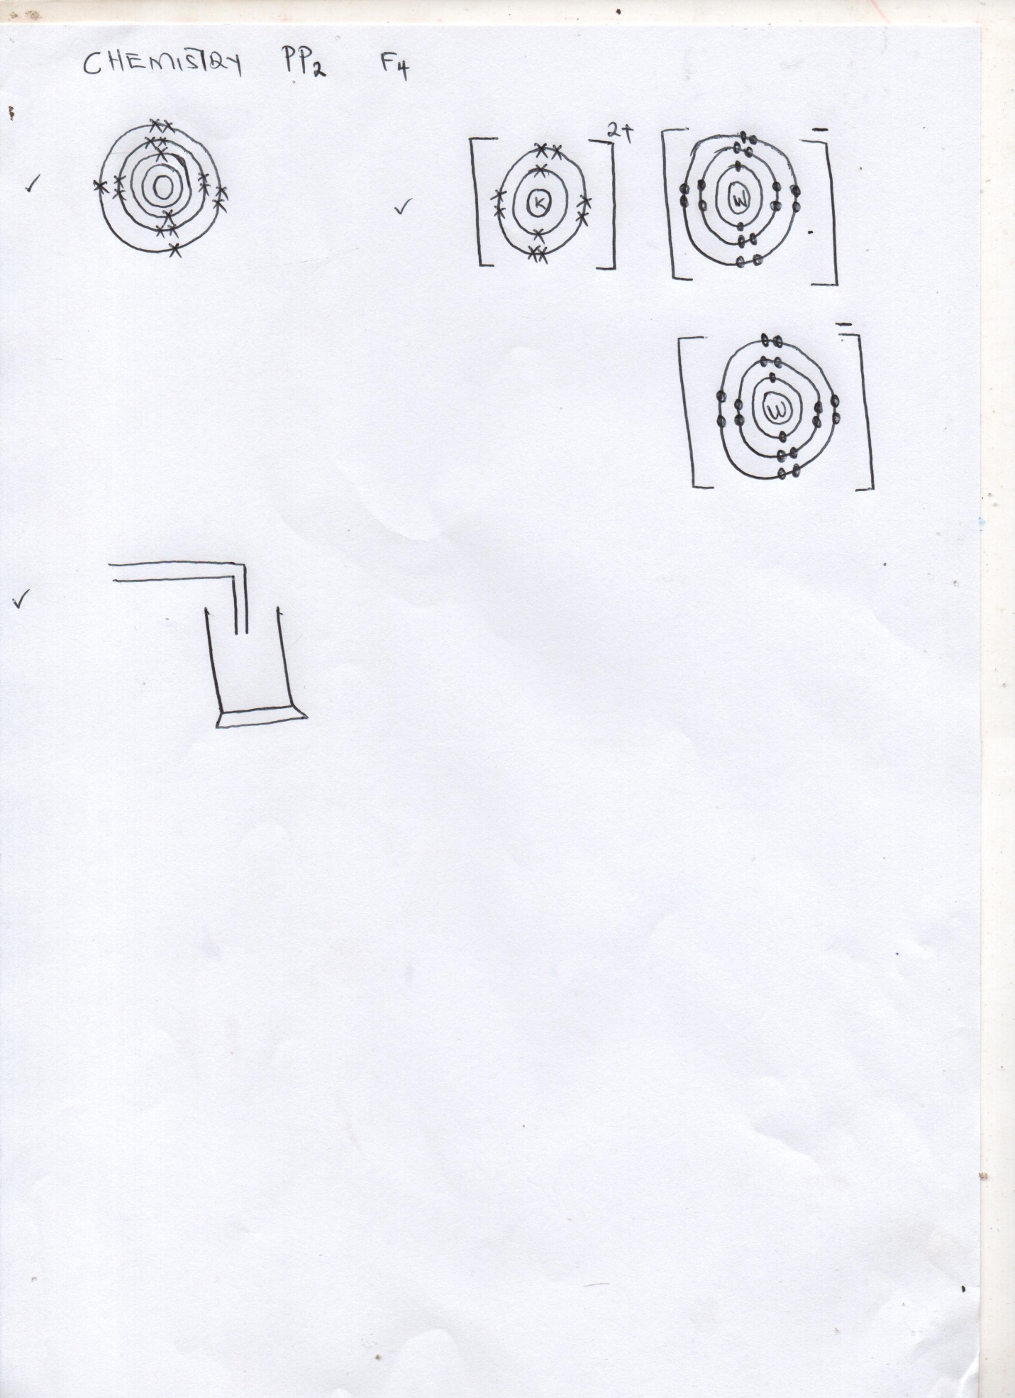
c)

d) i) Y -2,8,8,2 √ 1
w – 2,8,7√1
e) Period 3 should be shown on the grid
Group 5 otherwise penalize fully
f) M √
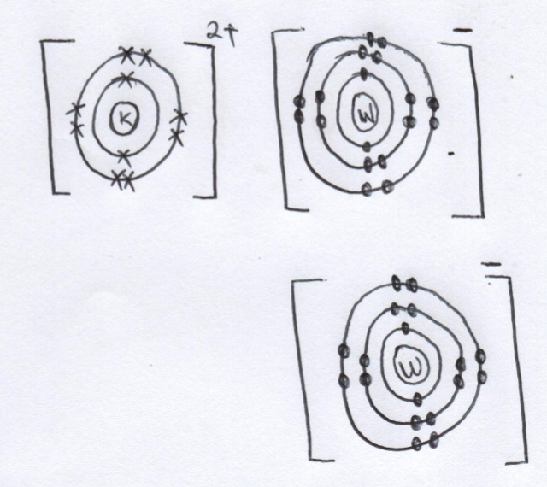
g) K W₂

h. K has a smaller √ ½ atomic radius than X
K has more √ ½ protons in the nucleus which increase the nucleus force of attraction √ ½ (higher nuclear charge) hence the electrons on the energy levels are strongly attracted towards the nucleus.
5 (i) 2 Pb (NO₃)_{2(S)} Heat 2 PbO_{(s)} +4 NO_{2 (g)} + O₂
- Penalize ½ mk if state symbols miss /wrong
- Penalize fully if not balanced
(ii) Sodium nitrate√ ½
Sodium nitrate √ ½
(iii) Charcoal glow red hot √1
(iv) To absorb Carbon (IV) oxide gas formed√1
(v) Carbon (II) oxide gas √1
b) i) Nitrogen gas – fractional distillation of liquid air
Hydrogen gas – Electrolysis of brines
- Cracking of hydrocarbon
- Water gas
(ii) Catalyst P platinum/ platinum – rhodium √ ½
Gas M – Nitrogen (II) Oxide √ ½
Liquid F – water √ ½
(iii) 4NH₃ +5O₂Platinum 4NO_{(g)} + 6H ₂O (₁₎
4 NO_{2 (g)} +2H₂O_{(l)+}O_{2(g)} 4 HNO_{3(aq)}
iv) – Manufacture of nitrate fertilizers, synthetic fibre, dyes, drugs, explosives,
Purification of metals (Any one ½ mk).
6. (a) (i) P - PbSO4 NOTE penalize the name fully
(ii)Q – Na₂ NO₃
(b) Pb²⁺ _{(aq)} + S04²⁻ _{(aq)} PbSO4_{(s)}
(c) Double decompositions/ precipitation
(d) Filtration
(e) Pb(NO₃)_{2 (aq)} + 2HCl_{(aq)}Pbcl_{2 (s)} + 2HNO_{3 (aq)}
f. warming
g. solubility
h. chloride
i. Pb(OH)₄ ²⁻

7. (a) (i) solid W – Sodium sulphite
(ii) Dropping funnel
(b)Drying agent
(c)

d Yellow iron (III) sulphate solution √1 turned pale green sulphur (IV) oxide gas reduced iron (III) ions to iron (II) ions√1.
e) Na₂SO_{3(S)} + 2Hcl_{(aq)} 2 Nacl_{(aq)}+SO_{2(g)} + H₂O_{(l)}
moles of Hcl
2 moles 1000 cm³
50 cm√ (1 mk)
$\frac{2×50}{1000}=\frac{100}{1000}$ = 0.1moles
Mole ratio Hcl : SO₂
2 : 1 √ ½
Moles of SO₂ ₌ $\frac{1}{2}$= 0.05moles
$\frac{0.05×24}{1}√$½
1Mole 24dm³= 1.2dm³√ ½
  - oles ?

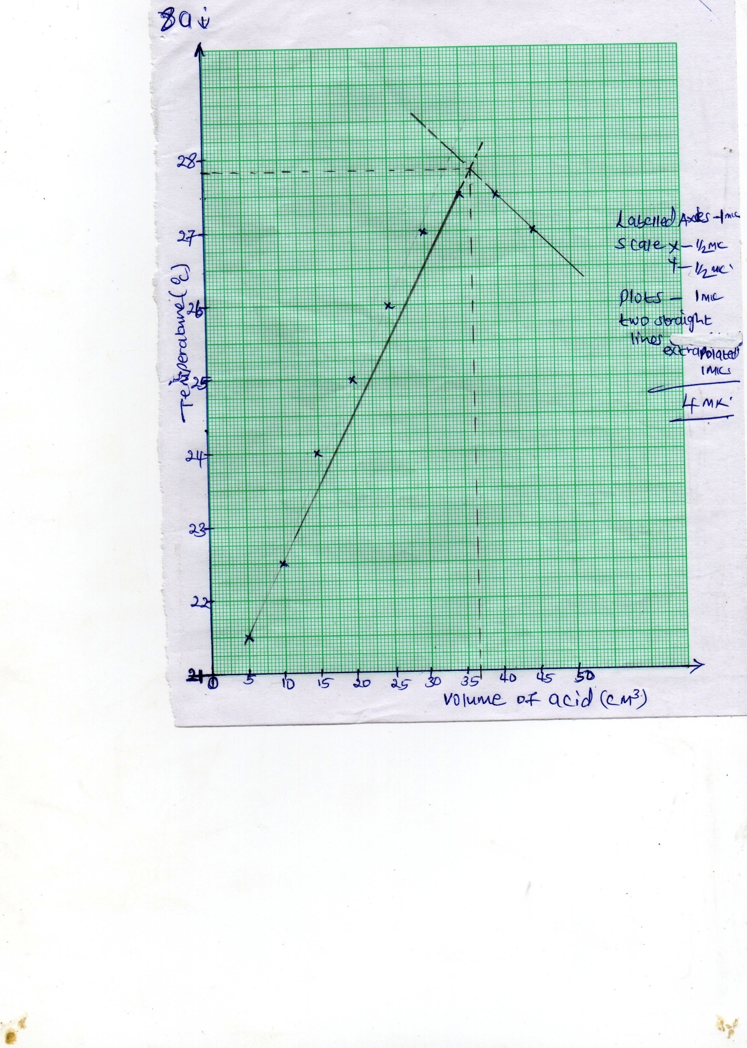

8.

a (i)Volume (shown on the graph) =36.5 cm³√ ½
Mole ratio.
NaOH : Hcl
- : 1
Moles of NaoH reacting
0.1 Moles 1000cm³
? 40cm³√1
$\frac{0.1×40}{1000}$= $\frac{4}{1000}$ = 0.004$√$ 1 ½
Mole of Hcl 0.004 moles 36.5 cm³
? 1000cm³
$\frac{0.004×1000}{36.5}$= 0.1096M½
b (i) $∆$H = MCDT NOTE
40 +36.5 =76.5CM³$√$ ½ 1. 27.8 must be shown on the graph;
MASS =76.5 $×$1 =76.5 g otherwise deny ½ mk
$$\frac{76.5g}{1000}×4.2×\left(27.8-20\right)√½$$
2.5061 KJ √ ½
NOTE
(ii) Mole of Hcl = 0.004 moles 2. If the units are missing deny ½ mk
0.004 moles 2.5061Kj
1 Mol ? if sign is missing deny 1mk.
$\frac{1×2.5061}{0.004}$ √ ½ = - 626.535Kjmol⁻¹

(iii)
Heat of products and heat of reaction ½mk. Enthalpy change ½mk
$∆H$=-626.535kJmol⁻¹
Reaction path
NaCl_{(aq)} + H₂O
NaOH_{(aq)} + Hcl_{(aq)}

iv) NaOH_{(aq)} + HCl_{(aq)} NaCl_{(aq)} + H2O_{(l)}$∆$H = -626.536kJmol⁻¹

