Name……………………………………………….Adm No………..Class…………
Signature……………………….. Date……………………………..

CHEMISTRY
233/2
November, 2020
2 hours
MOKASA I EXAM
(Kenya Certificate of Secondary Education)
Instructions
- Write your name, admission number and class in the spaces provided above.
- Sign and write the date of examination in the spaces provided above.
- Answer all the questions in the spaces provided in the question paper.
- All working must be clearly shown where necessary.
- This paper consists of 11 printed pages. Confirm this and that no questions are missing.
For Examiner’s Use Only
Question | Maximum Score | Candidate’s score
1 | 10
2 | 11
3 | 12
4 | 12
5 | 11
6 | 13
7 | 11
Total | 80

1.i) The setup below was used to investigate the reaction between metals and water.
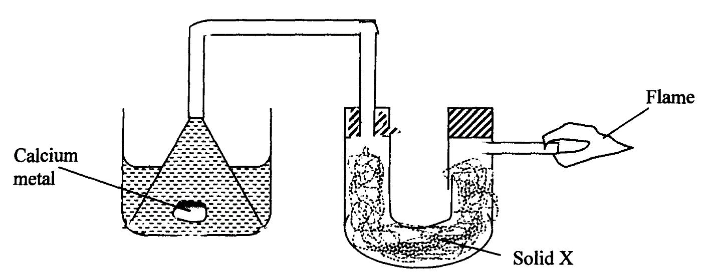

water

- Identify solid X and state its purpose.
Solid X ……………………………………………………………. (½ mark)

Purpose …………………………………………………………… (½ mark) (b) Write a chemical equation for the reaction that produces the flame. (1 mark)

………………………………………………………………………………………………………
ii) The set-up below was used to investigate the properties of hydrogen.
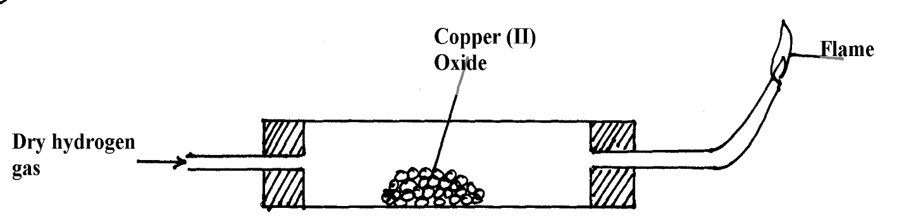

- On the diagram, indicate what should be done for the reaction to occur. (1 mark)
- Hydrogen gas is allowed to pass through the tube for some time before it is lit. Explain. (1 mark)

………………………………………………………………………………………………………
iii) Write an equation for the reaction that occurs in the combustion tube. (1 mark)

………………………………………………………………………………………………………

iv) When the reaction is complete, hydrogen gas is passed through the apparatus until it cools down. Explain. (2 marks)
………………………………………………………………………………………………………

………………………………………………………………………………………………………v) What property of hydrogen is being investigated? (1 mark)

……………………………………………………………………………………………………… vi) What observation confirms the property stated in (v) above? (1 mark)

………………………………………………………………………………………………………vii) Why is zinc oxide not used to investigate this property of hydrogen gas?(1 mark)

………………………………………………………………………………………………………

………………………………………………………………………………………………………

2. I. The diagram below represents an incomplete set-up of apparatus that can be used to prepare and collect dry carbon (iv) oxide gas. Complete the diagram and answer the questions that follow.
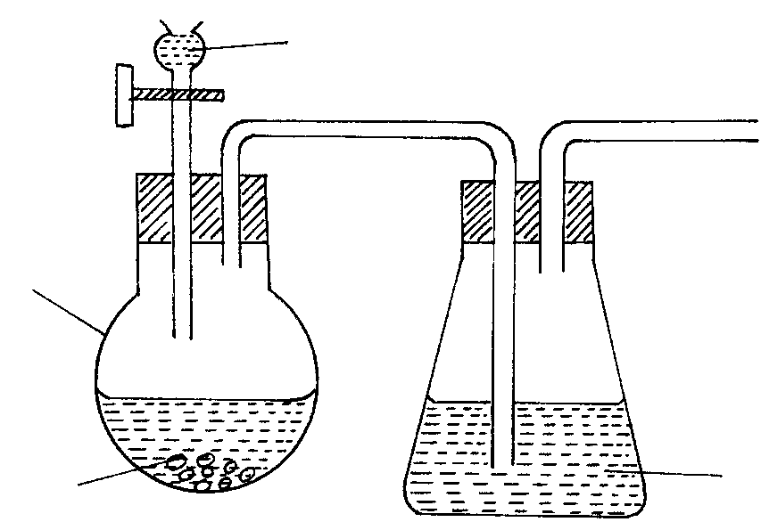
Water
Liquid R
Marble chips
Flask S

- Complete the above diagram. (3 marks)
b) Identify liquid R. ……………………………………………………………….. (1mark)
c) Write the equation for the reaction taking place in the flask S. (1 mark)

………………………………………………………………………………………………………
d) Explain why it is not advisable to use lead (II) carbonate in place of marble chips. (1 mark)
………………………………………………………………………………………………………………………………………………………………………………………………………………
II. The diagram below is used to investigate the effect of carbon (II) oxide on lead (II) oxide. Study it and answer the questions that follow.

Combustion tube M
Lead (II) oxide
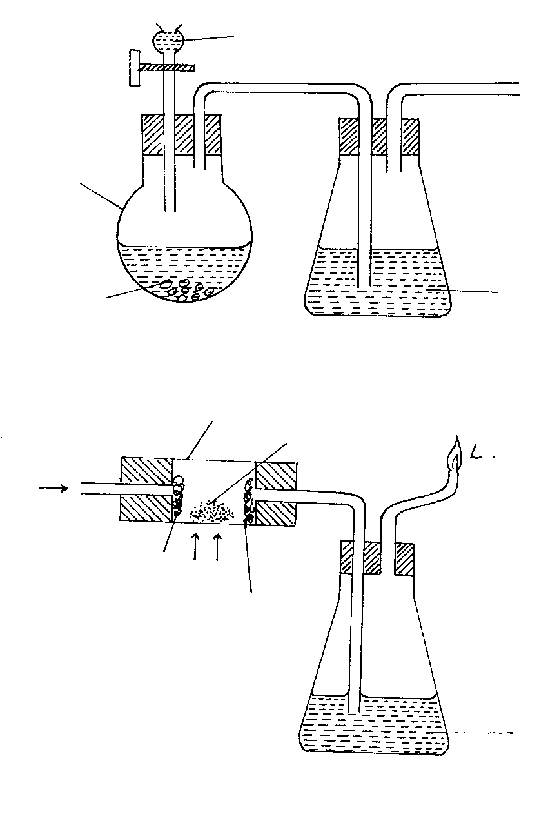
L
Liquid K
Glass wool
Glass
wool
CO
a) Write an equation for the laboratory preparation of carbon (II) oxide. (1 mark)

………………………………………………………………………………………………………
b) State and explain the observation in the combustion tube M. (2 marks)

………………………………………………………………………………………………………

………………………………………………………………………………………………………
c) Identify liquid K and state its function. (1 mark)
………………………………………………………………………………………………………

………………………………………………………………………………………………………
d) Why is it necessary burn excess gas at L. (1 mark)

………………………………………………………………………………………………………

………………………………………………………………………………………………………

3. (a) Name the following organic compounds.
i) CH₃COOCH₂CH₃ (1mark)

……………………………………………………………………………………………
ii) CH₃CH₂CHCCHCH₂CH₃ (1mark)

………………………………………………………………………………………………
(b) Study the flow diagram below and use it to answer the questions that follow.

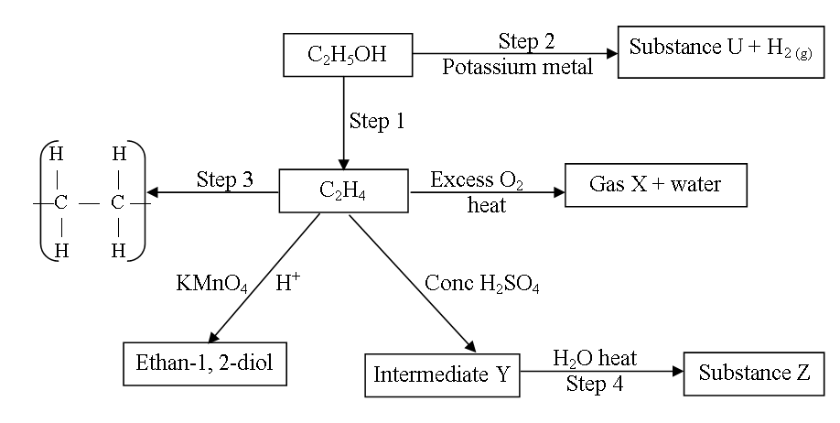

(i) Name the compounds;
U………………………………………………………………. (½ mark)
Gas X…………………………………………………………. (½ mark)
Intermediate Y……………………………………………….. (½ mark) (ii) Name the process which leads to the formation of substance Z from the intermediate Y. (1 mark)
………………………………………………………………………………………………………
(iii) Identify the reagent and the condition for step 1
Reagent ……………………………………………………………… (1 mark)
Condition ……………………………………………………………. (1 mark)
iv) State one disadvantage for the continued use of items made from compound formed in step 3. (1 mark)
………………………………………………………………………………………………………
v) Write a balanced equation for the reaction taking place in step 2. (1 mark)
………………………………………………………………………………………………………
c) Below are structures of two cleaning agents
R – COO⁻Na⁺ …………A
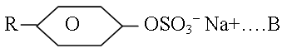
i)Identify the cleaning agent suitable to be used in water containing calcium chloride. …………………………………………………………………………… (1 mark)
ii)State one advantage of using cleaning agent A. (1 mark)
………………………………………………………………………………………………………

iii) Name the cleaning agent A. …………………………………………… (½ mark)
d) Ethanol is an important organic solvent. It can be prepared by the fermentation of glucose, C₆H₁₂O₆. Give two conditions necessary or the reaction to take place. (1 mark)
………………………………………………………………………………………………………
……………………………………………………………………………………………………..
4. The grid below represents part of the periodic table. Study it and answer the questions that follow. The letters do not represent the actual symbols of the elements.

 |  |  |  | F | G | H | I
C |  |  |  |  |  |  |  | K
D | E
 |  |  |  |  |  |  | J

- Identify the most reactive non-metal. Explain. (2 marks)

…………………………………………………………………………………………………
ii) What is the name given to the family of elements of which I and J belong? . (½ mark)
………………………………………………………………………………………………………
iii) Using dots (•) and crosses (×) to represent electrons, show bonding in the compound formed between C and H. (2 marks)

iv) How does the atomic radius of F compare with that of I. Explain. (2 marks)

…………………………………………………………………………………………………

…………………………………………………………………………………………………
b) Study the table below and answer the questions that follow.
Substance | M | N | O | P | Q | R
M.Pt. °C | 801 | 1356 | -101 | 26 | -39 | 113
B.Pt °C | 1410 | 2850 | -36 | 154 | 457 | 445
Electrical conductivity in solid state | Poor | Poor | Poor | Poor | Good | Poor
Electrical conductivity in molten state | Good | Poor | Poor | Poor | Good | Poor

i) Explain why substance M is a good conductor in molten state and not in solid state. (2 marks)
………………………………………………………………………………………………………

………………………………………………………………………………………………………

ii) What is the most likely structure of substance N. Explain. (1 ½ marks)
………………………………………………………………………………………………………

………………………………………………………………………………………………………

iii) Identify, with reasons, a substance that exists as a liquid at room temperature. . (2 marks)
………………………………………………………………………………………………………

………………………………………………………………………………………………………

5. The flow chart below shows a sequence of reaction involving a mixture of two salts, mixture M. Study it and answer the questions that follow.
Solid N

Mixture M

Step (I) (i) Addition of water
(ii) Filtration

Solution P
Step (V) magnesium powder

Step (IV) Excess aqueous
ammonia
Products
Deep blue
Solution I

Step (IV) (i) Acidified barium
nitrate solution
(ii) Filteration

Step (II) Heat

White solid
Colourless solution
Black solid Q and gas which forms a white precipitate when bubbled through calcium hydroxide solution.

Step (VII) Excess aqueous ammonia

White Precipitate
which dissolves to
form a colourless solution
Step (III) Dilute sulphuric (VI) acid

Blue solution S

I. a) write the formula of the following:
(i) Anion in solid Q………………………………………………………… (1 mark)
(ii) The two salts present in mixture M. (2 marks)
………………………………………………………………………………………………………

………………………………………………………………………………………………………
- Write an ionic equation for the reaction in step VI. (1 mark)

………………………………………………………………………………………………………
- State and explain two observations made in step V. (3 marks)
………………………………………………………………………………………………………

………………………………………………………………………………………………………

………………………………………………………………………………………………………

II. a) You are provided with copper solid, sodium carbonate solid, dilute hydrochloric acid, distilled water and dilute nitric (v) acid. Describe how you can prepare crystals of copper (II) carbonate. (3 marks)
………………………………………………………………………………………………………

………………………………………………………………………………………………………

………………………………………………………………………………………………………

………………………………………………………………………………………………………

………………………………………………………………………………………………………

………………………………………………………………………………………………………

(b) Name the industrial process by which the sodium carbonate used in II (a) above can be obtained. (1 mark)

………………………………………………………………………………………………………

6. (a) From an experiment, 25.0cm³ of hydrochloric acid required 20.0cm³ of 0.02M
sodium carbonate for a complete reaction. Calculate:
(i) The number of moles of sodium carbonate used. (1 mark)

………………………………………………………………………………………………………

………………………………………………………………………………………………………
(ii) The number of moles of hydrochloric acid used. (1 mark)

………………………………………………………………………………………………………

………………………………………………………………………………………………………

(iii) The molarity of the acid. (1 mark)

………………………………………………………………………………………………………

………………………………………………………………………………………………………

………………………………………………………………………………………………………
(b) A solution of sodium hydroxide was found to contain 12.4g/dm³ of sodium hydroxide. 25cm³ of this solution reacted with 15cm³ of a solution of sulphuric (VI) acid. (Na=23.0, H=1.0, S=32.0, O=16.0)
(i) Find the molarity of the sodium hydroxide solution. (1 mark)
………………………………………………………………………………………………………

………………………………………………………………………………………………………

………………………………………………………………………………………………………
(ii) Calculate the number of moles of sodium hydroxide solution used. (1 mark)

………………………………………………………………………………………………………

………………………………………………………………………………………………………
(iii) Calculate the number of moles of the acid used. (2 marks)

………………………………………………………………………………………………………

………………………………………………………………………………………………………
(iv) Determine the concentration of the sulphuric (VI) acid solution in g/dm³. . (3marks)

………………………………………………………………………………………………………

………………………………………………………………………………………………………

……………………………………………………………………………………………………
(b). (i) State the Charles law. (1 mark)
………………………………………………………………………………………………………

………………………………………………………………………………………………………
(ii) A certain mass of gas occupies 146 dm³ at 291K and 98.31 kPa. What will be its
temperature if its volume is reduced to 133dm³ at 101.325 kPa? (2 marks)

………………………………………………………………………………………………………

………………………………………………………………………………………………………
7. (a) Define a saturated solution. (1 mark)

………………………………………………………………………………………………………

………………………………………………………………………………………………………
(b) The table below represent the solubilities of sodium nitrate and Sulphur (IV) oxide at different temperatures.

Temperature ( ºC) | 10 | 18 | 26 | 34 | 42
Solubility of sodium nitrate  ( g/ 100g of water) | 20 | 29 | 40 | 53 | 68
Solubility of sulphur ( IV) oxide  ( g/ 100g of water) | 78 | 55 | 45 | 40 | 36

On the grid provided below, plot a graph of solubilities of sodium nitrate and Sulphur (IV) oxide against temperature. (4 marks)


Using the graph;
- Determine the solubility of Sulphur (IV) oxide at 16ºC. (½ mark)

………………………………………………………………………………………………………
- The concentration, in moles per litre, of sodium nitrate at 16 ºC. (assume density of solution is 1 g/cm³) (Na=23, 0=16, N=14). (3 marks)

………………………………………………………………………………………………………

………………………………………………………………………………………………………

………………………………………………………………………………………………………
- Mass of crystals formed when a solution of sodium hydroxide is cooled from 40ºC to 26ºC. (2 marks)
………………………………………………………………………………………………………

………………………………………………………………………………………………………
- What is the relationship between solubility of sodium nitrate and temperature? (1 mark)

………………………………………………………………………………………………………
(c) Give one advantage of hard water. (½ mark)

………………………………………………………………………………………………………
(d) Explain why the reaction between 1g of sodium carbonate with 2M hydrochloric acid is faster than between 1g of sodium carbonate with 2M ethanoic acid. (1 mark)

………………………………………………………………………………………………………

………………………………………………………………………………………………………

