233/3
CHEMISTY PAPER 3
PRACTICAL
FORM 4

MURANGA EAST 2021
KENYA CERTIFICATE OF SECONDARY EDUCATION (KCSE)

Marking Scheme

 | I | II | III
Final reading | 12.5 | 25.0 | 12.5
Initial reading | 0.2 | 12.5 | 0.0
Volume used (cm³) | 12.5 | 12.5 | 12.5
Marks distributed as follows:
- Complete table (1mk)
3 titration done (1 mk)
Incomplete table with 2 titration (½ mk)
Incomplete table with one titration done (0 mk)
- Penalties
- Wrong arithmetic
- Inverted table
- Unrealistic title values (unless explained)
Penalize ( ½ mk) for each to a miximum of (½ mk)

- Decimal place (1mk)
- Accept only 1 or 2 d.p used consistently, otherwise penalize fully.
- Accept inconsistency in the use of zeros as initial burette reading e.g. 0.0, 0.00 or 0.000.
NB decimal place tied to 1st and 2nd rows only.

- Accuracy (1 mk)
- Compare candidate’s title value with school value S.V. if one value within $±$ 0.1 of S.V (1mk)
No value within $±$ 0.1 of S.V butat least 1 value within $±$ 0.2 or S.V (0 mk)

- Averaging (1 mk)
Values averaged must be sown
If 3 consistent titrations done and averaged = (1 mk)
If 3 titration done, but only 2 are consistent and averaged = (1 mk)
If only 2 titrations done, are consistent and averaged = (1 mk)
Otherwise penalize fully

CALCULATIONS
- $\frac{12.5+12.5+12.5}{3}\left(\frac{1}{2}mk\right)=12.5{cm}^{3} \left(\frac{1}{2}mk\right)$

- (i) Moles in 250cm³ = $\frac{0.5}{40}=0.0125 moles (\frac{1}{2}mk)$

Moles used =

$\frac{0.0125 ×25}{250} \left(\frac{1}{2}Mk\right)=0.00125 moles$

(ii) Moles of acid reacting = $0.00125\left(\frac{1}{2}mk\right)$mole ratio 1:1
250 ?
$$\frac{0.0125 ×25}{250} \left(\frac{1}{2} mk\right)=moles (\frac{1}{2} mk)$$
(iii) Molarity of solution A
10cm³ = 0.25 moles
1000 =?
$$\frac{ 1000 ×0.25}{10}\left(\frac{1}{2}mk\right)=25 moles\left(\frac{1}{2}Mk\right)$$

PROCEDURE II
TABLEII
Volume of  solution A  (cm³) | volume of distilled water | Concentration of solution A(moles/1) | Time(s) | $$\frac{I}{t}\left(s^{-1}\right)$$
12 | 0 | 2.5 | 25.5 | 0.0363
10 | 2 | 2.08 | 34.25 | 0.0292
8 | 4 | 1.67 | 45.45 | 0.0220
6 | 6 | 1.25 | 69.44 | 0.0144
4 | 8 | 0.83 | 120.01 | 0.0083

Complete table (4mks)
Decimal places (tied to 3rd and 5th column) (1mk)
Accuracy (tied to row (i) to (iv) (1mk)
Trend (gradual increase in time) (1 mk)
Questions
- (i) read from graph (1mk)
Value of $\frac{I}{t}$ (1mk)
Correct answer (½ Mk)

 | Observation | inference
2. (a) | - Colourless liquid condenses at coller parts of test tube  - Gas evolved turns red litmus blue  - A white residue remain  Any 2 (1mk) | - Hydrated salt  - NH⁺₄ ions  Any 2 correct ions award (1 mk)
(b) i) | - Solid dissolves (½ mk) to form a colourless  solution ( ½ mk) | Mg²⁺AI³⁺,Zn²⁺ Present  Any One  Or Cu²⁺, Fe²⁺, Fe³⁺ absent ( ½ mk)
(ii) | white precipitate is formed ( ½ mk) | CO²⁻₃,SO⁻²₄.Cl⁻,SO²⁻₃ present  Any two ions award ( ½ mk)  Penalize the ( ½ mk) for any contradictory ion.
(iii) | A white precipitate form ( ½ mk) | SO²⁻₄ ions confirmed ( ½ mk)
(iv ) | White precipitate ( ½ mk) dissolves in excess  to form a colourless solution ( ½ mk) | Zn²⁺, Pb²⁺ or AI³⁺  Any 3 ions – (1mk)  2 ions ( ½ mk)  0 mk for any only one ion
(v) | White precipitate ( ½ mk) in excess | Pb²⁺, AI³⁺ present  Both ions (1mk)  One ion ( ½ mk)
(vi) | No white precipitate formed (1 mk) | Pb²⁺ absent or AI³⁺ present (½ mk)

 | Observation | inference
3. (a) | Dissolves form (½mk) a colourless homogenous solution (½ mk) | Polar substance ( ½ mk)
(b) (i) | PH value 1 – 3 ( ½ mk) | Strong acid present ( ½ mk)
(ii) | Purple acidified  KMnO₄ decolorised (1 mk) | 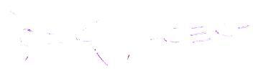  OR –OH present
(iii) | Bromine water decolourised (1 mk) | 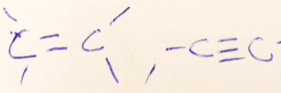  OR –Oh. Present  All three (1mk)  Two only (½ mk)
(iv) | Effervescence ( ½ mk) | 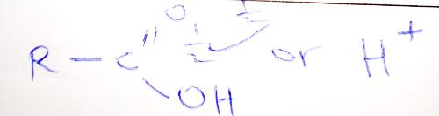  Present
(v) | Sweet smelling  Compound formed (1 mk) | 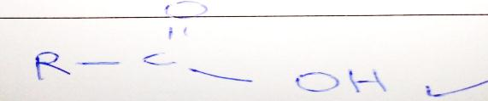  Present ( ½ mk)

