OPENER EXAM YEAR 2021
NAME………………………………………………………………….………….ADM.NO:………………
CLASS: ……………………………..DATE:……..………….SIGN:……………………………………….
CHEMISTRY PAPER 2
FORM III
TIME: 2 HOURS

INSTRUCTIONS TO STUDENTS
1. Answer all questions in this question paper.
2. All your answers must be written in the spaces provided in this question paper.
Question | Maximum score | Candidates score
1 - 7 | 80

- The set up below was used to determine the percentage of oxygen in air. Use it to answer the questions that follow.
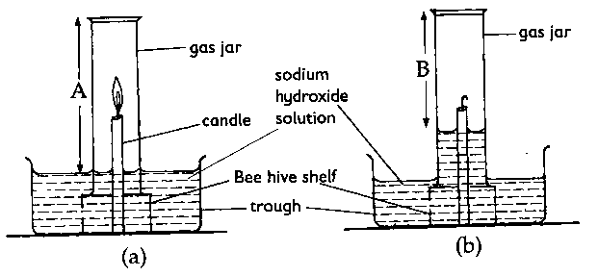

- i) State the observations made after the experiment. (1 mk)

ii) What was the length of the air column in the gas jar before and after burning? (1 mk)

iii) Determine the percentage of air used up by the burning candle. (A=10cm, B=79cm) (2 mks)

- State two sources of errors in the experiment. (2 mks)

- Why is it necessary to leave the apparatus to cool before taking the final reading? (1 mk)

- i) Write a balanced chemical equation for the reaction sodium peroxide and water. (1 mk)

- If 39g of sodium peroxide was used, calculate the volume of oxygen gas prepared at r.t.p. (3 mks)

- Using dot and cross diagrams, draw the structure of ozone (O₃). The atomic number of oxygen is 8. (2mks)

- State two properties of oxygen gas that makes it suitable to collected by over water method. (2mks)

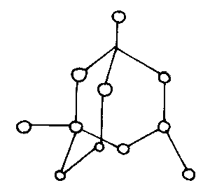
- a) The diagram below shows two allotropes of carbon
A
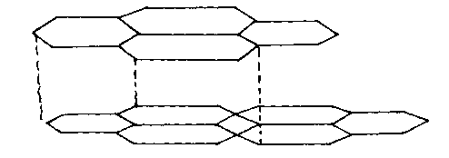
B

(i) Identify allotrope (2mks)
A……… B………………………..

ii) Give a reason why allotrope A is used as a lubricant (1mk)

(iii) State one use of allotrope B (1mk)

b) The diagram below is a set-up used in the laboratory preparation of Carbon (II) oxide. Use it to answer the questions that follow.
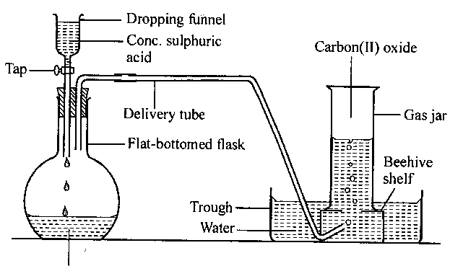
B
A
- Name
A: Substance A (1 mk)

B: Apparatus B (1 mk)

- Write a balanced chemical equation for the reaction taking place in the flask. (2 mks)

iii) State one use of carbon (II) oxide gas (1 mk)

c) Give the chemical name of trona (Na₂CO₃.NaHCO₃.2H₂O) (1 mk)

- The grid below shows part of the periodic table. Use it to answer the questions that follow. The letters are not the actual symbols.
A
B
L
F
G
C
H
K
D
J
E

- i) Write the equation for the reaction that occurs between elements L and D. (1 mk)

ii) Explain why element H has a higher boiling points than element D. (2 mks)

iii) State one use of element E (1 mk)

iv) Compare and explain the atomic radius of B and C. (2 mks)

- i) Write a balanced equation for reaction between element L and oxygen. (2 mks)

ii) 11.5g of L was completely burnt in oxygen. Calculate the volume of gas that was used. (3 mks)
(L = 23, O = 16.0, molar gas volume at room temperature is 24dm³)

- The ionization of magnesium can be represented diagrammatically as shown in the figure below.
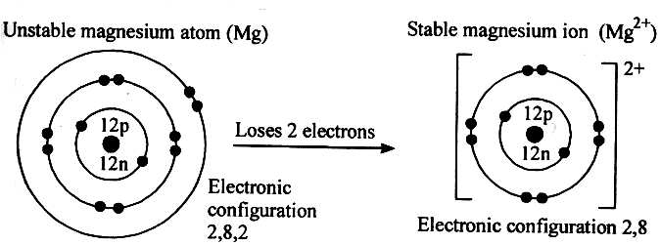
Define the following terms: (4 mks)
- Ionization energy

- Electron affinity

- Electronegativity

- Electropositivity

- a) The diagram below represents an experiment which was carried out by a student, to investigate the effect of passing an electric current on molten sodium chloride.
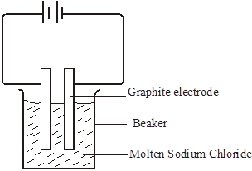
  - Molten sodium chloride is a binary electrolyte. State the meaning of the term binary electrolyte. 1 mark

  - State observations made at the
A: anode 1 mark

B: Cathode 1 mk

  - Write an equation to show what happens at the cathode and anode. 2 mks
At the cathode

At the anode

  - Show the direction of flow of electrons on the set up 1 mk

b) Define the following terms; (4 mks)
i) Electrolyte

ii) Anode

- Cathode

- Electrode

c) State the use of the battery (cell) in the electrolytic cell. 1 mk

- State two industrial applications of electrolysis. 2 mks

- i) Four athletes A, B, C and D were suspected of using NSAID and EPO drugs as blood boosters to enhance their performance. Their blood samples were taken and analyzed using chromatography. The results obtained were recorded in the chromatogram below.
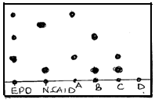
- State and explain two factors that determine the distance travelled by a sample along the filter paper.
(2 mks)

- On the diagram above indicate the baseline and the solvent front. (1 mks)

- Which athlete(s) tested positive of the use of EPO drug only? (1 mks)

- Which athlete(s) tested positive of use of both EPO and NSAID drugs. (1 mks)

(e) Which athlete had his blood sample negative of EPO and NSAID drugs? (1 mk)

(f) Name a suitable solvent used in papers chromatography. (1 mk)

ii) Below is a structure of aluminium chloride dimer. Study it and answer the questions that follow
Cl Cl Cl
Bond Y
Al Al

Cl Cl Cl

Bond X
Identify bond
X ……………………………………………………………….. (1mk)

Y ……………………………………………………………………… (1mk

6. a) The diagram below shows a heating curve for a sample of compound X.
(i) Is X a solid, a liquid or a gas at room temperature, 20 °C?
..................................................................................................................................... (1mk)

(ii) Name the change of state which occurs in region DE.
..................................................................................................................................... (1mk)

(iv) Explain how the curve shows that a pure sample of compound X was used. (1 mk)
...........................................................................................................................................
...............................................................................................................................
b) Compound X is a hydrocarbon. It contains 85.7% of carbon. The mass of one mole of X is 84 g.
(i) What is the percentage of hydrogen in the compound? (1mk)
.......................................................................................................................................

(ii) Calculate the empirical formula of X. Show your working. (3 mks)

Element | C | H
RAM | 12 | 1
% Mass | 85.7 | 14.3
No. of moles | 85.7  12  =7.142 | 14.3  1  = 14.3
Divide by smallest | 7.142  7.142  = 1 | 14.3  7.142  2
Empirical formula | CH₂

(iii) What is the molecular formula of compound X? (2 mks)

- The flow chart below shows the industrialization of ammonia and the process used in the manufacture of some ammonium compounds. Study it and answer the questions that follow
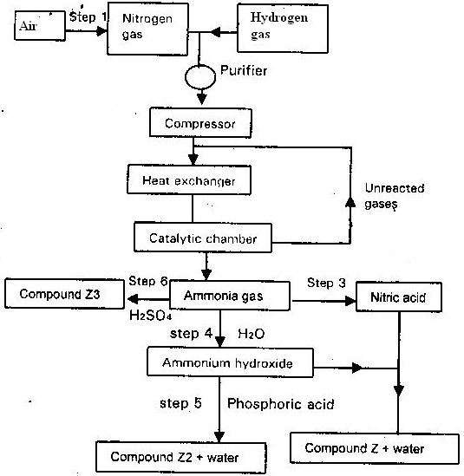
(a) Give the name of the
(i) Process in step 1 (1 mk)

(ii) Reaction that takes place in step 5 (1 mk)

(b) Write a balanced chemical equation for the reaction between nitrogen and hydrogen. (1 mk)

(c) Explain why it is necessary to compress nitrogen and hydrogen in this process . (2 mks)

(d) Write an equation for the reaction which takes place in step 6 (1 mk)

(e) Name the catalyst and reagents used in step 3 (2 mks)

(f) Name compound Z₁ (1mk)

(g) Give one commercial used of compound Z₂ (1 mk)

