233/2
MARKING SCHEME
CHEMISTRY
PAPER 2
THEORY
1. a) i. Solid A Sulphur/ S_{(s)}
ii. Gas D Sulphur (IV) oxide/ SO_{2(g)}
iii. Solid Q Barium sulphate/ BaSO_{4(s)}
iv. Solution M Copper (II) nitrate/ CO(NO₃)_{2(aq)}
b) 2H₂O_{2(l)} MnO₂ 2H₂O_{(l)} + O2_{(g)}
c)
i Solid G 4K_{(s)} + O₂ 2K₂O_{(s)}
ii Gas D S(s) + O_{2 (g)} Heat SO_{2(g)}
iii Cu(s) + H₂SO_{4(aq)} CuSO_{4(aq)} + H2O_{(l)}
iv Relights a glowing splint
v Ba²⁺_{(aq)} + SO²⁻_{(aq)} BaSO_{4(s)}
vi -Oxy- acetylene flame used in welding.
-Oxygen enriched air is used in hospitals by patients with breathing difficulties.
-When mixed with heliumit is used by mountain climbers and deep-sea divers.
-Remove iron impurities during steel making
- To burn fuelssuch as those used to for propelling rocket.
2. (a) (i) W and Z
Belong to the same chemical family.
(ii) X₂O₇
- X

Its ionic radius is larger than its atomic radius or has 1 electron in the outermost energy that can easily be lost.
(iv) Atomic radius of Z is smaller than that of Y because Z has a greater nuclear charge(more protons) that tends to pull its outer electrons more strongly inwardly reducing the size of the atom.
(b) (i) 2NaOH_{(aq)} + H₂SO_{4(aq)} Na₂SO_{4(aq)} + H2O_{(l)}
(ii) (I) No. of moles of acid used = 40 x 0.5 mole =0.02 (½mk)
100
Mole ratio Base: Acid = 2:1
No. of moles of base reacted = 2 x 0.02 = 0.04 mole. (½mk)
1
(II) 0.04mol in 100cm³ = 1000 x 0.04 = 0.4mol.
?--------------1000cm³ 100

(III) Mass of NaOH in 1 litre of solution = (0.4x40)
= 1.6g (½mk)
Mass of unreacted substance = (17.6-1.6)_{g} (½mk) = 16g (½mk)

3.(a) (i) Sodium hydroxide/potassium hydroxide
NaOH_{(aq)} + CO_{2(g)} NaHCO_{3(aq)}
(ii)Oxygen
- Argon, Neon
- (i)From mole ratio NH₃ : NO : HNO₃
4 : 4 : 4
1 : 1 : 1
RFM of HNO₃ =1+14+48 =63
Moles of NH₃==0.1333……
Moles of HNO₃= 0.1333……
Mass of HNO₃= 0.1333 × 63= 9.3979. = 8.4

- % of nitrogen in urea = × 100 = 46.67 %
% of nitrogen in NH₄NO₃ = × 100 = 35%
Urea is the best because it has higher % of nitrogen
- Magnesium oxide
-Magnesium nitride
- Mg₃N_{2(s)} + H₂O _{(l)} Mg(OH)_{2(aq)} + NH_{3(g)}
Production of ammonia which is basic hence litmus paper turns blue
- Nitrogen(IV)oxide
- When used as anesthesia patients recovering from it laugh hysterically
4. a)C – has an E.M.F of 0.00_{V} and is used as the reference electrode (2marks)
b)F⁻ - has the highest positive E^{Ө}value and is used as the reference electrode. (2marks)
c) neat diagram

D_{(s)}
D²⁺_{(aq)}

B_{(s)}
B dipped in B²⁺_{(aq)} 1/2mk
D sipped in D²⁺_{(aq)} 1/2mk
Salt bridge 1/2mk
Voltmeter present 1/2mk
Workability 1mk

Salt bridge

B²⁺_{(aq)}

d)overall potential = E^{Ө} – E^{Ө} oxides
= ⁺O. 340 – (-2.38v) E^{Ө} = 12.72v
e) (i) Pb_{(s)} Pb²⁺_{(aq)} + 2e⁻ (1mark)
(ii) Q = It (3marks)
= 4 x (18 x 60 + 15)
= 4380c
2F 1mole pb
2 x 96500C 207g Pb
4380C x
X =

5(a) (i) S - Sodium propanoate
T -Polypropene
H- propene/ prop-1-ene
K -propylethanoate
- – As a dehydrating agent
_ As a catalyst
(iii)
Step | Condition | reagents
I | warming | Ethanoic acid; conc H₂SO₄
II | Room temperature | Sodium metal

(iv) _Esterification
_Neutralisation
- Making crates; carpet; plastic bottles; chairs; ropes
- CH₃CH₂COOH + NaOHCH₃CH₂COONa + H₂O
2CH₃CH₃ + 5O₂ 2CO₂+6H₂O

- 2-methylbut-1,3-diene

6 (a)
Pressure (atmospheres ) | 10 | 8 | 5 | 2 | 1
Volume (cm³) | 160 | 200 | 320 | 800 | 1600
Reciprocal of pressure (¹/_{p}) | 0.10 | 0.23 | 0.20 | 0.50 | 1.00

(b) Graph Total 4 marks

Scale 1 mark

Plotting - If more than 4 values are plotted, award 2 marks (max)
-If 3 values are plotted, award 1 mark
- If less than 3 values are plotted, award 0 mark

Line graph from the origin 1 mark

Volume against reciprocal of pressure
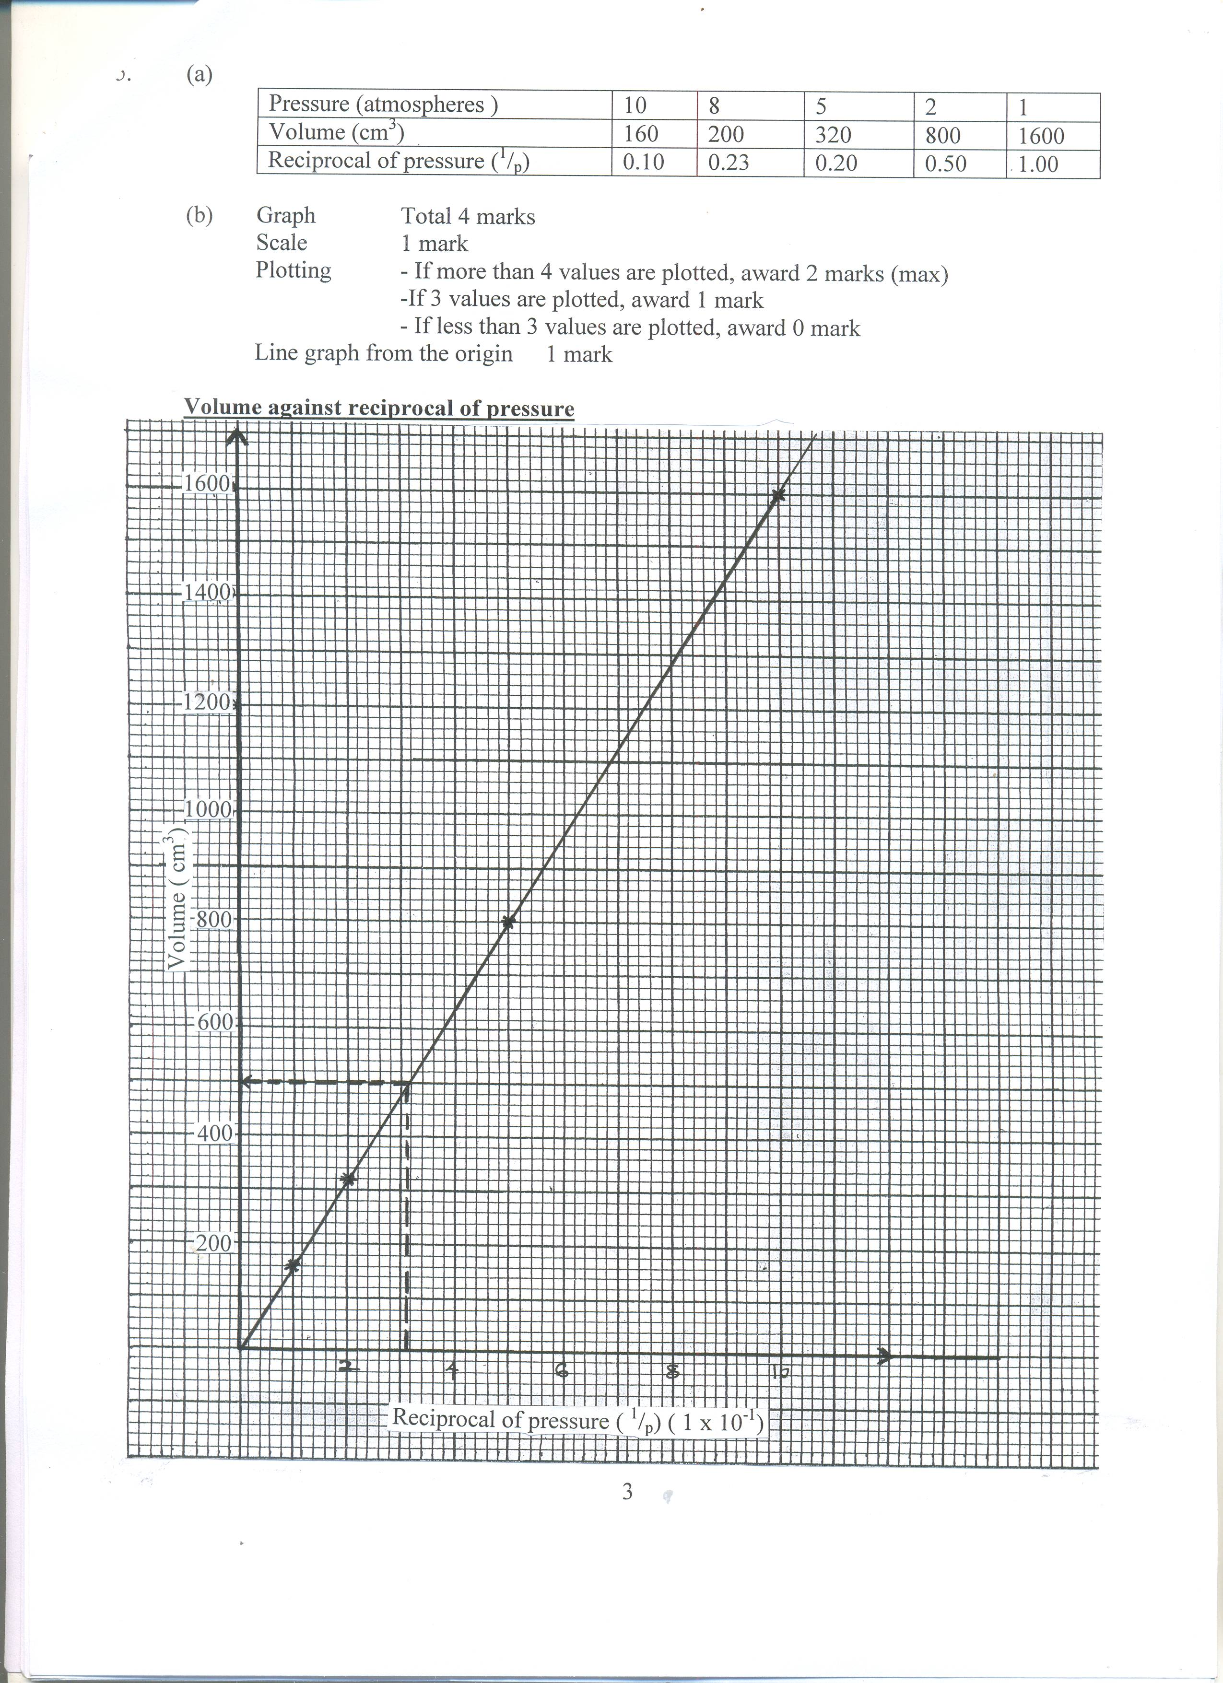

(d ) Correct value from the graph = 1 mark 500 ± 10cm³
Plotted line on the graph = 1 mark
- Volume and the reciprocal of pressure are directly proportional

(e) R.M.M (Mr) of CO = 12 + 16 = 28
R.M.M (Mr) of CO₂ = 12 + 32 = 44

RCO = √MrCO₂
RCO₂ MrCO √ ½

RCO = 44 √ ½
RCO₂ 28

RCO = 1.254 √ ½
RCO₂
CO diffuses 1.254 times faster than CO₂

7.(a) Crush the one powder and react with HNO₃(aq) free the ions; filter to obtain a filtrate, the filtrate in a test tube, add drops of HCl/NaCl/KI; A white precipitate /yellow precipitate formed confirms present

- i) gas K is Sulphur (IV) oxide

ii) 2CuFeS_{2(s)} + 4O_{2(g)}Cu₂S_{(s)} + 3SO_{2(g)} + 2FeO_{(s)}
Fe²⁺

CO₂/CO (1 mark)
Reducton//Redox
Cu²⁺reduced to Cu if coke oxidesed to Co/Co2
C)

Battery

Anode
Impure copper

Cathode purecopper sheet
Sludge
d) Rfm for CuFeS₂=63.5+56+64=183.5
Copper(II)sulphate solution\Cu2+(aq)

CuFeS2 Cu
183.5 63.5
810Kg = 280.3Kg
%Purity = = 74.92%

