Name …………………………………………………. Index No………………/………
School…………………………………………………. Candidate’s sign……………………
Date…………………………………
233/1
Chemistry THEORY
PAPER 1
MARCH 2020
2 Hours
MAGS 2 CYCLE 7
Kenya Certificate of Secondary Education (K.C.S.E)

INSTRUCTIONS TO CANDIDATES
- Answer ALL questions in the spaces provided
- Mathematical tables and electronic calculators may be used.
- All working MUST be shown clearly where necessary.

For examiners use only
Maximum score | Candidate’s score
80

This paper consists of 13 printed pages. Candidates should check
the questions to ensure that all pages are printed as
indicated and no question(s) are missing

- Study the information given below and use it to answer the questions that follow;
Red dye is more soluble than green dye, green is more soluble than yellow whereas blue dye is the least soluble.
i) Represent the three dyes on a round paper chromatography. (2marks)

ii) Name one industrial application of chromatography. (1mark)
……………………………………………………………………………………………………………………
- a) What is a fuel? (1mark)
……………………………………………………………………………………………………………………………………………………………………………………………………………………………………………………………………………………………………………………………………………………………
b) Calculate the heat value of ethanol if its molar enthalpy of combustion is-1360kjmol-1
(C=12.0, O=16.0, H=1.0) (2marks)
………………………………………………………………………………………………………………………………………………………………………………………………………………………………………………………………………………………………………………………………………………………………………………………………………………………………………………………………………………………………………………………………………………………………………………………………………………………………………………………………………………………………………………………………………………………………………………………………………………………………………
- Study the set up below and use it to answer the questions that follow.
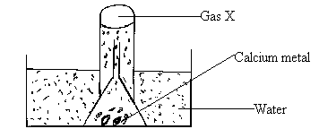
a) What physical property of calcium metal is demonstrated in the diagram above? (1mark)
………………………………………………………………………………………………………………………
b) What would be observed if water was replaced with dilute Sulphuric (VI) acid? (2marks)
………………………………………………………………………………………………………………………………………………………………………………………………………………………………………………………………………………………………………………………………………………………
4. A hydrocarbon decolorizes chlorine gas in presence of ultra violet light but does not decolorize acidified potassium manganate (VII) solution.
i) Name the homologous series to which the hydrocarbon belongs. (1mark)
………………………………………………………………………………………………………………………
ii) Draw the structural formula and name the fourth member of the homologous series to which the hydrocarbon belongs? (2marks)

………………………………………………………………………………………………………………………………………………………………………………………………………………………………………………………………………………………………………………………………………………………
……………………………………………………………………………………………………………………………………………………………………………………………………………………………………

5. Explain why a solution of hydrogen chloride in water turns blue litmus paper red but a solution of hydrogen chloride in methylbenzene has no effect on litmus papers. (2marks)
………………………………………………………………………………………………………………………………………………………………………………………………………………………………
……………………………………………………………………………………………………………………………………………………………………………………………………………………………………

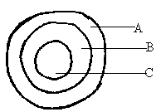
6. The diagram below represents a cross section of the apparatus used to extract sulphur from its deposits. Study it and answer the questions that follow.

a) State the role of the substance that is passed through;
i) A …………………………………………………………………………………….. (1mark)
ii) C……………………………………………………………………………………… (1mark)
b)Give one reason why the method shown in the diagram is suitable for extraction of sulphur. (1mark)
……………………………………………………………………………………………………………………………………………………………………………………………………………………………………................
7. Explain how you would obtain magnesium carbonate from a mixture of magnesium carbonate and sodium carbonate. (2mark
………………………………………………………………………………………………………………………………………………………………………………………………………………………………
……………………………………………………………………………………………………………………………………………………………………………………………………………………………………

8. 20g of potassium carbonate were dissolved in 50cm3 of water in a conical flask. Lemon juice was then added drop wise while shaking until there was no further observable change.
a) Explain the observation that was made in the conical flask when the reaction was in progress. (1mark)

………………………………………………………………………………………………………………………………………………………………………………………………………………………………
b) What observation would be made if lemon juice had been added to copper turnings in a conical flask?
Give a reason. (2marks)
………………………………………………………………………………………………………………………………………………………………………………………………………………………………
………………………………………………………………………………………………………………………
9. Explain why a burning magnesium continues to burn in a gas jar full of carbon (IV) oxide while a burning candle would be extinguished. (2marks)
………………………………………………………………………………………………………………………………………………………………………………………………………………………………
……………………………………………………………………………………………………………………………………………………………………………………………………………………………………
10. 8.4g of carbon (IV) oxide and 3.42g of water are formed when a hydrocarbon is burnt completely in oxygen. Determine the empirical formula of the hydrocarbon.
(H=1.0; C=12.0; O=16.0) (3marks)
………………………………………………………………………………………………………………………………………………………………………………………………………………………………
……………………………………………………………………………………………………………………………………………………………………………………………………………………………………
………………………………………………………………………………………………………………..
11. The melting point of nitrogen is -1960C while that of sodium is 980C, in terms of structure and bonding explain the differences in the melting points of nitrogen and sodium. (2marks)
………………………………………………………………………………………………………………………………………………………………………………………………………………………………
……………………………………………………………………………………………………………………………………………………………………………………………………………………………………
…………………………………………………………………………………………………………………
12. a) What is an amphoteric substance? (1mark)
……………………………………………………………………………………………………………………………………………………………………………………………………………………………………………………………………………………………………………………………………………………………

b) Identify the reagent that acts as a base in the equation below. Give a reason for your answer.
H2O2(aq) + H2O(I) H3+O(aq) + HO2(aq) (2marks)
………………………………………………………………………………………………………………………………………………………………………………………………………………………………
…………………………………………………………………………………………………………………
13. In the industrial manufacture of ammonia gas by Harber process, Nitrogen and hydrogen gases are reacted together.
a) State any two conditions necessary for ammonia to be formed in the Harber process. (1mark)
……………………………………………………………………………………………………………………………………………………………………………………………………………………………………
b) Nitrogen and hydrogen must be purified before they are reacted. Give a reason. (1mark)
……………………………………………………………………………………………………………………………………………………………………………………………………………………………………
c) Other than manufacture of fertilizers state one use of ammonia. (1mark)
……………………………………………………………………………………………………………………………………………………………………………………………………………………………………
14. Describe how you would prepare crystals of potassium sulphate starting with 100cm3 of 0.5M potassium hydroxide. (3marks)

……………………………………………………………………………………………………………………………………………………………………………………………………………………………………
……………………………………………………………………………………………………………………………………………………………………………………………………………………………………
…………………………………………………………………………………………………………………15. Distinguish between atomic mass and relative atomic mass. (2marks) ……………………………………………………………………………………………………………………………………………………………………………………………………………………………………

16. Study the diagram below and answer the questions that follow:
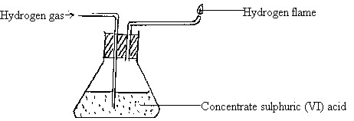
a) Name one chemical and one physical property of hydrogen being demonstrated in the set-up above.

i) Chemical property. (1mark)
…………………………………………………………………………………………………………….......
ii) Write a chemical equation for the reaction taking place. (1mark)

b) Name any other substance that can be used in place of concentrated sulphuric (VI) acid. (1mark)
…………………………………………………………………………………………………………………………………………………………………………………………………………………………………
c) Give a reason why it is necessary to burn the hydrogen gas as shown in the set-up. (1mark)
……………………………………………………………………………………………………………………………………………………………………………………………………………………………………
17. The diagram below shows a simple distillation to separate water and ethanol.
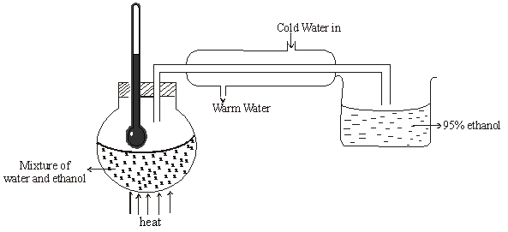

- State one of the conditions for the above process to take place. (1mark).
……………………………………………………………………………………………………………………
- Ethanol collected is 95% pure. Secondary distillation is carried out in which calcium metal is placed in ethanol to react with water. Give a reason why the following cannot be used. (2marks)
  - Sodium …………………………………………………………………………………………………………………………………………………………………………………………………………………………………….

  - Copper……………………………………………………………………………………………………………………………………………………………………………………………………………………..

18. A solution of potassium chloride was added to a solution containing a lot of lead (II) nitrate. A precipitate that weighed 5.56g was formed. Find the amount of potassium chloride in the solution (3marks)
……………………………………………………………………………………………………………………………………………………………………………………………………………………………………
……………………………………………………………………………………………………………………………………………………………………………………………………………………………………
……………………………………………………………………………………………………………………………………………………………………………………………………………………………………
19. 1.9g of Magnesium chloride was dissolved in water. Silver nitrate solution was added till excess. Calculate the mass of silver nitrate that was added for complete reaction. (3marks)
(MgCl₂= 95, N=14, O=16, Ag = 108)
……………………………………………………………………………………………………………………………………………………………………………………………………………………………………
……………………………………………………………………………………………………………………………………………………………………………………………………………………………………
……………………………………………………………………………………………………………………………………………………………………………………………………………………………………

20. In an experiment 40cm³ of 0.5M nitric acid was reacted with excess Sodium Carbonate and the volume of Carbon (IV) Oxide produced recorded with time. In another experiment, the same volume and concentration of ethanoic acid was reacted with excess Sodium Carbonate and the volume of Carbon (IV) Oxide produced recorded with time.
a) Why was Sodium Carbonate used in excess? (1marks)

…………………………………………………………………………………………………………………

b) On the graph below sketch and label the curves of the volumes of Carbon (IV) Oxide produced against time. (2marks)

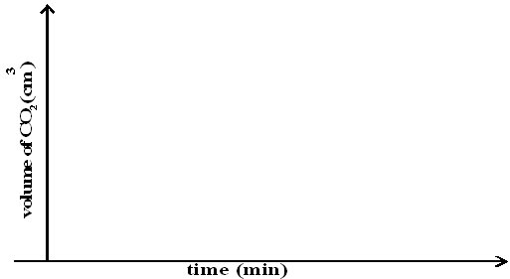

21. The figure below is an energy level diagram for the reaction.

2A_{(g)} + 2B_{(g)} 2AB_{(g)}

Energy (kJ)
Reaction progress
2AB_{(g)}

2A_{(g)} + 2B_{(g)}

Explain how the following conditions would affect the yield of AB.

- Increase in pressure. (2marks)
………………………………………………………………………………………………………………………………………………………………………………………………………………………………………………………………………………………………………………………………………………………………………………………………………………………………………………………………………………………………
- Decrease in temperature. (2marks)

……………………………………………………………………………………………………………………………………………………………………………………………………………………………………
……………………………………………………………………………………………………………………………………………………………………………………………………………………………………

22. A white solid K was heated. It produced a brown gas A and another gas B which relights a glowing
splint. The residue left was yellow even after cooling.
- Identify gases A and B. (2marks)
………………………………………………………………………………………………………………
- Write a balanced chemical equation for the decomposition of solid K. (1mark)
…………………………………………………………………………………………………………………………………………………………………………………………………………………………………… 23. The scheme below shows some reaction sequence starting with solid M.
Solid M
Solid N
White ppt
Colourless Solution Q
+ Gas which burns with a ‘pop’ sound
Few drops of NH_{3(aq)}
Excess NH_{3(aq)}
H₂SO_{4(aq)}

- Name solid M. (1mark)
……………………………………………………………………………………………………………………

- Write the formula of a complex ion present in solution Q. (1mark)
……………………………………………………………………………………………………………………… Write an ionic equation of the reaction between barium nitrate and solution N. (1mark)
………………………………………………………………………………………………………………………
24. (a) What is meant by a saturated solution? (1mark) …………………………………………………………………………………………………………………………………………………………………………………………………………………………………………………..
(b) In an experiment to determine the solubility of solid Y in water at 30⁰C the following results were
obtained.
Mass of evaporating dish = 26.2g
Mass of evaporating + saturated solution = 42.4g
Mass of evaporating dish + dry solid Y = 30.4g
Using the information, determine the solubility of solid Y at 30⁰C. (2marks)
………………………………………………………………………………………………………………………………………………………………………………………………………………………………………………………………………………………………………………………………………………………………………………………………………………………………………………………………………………………………

25. Compare the electrical conductivity of dilute Sulphuric (VI) acid and concentrated Sulphuric (VI) acid. Explain your answer. (2marks)
………………………………………………………………………………………………………………………………………………………………………………………………………………………………………………………………………………………………………………………………………………………………………………………………………………………………………………………………………………………………
26. Draw a well labelled diagram of a setup used to prepare and collect dry Sulphur IV oxide. (3marks)

27. The molar heat of formation of carbon (II) oxide is -105kJmol⁻¹, molar heat of combustion of carbon
is -393kJmol⁻¹.
By using an energy cycle diagram, determine the molar heat of combustion of carbon (II) oxide. (3marks)
……………………………………………………………………………………………………………………………………………………………………………………………………………………………………………………………………………………………………………………………………………………………………………………………………………………………………………………………………………………………………………………………………………………………………………………………………………………………………………………………………………………………………………………………………………………………………………………

28. In an experiment, a small amount of charcoal was added into a test tube and 5cm³ of concentrated
nitric (V) acid added, then warmed.
- State the observation that was made. (1mark)
………………………………………………………………………………………………………………………………………………………………………………………………………………………………………………
(ii) Explain the observation made in (i) above. (1mark) ………………………………………………………………………………………………………………………………………………………………………………………………………………………………………………
(iii) Write an equation for the reaction that took place. (1mark) ………………………………………………………………………………………………………………………………………………………………………………………………………………………………………………………………………………………………………………………………………………………………………

