NAME: ………………………………… ADM NO: …………… CLASS: ……….

233/2
CHEMISTRY
PAPER 2
FORM 4
END TERM 1 EXAM
TIME: 2 HOURS

INSTRUCTIONS:
Answer all the questions in the spaces provided.

1. Below is a table of oxides of period 3 elements. Use it to answer the questions that follow.
Element | Na | Mg | Al | Si | P | S | Cl
Oxides | Na₂O  Na₂O₂ | MgO | Al₂O₃ | SiO₂ | P2O₃  P₂O₅ | SO₂  SO₃ | Cl₂O₇
Nature of oxides | I | II | III | IV | V | VI | VII

(a) Compare the electrical conductivity of oxides of Sodium to those of phosphorus. (2 mks)

(b) Which oxides would react with dilute Sulphuric acid. Explain. (2 mks)

(c) Write down balanced equation to show how one of the oxides would react with both 2M
hydrochloric acid and 2M Sodium hydroxide solution. (2 mks)

(d) What structure would be formed by the oxides of silicon? Explain your answer. (2 mks)

The melting point of SO₂ is lower than that of MgO. MgO has a giant ionic structure while
SO₂ has a simple molecular structure.

(e) Describe how you would prepare a dry sample of lead (II) nitrate from the following
reagents. Lead (II) oxide and dilute nitric (V) acid. (3 mks)

(f) Alum used in treating water is both advantageous and disadvantageous. Explain.(2 mks)

(g) When a blue litmus paper is dipped in a solution of aluminium Chloride it turns red. Explain.

2. The set up below was used to prepare hydrogen chloride gas and salt T. (1 ½ mks)

(a) Identify the following:
(i) Liquid M.

(ii) Gas V

(iii) Salt T

(b) Write down balanced chemical equations for reactions that occur at: (2 mks)
(i) Flask I

(ii) Combustion tube.

(c) Name the process that formed salt T as shown in the diagram. (½ mks)

(d) Sulphuric (VI) acid is used as a drying agent in this experiment. Explain why calcium oxide
is unsuitable for the same purpose in this reaction. (1 mk)

(e) The water in the beaker was found to have a pH of 2.0 at the end of the experiment. Explain.
(1 mk)

(f) Calculate the mass of salt T formed if 480cm³ of hydrogen chloride gas measured at room
temperature was reacted with aluminium powder (Al = 27, Cl = 35.5 MGV = 24dm³)(2 mks)

(g) Draw a well labeled diagram showing how you would dissolve hydrogen chloride in water.
(2 mks)

(h) Explain why hydrogen chloride gas dissolved in methyl benzene does not react with calcium
carbonate. (1 mk)

(i) Using an equation, state the observation made when a gas jar containing hydrogen chloride
gas is opened near an open bottle of liquid ammonia. (1 mk)

3. Use the information below to answer the questions that follow.
Ca_{(s)} + ½ O_{2(g)} CaO_{(s)} $∆H$= - 635kj/mol-1

C_{(s)} + O_{2(g)} CO_{2(g)} $∆H$ = - 394kj/mol

Ca + C + $\frac{3}{2}$O₂ CaCO_{3(s)} $∆H$= - 1207 kj/mol

(a) Calculate the enthalpy change for the reaction. (3 mks)
CaO_{(s)} + CO_{2(g)} CaCO_{3(s)}

(b) State one factor that should be considered when choosing fuel for cooking. (1 mk)

(c) A student used the apparatus shown to calculate the energy released when ethanol burns.
The energy released by the burning ethanol raises the temperature of the water in the copper
colorimeter.
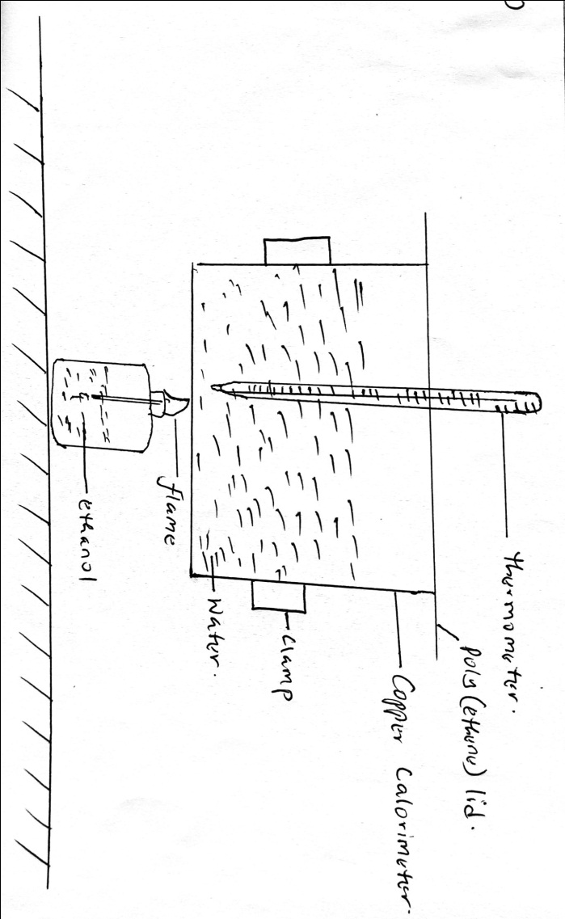

Volume of water used = 500cm³
Initial temperature of water = 25ºC
Final temperature of water = 44.5ºC
Mass of ethanol + Lamp before burning = 121.5g
Mass of ethanol + lamp after burning = 120.0g

Calculate the:
(i) Heat evolved during the experiment (density of water = 1g/cm³, specific heat capacity
of water = 4.2jg⁻¹K⁻¹) (3 mks)

(ii) Molar heat of combustion of ethanol. (3 mks)
(C = 12, O = 16, H = 1)

(d) Write the thermo equation for the complete combustion of ethanol. (1 mk)

(e) Sketch a simple energy diagram for the reaction of ethanol in air. (3 mks)

4. Name the following compounds using the LUPAC system.
(a) (i) CH₃CH₂COOCH₂CH₃ (1 mk)

(ii) CH₃CH₂CHC=CH (1 mk)

(b) Study the scheme below and answer the questions that follow.

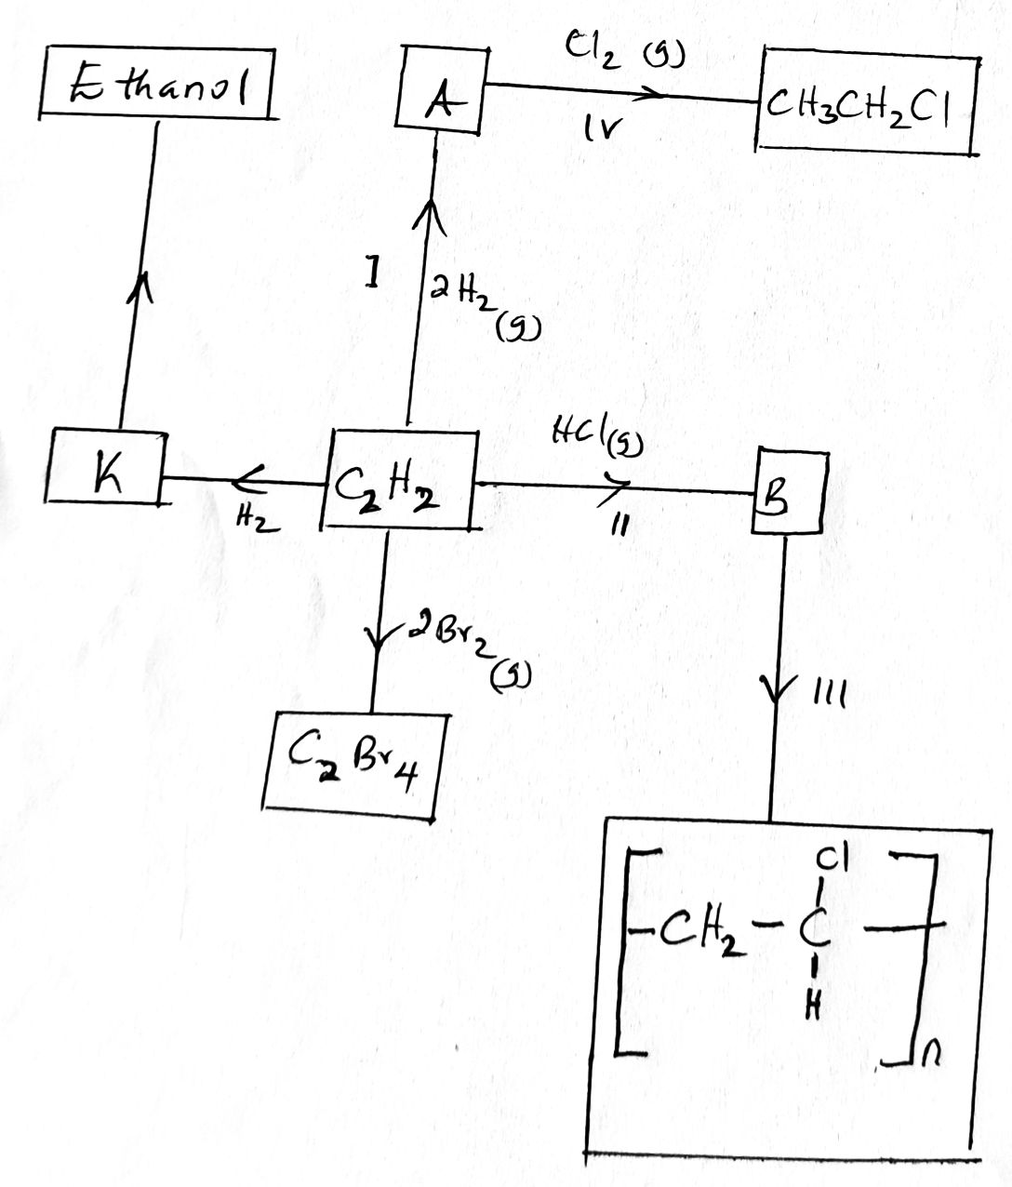

(i) Identify the catalyst used in step I. (1 mk)

(ii) Name the compounds A and B. (1 mk)
A

B

(iii) Give one disadvantage of compound formed in step III. (1 mk)
(iv) Name the reactions taking place at steps. (2 mks)
III

IV

(c) Compound A and B have the same molecular formula C₃H₆O₂. Compound A liberates
Carbon (iv) oxide on addition of aqueous Sodium carbonate while compound B does not.
Compound B has a sweet smell. Draw the possible structures of:
(i) Compound A (1 mk)

(ii) Compound B. (1 mk)

(d) A student mixed equal volumes of ethanol and butanoic acid. He added a few drops of
concentrated Sulphuric (vi) acid and warmed the mixture.
(i) Name and write the formula of the main products. (2 mks)

(ii) Which homologous series does the product named in (i) above belong? (1 mk)

5. Use the standard electrode potentials given below to answer the questions that follow.
Element Volts(V)
Ag⁺_{(aq)} + e- Ag(s) + 0.80

Cu²⁺_{(aq)} + 2e- Cu(s) + 0.34

Pb²⁺_{(aq)} + 2e Pb(s) - 0.13

Zn²⁺ _{(s)} + 2e- Zn(s) - 0.76

(a) Select two half-cells which when combined give the lowest workable cell (lowest e.m.f).
(1 mk)

(b) Calculate the e.m.f of the cell formed by combining the two half-cells in (a) above.(1 mk)

(c) (i) Select the strongest oxidizing agent. (½ mk)

(ii) Strongest reducing agent (½ mk)

(d) A cell was set up using lead and zinc electrodes as shown below.
(i) Write down the half equation for the half-cell in which oxidation occurs. (1 mk)

(ii) Write down the overall cell equation. (1 mk)

(iii) What is the role of the salt bridge (2 mks)

(e) An iron cup was electroplated using chromium. The chromium electrode and the iron cup
was thoroughly cleaned and weighed before being dipped into the electrolyte.
(i) Why was it necessary to clean the metals before dipping them into the electrolyte?
(1 mk)

(ii) A current of 0.75A was passed through the solution for one hour and four minutes. The
mass of chromium deposited on the cup was 0.52g (1 Faraday = 96500C, Cr = 52)
I. Calculate the quantity of electricity. (1 mk)

II. How many moles of chromium were deposited? (1 mk)

III Calculate the quantity of electricity to deposit one mole of chromium.(2 mks)

IV. Calculate the number of Faradays required to deposit one mole of chromium and
hence deduce the change of ion. (2 mks)

6. Nitrogen and hydrogen react to form ammonia gas as shown in the following equation.

N_{2(g)} + 3H_{2(g)} 2NH_{3(g)} $∆H$ = -97 Kj/mol

The figure below shows how the percentage of ammonia gas in the equilibrium mixture changes
with temperature.

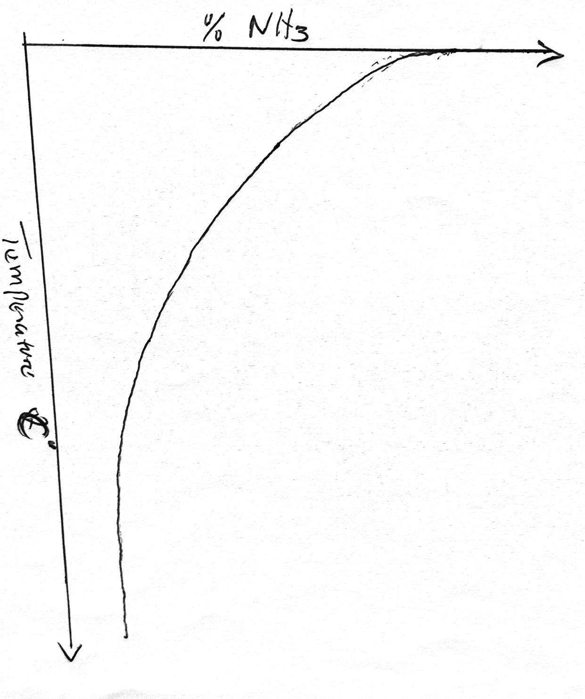
(a) Explain why the percentage of ammonia gas changes as shown in the figure above.
(2 mks)

(b) On the following axis, sketch a graph showing how the percentage of ammonia gas in the
equilibrium mixture changes with pressure. (1 mk)

%
NH₃

Pressure atmosphere

(c) Bismuth chloride (BICl₃) reacts with water according to the equation given below.

BiCl_{3(g)} + H2O_{(l)} BiOCl_{(s)} + 2HCl_{(aq)}
(i) State what would happen when a few drops of dilute hydrochloric acid are added to
the mixture at equilibrium. (1 mk)

(ii) Give a reason for your answer in (a) (i) above. (1 mk)

(d) (I) In that harbor process, the industrial manufacture of ammonia is given by the
following equation:

N_{2(g)} + 3H₂ 2NH_{3(g)} $∆$H = -97jh/mol

(i) Name one source of hydrogen used in the process. (1 mk)

(ii) Name the catalyst used in the above reaction. (1 mk)

(iii) What is the effect of increasing temperature on yield of ammonia. Explain.
(2 mks)

(II) The curves below were obtained when equal volumes of 2M HCl were reacted with
3.0g of marble chips (CaCO₃). In one of the reactions, the acid was warmed before
adding this marble chips.
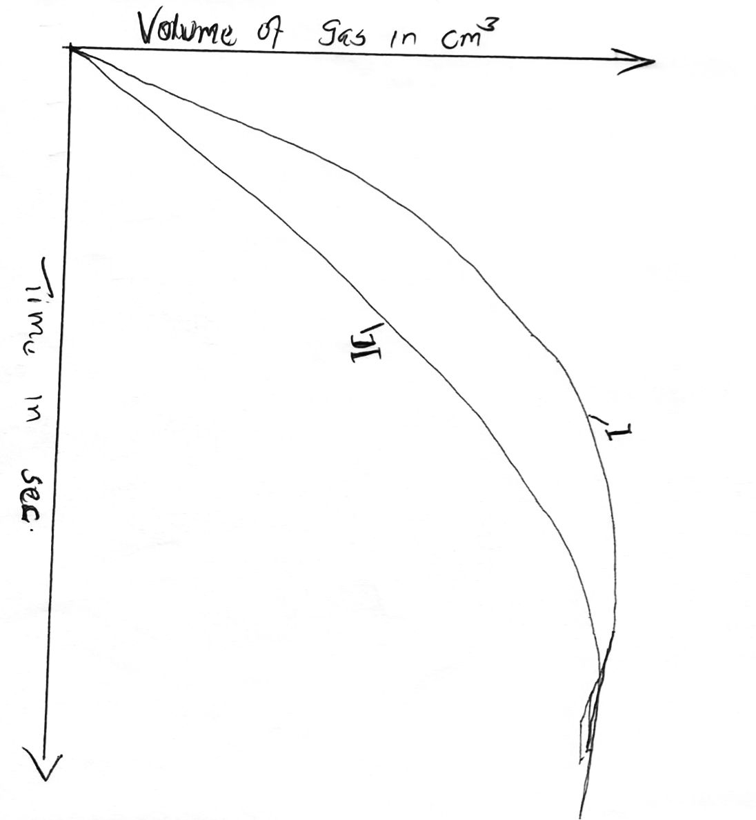

(i) Write down the equation for the reaction. (2 mks)

(ii) Identify the curve representing the reaction where the acid was warmed.
(1 mk)

