CHEM PP2

LANJET MARKING SCHEME

1. (a) (i)

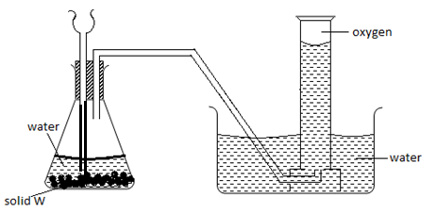

The thistle funnel has to dip inside the solution so that the gas does not escape through it.

(ii) Sodium peroxide Na2O2

(b) (i) 4P(s) + 5O2(g) → 2P2O5(g)

(ii) Phosphorous (V) oxide dissolves in water to form an acid (Phosphoric acid)

(c) A firm oxide (aluminium Oxide) is formed on the surface of the metal. This oxide protect aluminium from further attack

(d) (i) A reaction which proceeds by production of heat i.e heat is lost to the surroundings.

(ii) The yield will be lowered: through the Le- Chateliers principle, the yield is expected to increase. But lower temperatures will result into fewer particles attaining activation energy.

(iii) RMM of SO3 = 32 + 48 = 80

Moles of SO3 used = 350 = 4.38 moles

80

Moles of H2S2O7 = 4.38 moles

RMM of H2S2O7 = 2 + 64 + 112 = 178

Mass of H2S2O7 = 4.38 x 178 = 779.6 kg

2. (i) C2 H4 O2 it melting point is higher than 100 C

(ii) CH14 and C5 H12

C6 H14  has a higher melting point since it is more bulky compared to C5 H12; hence the vanderwaals force between the molecules of C6 H14 is abit stronger.

iii) C3H8O is more soluble in water than C5H12: because it formshydrogen bonds with water molecules i.e it is polar due to the presence of (-OH) group.

b) i) C4H8

ii) C4H8(g) + 6O2(g) → 4O2(g) + 4 H2O(l)

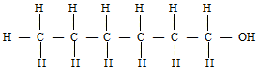c) i)

**Reagents**

ii). – Concentrated sulphuric acid

* Al2O3 or phosphoric acid (Catalyst)

**Conditions**

Heat (160-1800C)

d) i) Saponification/Hydrolysis

ii) Fats/ ester

e) i) Polymerisation

ii) Substitution

3. a) - potassium manganate (vii)

- Lead (IV) oxide

- Manganese (IV) oxide

- Calcium chlorate (CaOCl2)

b) i) to remove all the oxygen which would form iron (iii) oxide instead

of iron (iii) chloride.

ii) CaO can absorb both Cl2 and moisture, CaCl2 can only absorb moisture.

iii) RMM FeCl3 = 162.5

Moles of FeCl3 = 0.5 = 0.003

162.5

Moles of Cl2 = 3 x 0.003 = 0.0045

Vol of Cl2= 0.0045 x 24000 = 110.8cm3

c) Fe3+  is reduced to Fe2+; H2S is oxidized to sulphur

d) Turns, red then white because chlorine is acidic and a bleaching agent inpresence of water.

e) i) M 2:8

C 2:8:8

ii) Ionic bond

iii) Group one, Period 4

iv) “R” has a large atomic radius that “L”. The outermost electrons in “R” are not held tightly its nucleus.

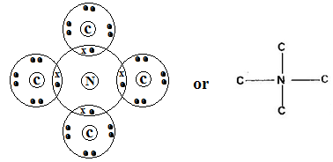e)

1. a) i) ∆H1& ∆H2

∆H3& ∆H4

∆H1 – Atomisation

∆H4 – Condensation

* + - * 1. i) ∆H latt + -4690 + (3x -364) = 332

∆H latt – 5782 = -332

∆H latt - = 5450kJmol-1

draw

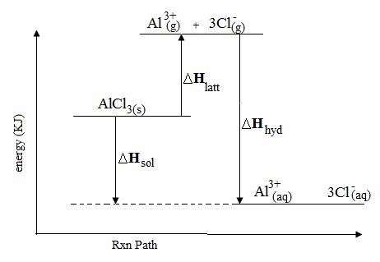

* + - * 1. i) 2C4H9OH(l) + H3O2(g)8CO2(g)+ HOH2O(l)

Draw

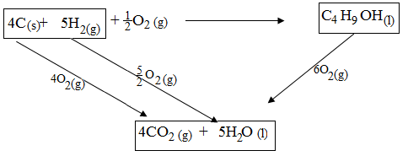

∆Hf + -2676 = (4 x -393) + (5 x -286)

∆Hf = -1572 + -1430 + 2676 = -326kJ mol-1

5. a) i) G(s)  + H2+(aq) G2+(aq) + H(s)

iii) EMF = E0red – E oxi

+ 0.34 + 0.44 = + 0.78v

b) i. K …. Cathode

J …… Anode

ii. M – 4H+(aq) + 4e- 2H2(g)

H – 4OH-(aq)  2H2O(l)+ O2(g) + 4e-

iii. HCl(aq)ions are readily discharged to chlorine gas hence there will be a mixture of two gases as the anode products (oxygen and chlorine gases)

c) 144750 Columbus = 144750 Faradays = 1.5F

96500

2 faradays gives 64g of copper

1.5 faradays give 1.5 x 64 = 48g

2

6. i) I) Carbon (II) Oxide / Carbon (IV) Oxide

II) Dilute Sulphuric acid

**Chamber I**

ii) ZnO(s) + C(s) CO(g) + Zn(s)

**Roaster**

2ZnS(s) + 3O2(g) SO2(s) + ZnO(s)

**Chamber II**

Zn(s) + H2SO4(aq) ZnSO4(aq) + H2(g)

iii) I: Mass of ZnS = 45 x250 = 112.5g

100

II: 22 ZnS(s) + 3O2(g) 2SO2(g) + 2ZnO(s)

Moles of ZnS =112.5 = 1.16 moles

97.4

Volume of SO2≡ 1.16 Moles

Volume of SO2 = 1.16 x 24 = 24.72 dm3

III 65.4 x 112.5 = 75.54g of Zn

97.4

b) - Cause acidic rain

- SO2 is poisonous

c) Contact process: SO2 (by product) can be used to manufacture sulphuric

7. a)

|  |  |
| --- | --- |
| Nuclear reactions | Chemical reactions |
| Inolves protons and neutrons | Involve valency electrons |
| Reaction rate not affected by element changes | Reaction rate is influenced by element changes |
| Involve huge amount of energy | Involve little amount of energy |
| There is change in mass | No change in mass |

Any pair  
 b) i) 1: Alpha II: beta

ii) 210 206 4

PoPb + He

84 82 2

c) i)

0 20 40 60 80 100

100

80

60

40

20

Time in minutes

Perscentage of bismuth remaining

ii) I 120 minutes

II % value at 70 minutes = 9% ± 2

Mass = 0.16 x 100 = 1.778(g)

9±

d) - Treatment of cancer

- Sterlization of surgical equipment

- Treatment of leation of goiter

- Regulate heat pace makerAny one

- Detection of blood circulation disorders

- Measure of uptake of iodine.