NAME: ……………………………….. ADM NO: ………….. CLASS:
233/2
CHEMISTRY
PAPER 2
2022

INSTRUCTIONS TO CANDIDATES:
Answer all the questions in the spaces provided.
Mathematical tables and electronic calculators may be used.
All working must be clearly shown where necessary.

1. The grid below represents part of the periodic table. Study it and answer the questions that
follow.
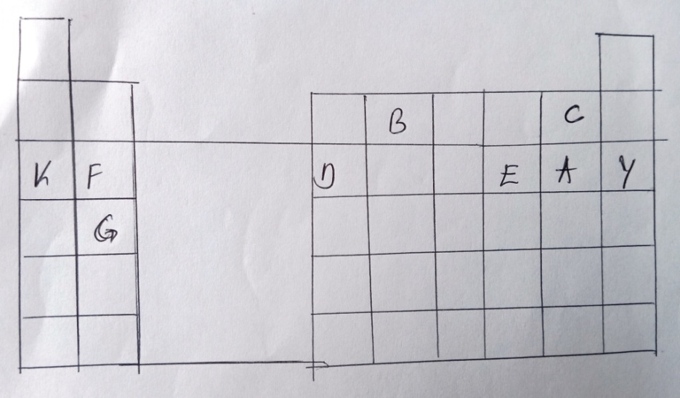
(a) Identity the family name to which element F and G belong. (1 mk)

Alkaline earth metals
(b) Name the type of bond formed when a and F belong. (1 mk)
Ionic bond

(c) Write the formula of the oxide formed when D reacts with oxygen. (1 mk)
D₂O₃

(d) What type of oxide is formed in (c) above. (1 mk)

(e) Compare the atomic radii of F and D. Explain. (2 mks)
- Has a smaller atomic radius than F because D has more protons hence stronger
to F.

(f) Element F burns in air to form two products. Write two equations of the two products
formed. (3 mks)
2F_{(s)}
₎ F₃N_{2(s)}
(g) Stat e two uses of element K and its compounds. (2 mks)
- K cyanide is used in the extraction of gold
- Mixture of K and potassium is used as nuclear coolant.

2. (a) Name the following organic compounds.
(i) CH₃CH₂CH(Br)CH₃
2, 3 – dibromo – 2 - chloropentane
O
O
(ii) CH₃-CH₂CH₂-CH₂-C-OH
OH
Butanoic acid

(iii) CH₂CHCH₂CH(Br)CH₃
4 – bromopent-i-ene

(b) Study the flow chart below and answer the questions that follow.

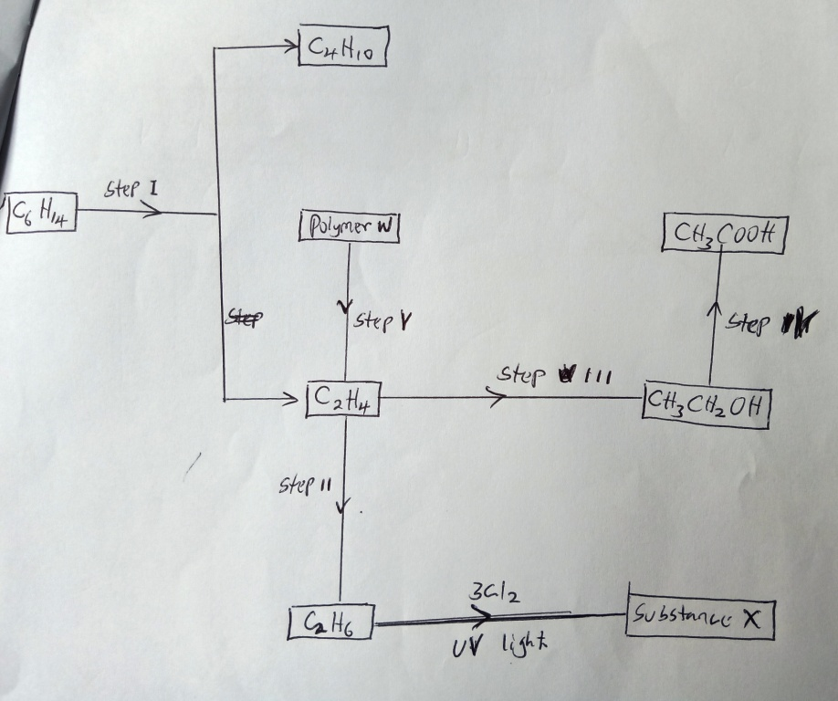

Name:-
(i) The process that occur in steps marked I, II and IV. (1 mk)
I – cracking
II- Hydrogenation
IV – Oxidation
(ii) The reagent and conditions in step II. (1½ mks)
Reagent – hydrogen
Conditions – temp 150 – 250ºC, nickel catalyst
(iii) Draw the structural formula of substance X, give the name of the substance. (2 mks)
Cl Cl
│ │
Cl ─ C ─ C ─ Cl
│ │
Cl Cl

(c) The diagram below shows a structure of a cleansing agent.

OSO₃⁻Na⁺
R

(i) Name the cleansing agent above. (1 mk)
Sodium alkylbenzene sulphonate

(ii) State the type of cleansing agent above. (1 mk)
Soapless detergent

(iii) Name the material added to the cleansing agent in order to improve its cleansing
property.
Tetraoxophosphate materials

3. (a) 50cm³ of 1M copper (II) Sulphate solution was placed in a 100cm³ plastic beaker. The
temperature of the solution was measured. Excess metal A powder was added to the
solution, the mixture stirred and the maximum temperature was repeated using powder of
metal B and C. The results obtained are given in the table below.

 |  | A | B | C
Maximum temperature ºC |  | 2.63 | 31.7 | 22.0
Initial temperature (ºC) |  | 22.0 | 22.0 | 22.0

(i) Arrange the metal A, B, C and Copper in order of reactivity starting with the least
reactive. Give reasons for the order. (3 marks)
C, Copper, A, B.
B is the most reactive because it has highest $∆$T.
C is the least reactive because it cannot displace ions of copper from solution.
A is more reactive than Copper because it displaces Cu²⁺ from solutions.

(ii) Other than temperature change, state one other observation that was made when the
most reactive metal was added to the copper (II) Sulphate solution. (1 mk)
- Blue colour of the solution fades /disappeared
- Black deposit is formed.
(b) The Standard enthalpy change of formation of methanol is -239Kjmol-1

(i) Write the thermal chemical equation for the standard enthalpy change of formation of
methanol. (1 mk)

C_{(s)} + 2H_{2(g}) + ½ O_{2(g)} H₃OH_{(g}) $∆H= -239Kjg/mol$

(ii) Use the following data to calculate the enthalpy change for the manufacture of methanol
from carbon (II) oxide and hydrogen. (3 mks)

CO_{(g)} + ½ O_{2(g)} CO₂; $∆$H^{ɵ} = -283Kj/mol

H_{2(g)} + ½ O_{2(g)} H₂O_{(l);} = $∆$H^{ɵ} = -286Kj/mol

CH₃OH + $3/2$ CO_{2(g)} + 2H₂O; $∆$H^{ɵ} = -715Kj/mol

C + 2H₂ + ½ O₂ CH₃OH

$∆$H= -283Kj/mol $∆H= -286Kj/mol$ $∆H=-715Kj/mol$

O₂ O₂ O₂

CO₂ + H₂O

$∆H$_{σ}CH₃OH = $∆$H_{c}C + $∆$H_{c}H₂ - $∆$H_{c}CH₃OH

= -283 + 2(-286) – (-715)
= -283 – 576 + 715
= -859 + 715

$∆H$_{f} CH₃OH = - 144Kj/mol

(c) Study the information given in the table below and answer the questions that follow.
Bond | Bond energy (Kjmol⁻¹
C – H  Cl – Cl  C – Cl  H - Cl | 414  244  326  431

Calculate the enthalpy change for the reaction. (3 mks)
CH_{4(g)} + Cl_{2(g)} CH₃Cl_{(g)} + HCl_{(g)}

H H
│ │
H ─C─H + Cl─H H─C─Cl + H─Cl
│ │
H H

Bond breaking energy – Bond formation energy

BBE - BFE

4(414) + 244 = 3 (414 + 326 + 431

(1900 – 1999) = -99Kj

= -99Kj

4. Carbon IV oxide is produced when solid X is heated strongly. It can also be prepared by adding
dilute hydrochloric acid to solid X. The reaction between X and dilute Sulphuric acid, however
gradually slows down and stops.
(a) (i) Name solid X. (1 mk)
Calcium carbonate

(ii) Write an ionic equation for the reaction of X and acid. (1 mk)
CO₃²⁻_{(s)} + 2H⁺_{(aq)} CO_{2(g)} + H₂O_{(l)}

(b) A gas jar full of Carbon (IV) oxide was inverted over burning candle.
(i) State the observations made. (1 mk)
Candle is immediately extinguished

(ii) What two properties of carbon (IV) oxide does this observation illustrate. (2 mks)
- It does not support combustion and it is denser than air since it is poured
downwards from gas jar.

(iii) Name a practical everyday use of this property of carbon (IV) oxide. (1 mk)
As a fire extinguisher

(c) The flow diagram below shows some reactions of calcium compounds.

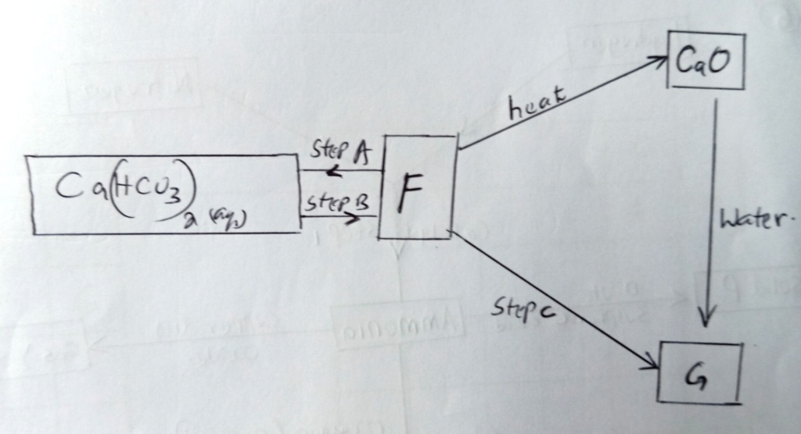
(i) Name compound F and G. (2 mks)
F = Calcium carbonate
G = Calcium hydroxide

(ii) Write equations for reactions in step A, B and C. (3 mks)
Step A: CaCO_{3(s)} + H₂O_{(l)} + CO_{2(g)} Ca(HCO₃)_{2(aq)}

Step B: Ca(HCO₃)_{2(aq)} CaCO₃(s) + CO_{2(g)} + H₂O_{(l)}

Step C: Ca(OH)_{2(g)} CaCO_{3(s)} + H₂O

5. A piece of sodium metal which had been exposed to air, was found to be covered with a white
powder. The piece was dropped into 50g of ethanol and 2400cm³ of hydrogen gas measured at
room temperature and pressure was obtained. The unused ethanol was distilled off and a white
solid remained (Na = 23, molar gas volume at room temperature and pressure = 24dm³)

(i) Name the other substance formed other than hydrogen. (1 mk)
Sodium ethoxide

(ii) Calculate the mass of sodium that dissolved in ethanol. (2 mks)
2C₂H₅OH_{(l)} + 2Na(s) 2C₂H₅ONa_{(l)} + H_{2(g)}
2 moles Na gives 1 mole H2 at r.t.p.

46g Na gives 24.000cm³

2400cm³

2400cm³ x 46g
24000cm³ = 4.6g of sodium

(iii) What mass of ethanol was distilled of assuming there was no loss during the process?
(2 mks)
2 moles of C₂H₅OH 1 mole of H₂ gas

(2 x 46)g C₂H₅OH gives 24000cm³

X 2400cm³

2 x 46 x 2400
2400 = 9.2g

Mass of distilled = (50g – 9.2g) = 40.8g

(iv) The ethanol was distilled off at 80ºC, while the white solid remained unaffected at this
temperature. What is the difference in structure of ethanol and the white solid. (2 mks)
Ethanol is molecular structure with hydrogen bonds between molecules while white solid must be giant ionic structure with strong ionic bonds.

(b) Name another liquid which produces;
(i) Hydrogen with sodium metal. (1 mk)
Water

(ii) What difference would you observe if identical pieces of sodium were dropped
separately into small beakers containing ethanol and this other liquid? (2 mks)

(c) (i) Name the white powder coating the original piece of sodium, explain how it was formed.
(3 mks)
Sodium in air forms sodium oxide, which in presence of moisture forms sodium hydroxide, which reacts with carbon (iv) oxide in air to form sodium carbonate.

(ii) Describe one test by which you could identify white powder which originally covered
sodium. (2 mks)
Add dilute HCl acid. Effervescence occurs and colourless gas is given off which forms a white precipitate in lime water.

6. The scheme below shows various reactions starting with hydrogen and nitrogen. Study it
carefully and answer the questions that follow.

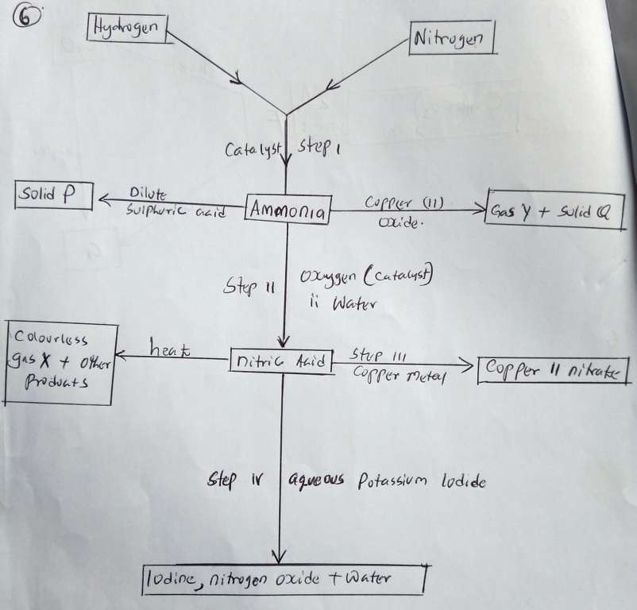
(i) Give one condition other than the of a catalyst that would favour the reaction in step I. (1 mk)
High pressure

(ii) Name the catalysts used in step I and II. (2 mks)
Step I - finely divided iron
Step II – Vanadium V oxide/platinum

(iii) Name substances P, Q, X and Y . (2 mks)
P – ammonium sulplhate
Q – Copper metal
X – Oxygen
Y – nitrogen gas

(iv) Write equations for the reactions that takes kplace in step II. (3 mks)

4NH₃(g) + 5O_{2(g)} 4NO(g) + 6H2O_{(l)}

2NO(s) + O_{2(g)} 2NO₂

4NO_{2(g)} + 2H₂O_{(g)} + O_{2(g)} HNO_{3(aq)}

(v) Name the oxidizing agent for the reaction that takes place in step IV. (1 mk)
Nitric acid

(vi) Why is a concentrated nitric acid transported on aluminium container and not copper? (1 mk)
Concentrated nitric acid with copper oxidizes it to Copper(II) nitrate, while aluminium forms layer of aluminium oxide which is a passive and stops any further action by the acid.

7. Use standard electric potentials for elements A, B, C, D and F given below to answer the
questions that follow.
E^{ɵ} (volts)
A²⁺_{(aq)} + 2e- A_{(s)} -2.90

B²⁺_{(aq)} + 2e- B_{(s)} -2.38

C⁺_{(aq)} + 2e- ½ C_{(g)} -0.00

D²⁺_{(aq)} + 2e- D_{(s)} +0.34

½ F_{2(g)} + e- F⁻_{(aq)} +2.87

(i) Which element is likely to be hydrogen? Give a reason for your answer. (2 mks)
C⁺/C₂ = hydrogen is used as the reference electrode
E^{ɵ} value is 0.00/standard electrode potential

(ii) What is the E^{ɵ} value of the strongest reducing. (1 mk)

E^{ɵ} = -2.90V

(iii) In the space provided, draw a labeled diagram of the electrochemical cell that would be
obtained when half-cells of elements B and D are combined. (3 mks)

(iv) Calculate the E^{ɵ} value of the strongest reducing agent. (2 mks)
2.38 + 0.34 = 2.72
0.34 –(-2.38) = +2.72
(0.34 + 2.38) = +2.72V

(b) During the electrolysis of aqueous copper II Sulphate using copper electrodes, al current of
0.2 amperes was passed through the cell for 5 hours.
(i) Write an ionic equation for the reaction that took place at the anode. (1 mk)

Cu_{(s)} Cu²⁺_{(aq)} + 2e-

or
Cu_{(s)} Cu²⁺_{(aq)}

(ii) Determine the change in mass of the anode which occurred as a result of the electrolysis
process. (C.u = 63.5, 1 Faraday = 96,500 coulombs) (2 mks)

C = AI
(0.2 x 5 x 60 x 60)

0.2 x 5 x 60 x 60 x 63.5
2 x 96500
63 .5g Cu requires 2 x 96500

3600 C produces 63. 5 x 3600
2 x 96500

= 1.18gm

