NAME: ……………………………………………………………………………………… INDEX NO: …...……………………….
SIGNATURE: ….………………………………………… DATE: ……………………………………

451/2
COMPUTER STUDIES
PAPER 2
PRACTICAL

TIME 2 ½ HOURS

SMARTPASS EXAMINATION
Kenya Certificate of Secondary Education (KCSE)
MODEL ONE 2019

451/2
COMPUTER STUDIES
PAPER 2
PRACTICAL

INSTRUCTIONS TO CANDIDATES

- Type your name and index number at the top right hand corner of each printout.
- Write your name and index number on the Dvd/Cd. .
- Answer any two questions.
- All questions carry equal marks.
- All answers must be saved in your diskette.
- Hand in all the printout and the Dvd/Cd
- ALL fields with currency must be formatted to Ksh

This paper consists of 4 printed pages. Candidates should check the question paper to ensure that all pages are printed as indicated and no questions are missing.
- The extract below shows a spread sheet used to record books stored in the library. The books are borrowed by students under the plan of Short and long loan borrow type. A short loan borrow type attracts a fee of Ksh 7.50 per day while the Long loan borrow type attracts a fee of Ksh 5 per day.
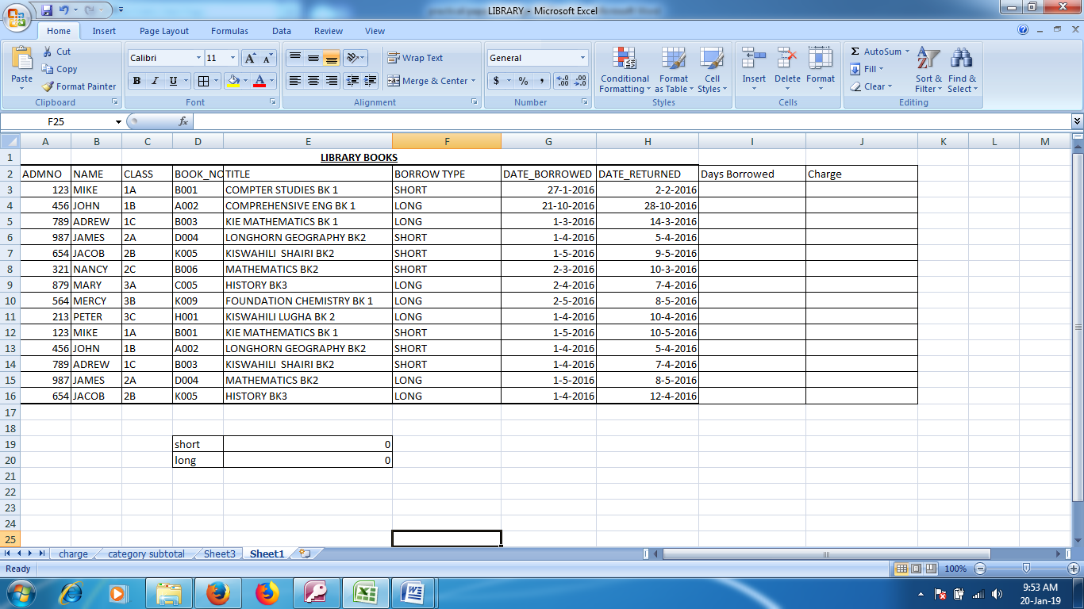

(a)(i)Create a worksheet and save the spreadsheet as Library (1 Mark)
(ii) Insert a label In the row 1 merge the cells center the label (1 Mark)
(iii) Insert the data in the sheet as shown above (19 Marks)
(iv) Name the worksheet as Charge (1 Mark)
(b) (i) Using the formula or functions calculate the days borrowed and charge for every Individual
student (8 Marks)
(ii) Create a table showing the total charge for each category and use formula to calculate the values (8 Marks)
(iii). Create a Pie chart Based on b(ii) Above (4 Marks)
(c) (i) Copy the Data in the worksheet charge to a new worksheet and rename the worksheet as
category subtotal (1Mark)
(ii) Sort the data in the worksheet in the part c(i) in ascending values of borrow type (2 Mark)
(iii) Insert the subtotals in the sorted worksheet category subtotal based on Category and Charge (3 Mark)
(d) Print charge worksheet, Category subtotal and the Chart (3 Marks)
- ABC cleaning services offers cleaning services to clients categorized as Small, Medium, Corporate and Big.
The table in figure 1 represents the charges to their clients and number of cleaners depending on the client. The Administrative Charge(Ksh)/Day and Consumable fee(Ksh)/day are the charges made to the clients
Category | Administrative Charge(Ksh)/Day | Consumable fee(Ksh)/day | No of Cleaners
Small | 5000 | 1000 | 4
Medium | 10000 | 1500 | 6
Corporate | 15000 | 2000 | 8
Big | 20000 | 2500 | 10

Figure 1
The cleaners are paid a fixed amount of 500 shilling per day on each cleaning day.
Invoices are sent to Clients on monthly bases
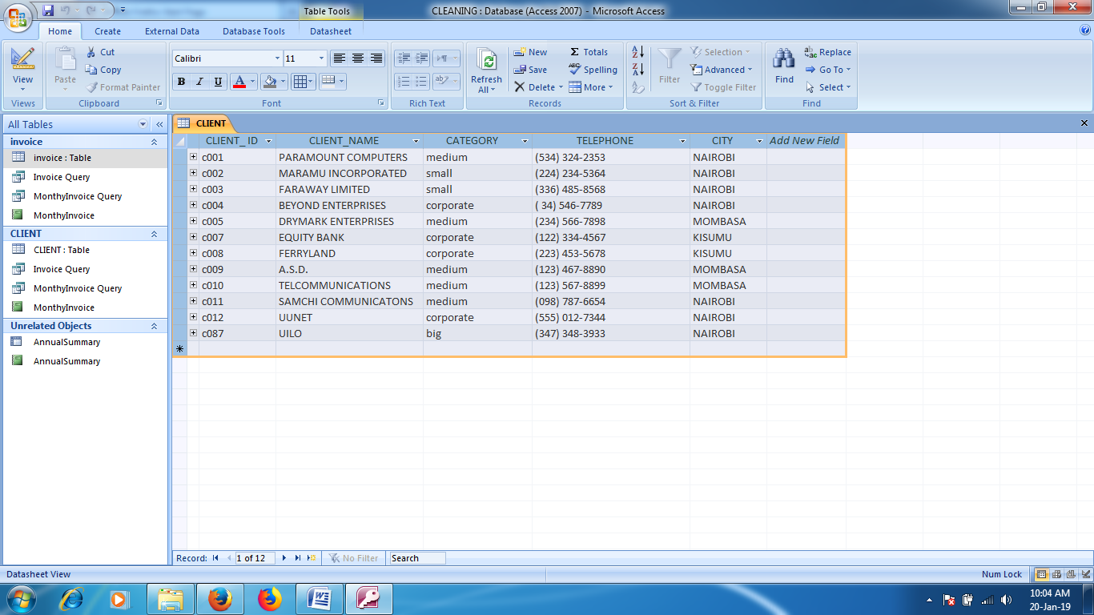
The following tables shows data for the client and invoice table
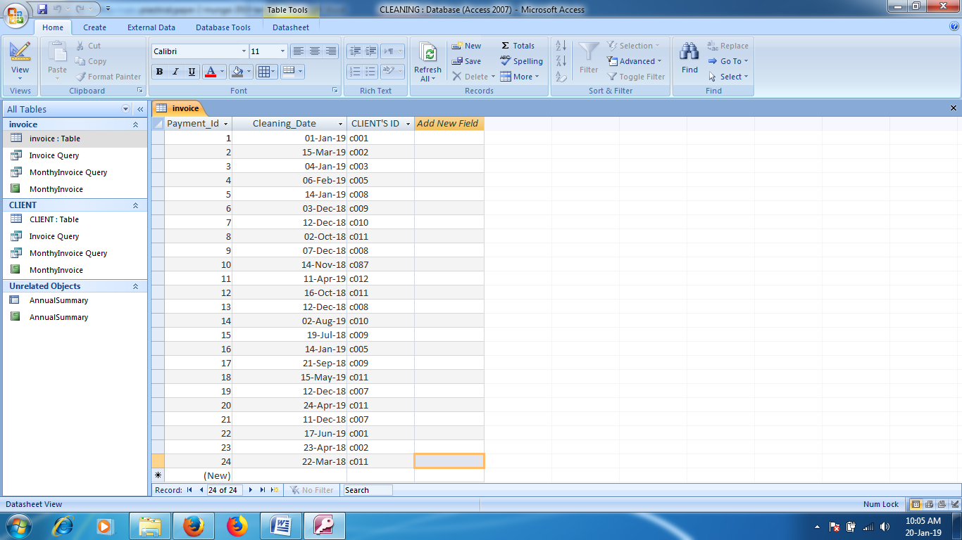

- (i) Create a database and save the database as cleaning (1 Mark)
(ii) Create the two tables Client and Invoice (2 Marks)
(iii)Create the relationship between the two tables (1 Mark)
(iv) Fill in the data in the two tables (10 Marks)
- (i)Create a query to show Total charge made to the Clients with the following fields. CLIENT_ ID, CLIENT_NAME, CATEGORY, TELEPHONE, CITY, Cleaning Date, Month, Year, Administrative Charge (Ksh), Consumable Fee And Total Charge. Save the Query as invoice
(14 Marks)

(ii) Create a query Based on the query in Part b(i) above with the following fields CLIENT'S ID, CLIENT_NAME, CATEGORY, TELEPHONE, CITY, Cleaning, Date, Month, Year, Administrative Charge(Ksh), Consumable Fee And Total Charge. Save the Query as client invoice it should filter out the fields by criteria of CLIENT_ID, Month and year
(3 Marks)
(iii) Create a query Based on the query in Part b(i) above which should show total annual invoices with individual monthly totals save the query as annual summary
(5 Marks)
- (I) Create a report based on b(ii) Showing all the appropriate summaries Save the report as monthly invoice (5 Marks)
See sample below
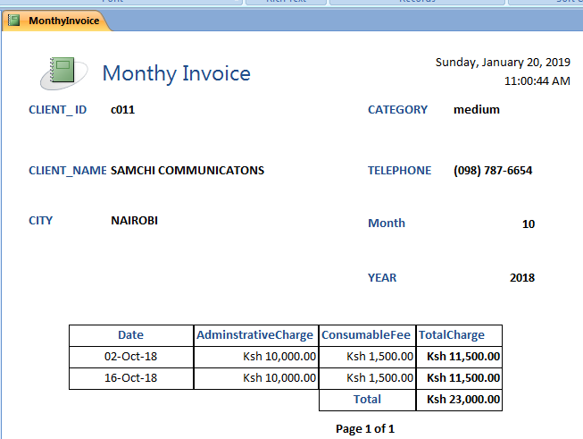
(ii) Create a report based on and b(ii) Showing all the appropriate summaries save the report as annualsummary (5 Marks)
See sample Below
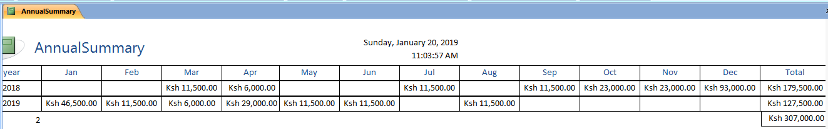
(iii) Print
- Annual Summary report________________________________ (1Mark)
- Monthly Invoice report________________________________ (1 Mark)
- Invoice Query_________________________________________(1 Mark)
- Annual Summary______________________________________ (1 Mark)

