451/2 SMARTPASS COMPUTER STUDIES PAPER 2 MARKING SCHEME MODEL ONE 2019
- The extract below shows a spread sheet used to record books stored in the library. The books are borrowed by students under the plan of Short and long loan borrow type. A short loan borrow type attracts a fee of Ksh 7.50 per day while the Long loan borrow type attracts a fee of Ksh 5 per day.
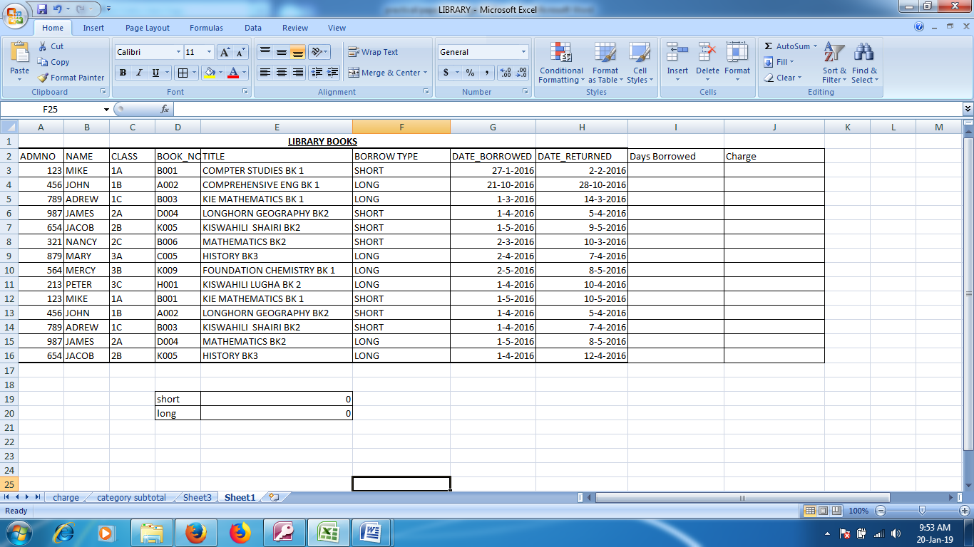
(a)(i)Create a worksheet and save the spreadsheet as Library (1 Mark)
- Creating a worksheet _____________________________________________1 Mk
(ii) Insert a label In the row 1 merge the cells center the label ( 1 Mark)
- Label Created cell Merged and Centered_______________________________1Mk
(iii) Insert the data in the sheet as shown above ( 19 Marks)
- AdmnNo____________________________________________________________2 Mks
- Name_______________________________________________________________2 Mks
- Book_No_____________________________________________________________6 Mks
- Borrow type___________________________________________________________3mks
- Date Borrowed_________________________________________________________3Marks
- Date Returned________________________________________________________3Mks

(iv) Name the worksheet as Charge ( 1 Mark)
- Naming Worksheet______________________________________________________1mk
(b) (i) Using the formula or functions calculate the days borrowed and charge for every Individual
student ( 8 Marks)
- Days Borrowed____________________________________________________4Mks
- =DATEDIF(G3,H3,"d")
- Charge___________________________________________________________4Mks
- =IF(F3="short",I3*7.5,I3*5)
(ii) Create a table showing the total charge for each category and use formula to calculate the values ( 8 Marks)
short | 337.5
long | 290

- Short____________________________________________________4Mks
- =SUMIF($F$3:$F$16,"short",$J$3:$J$16)
- Long____________________________________________________4mks
- =SUMIF($F$3:$F$16,"Long",$J$3:$J$16)
(iii). Create a Pie chart Based on b(ii) Above ( 4 Marks)

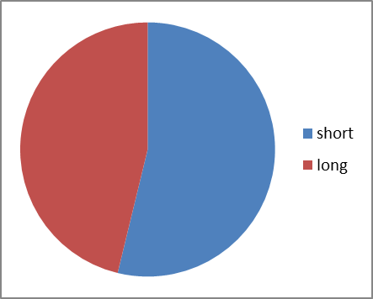

Legends_________________________________________1Mks
PieChart__________________________________________3Mks

(c) (i) Copy the Data in the worksheet charge to a new worksheet and rename the worksheet as
category sub total ( 1Mark)
- Cpying,Pasting Naming________________________________1Mk
(ii) Sort the data in the worksheet in the part c(i) in ascending values of borrow type (2 Mark)
- Sorting in ascending order_____________________________1Mk
(iii) Insert the subtotals in the sorted worksheet category subtotal based on Category and Charge (3 Mark)
- SubToals_____________________________________________________3mks
(d) Print charge worksheet,Categorysubtotal and the Chart ( 3 Marks)
- Each Document printing __________________________________________1Mk
- ABC cleaning services offers cleaning services to clients categorized as Small,Medium,Corporate and Big.
The table in figure 1 represents the charges to their clients and number of cleaners depending on the client. The Adminstrative Charge(Ksh)/Day and Consumable fee(Ksh)/day are the charges made to the clients
Category | Adminstrative Charge(Ksh)/Day | Consumable fee(Ksh)/day | No of Cleaners
Small | 5000 | 1000 | 4
Medium | 10000 | 1500 | 6
Corporate | 15000 | 2000 | 8
Big | 20000 | 2500 | 10

Figure 1
The cleaners are paid a fixed amount of 500 shilling per day on each cleaning day.
Invoices are sent to Clients on monthly bases
The following tables shows data for the client and invoice table
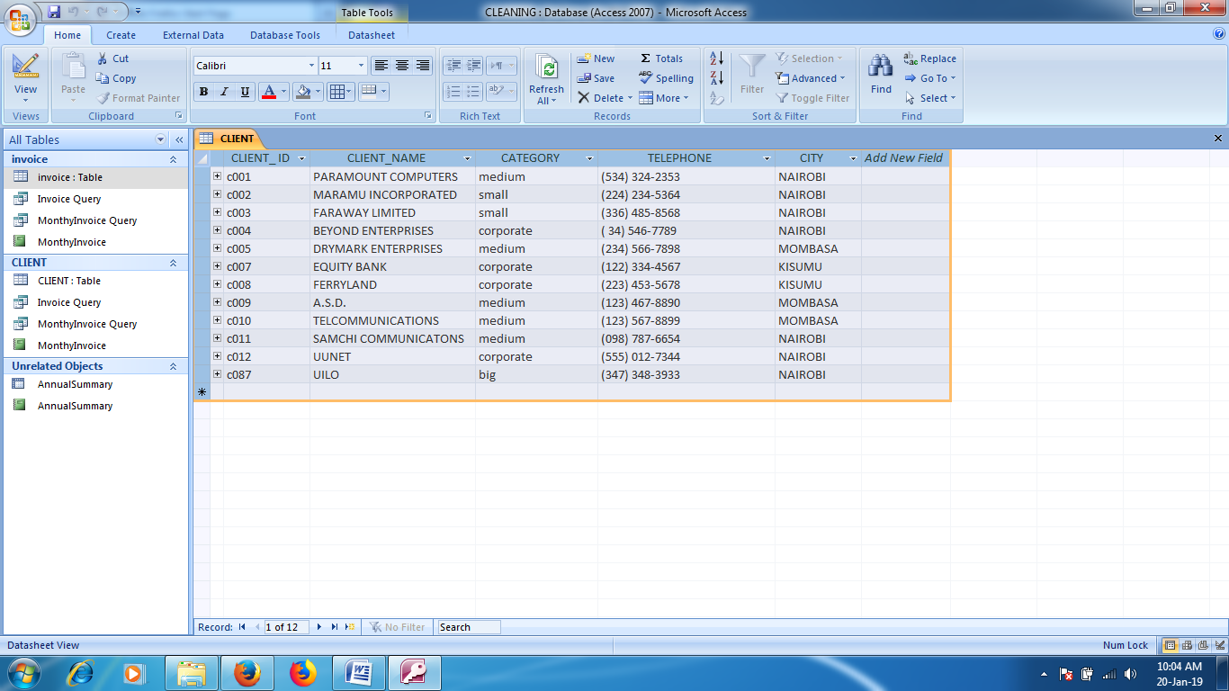
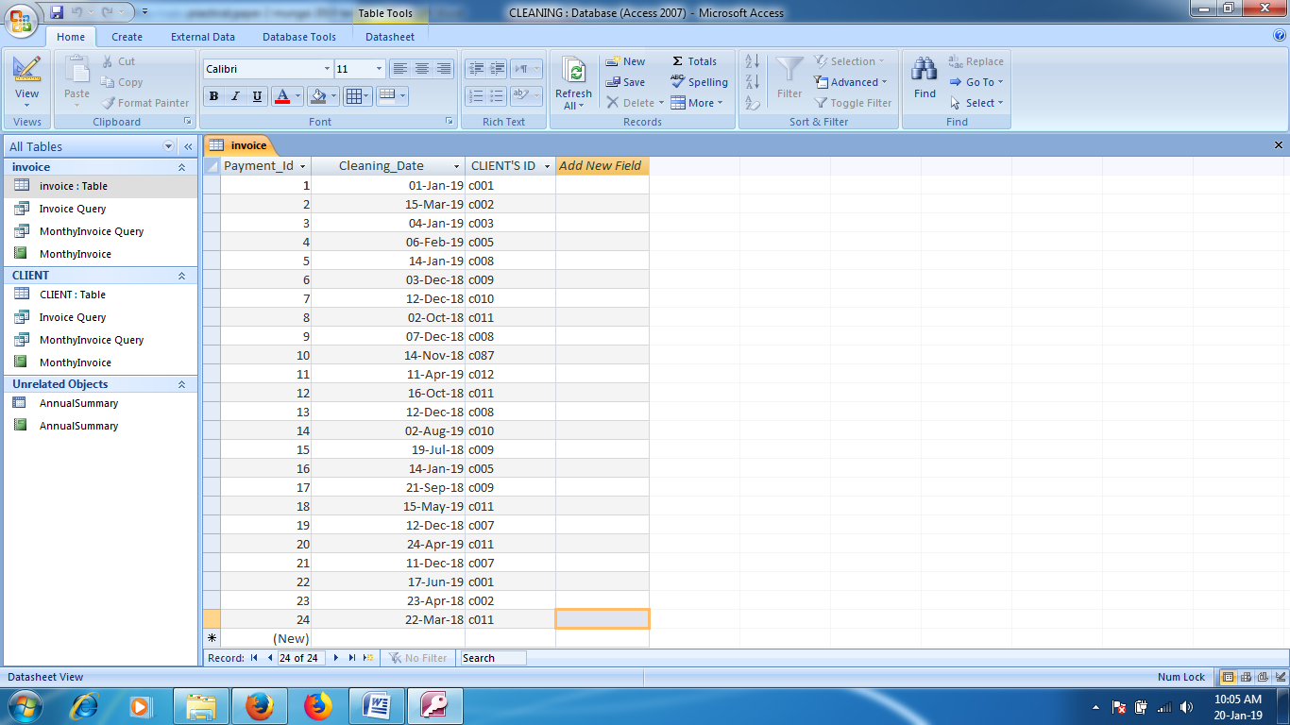

- (i) Create a database and save the database as cleaning ( 1 Mark)
- Creating a database_____________________________________________1Mk
(ii) Create the two tables Client and Invoice (2Marks)
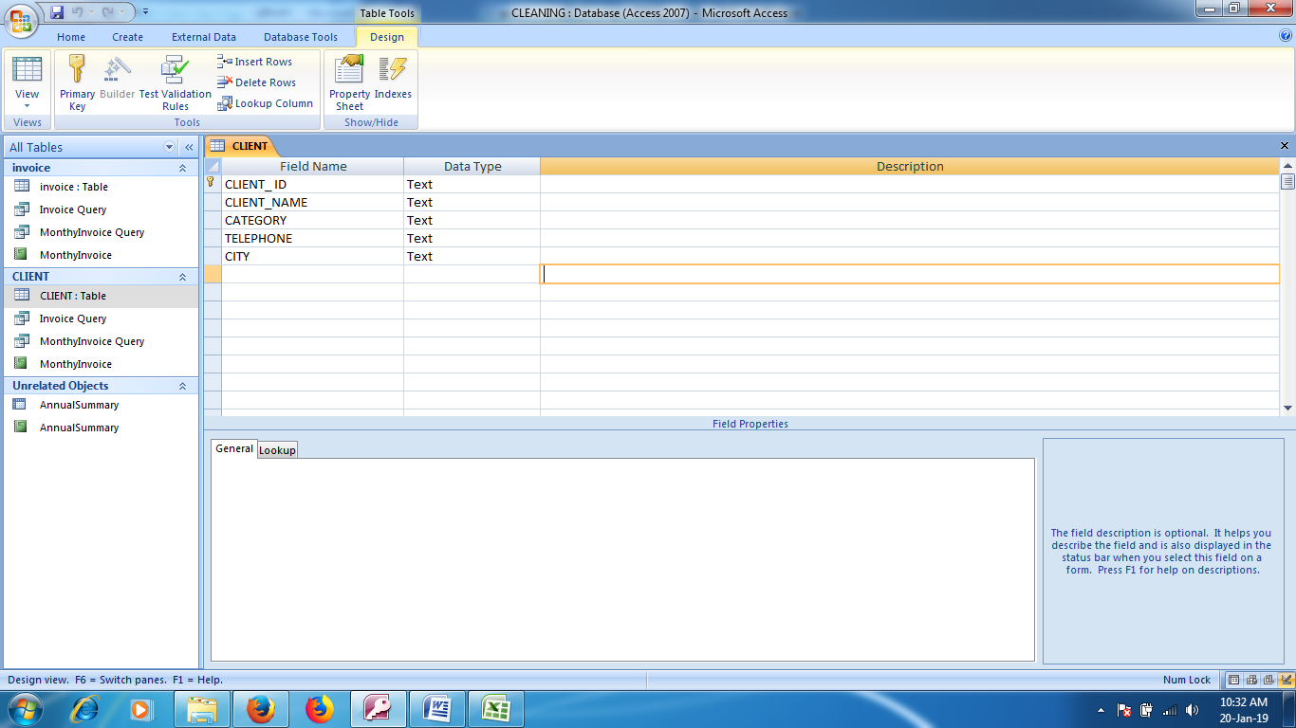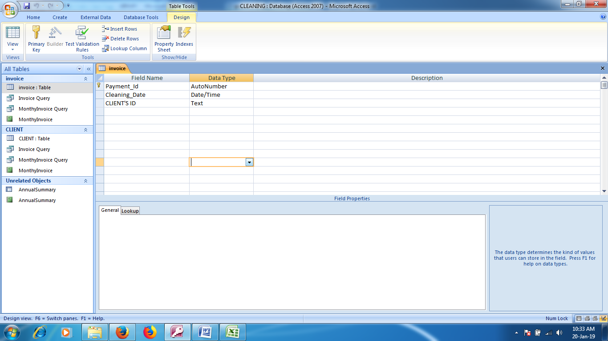
- @Table 1Mk____________________________________________________2 Mks
(iii)Create the relationship between the two tables (1 Mark)
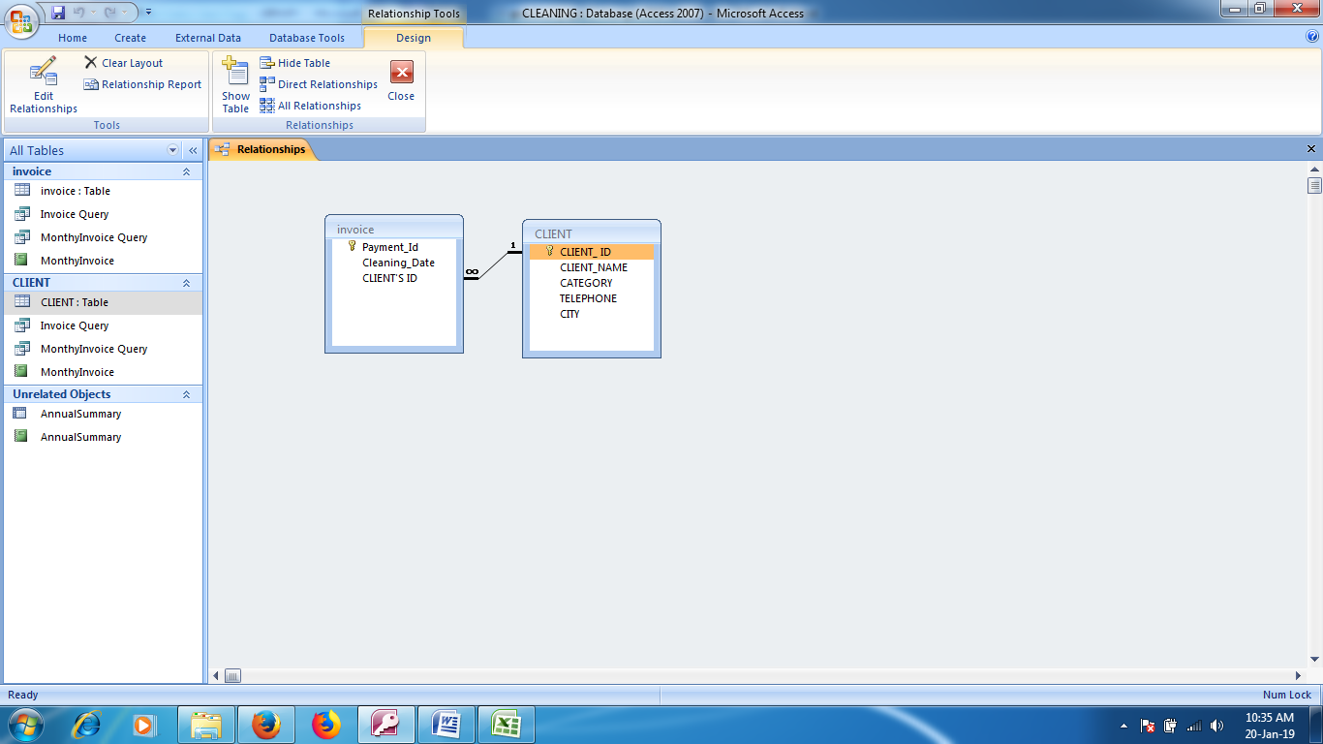
(iv) Fill in the data in the two tables (10 Marks)
- Table Client
- Client_Id____________________________________________1mk
- Client_Name_________________________________________2Mk
- Category_____________________________________________1Mk
- Telephone____________________________________________2 Mk
- City__________________________________________________1Mk
- Table Invoice
- Cleaning Date_____________________________________________2Mks
- Clint_Id__________________________________________________1Mk

- (i)Create a query to show Total charge made to the Clients with the followingfields. CLIENT_ ID, CLIENT_NAME, CATEGORY, TELEPHONE, CITY, Cleaning_Date,Month, Year,AdminstrativeCharge(Ksh), ConsumableFee And TotalCharge. Save the Query as invoice
(14 Marks)
- Month: Month([Cleaning_Date]) _____________________________________2Mk
- year: Year([Cleaning_Date]) ___________________________________________2Mk
- AdminstrativeCharge: IIf([CATEGORY]="Small",5000,IIf([CATEGORY]="Medium",10000,IIf([CATEGORY]="corporate",15000,IIf([CATEGORY]="Big",20000,"Error in Entry"))))________________6 Mks
- ConsumableFee: IIf([CATEGORY]="Small",1000,IIf([CATEGORY]="Medium",1500,IIf([CATEGORY]="corporate",2500,IIf([CATEGORY]="Big",3000,"Error in Entry"))))___________________2Mks
- TotalCharge: [ConsumableFee]+[AdminstrativeCharge] _____________________2Mks

(ii)Create a query Based on the query in Part b(i) above with the following fields CLIENT'S ID, CLIENT_NAME, CATEGORY, TELEPHONE, CITY, Cleaning_Date,Month, Year,AdminstrativeCharge(Ksh), ConsumableFee And TotalCharge. Save the Query as clientinvoice it should filter out the fields by criteria of CLIENT_ID,Month And year (3 Marks)
- Criteria
- Client_Id______________________________________________1Mk
- Month________________________________________________1mk
- Year__________________________________________________Mk
- 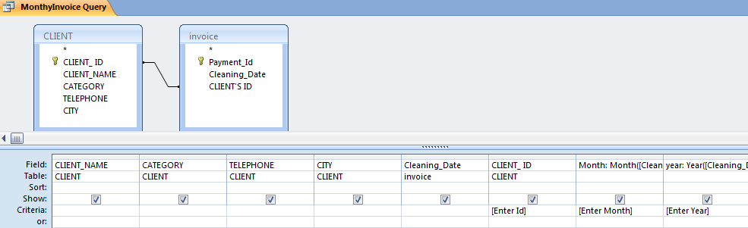
(iii)Create a query Based on the query in Part b(i) above which should show total annual invoices with individual monthly totals save the query as annualsummary
(5 Marks)
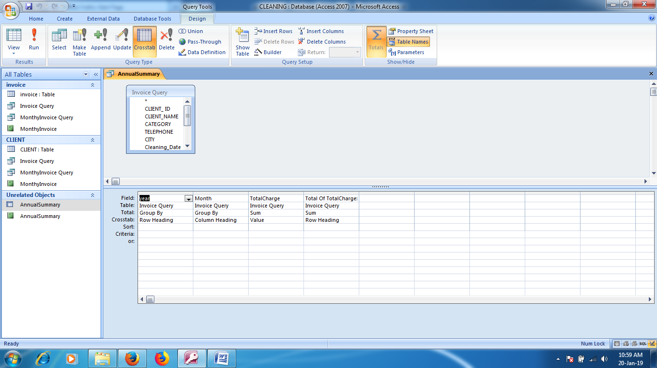
- (I) Create a report based on b(ii) Showing all the appropriate summaries Save the report as monthly invoice ( 5 Marks)
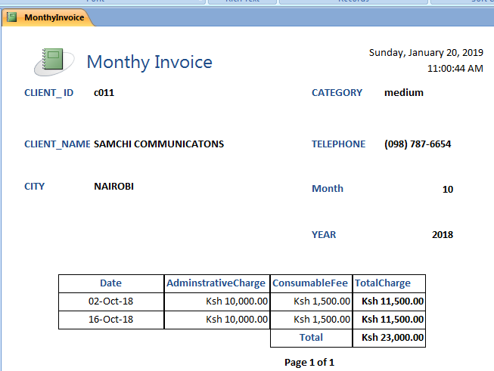
- Correct title____________________________________________1mks
- Headers And Lables______________________________________1Mk
- Details DATA___________________________________________2Mks
- Summary______________________________________________1Mk
(ii) Create a report based on and b(ii) Showing all the appropriate summaries save the report as annualsummary ( 5 Marks)
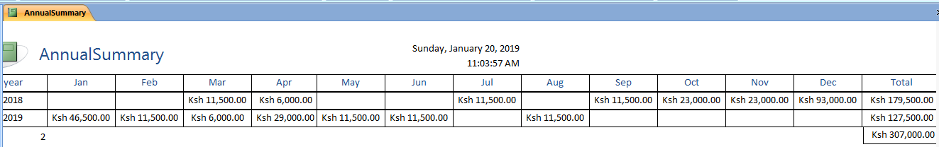
Year______________________________________________________1Mk
Properly Labelled Mnths______________________________________1Mk
Row Totals_______________________________________________2mk
Grand Total_______________________________________________1Mk
(iii) Print all the reports and the queries ( 4 Marks)
- Print
- Annual Summay report________________________________1Mk
- Monthly Invoice report________________________________1 Mk
- Invoice Query_________________________________________1Mk
- AnnualSummary______________________________________1Mk

