NAME: …………………………………………. INDEX NO: ……………………………….

SCHOOL: …………………………………….. DATE : …………………………………….

CANDIDATE’S SIGNATURE: …………………

GOLDEN ELITE EXAMINATIONS

451/1
COMPUTER STUDIES
PAPER 1
(THEORY)
TIME: 2½ HOURS

Instruction to Candidates.
- Write your Name and Index Number in the spaces provided at the top of this paper.
- Sign and write the date of examination in the spaces provided above.
- This paper consists of TWO sections; A and B.
- Answer ALL the questions in Section A.
- Answer question 16 and any other THREE questions from Section B.
- All answers should be written in the spaces provided on the question paper.

For Examiner’s Use Only.
Section | Question | Candidate’s Score
A | 1 - 15
B | 16
B | 17
B | 18
B | 19
B | 20
TOTAL SCORE

This paper consists of 11 printed pages. Candidates should check the question paper to ascertain that all the pages are printed as indicated and that no questions are missing.

SECTION A (40 marks)
Answer ALL the Questions in the spaces provided.

- (a) What is a peripheral device? (2 marks)
………………………………………………………………………………………………………………………………………………………………………………………………
(b) Give two examples of peripheral devices. (1mark)
………………………………………………………………………………………………………………………………………………………………………………………………
- State any six characteristics of the fifth generation computers. (3 marks)
………………………………………………………………………………………………………………………………………………………………………………………………………………………………………………………………………………………………………………………………………………………………………………………………………………………………………………………………………………………………………………………………………………………………………………………………………………
- Explain the term hard disk crashing (2 marks)
………………………………………………………………………………………………………………………………………………………………………………………………………………………………………………………………………………………………………
- Give two ways of erasing contents of a cell in a worksheet. (1marks)
…………………………………………………………………………………………………………………………..……………………………………………………………………….
- List three control structures used in programming language. (3 marks)
………………………………………………………………………………………………………………………………………………………………………………………………………………………………………………………………………………………………………

- Distinguish between a file and a folder as used in windows operating system. (2 marks)
…………………………………………………………………………………………………
……………………………………………………………………………………………………………………………………………………………………………………………………
- While on an environmental conservation trip, students were told never to dispose
off laptop batteries carelessly in landfills. Describe potential environmental hazards associated with those batteries. (2 marks)
…………………………………………………………………………………………………
………………………………………………………………………………………………………………………………………………………………………………………………………………………………………………………………………………………………………
- Differentiate between the Insert mode and the overtype mode as used in Microsoft
word processing. (2 marks)
…………………………………………………………………………………………………
………………………………………………………………………………………………………………………………………………………………………………………………………………………………………..………………………………………………………………
- A signal wave has three salient properties; Frequency, wavelength and amplitude.
Describe each one of them. (3 marks)
…………………………………………………………………………………………………
………………………………………………………………………………………………………………………………………………………………………………………………………………………………………………………………………………………………………
- (a) Differentiate between single mode and multimode fiber optic cables. ( 2 marks)
……………………………………………………………………………………………………………………………………………………………………………………………………………………………………………………………………………………………………….
(b) State one application area for each mode of fiber optic cables. (2marks)
………………………………………………………………………………………………………………………………………………………………………………………………………………………………..……………………………………………………………
- Fig. 2.4 shows electronic pathways on a section of a motherboard. Study the
Illustration and answer the question that follows.
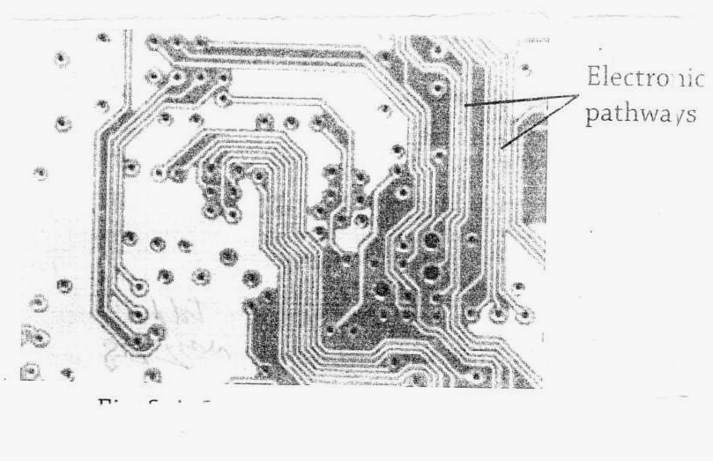

Fig.2.4: Section of a motherboard.

- What name is given to the pathway? (1 mark)
………………………………………………………………………………………………………………………………………………………………………………………………
- Explain three types of the pathways in (a) above. (3 marks)
………………………………………………………………………………………………………………………………………………………………………………………………………………………………………………………………………………………………………………………………………………………………………………………………………………………………………………………………………………………………
- Explain how an operating system such as Microsoft windows ensures that there is
no hardware conflict. (2 marks)
………………………………………………………………………………………………………………………………………………………………………………………………………………………………………………………………………………………………………
- (a) You may have come across the term ‘Garbage in Garbage out’ (GIGO).
Explain the meaning of this statement with regard to data processing. (2 marks)
………………………………………………………………………………………………………………………………………………………………………………………………………………………………………………………………………………………………
- State four operations you would undertake to safeguard data integrity. (2 marks)
………………………………………………………………………………………………………………………………………………………………………………………………………………………………………………………………………………………………………………………………………………………………………………………………
- In the text extract in Fig.4.5 below, the first character occupies more than one line.

Scientific discoveries are truly amazing. Take for
example the recent discovery that the white flashes
in storms are caused by gamma rays emitted when
electrons and positrons combine. This is the clearest
evidence yet that matter and anti-matter exist in our
world!

Fig. 4.5: Text extract
- State the formatting feature used for the first character. (1 mark)
………………………………………………………………………………………………………………………………………………………………………………………………
- Explain the importance of using the formatting feature in (a) above. (1 mark)
………………………………………………………………………………………………………………………………………………………………………………………………
- Differentiate between mouse pointer and insertion pointer. (2 marks)
……………………………………………………………………………………………………………………………………………………………………………………………………
SECTION B (60 marks)
Answer Question 16 and any other three questions from this section in the spaces provided.
- (a) Define the term ‘problem definition’ (1 mark)
………………………………………………………………………………………………………………………………………………………………………………………………
- In any given circumstance, there are several reasons that may motivate a programmer
to identify a problem worth solving. State three such reasons. (3 marks)
………………………………………………………………………………………………………………………………………………………………………………………………………………………………………………………………………………………………
- Study this flowchart and use it to answer the questions that follow.
Start
Stop
S = 1
Y
Y < 10 ?

S
Y = Y/10
S = S + 1
NO
YES

(I) Give the expected output from the flowchart when the value of Y is:
(i) 48 (2 marks)
………………………………………………………………………………………………………………………………………………………………………………………………………………………………………………………………………………………………
(ii) 9170 (2 marks)
………………………………………………………………………………………………………………………………………………………………………………………………
(iii) – 800 (2 marks)
………………………………………………………………………………………………………………………………………………………………………………………………
(II) Write the pseudocode that can be used to create a program represented by the above
Flowchart. (5 marks)
………………………………………………………………………………………………………………………………………………………………………………………………………………………………………………………………………………..……………..
………………………………………………………………………………………………
………………………………………………………………………………………………………………………………………………………………………………………………
- (a) The magnitude of a number can be determined using three parameters. Using
Examples, describe the three parameters. (3 marks)
………………………………………………………………………………………………………………………………………………………………………………………………………………………………………………………………………………………………………………………………………………………………………………………………
- Using two’s complement, show how the arithmetic below would be carried out on
a 8 – bit computer system.
(+54) – (+29). (5 marks)
……………………………………………………………………………………………………………………………………………………………………………………………………………………………………………………………………………………………………………………………………………………………………………………………………………………………………………………………………
(c) Using one’s complement, perform the following binary arithmetic leaving the answer in decimal notation. (5 marks)
1101₂ - 100101₂
…………………………………………………………………………………………………………………………………………………………………………………………………………………………………………………………………………………………………………………………………………………………………………………………………………………………………………………………………………………………………………………………….……………………………………………………………..……………………………………………………………………………………………………………………………………………………………………………………………………………………………………………………………………………………………………………………………………………………………………………………………………………………………………….………………………………………………………
(d) Differentiate between a word and a word length as used in data representation. (2 marks)
………………………………………………………………………………………………………………………………………………………………………………………………………………………………………………………………………………………………………………………………………………………………………………………………
- (a) Write down the three letter file name extensions (e.g sys) that are normally
associated with the following file type.
- A simple ASCII text file. (1 mark)
………………………………………………………………………………………………………………………………………………………………………………
- A Microsoft word document. (1 mark)
………………………………………………………………………………………………………………………………………………………………………………
- A digital photograph (1 mark)
………………………………………………………………………………………………………………………………………………………………………………
- A Microsoft power point presentation (1 mark)
………………………………………………………………………………………………………………………………………………………………………………
- A bit mapped image. (1 mark)
………………………………………………………………………………………………………………………………………………………………………………
- A scanner is quite a useful input device. Describe three useful tasks which a scanner
can fulfill. (3 marks)
………………………………………………………………………………………………………………………………………………………………………………………………………………………………………………………………………………………………………………………………………………………………………………………………………………………………………………………………………………………………………………………………………………………………………………………………
(c) Describe two types of scanner that are used for inputting data into a computer. (4marks)
………………………………………………………………………………………………………………………………………………………………………………………………………………………………………………………………………………………………………………………………………………………………………………………………
- (i) Previously scanners were connected to a computer via the parallel port,
but this has be replaced by USB. Briefly explain the difference between
these two ports. (2marks)
……………………………………………………………………………………………………………………………………………………………………………………
(ii) Explain why USB has been preferred over parallel port. (1 mark)
…………………………………………………………………………………………………………………………………………….……………………………………
- (a) Differentiate between the following characteristics of a system:
(i) Hard system and Soft system. (2marks)
……………………………………………………………………………………………………………….…………………………………………………………………..
(ii) Boundary and Environment. (2marks)
……………………………………………………………………………………………………………………………………………………………………………………
(iii) Open and Closed system. (2marks)
……………………………………………………………………………………………………………………………..………………………………………………………
(b) Define the following terms as used in system development.
(i) System Entropy (1 mark)
………………………………………………………………………………………………………………………………….…………………………………………………
(ii) System feedback. (1 mark)
………………………………………………………………………………………………………………………………………………………………………………………………
(c) State two advantages and two disadvantages of using interview as a method of
data collection.
Advantages. (2 marks)
………………………………………………………………………………………………………………………………………………………………………………………………
Disadvantages. (2 marks)
…………………………………………………………………………………………………………………………………………..…………………………………………………
- Under what circumstances would a questionnaire be best suited for data
collection. (3 marks)
…………………………………………………………………………………………………………………………………………………………………………………………………………………………………………………………………………………………………………………………………………………………………………………………….
- (a) List two devices used in wireless communication. (2marks)
………………………………………………………………………………………………………………………………………………………………………………………………
(b) Explain the following communication devices:
(i) Hubs. (1 mark)
…………………………………………………………………………………………………………………………………………………….………………………………
(ii) Modem (1 mark)
……………………………………………………………………………………………………………………………………………………………………………………
(iii) Codec (1 mark)
……………………………………………………………………………………………………………………………………………………………………………………
(iv) Bridge (1 mark)
……………………………………………………………………………………………………………………..……………………………………………………………
(c) Describe the following terms with respect to data communication.
(i) Bandwidth (1 mark)
……………………………………………………………………………………………………………………………………………………………………………………

(ii) Attenuation (1 mark)
……………………………………………………………………………………………………………………………………………………………………………………
(d) Distinguish between videotex and teletext. (2marks)
…………………………………………………………………………………………………………………………………………………………………………………………………………….………………………………………………………………………………………………………………………………….…………………………………………
- (i) What is virtual reality? (1 mark)
……………………………………………………………………………………………………………………………………………………………………………………
(ii) Explain four uses of virtual reality. (4 marks)
…………………………………………………………………………………………………………………………………………………………………………………………………………………………………………………………………………………………………………………………………………………………………………………………………………………………………………………………………………………………………………………………………………………………………………………………………………………………………………………………………………………………………………….…………………….………………

