**CROP PESTS AND DISEASES**

This topic entails the following:

* Definition of a pest and a disease
* Main cause of crop diseases
* Description of harmful effects of crop pests and diseases
* Identification of crop pests and diseases
* Control measures of crops pests and diseases

The following relevant questions and their answers in this topic will greatly motivate and help the user to comprehend and understand the required concepts and practices:

1. State **two** possible causes of swelling on the roots of legume crops

2. Discuss the various cultural methods of controlling pests in crops

3. What does the term ‘close season’ mean in crop production?

4. Explain **five** cultural methods of pest control in stored grains

5. Name **four** symptoms of viral infections in plants

6. Study the illustrations given below and then answer the questions that follow:-

**C**

**D**

(a) Identify the pests shown by the illustrations **B, C** and **D**

(b) State **one** effective method of controlling the pest labelled

(c) Name the type of crop commonly attacked by the pest labelled ‘**C**’

7. State the various practices carried out in the field to help control crop diseases

8. State t**wo** ways in which pesticides kill crop pests

9. The diagram below shows kale seedling attacked by a pest

(a) Identify the pest

(b) What damage does the pest cause to the crop

(c) State **two** methods of controlling the pest

11. Define the term ‘economic injury level of a pest and integrated pest control management

12. List **four** harmful effects of crop pests

13. The diagram below shows a fungal disease in a section of potato crop leaf

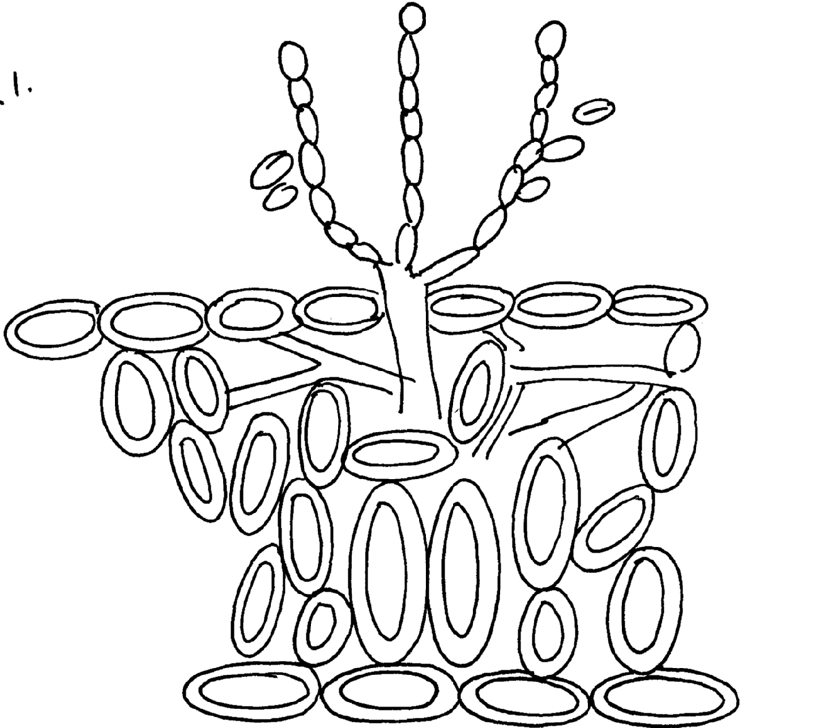

a) Identify the fungal disease

b) (i) State the causal organism of the disease identified above

ii) Give **two** symptoms of the above disease

c) Give **two** control measures of the disease

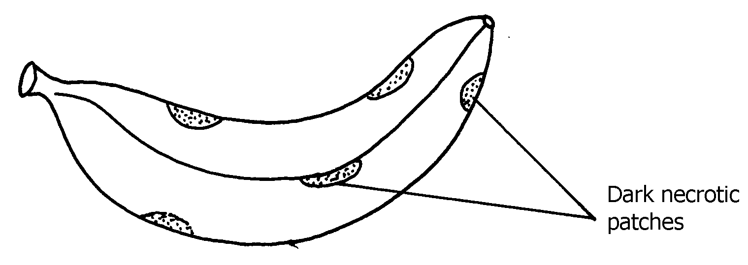14. The diagram below shows a banana fruit infected by a certain disease.

1. Identify the disease
2. Suggest any **one** control measure for the disease you have named in **(a)**

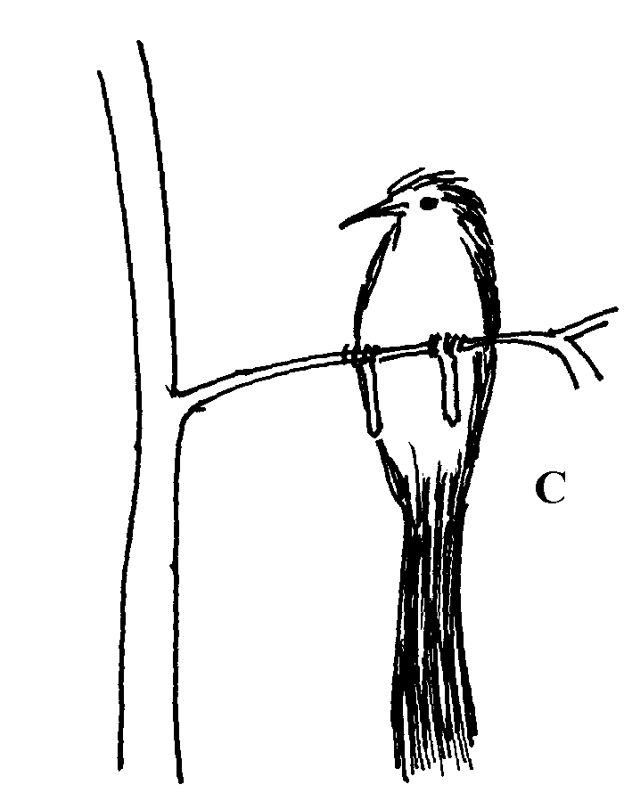15. The diagram below shows a crop pest;

(a) Identify the crop pest

(b) State **two** damages the pest would cause to crops

16. Give two symptoms of nematode attack on bananas.

17. Give **four** cultural practices used in controlling crop pests

18. State **three** symptoms of coffee berry disease.

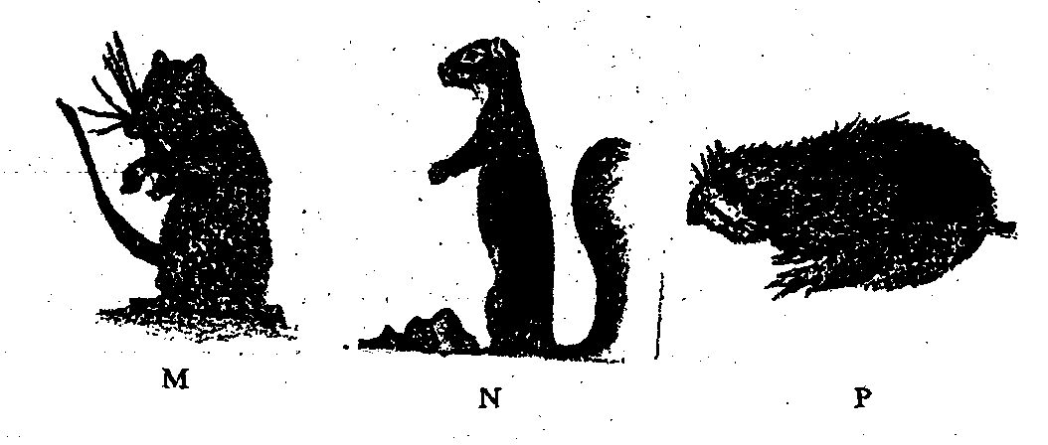19 (i) Use the diagrams below to answer the question that follow.

(a) Identify the crop pests labeled **M**, **N** and **P**

(b) State **one** control measures of crop pests labeled **M**

(c) State the damage caused to crops by crop pest labeled **N**

20. State and explain the cultural methods of pest control