**CROP PRODUCTION V (VEGETABLES)**

This topic entails the following:

* Growing or production of a vegetable crop form nursery establishment to harvesting
* Keep records of crop production.
* Market vegetable crop produce
* Give reasons or importance of growing vegetable crops.
* The vegetable crops include the following: Tomatoes, cabbages, onions, carots, kales.

The following relevant questions and their answers in this topic will greatly motivate and help the user to comprehend and understand the required concepts and practices:

1. The diagram below is of a tomato plant. Study it and answer the questions that follow:-

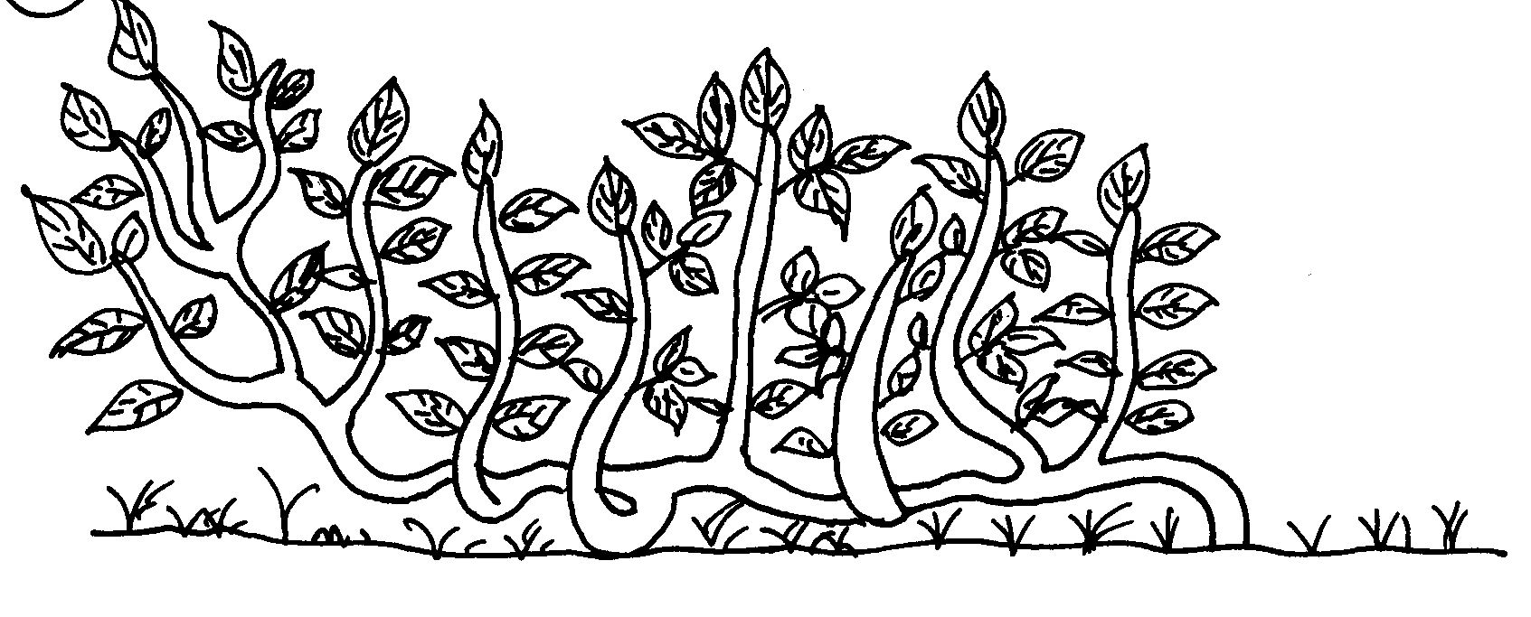

a) State **three** management practices that have not been carried on the plant above b) For each management practice state **one** reason why it should be carried out

c) Name **two** diseases that attack the crop above in the field

2. Describe the production of tomatoes (*lycopersicon esculentum*) under the following subheadings

a) Varieties

b) Nursery establishment

c) Field management practices

3. List **four** symptoms of late blight in tomatoes

4. State any **four** factors considered when grading tomatoes for fresh market

5. State **two** ways of controlling purple blotch in onions

6. The following is an illustration of an infected tomato plant. Study it carefully and answer the

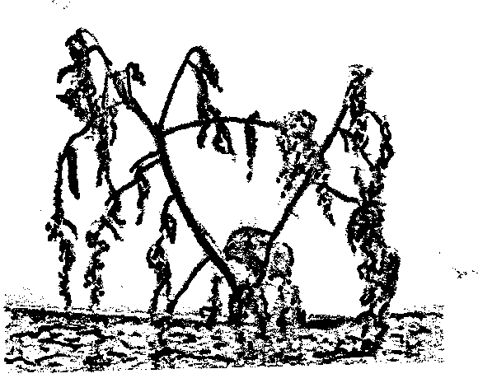 questions below:-

(a) Identify the disease which may have caused the condition shown in the illustration

(b) Name any other crop which may be affected by the disease identified in **(a)** above (c) Mention **two** other factors which can lead to the same condition as shown by the illustration

(d) State **two** measures that can be sued to control the disease named in **(a)** above

7. Give t**wo** ways in which pruning helps to control diseases in tomatoes

8. Outline **four** ecological requirements for cabbages

9. a) Mention **two** pests which attack tomatoes

b) Give **two** causes blossom end rot disease in tomatoes

10. List three ecological requirements of tomatoes.