Marking scheme
101/3
ENGLISH PAPER 3
(IMAGINATIVE COMPOSITION, LITERARY ESSAYS BASED ON SET TEXTS)
MARCH 2020
TIME: 2½ hours

MAGS 3 CYCLE 6-2019 EXAMINATIONS
Kenya Certificate of Secondary Education (K.C.S.E.)

INSTRUCTIONS TO CANDIDATES:-
- Write your name and index number in the spaces provided above.
- Sign and write the date of examination in the spaces provided above.
- Answer THREE questions ONLY.
- Questions one and two are compulsory.
- Each of your essay must not exceed 450 words.
- ALL answers must be written in Blue ink.

For Examiner’s Use Only:
Question | Maximum Score | Candidate’s Score
1 | 20
2 | 20
3 | 20
TOTAL | 60

Q2
Sample
Isben’s A Dolls House shows how this society is corrupt. Many characters are involved in one ways or the other with morally un acceptable behavior.
To begin with, Nora forges her father’s signature to secure a loan when her husband got ill and could not raise the required amount for his treatment, Nora decided to take matter into her own hands. She went to borrow money from the bank(Krogstad) in the process Nora had to have some written documents to her to secure the loan. She then decided to forge her father’s signature which later come to haunt her.
Secondly, Kregstad forging someone’s name to illegally get access to his money. As an employee of the bank, he took advantage of his position to exploit his clients. His act was later reveled and he was to face the law (punishment) but got himself out of it through corrupt ways. “…but Krogstad did nothing of that sort; he got himself out of it by a cunning trick, and that is why he has gone under altogether …”pg 46.
Moreover, Dr. Rank secretly admiring Norah despite knowing that she’s a wife to Torvald his close friend. Dr. Rank still wants to have an affair with her. He feels Nora should be in his company as much as she is in Torvald’s. This clearly shows the level of rot that is portrayed in this society. When Nora tells him that she is certain that Torvald would willingly give his life for her. Rank interjects and says that it’s not Torvald only who can do that. This insicuates that he’s willing to do anything for her because of what he feels for her.
“…do you think he’s the only one who would gladly give his life for your sake? I was determined you should know before I went away …”pg 68
Finally, Torvald giving Mrs. Linde a job at the bank, he uses his position as the manager of the bank. He uses his position as the manager of the bank to offer Mrs. Linde a job illegally without any due process followed as a public institution, we expect that after the position Krogstad was holding fell vacant after his dismissal, the due process of recruitment and interviews were to follow. This didn’t happen. Instead, Torvald just offered it directly in his house to Mrs. Linde. This is being corrupt and illegal use of the one’s position and power.
Pg 58 “… it is his/Krogstad’s post that I have arranged Mrs. Linde shall have …”
In conclusion, it is clear that corruption runs in the veins of most characters in this play for us to achieve a corrupt free society, the root causes of corruption should be identified and addressed promptly.

Q3
(A) Memories we lost
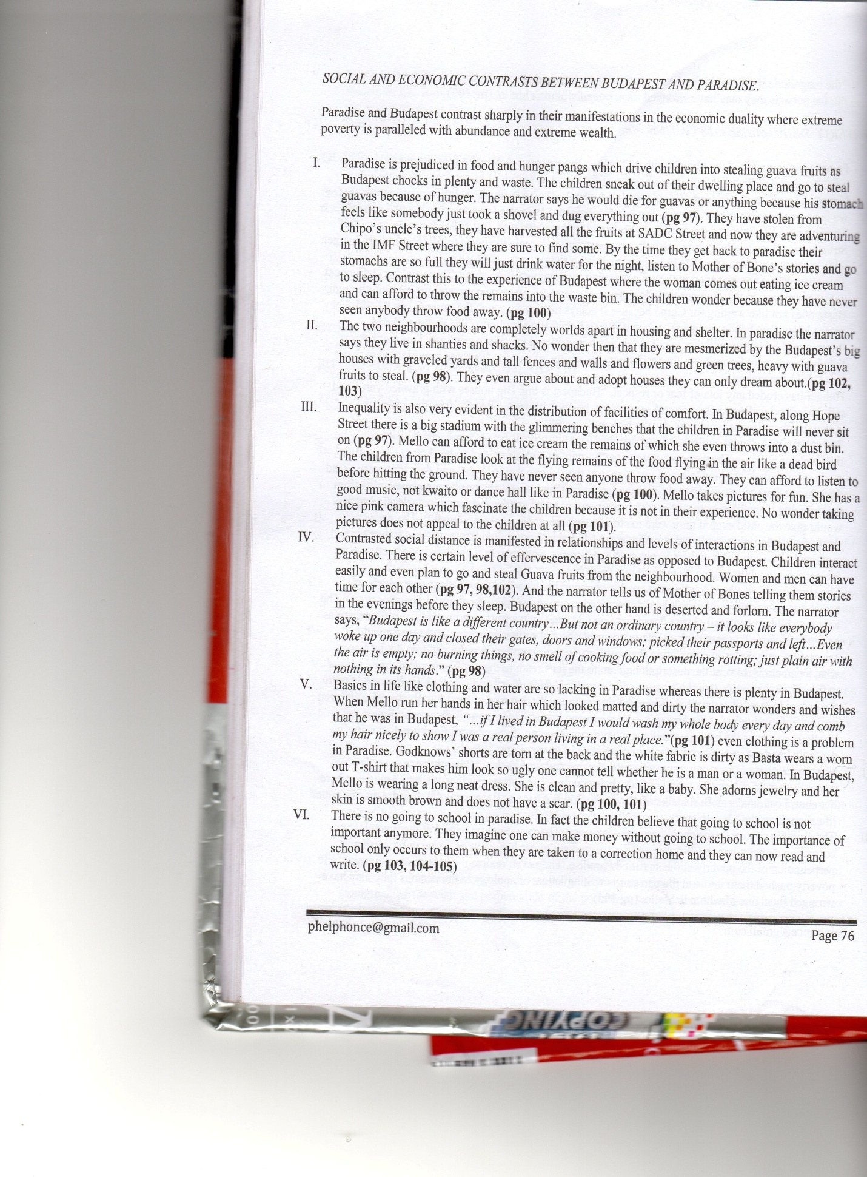

(b) the pearl
Introduction
- Juana advise Kino to throw away the pearl back to the see in vain.
- Juan Thomas advises Kino to sell the pearl locally instead of trying to go to the city.
- The merchants want to take the pearl at one thousand five hundred pesos which though small, Kino has never handled such amount of money before but he declines to let go.
- Juana asks her husband, Kino to stay in the cave but he opts to follow the trackers to his disadvantage
- Juana throws the pearl back into the sea.
Conclusion
In conclusion, it would be wise to follow advice given by sincere people to avoid regretting later
(c) INHERITANCE
King Lacuna abuses power and takes advantage of his position to exploit and oppress his subjects.
i) Unlawful sacking of workers. When Juda refuses, he faces the consequences by being sacked and evicted from the government house and his car is taken away. He is also forced to sell his farm to Lacuna’s cronies for peanuts and the wife is forced to work in the same farm to make ends meet.
ii) People are brutally murdered as Lakuna orders the killing of anyone who opposes his leadership.
He asks Juda Zen Melo to kill his brother Bengo who is an activist and a threat to his leadership. After many days of job searching, Juda gets a job as a machine operator in one of the silvers factories, but he is killed while operating the machine.
His greed for power makes him kill his father. It is ridiculous that he takes his father’s life so that he can get to power. He colludes with the imperialists to poison his father so that he is installed the new king.
iii) Embezzlement of funds from the public coffer. Lakuna embezzles funds meant for public use. His leadership is also satirized when he uses money meant for the country’s economic growth for his own selfish gains. He admits having bought himself an aircraft with loans advanced to him in the name of his subjects. It is ironical and unbelievable that he justifies that action by saying that he cannot be at the same level with his subjects and that he has to soar above them and their complaints and hatred.
iv) To make matters worse, he deposits the remaining money in his own accounts in the same banks that lend the money. His is the highest level of impunity and when the financiers force him to pay the loans, he swears that he will make his subjects pay for him so that he remains in power.
v) Corruption is evident in Kutula. Lacuna is also corrupt and practices nepotism. The subjects are aware that for you to get a job, you must know or be of the king’s tribesmen; otherwise, getting a job will remain elusive.

vi) Appointments are also made politically and those given the jobs must pledge their loyalty by giving a kick back and their positions will remain secure regardless of their performance. He collects 30 per cent of what the ministries get as a sign of their loyalty and in return their positions are guaranteed.
vii) People are forced to do certain things against their wish. Lakuna Kasoo forces everyone to attend the commemoration of his father, declaring it a public holiday.
After the celebrations, he forces Lulu to entertain him and he swears to make her his second wife, with or without her consent. When she refuses to toe the line, she is detained in his palace for days and denied the opportunity to attend her father's funeral.
viii) There is forceful eviction as Lacuna Kasoo also orders the eviction of the natives from the valley to create room for foreigners to occupy it and make it productive for their own selfish gain. All he cares about is the continued financial gains from the foreigners at the expense of the welfare his own people. He even orders drastic action to be taken against those who resist. By doing this, the citizens will be made homeless and they will be enslaved and they will live at the mercy of the foreigners who will benefit from the produce.
ix) There is imposition of labour laws that are oppressive to the people. Lacuna Kasoo conspires with the colonialists to cut down on employment and quadruple production of the exports by making them work long hours and on lower wages.

