FORM 2 ENGLISH EXAMINATIONS
END OF TERM 1 2022

INSTRUCTIONS TO CANDIDATES

Answer all questions in the spaces provided

 | QUESTIONS | MAXIMUM SCORE
 | Writing | 20mks
 | Cloze test | 10mks
 | Oral skills | 10mks
 | Comprehension | 20mks
 | Poetry | 10mks
 | Oral literature | 15mks
 | Grammar | 15mks
 | TOTAL SCORE | 100

SECTION A
Composition (20mks)
- Write a composition entitled ‘The effects of Modern Technology on the Youth Today.’

……………………………………………………………………………………………………………………………………………………………………………………………………………………………………
…………………………………………………………………………………………………………………………………………………………………………………………………………………………………………………………………………………………………………………………………………………………………………………………………………………………………………………………………………
…………………………………………………………………………………………………………………………………………………………………………………………………………………………………………………………………………………………………………………………………………………………………………………………………………………………………………………………………………
…………………………………………………………………………………………………………………………………………………………………………………………………………………………………………………………………………………………………………………………………………………………………………………………………………………………………………………………………………
………………………………………………………………………………………………………………………………………………………………………………………………………………………………………………………………………………………………………………………………………………………………………………………………………………………………………………………………………....
…………………………………………………………………………………………………………………………………………………………………………………………………………………………………………………………………………………………………………………………………………………………………………………………………………………………………………………………………………
…………………………………………………………………………………………………………………………………………………………………………………………………………………………………………………………………………………………………………………………………………………………………………………………………………………………………………………………………………
…………………………………………………………………………………………………………………………………………………………………………………………………………………………………………………………………………………………………………………………………………………………………………………………………………………………………………………………………………
…………………………………………………………………………………………………………………………………………………………………………………………………………………………………………………………………………………………………………………………………………………………………………………………………………………………………………………………………………
…………………………………………………………………………………………………………………………………………………………………………………………………………………………………………………………………………………………………………………………………………………………………………………………………………………………………………………………………………
……………………………………………………………………………………………………………………………………………………………………………………………………………………………………………………………………………………………………………………………………………………………………………………………………………………………………………………………………….
………………………………………………………………………………………………………………………………………………………………………………………………………………………………………………………………………………………………………………………………………………………………………………………………………………………………………………………………………..
…………………………………………………………………………………………………………………………………………………………………………………………………………………………………………………………………………………………………………………………………………………………………………………………………………………………………………………………………………
…………………………………………………………………………………………………………………………………………………………………………………………………………………………………………………………………………………………………………………………………………………………………………………………………………………………………………………………………………
…………………………………………………………………………………………………………………………………………………………………………………………………………………………………………………………………………………………………………………………………………………………………………………………………………………………………………………………………………
…………………………………………………………………………………………………………………………………………………………………………………………………………………………………………………………………………………………………………………………………………………………………………………………………………………………………………………………………………
…………………………………………………………………………………………………………………………………………………………………………………………………………………………………………………………………………………………………………………………………………………………………………………………………………………………………………………………………………
………………………………………………………………………………………………………………………………………………………………………………………………………………………………………………………………………………………………………………………………………………………
SECTION B
- Cloze Test (10mks)
Read the passage below and fill in each blank space with an appropriate word.

Most of us know 1__________________ our human rights are. We often demand that they be respected. This is as it should be. Unfortunately, some of us do 2__________realize that others have rights too. For instance, you have the right to 3________________ loud music. You have to consider if the music would be a nuisance to other people who want peace and 4________________ . What about the waywe dress? Should we dress to please ourselves? Should we dress to please others? Definitely, we come first. We must not dress in a way that 5________________the modesty of others. Also, many people defend the right to6 _______________. They know how harmful this is to our health. I, however, strongly believe that smoking should not be done I 7________________. Doing so denies others the right to enjoy a pollution free environment and 8____________ their health. Remember nobody is likely to 9_____________________ your rights if you do not respect those of others. Long live 10_______________ human rights.

SECTION C
- Oral Skills (10mks)
- For each of the following words provide a word pronounced in the same way. (5mks)
- bury __________________

- gate __________________

- cruise __________________

- taught __________________

- flecks __________________

- Identify the silent letters in the following words (5mks)
- Debut __________________

- Chassis __________________

- Crochet __________________

- rendezvous __________________

- poignant __________________
SECTION D
Comprehension (20mks)
Read the passage below and answer the questions that follow
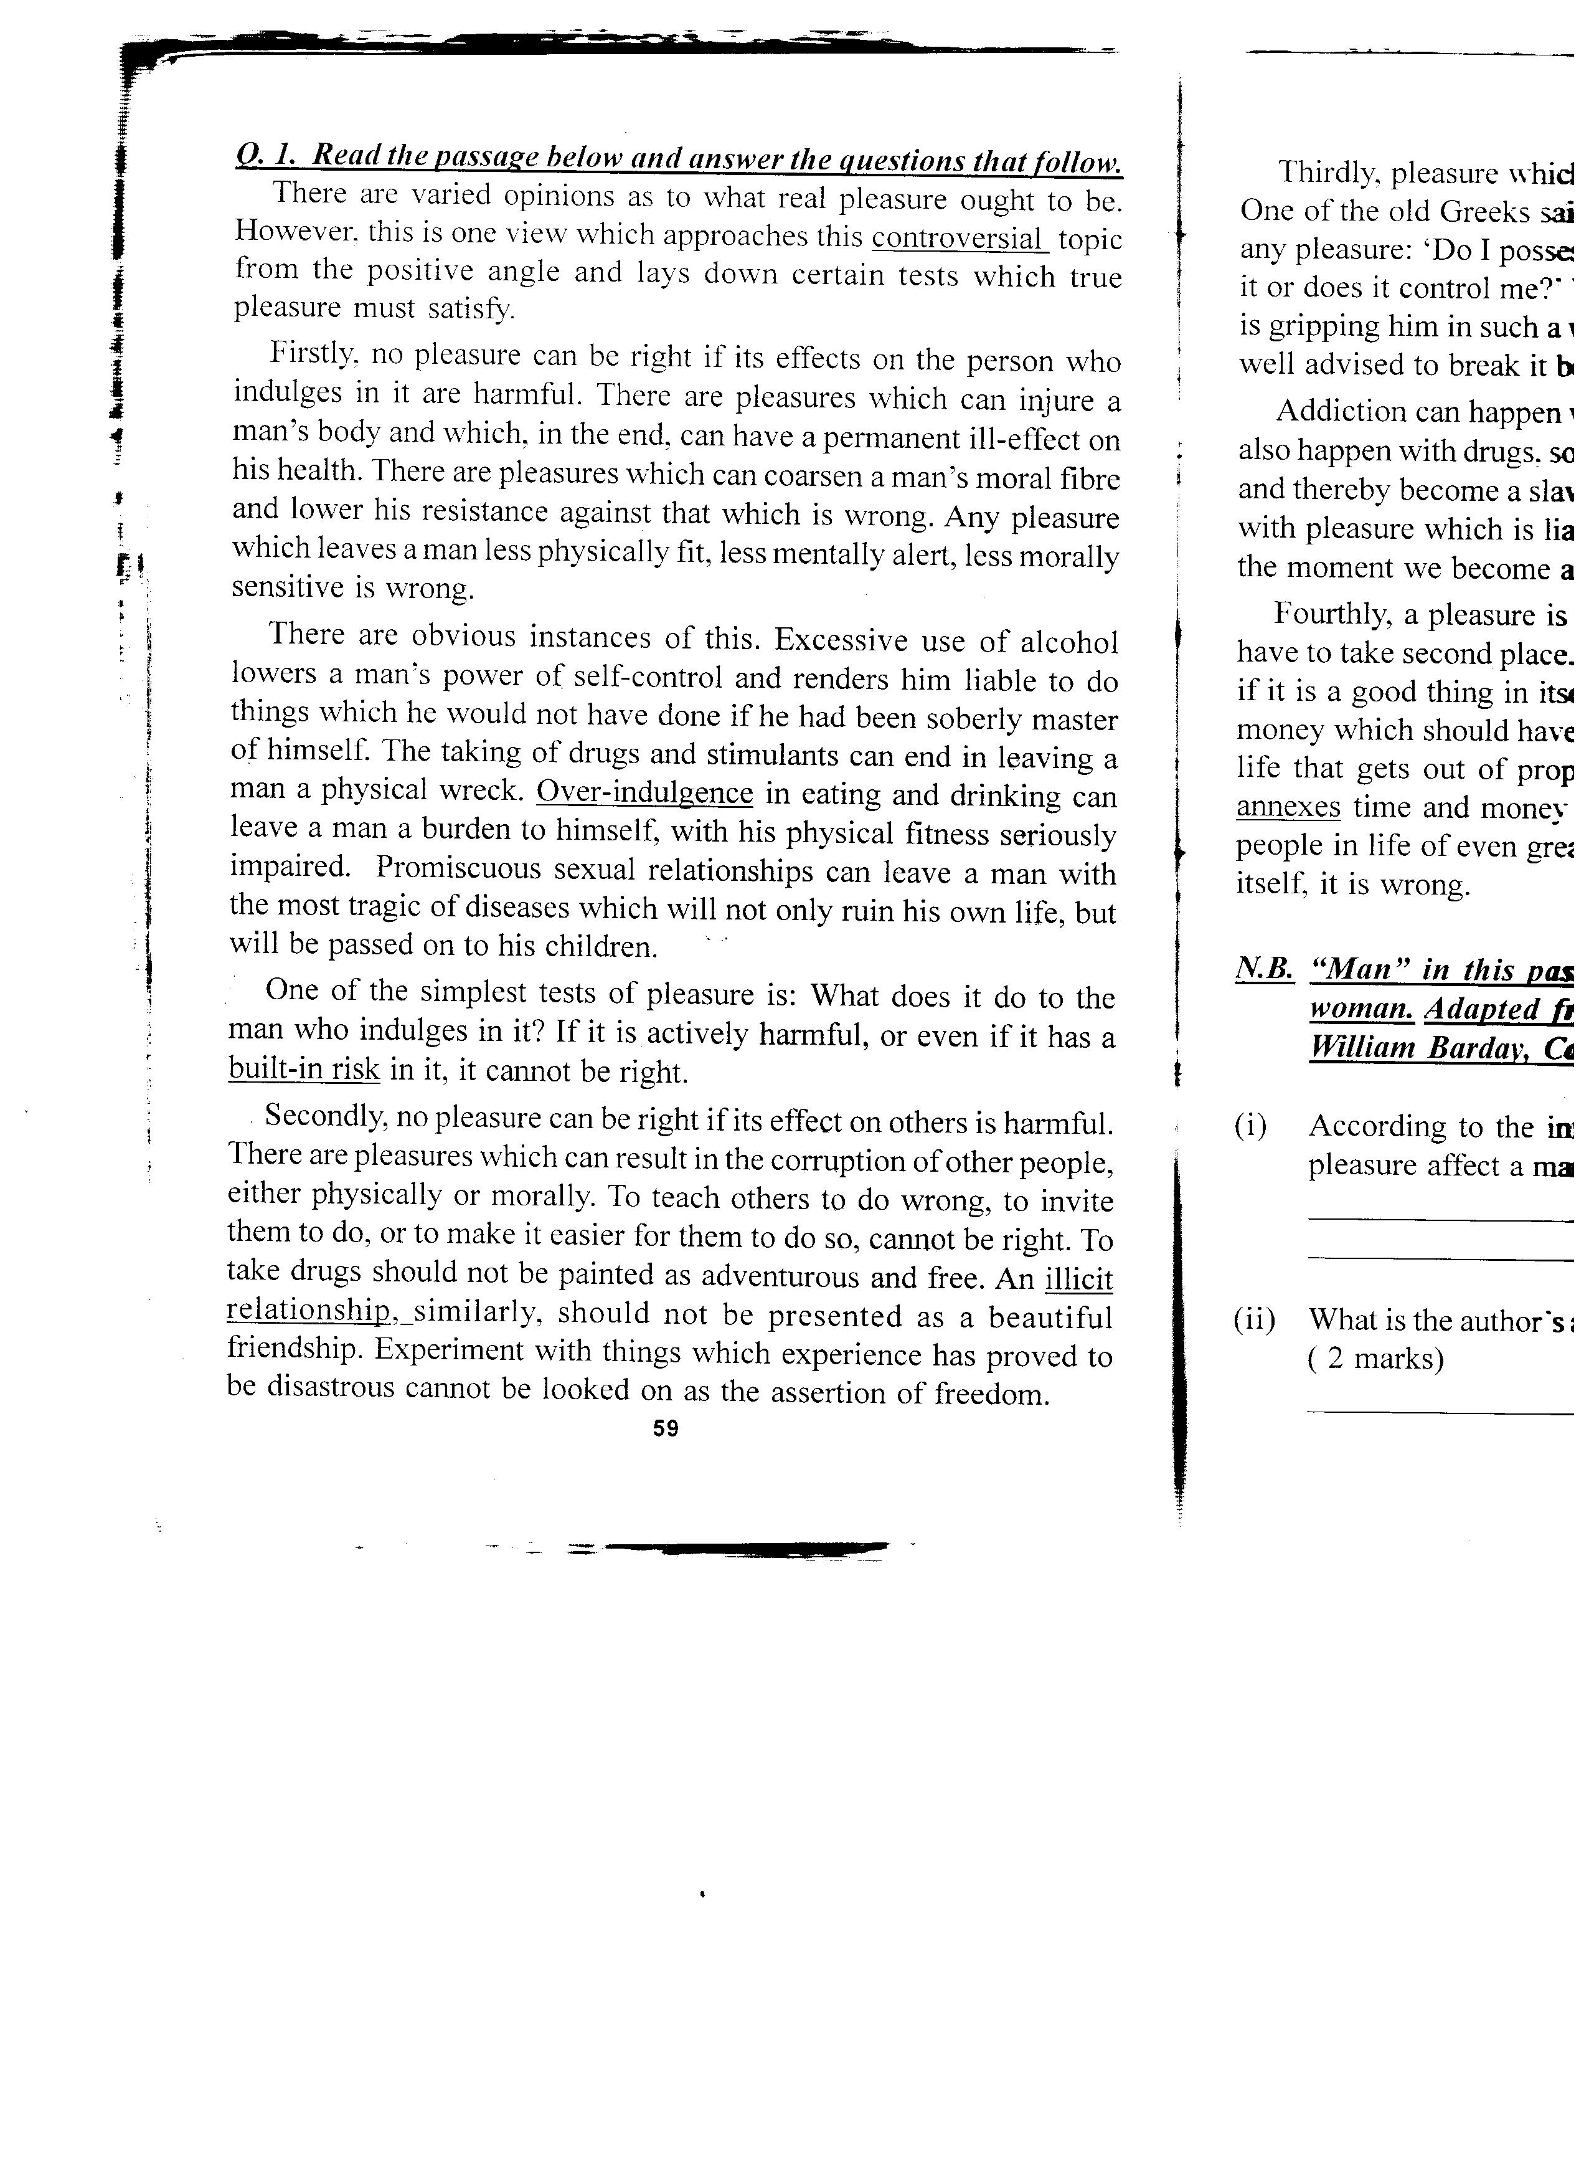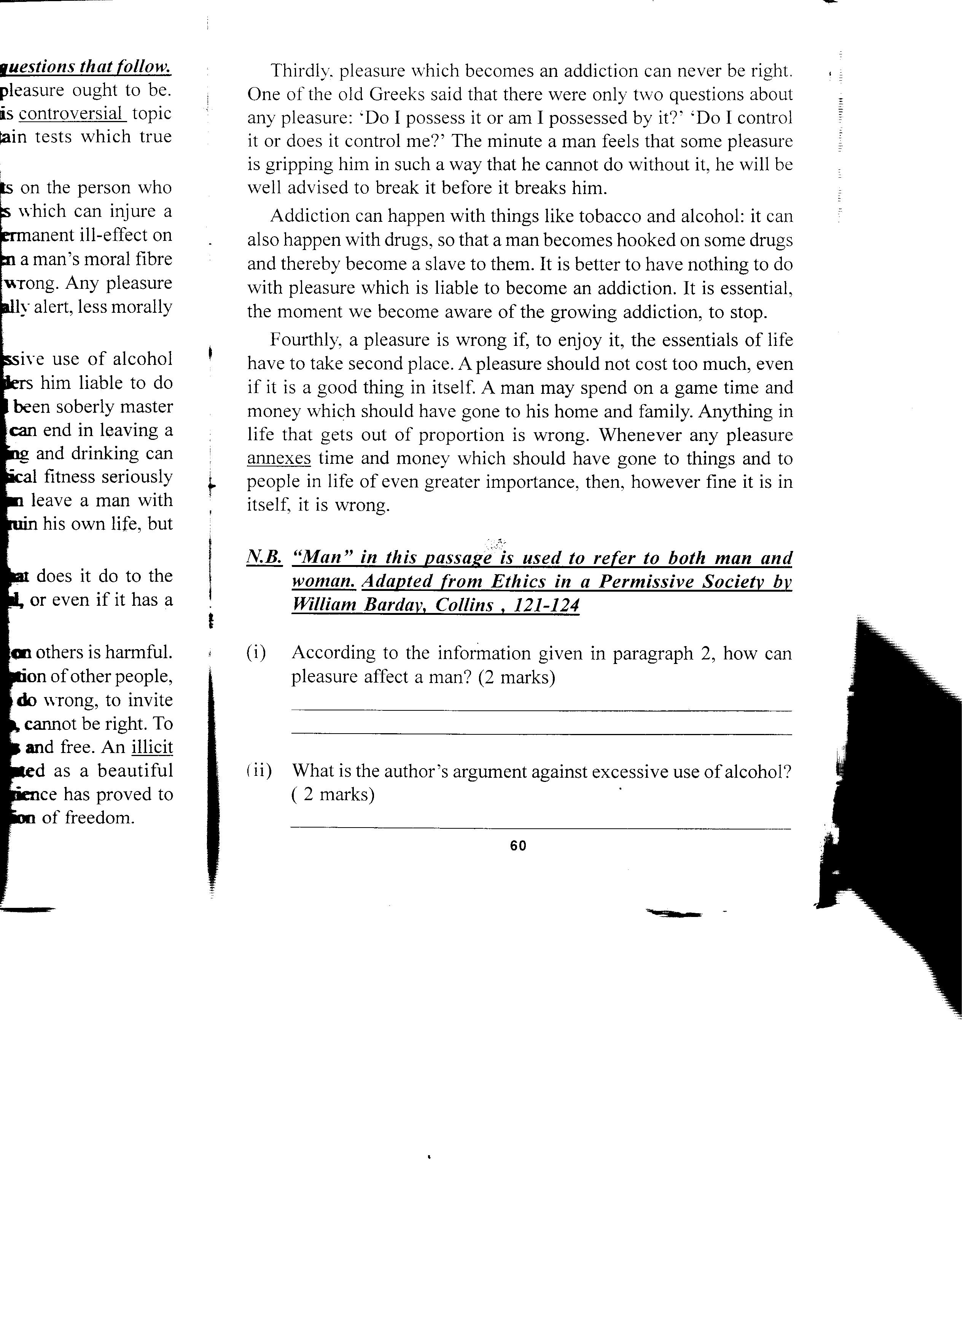
Questions
- According to the information given in paragraph 2, how can pleasure affect a man? (2mks)

- What is the author’s argument excessive use of alcohol? (2mks)

- Rewrite the following statements according to the instructions given after each.
- Addiction can happen with things like tobacco and alcohol: It can also happen with drugs (Begin Not only …………..) (2mks)

- A pleasure should not cost too much.
(Supply a question tag) (1mk)

- What is the author’s recommended test for pleasure? (2mks)

- How can pleasure become harmful to other people? (2mks)

- Pick any four adverbs of sequence used in the passage (2mks)

- State the author’s definition of true pleasure according to the last paragraph (2mks)

- Find out the meaning of the following words and phrases as used in the passage (5mks)
- Controversial

- Over-indulgence

- built –in-risk

- Illicit relationship

- annexes

SECTION E
Poetry (10mks) Read the poem below and answer the questions that follow

My Papa’s Waltz by Theodore Roethke
The whiskey on your breath
Could make a small boy dizzy;
But I hung on like death:
Such waltzing was not easy.

We romped until the pans
Slid from the kitchen shelf;
My mother’s countenance
Could not unfrown itself.

The hand that held may wrist
Was battered on one knuckle;
At every step you missed
My right ear scraped a buckle.

You beat time on my head
With a palm cake hard by dirt,
Then waltzed me off to bed
Still clinging to your shirt

Questions
- Say what happens in the poem (2mks)

- Who is the persona in the poem (1mks)

- What is the persona’s attitude towards Papa? (2mks)

- Identify figures of speech used in the poem (2mks)

- i) Identify and illustrate the rhyme scheme of the poem. (2mks)

ii) To what effect does the poet use rhyme in the poem (2mks)

SECTION F
Oral Literature (15mks)
Read the narrative below and answer the questions that follow:
This thing happened long time ago when people first appeared on earth. One day, the people were told that if they didn’t want to die, they should send chameleon with a fat piece of meat to take to the moon who would pass it to
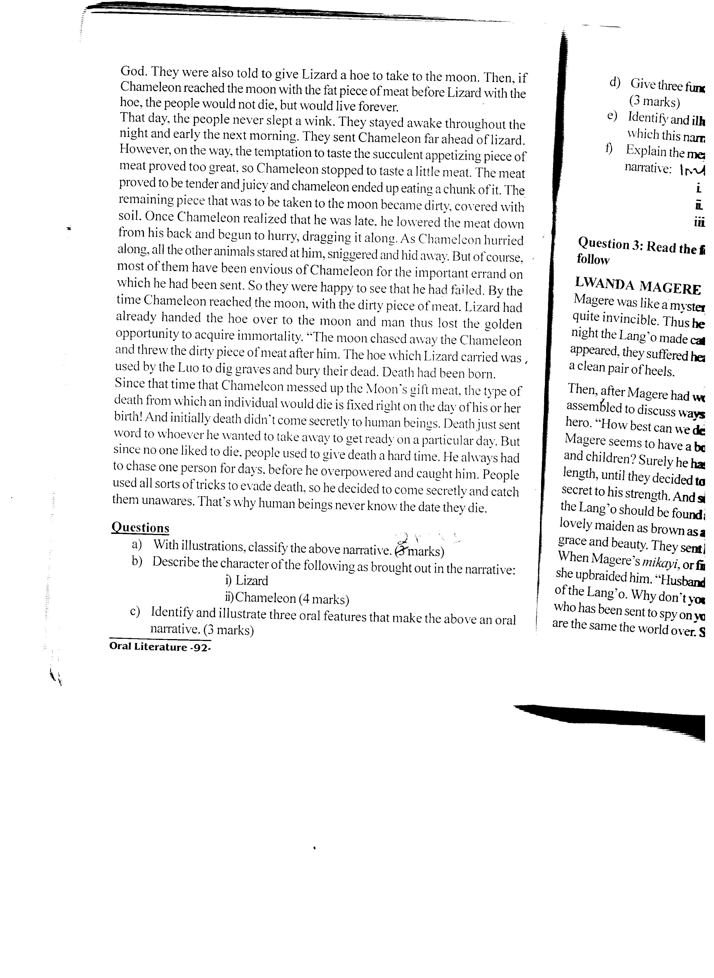

Questions
- With illustrations, classify the above narrative (2mks)

- Describe the character of the following as brought out in the narrative (4mks)
- Lizard

- Chameleon

- Identify and illustrate three oral features that make the above an oral narrative (3mks)

- Give three functions of the narrative that you have identified in (a) above (3mks)

- Identify and illustrate one economic activity of the community from which this narrative is drawn
(2mks)

- Explain the meanings of the following words and phrases as used in the narrative (1mks)
- Sniggered

- immortality

GRAMMAR (15MKS)
- Complete the following sentences by filing in the blanks with the correct proposition
(3mks)
- The traveller was robbed ___________________________ all his money
- Mike expressed his interest _____________________ modern art
- Juma’s parents no longer have much influence ___________________________ him.

- choose the correct pronoun to fill in the gap (3mks)

- She knows as well as _________________________ that food is not permitted in the dormitories (me, I )
- There’s not much difference between you and ______________________(he, him)
- I am taller than _______________ (she, her)

- Re-write the following sentences according to the instructions given after each
(4mks)
- He went to look for a window – cleaner since he could not do the work himself (rewrite to change the compound noun to plural)

- “I greeted the president this morning, “Esther exclaimed (change to indirect speech)

- If you have nothing more to contribute, we will stop the fundraising now (Begin: Unless…..)

- The favourite colour of Bosire is blue (correct the sentence where necessary)

- Rewrite the following sentences using the present perfect tense form of the verb in brackets
(3mks)
- The dresses I bought _________________________ (shrink)

- The market _______________________ (grow) and changed a great deal.

- The shirt ____________________ (cost) him a fortune

- Complete the following idiomatic expressions with the correct word. (2mks)
- Do not take him seriously, he is just pulling your ______________________

- Her behaviour is getting out of _____________________________.

