Name……………………………………………..……… Adm. No………..………………..

Date ………………………………………..................... Class: ……………………………..

FORM ONE
END OF TERM EXAMS
COMPUTER STUDIES

Instructions to candidates
Answer all questions.
All answers must be written in English.
Drawings to be drawn using a pencil.

for examiners use only
MAXIMUM SCORE | CANDIDATE’S SCORE
80

- a. Define the following terms as used in ICT. (4 Marks)
- Data.
………………………………………………………………………………………………………………………………………………………………………………………………………………………………………………
- Data processing
……………………………………………………………………………………………………………………………………………………………………………………………………………………………………………..
- Information
……………………………………………………………………………………………………………………………………………………………………………………………………………………………………………..
b. Clearly illustrate the two types of system units. (4 Marks)

- a. Give three characteristics of First Generation Computers. (3 Marks)
………………………………………………………………………………………………………………………………………………………………………………………………………………………………………………………………………………………………………………………………………………………………………………………………………………………………………………………………………………………………………………………………………………………………………………………………………………………
b. complete the table below about the mechanical tools that were considered to be the earliest computers. (5 Marks)
Tool | Application area | developer
Abacus | ……………………………. | ……………………………….
Napier Borne | ……………………………… | ……………………………..
Analytical Engine | ………………………………. | Charles Babbage

- State the technology used in each of the following computers. (5 Marks)
- 1st Generation Computers
………………………………………………………………………………………………………………………………………………………………………………………………………………………………………………
- 2nd Generation Computers
……………………………………………………………………………………………………………………………………………………………………………………………………………………………………………..
- 3rd Generation Computers
……………………………………………………………………………………………………………………………………………………………………………………………………………………………………………..
- 4th Generation Computers
……………………………………………………………………………………………………………………………………………………………………………………………………………………………………………..
- 5th Generation Computers
………………………………………………………………………………………………………………………………………………………………………………………………………………………………………………

- List the different types of computers when classified according to the following.
- According to physical size. (4 Marks)
………………………………………………………………………………………………………………………………………………………………………………………………………………………………………………
- According to functionality. (3 Marks)
………………………………………………………………………………………………………………………………………………………………………………………………………………………………………………
- According to purpose. (2 Marks)
………………………………………………………………………………………………………………………………………………………………………………………………………………………………………………
- Study the keyboard below and use it to answer questions. (5 marks)
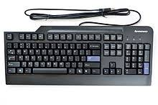
A
B
C
D
E

- Name the type of keys labeled
A: …………………………………………………………………………
B: ………………………………………………………………………….
C: …………………………………………………………………………
E: …………………………………………………………………………
F: …………………………………………………………………………
- Mention three types of keyboards that may be used to enter data into a computer. (3 Marks)
……………………………………………………………………………………………………………………………………………………………………………………………………………………………………………………………………………………………………………………………………………………………………………………………………………………………………………………………………………………………..

- Name the following types of mouse. (3 Marks)
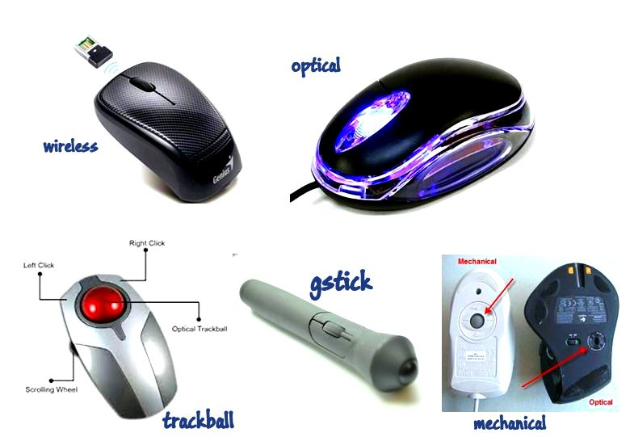

……………………………………………
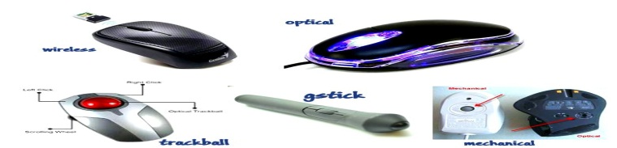

…………………………………………………

…………………………………………………
- Explain how computers are used in the following areas.
- Supermarket (2 Marks)
……………………………………………………………………………………………………………………………………………………………………………………………………………………………………………………………………………………………………………………………………………………………………………………………………………………………………………………………………………………………..
- Banks. (2 Marks)
……………………………………………………………………………………………………………………………………………………………………………………………………………………………………………………………………………………………………………………………………………………………………………………………………………………………………………………………………………………………..
- Explain the following components that make up a computer system. (6 Marks)
- Hardware
………………………………………………………………………………………………………………………………………………………………………………………………………………………………………………

- Software
………………………………………………………………………………………………………………………………………………………………………………………………………………………………………………
- Liveware
………………………………………………………………………………………………………………………………………………………………………………………………………………………………………………
- a. Define a computer laboratory. (2 Marks)
………………………………………………………………………………………………………………………………………………………………………………………………………………………………………………
b. give five factors to consider when preparing a computer laboratory. (4 Marks)
………………………………………………………………………………………………………………………………………………………………………………………………………………………………………………………………………………………………………………………………………………………………………………………………………………………………………………………………………………………………
………………………………………………………………………………………………………………………………………………………………………………………………………………………………………………
- Give five rules to observe when entering a computer laboratory. (5 Marks)
………………………………………………………………………………………………………………………………………………………………………………………………………………………………………………
………………………………………………………………………………………………………………………………………………………………………………………………………………………………………………………………………………………………………………………………………………………………………………………………………………………………………………………………………………………………
………………………………………………………………………………………………………………………
- Give three causes of fire in the computer laboratory. (3 Marks)
………………………………………………………………………………………………………………………………………………………………………………………………………………………………………………………………………………………………………………………………………………………………………………………………………………………………………………………………………………………………
- Why are powder and liquid fire extinguishers discouraged in the computer laboratory?
(2 Marks)
………………………………………………………………………………………………………………………………………………………………………………………………………………………………………………
………………………………………………………………………………………………………………………
- Give three precautions that prevent dust from entering the computer laboratory and damaging the computers. (3 Marks)
………………………………………………………………………………………………………………………………………………………………………………………………………………………………………………
………………………………………………………………………………………………………………………………………………………………………………………………………………………………………………
- Write the following abbreviations in full. (3 Marks)
- POST: ………………………………………………………………………..
- BIOS: …………………………………………………………………………
- UPS: …………………………………………………………………………..
- State three functions of a Uninterruptable Power Supply in a computer laboratory. (4 Marks)
………………………………………………………………………………………………………………………………………………………………………………………………………………………………………………
………………………………………………………………………………………………………………………………………………………………………………………………………………………………………………
- What is booting? (1 Mark)
………………………………………………………………………………………………………………………………………………………………………………………………………………………………………………
- Give two types of booting. (2 Marks)
………………………………………………………………………………………………………………………………………………………………………………………………………………………………………………

THIS IS THE LAST PRINTED PAGE.
GOOD LUCK

