NAME: ………………………………………………. ADM. NO: ……………CLASS…………….

END OF TERM 2, 2021
232 PHYSICS
FORM 1
TIME: 1 HOUR 45 MINS

INSTRUCTIONS TO CANDIDATES:
- Write your name, admission number and class in the spaces provided above.
- The paper consist of two Sections A and B. Answer all the questions in the spaces provided.
- Mathematical tables may be used.

FOR EXAMINER’S USE ONLY:
SECTION | MAXIMUM SCORE | CANDIDATE’S SCORE
A | 40
B | 30

TOTAL SCORE

SECTION A - (40 MARKS)

1. Define the term physics. (1 mark)

2. State three career opportunities related to physics. (3 marks)

3. The table below shows some basic quantities and their SI units. Complete the table to show the missing entries. (2 marks)

 | Quantity | S.I unit | Symbols
1 |  | Candela
2 | Amount of substances

4. A stone of mass, 40g was completely immersed in a liquid. The levels of the liquids are shown
in the figure.
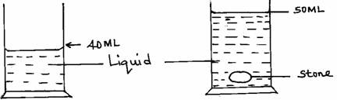

Determine the density of the stone in SI unit. (2 marks)

5. (a) One of the factors that affect surface tension is temperature of the liquid. State one other
factor. (1 mark)

- Use surface molecules A, B, C and inner molecule D shown below, to explain why surface
of a liquid is under tension. (2 marks)
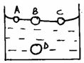

6. Name two forces that determine the shape of a liquid drop on a solid surface. (2 marks)

7. 1800cm³ of fresh water of density 1000kg/m³ is mixed with 2200cm³ of sea water of density 1025kg/m³. Calculate the density of the mixture (4mks)

8. State the reason why it may not be possible to suck a liquid in to your mouth using a drinking straw
in the surface of the moon. (1 mark)

9. In building construction, beans made of concrete are reinforced with steel. Explain. (2 marks)

10. When a liquid is heated in a glass flask, its level first falls and then rises. Explain this observation.
(2 marks)

11. Name the thermometric liquid that is most suitable to use in very cold places. (1 mark)

12. (a) State one factor which makes gases compressible. (1 mark)

(b) The figure below shows a set up used to demonstrate Brownian motion in gases.

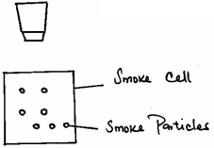

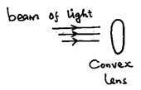

State the role of the; (3 marks)
- Convex lens.

- Microscope.

(iii) Beam of light.

(c) Define the term diffusion. (1 mark)

13. Highlight two factors which shows that heat from the sun does reach the earth surface by convection.

(2 marks)

14. The figure below shows some wax at the end of a copper rod.
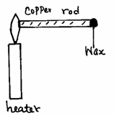

State three factors that affect the rate at which the wax melts. (3 marks)

15. (a) Define force and give its S.I units (2mks)

(b) State three effects of force on an object (3mks)

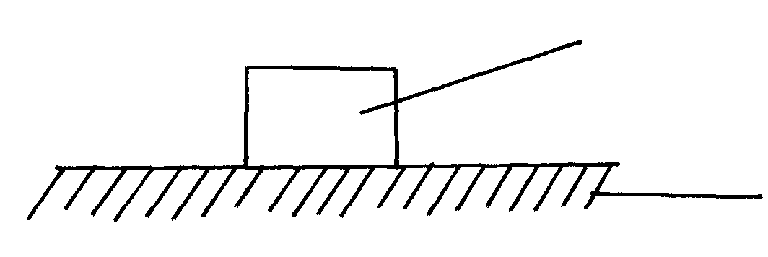
(c) Name and show forces acting on a box placed on a table. (2mks)
Box
Table surface

SECTION B - (30 MARKS)

- A ream of foolscaps containing 500 papers has a thickness of 50mm and a mass of 2kg. if it has a width of 200mm and a length of 300mm, find;
- The thickness of one sheet of paper (2 marks)

- The mass of one sheet of paper (2 marks)

- The volume of one sheet of paper (3 marks)

- The density of the paper. (3 marks)

8
17. (a) Two identical aluminium rods shown in the figure below are heated by the same Bunsen
burner. One rests on a metal block and the other on a wooden block.
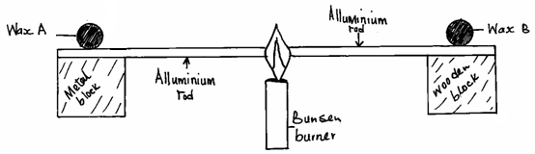

State with a reason which wax is likely to melt. (2 marks)

- Two identical cans A and B were each filled with hot water at the same temperature and
covered with an air tight lid as shown below.
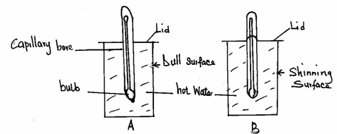

Given that the outer surface of can A is dull while that of B is shiny, state with a reason
which thermometer would show lower temperature after ten minutes. (2 marks)

(c) State the purpose of the following features of a thermometer. (3 marks)
(i) Narrow capillary bore.

(ii) Thin bulb.

(iii) Thick glass stem.

- State three properties of mercury that makes it a good thermometric liquid. (3 marks)

18. States the reason why it is not correct to quote the weight of solid objects in kilograms. (1 mk)

19. Wasike found that the width of his desk was approximately 10 palm-lengths. If his palm was 15.0cm long,
what was the width of his desk in metres? (3 mks)

20. Describe how to estimate the height of a tree using a rod of about 2m long and a tape measure.(3 mks)

21. The mass of an empty density bottle is 20g its mass when filled with water is 40.0g and 50.0 when filled
with liquid x. Calculate the density of liquid X if the density of water is 1000kgm⁻³. (3 mks)

