NAME ----------------------------------------------------------------------- INDEX NO---------------------------------------
DATE_________________________ CANDIATES SIGNATURE ____________

232/1
PHYSICS
PAPER 1
(THEORY)

INSTRUCTIONS TO CANDIDATES
- Write your name and index number in the spaces provided
- This paper consist of two section A and B
- Answer all questions in section A and B in the spaces provided
- All working must be clearly shown in the spaces provided in this booklet.
- Non- Programmable silent electronic calculators and KNEC mathematical tables may be used
SECTION | QUESTION | MAXIMUM SCORE | CANDITATES SCORE
A | 1-12 | 25
B | 13 | 11
 | 14 | 8
 | 15 | 11
 | 16 | 9
 | 17 | 13
 | 18 | 3
TOTAL SCORE |  | 80

This paper consist of 9 printed pages candidates should check the questions paper to ascertain that all the pages are printed as indicated and that no questions are missing

SECTION A 25MKS
Answer all the questions in this section in the spaces provided.
- Figure 1 shows a micrometers screw gauge with negative zero error of 0.02mm uses to measure the diameter of a ball bearing
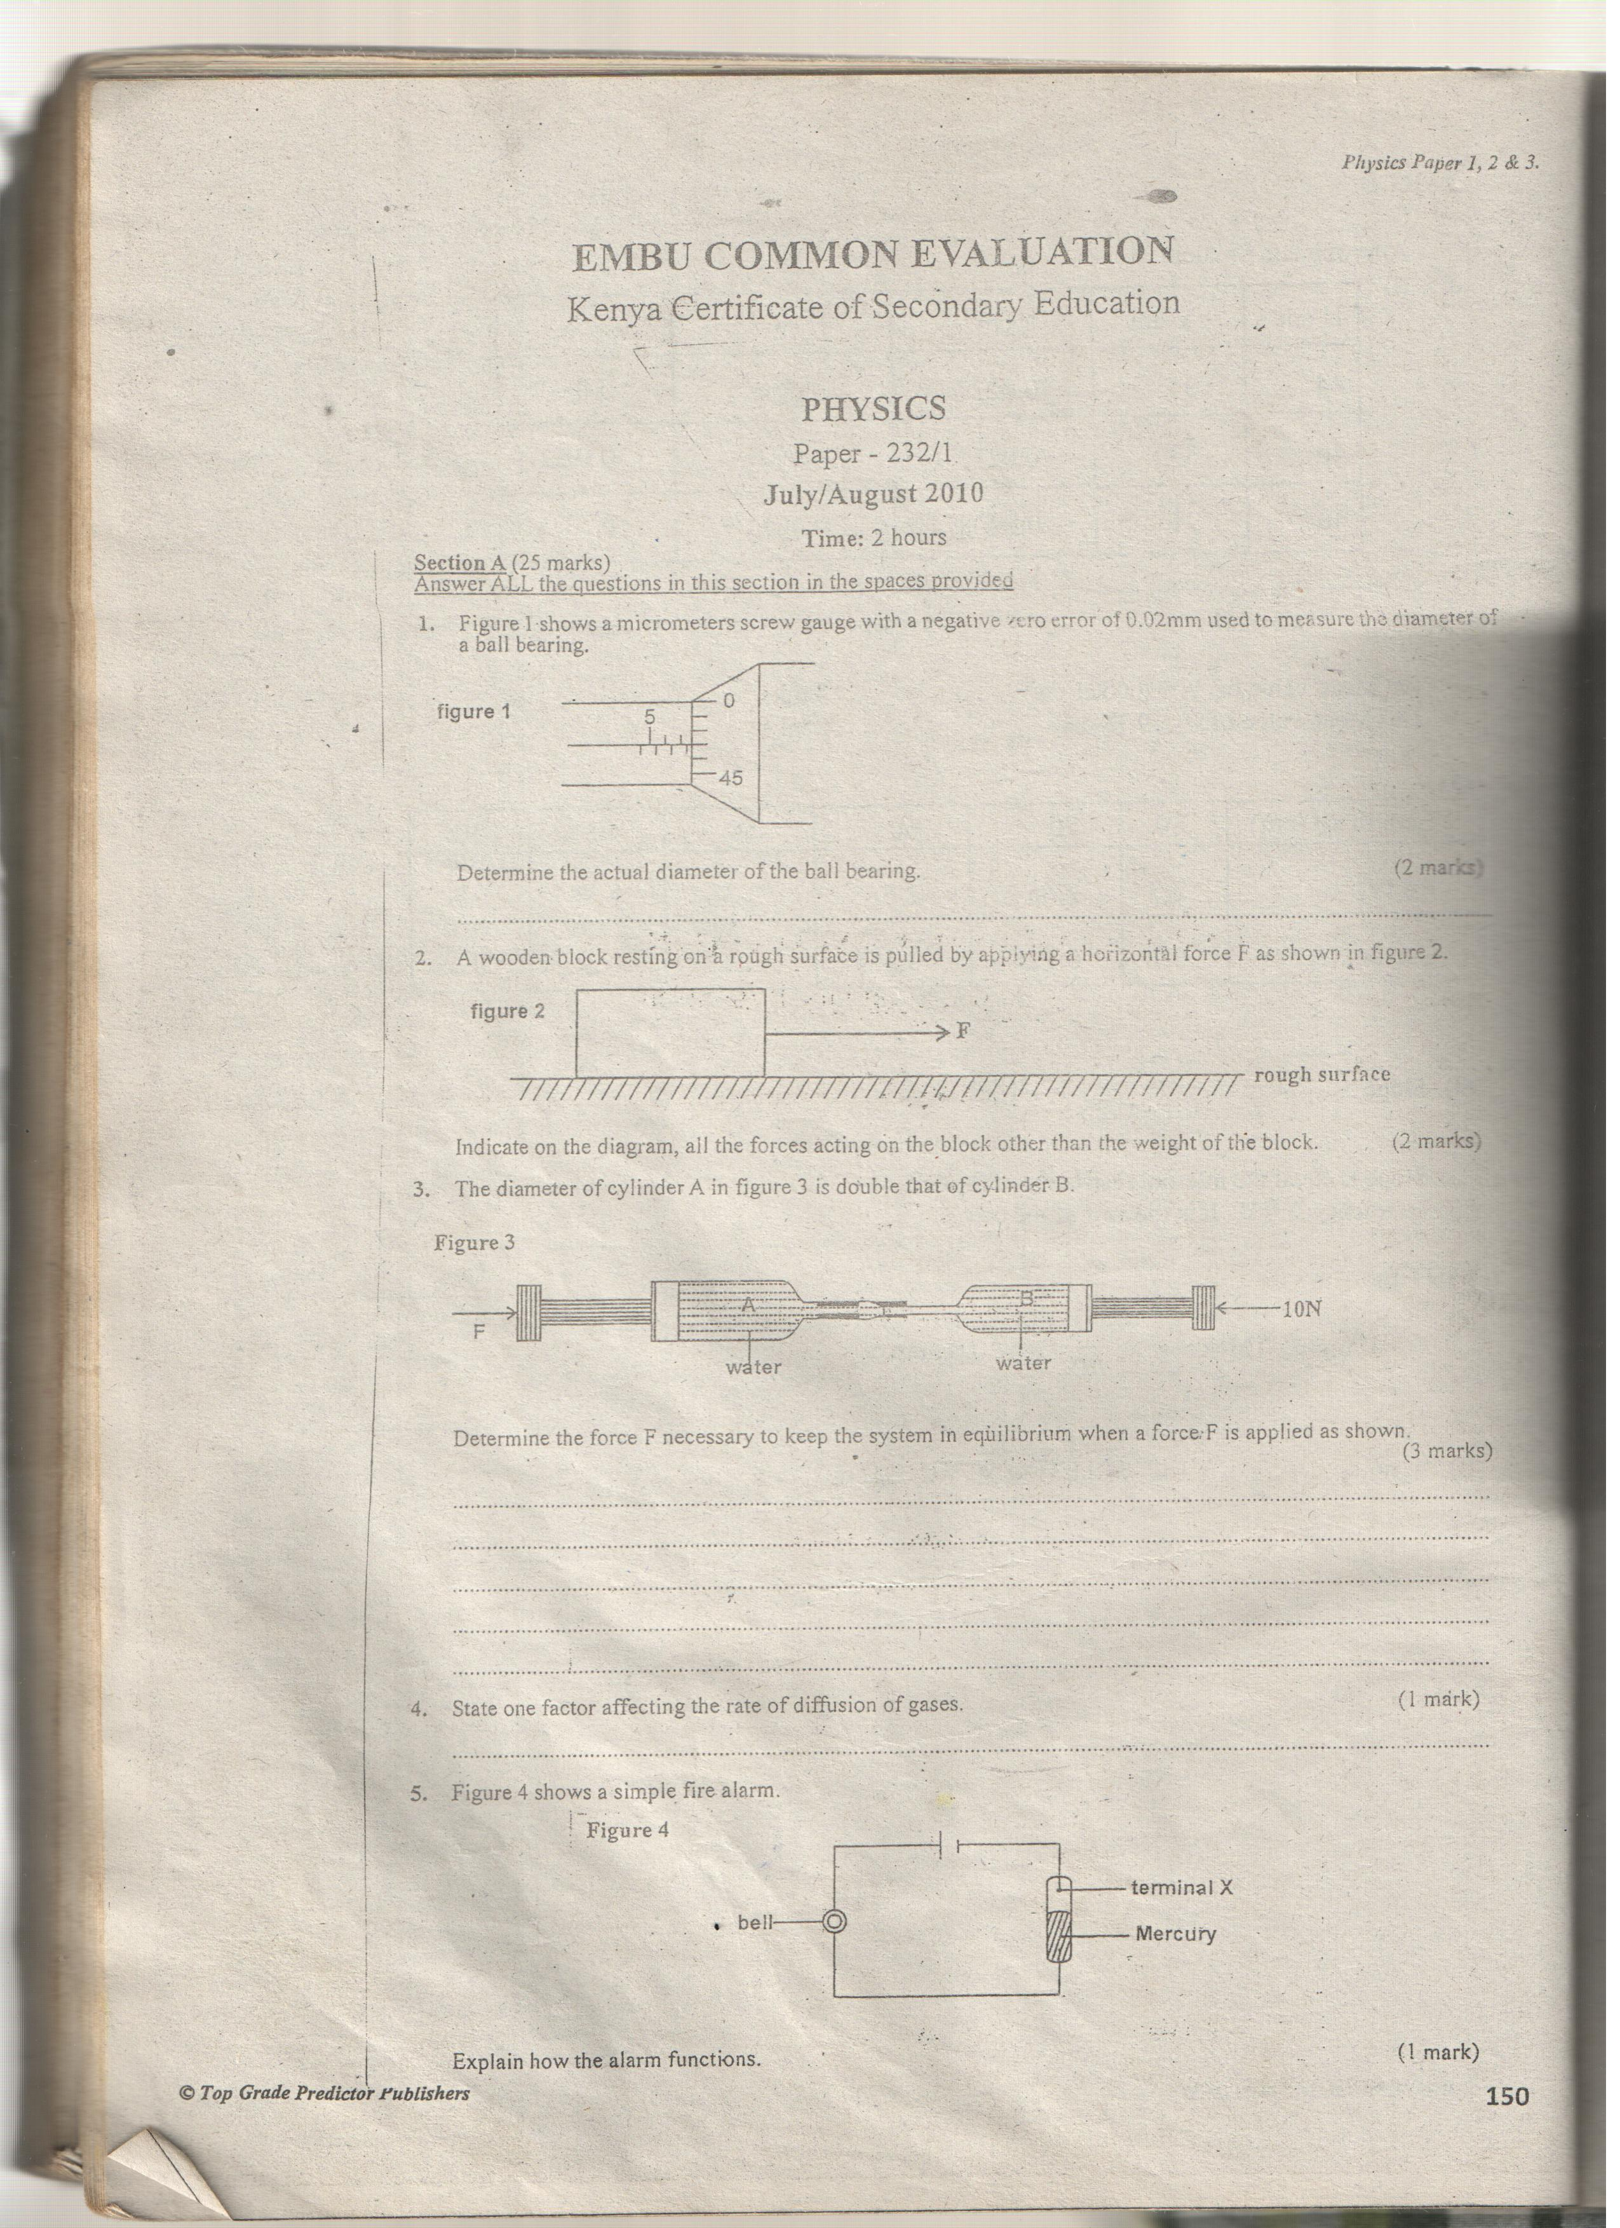
Determine the actual diameter of the ball bearing (2mks)

- A wooden block resting on a rough surface is pulled by applying a horizontal force F as shown in figure 2
Indicate on the diagram, all the forces acting o the block other than the weight of the block (2mks)

- The diameter of cylinder A in figure 3 is double that of cylinder B
Determine the force F necessary to keep the system in equilibrium when a force F is applied as shown (3mks)

- State one factor affecting the rate of diffusion of gases (1mk)

- Figure 4 shows a simple fire alarm

Explain how the alarm functions (1mk)

- Figure 5 shows two identical containers A and B containing equal amounts of water an identical ice blocks

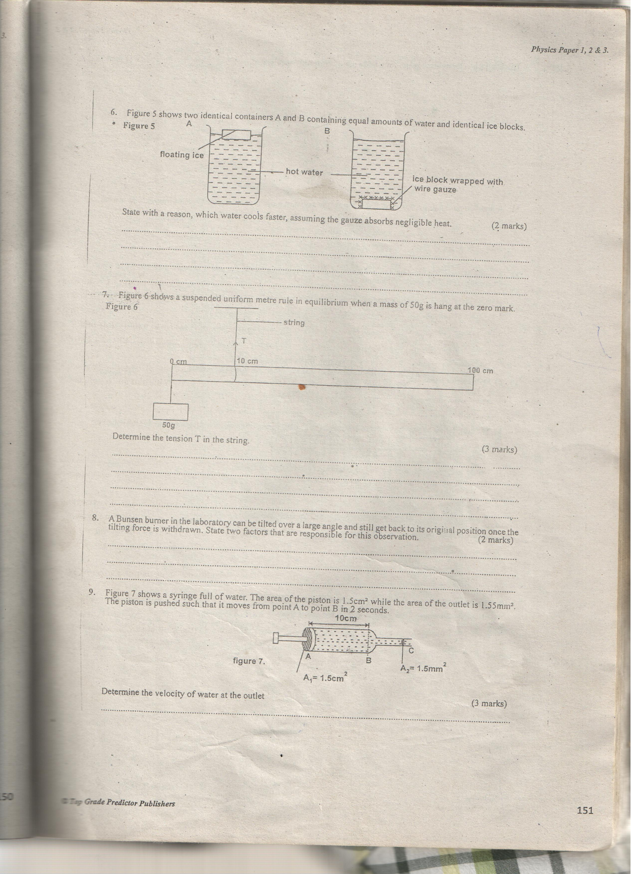

State with reason, which water cools faster, assuming the gauze absorbs negligible heat (2mks)

- Figure 6 shows a suspended uniform meter rule in equilibrium when a mass of 50g is hang at the zero mark
Determine the tension T in the string (3mks)

- A Bunsen burner in the laboratory can be tilted over a large angle and still get back to its original position once the tilting force is withdrawn. State two factors that are responsible for this observation (2mks)

- Figure 7show a syringe full of water. The area of the piston is 1.5cm3 while the area of the outlet is 1.55mm2 The piston is pushed such that it moves from point B in 2 seconds

Determine the velocity of water at the outlet (3mks)

- Sketch a velocity time graph for a body that is uniformly accelerated (1mk)

- A high jumper loads on saw dust. Explain how the saw dust helps in reducing the force of impact (2mks)

- A bullet of mass 20g moving with a velocity of 30m/s penetrates a sand bag and is brought to rest in 0.05s. Find the average retarding force of the sand (3mks)

SECTION B 55 MKS

- a) State Hooke’s law for a spiral spring (1mk)

b) In an experiment, a spiral spring was hung vertically from a stand and various weights attached in turn to its lower end. The extension of the spring for the various weight was noted. The results were recorded as shown in the following table.
Load(N) | 0 | 0.2 | 0.4 | 0.6 | 0.8 | 1.0 | 1.1
Extension (cm) | 0 | 0.95 | 1.9 | 2.9 | 3.9 | 5.5 | 7.25

- Plot the graph of load (y-axis) against the extension of the spring (5mks)
- From the graph, determine the elastic limit of the spring (1mk)

- From the graph, determine the spring constant within Hooke’s law (4mks)

- State what is meant by streamline flow. (1mk)

b) The figure below shows the cross section of an aeroplane wing (aerofoil), with the aeroplane moving in the direction shown by the arrow.
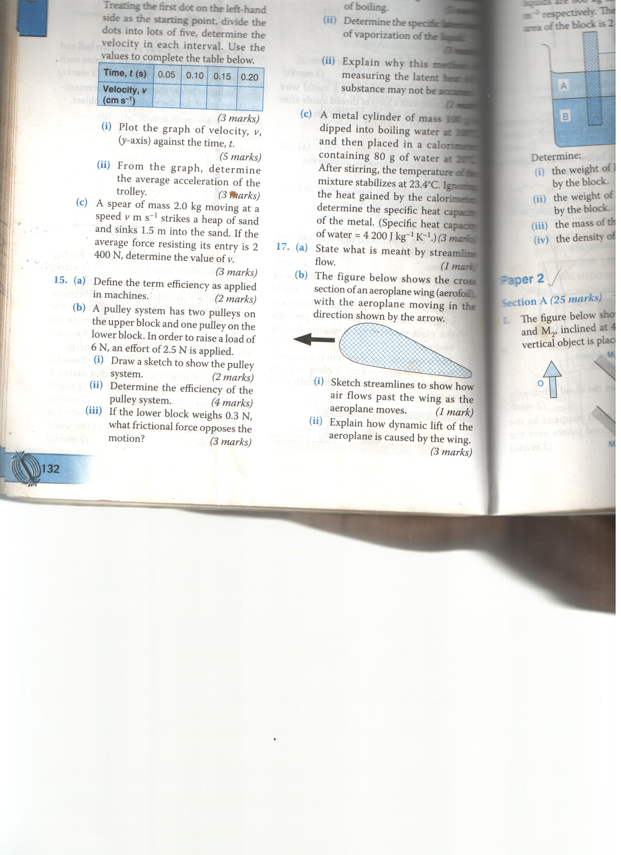

- Sketch streamlines to show how air flow fast the with as the aeroplane moves (1mk)

- Explain how dynamic lift of the aeroplane is caused by the wing. (3mks)

c) A water pipe of diameter 5.2cm is connected to another pipe of diameter 1.3cm. The speed of the water in the smaller pipe is 3ms-1. What is the speed of the water in the larger pipe? (3mks)

- a) Explain how a person is able to draw milk from a glass using a straw (2mks)

b) The following diagram shows a simplified hydraulic braking system of a car.
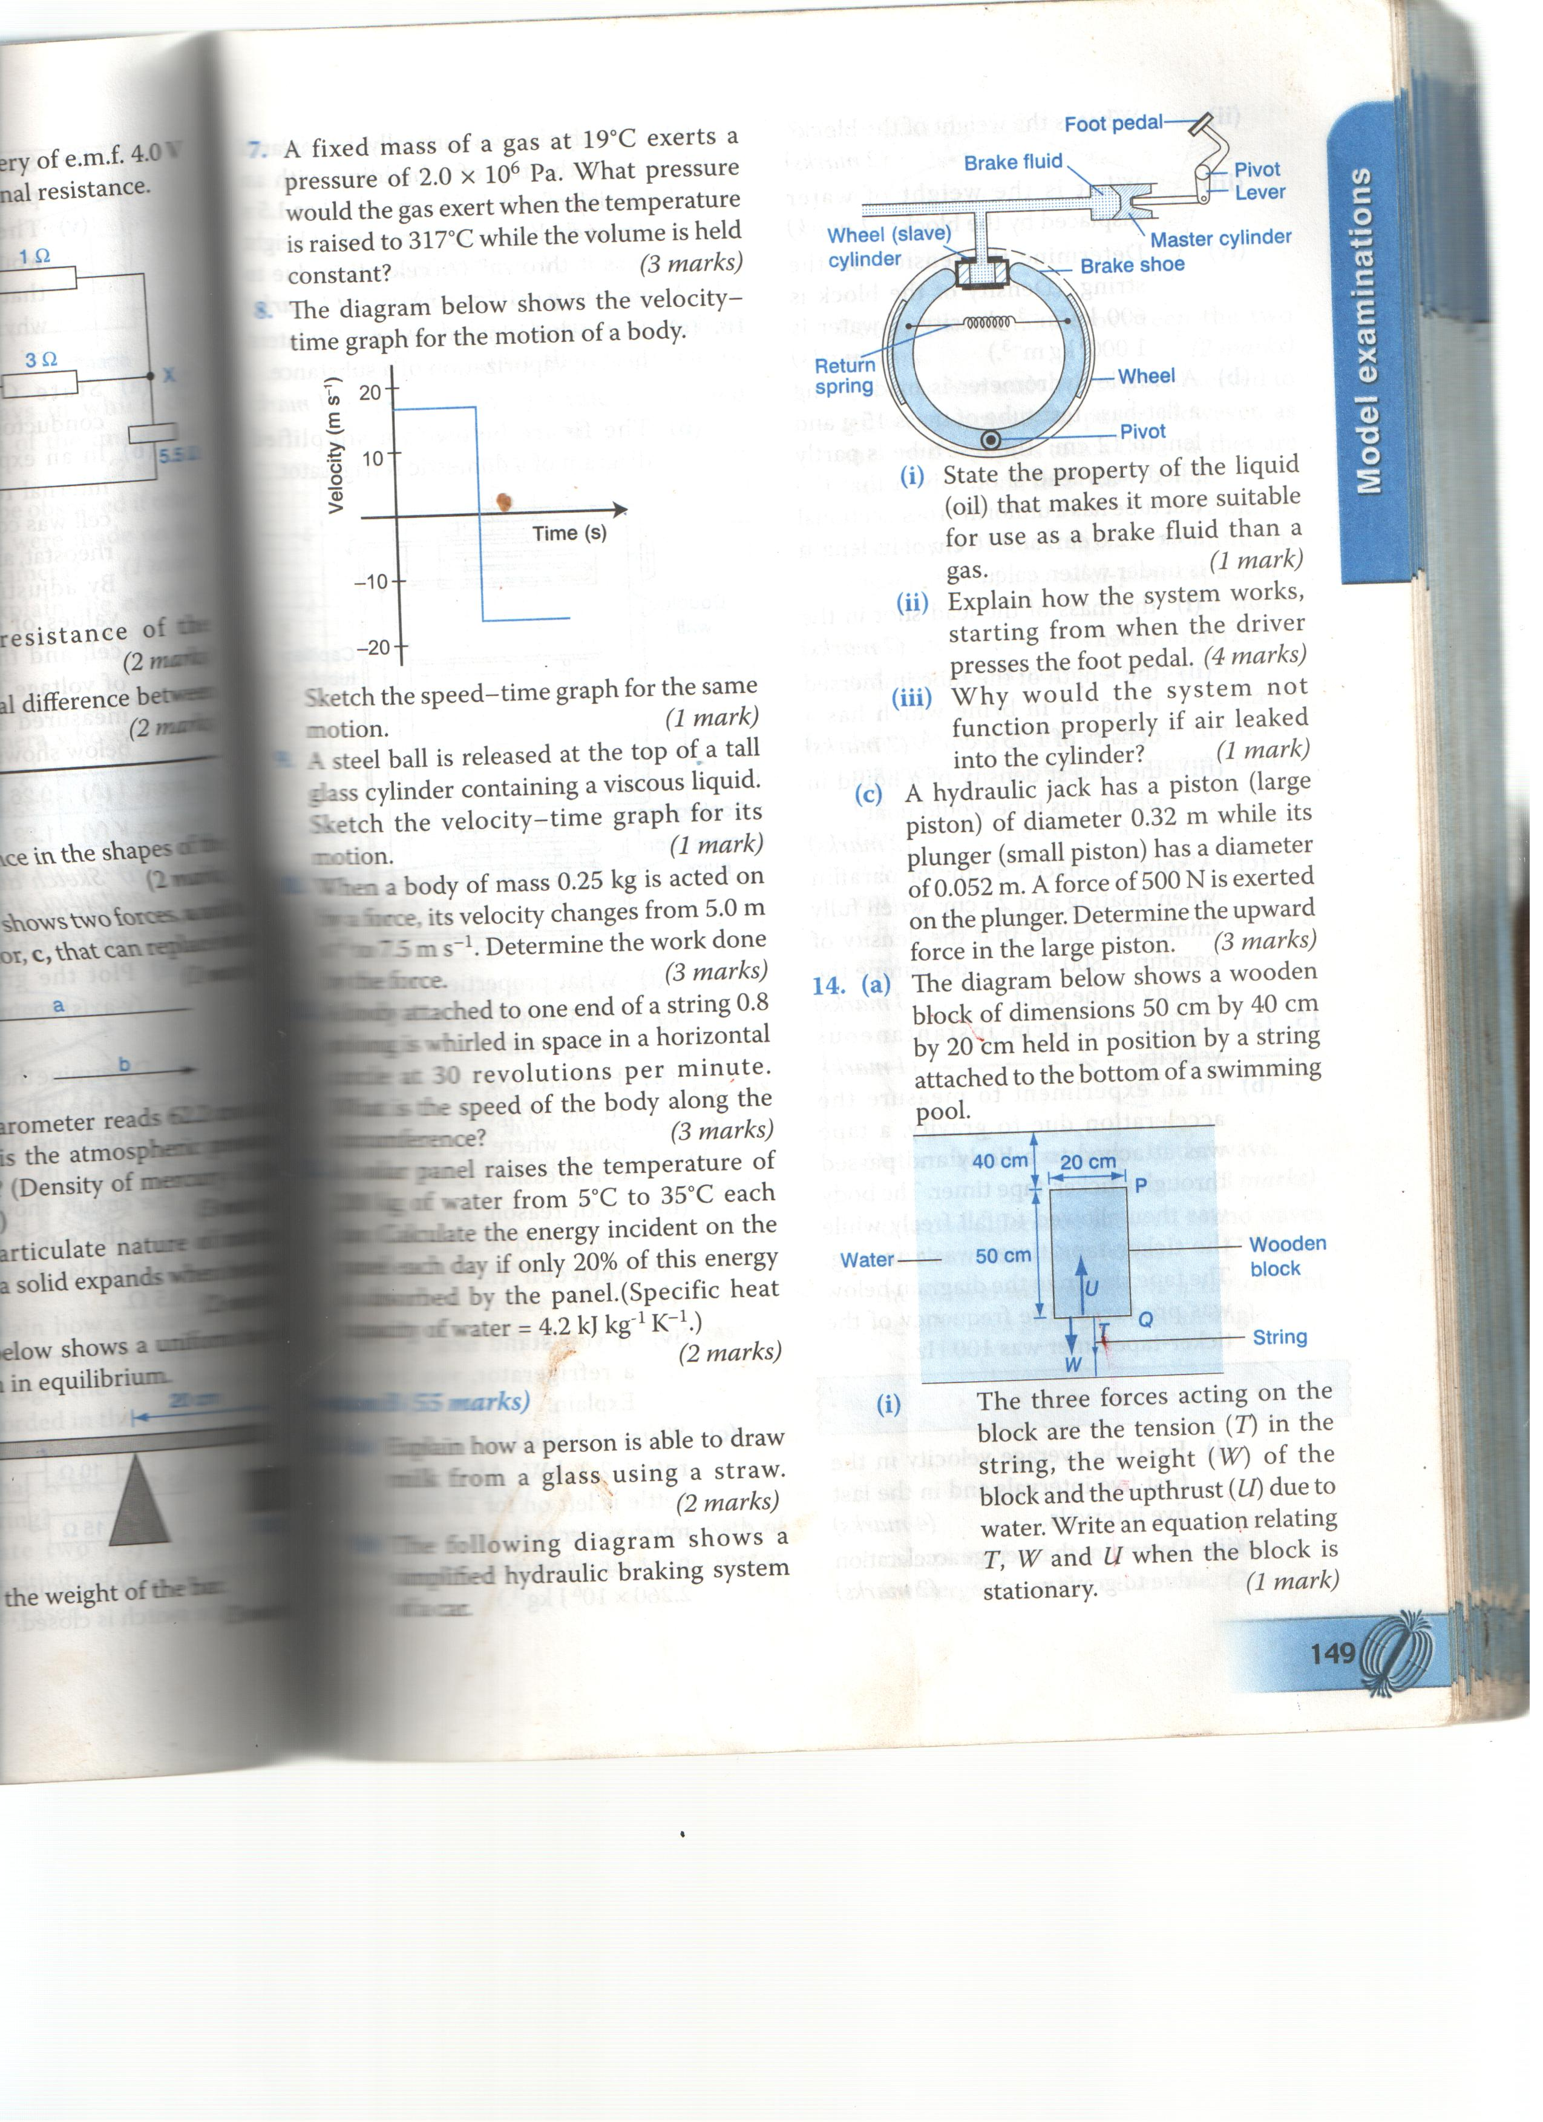

- State the property of the liquid (oil) that makes it more suitable for use as a brake fluid than a gas (1mk)

- Explain how the system works, starting from when the driver presses the foot pedal (4mks)

- Why would the system not function properly if air leak into the cylinder? (1mk)

- a) In an experiment to demonstrate Brownian motion, smoke was placed in an air cell and observed under a microscope, Smoke particles were observed to move randomly in the cell.
- Explain the observation (1mk)

- Give a reason for those of smoke in this experiment (1mk)

- What would be the most likely observation if the temperature in the smoke cell was raised? (1mk)

b) An oil drop of average diameter 0.7mm spreads out into a circular patch of diameter 75cm on the surface of water in trough.
- Calculate the average thickness of a molecule of oil (4mks)

- State two assumptions made in (i) above when calculating the thickness of the oil molecule (2mks)

- The figure below shows path of ray of yellow light through a glass prism. The speed of yellow light in the prism is 1.88 x 108m/s.
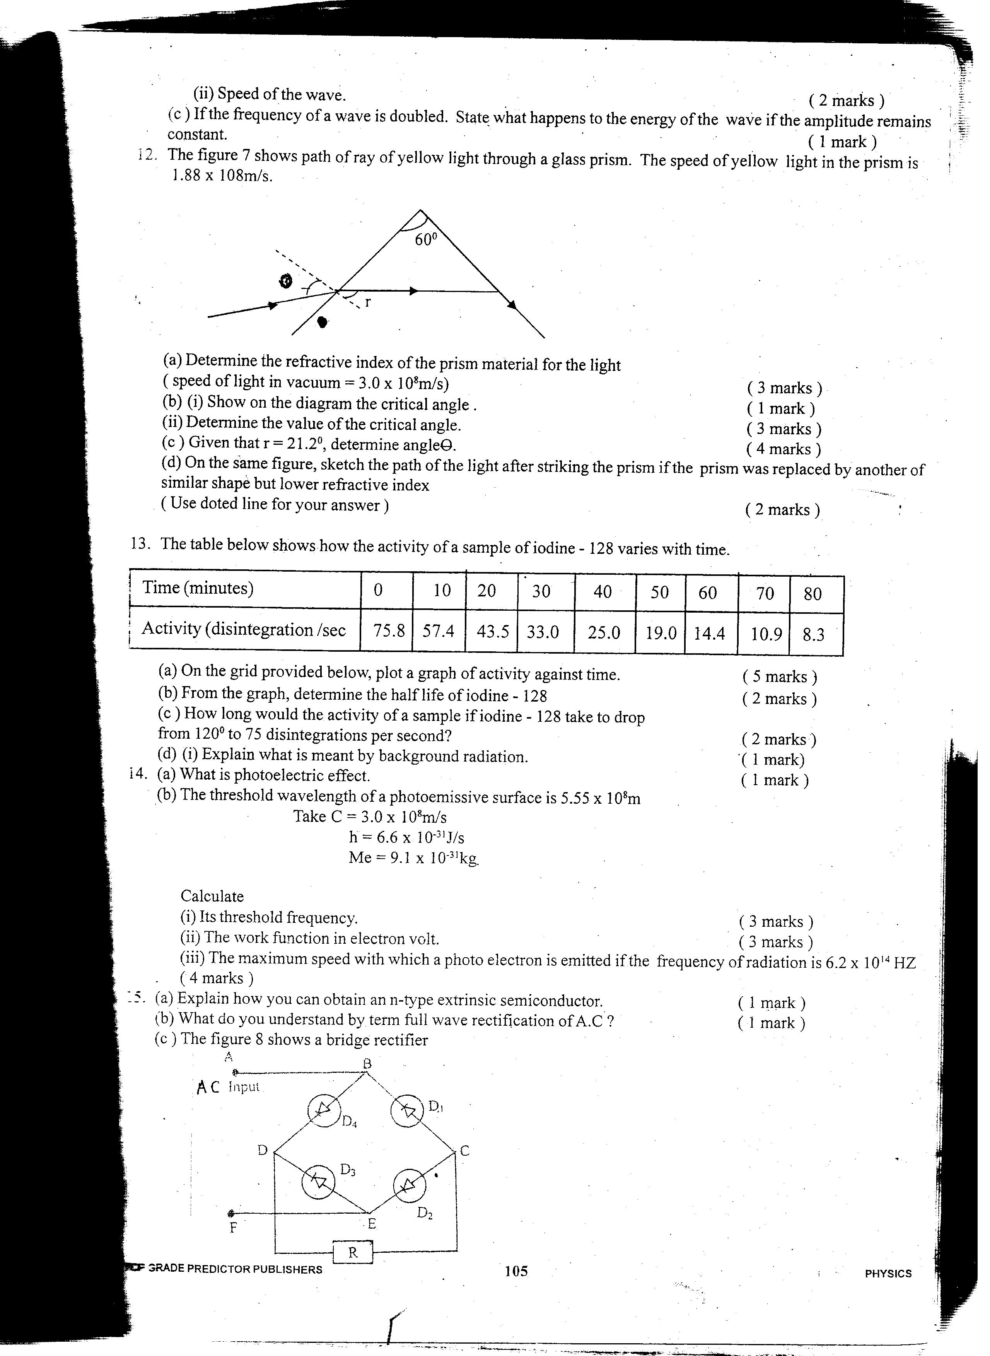

- Determine the refractive index of the prism material for the light (speed of light in vacuum = 3.0 x 10⁸m/s (3mks)

- i) Show on the diagram the critical angle (1mk)
- Given that r=21.2°, determine angle Ө (3mks)

- On the same diagram sketch the path of the light after striking the prism if the prism was replaced by another of similar shape but lower refractive index (use dotted line for your answer ) (2mks)

- The figure below shows a wave profile
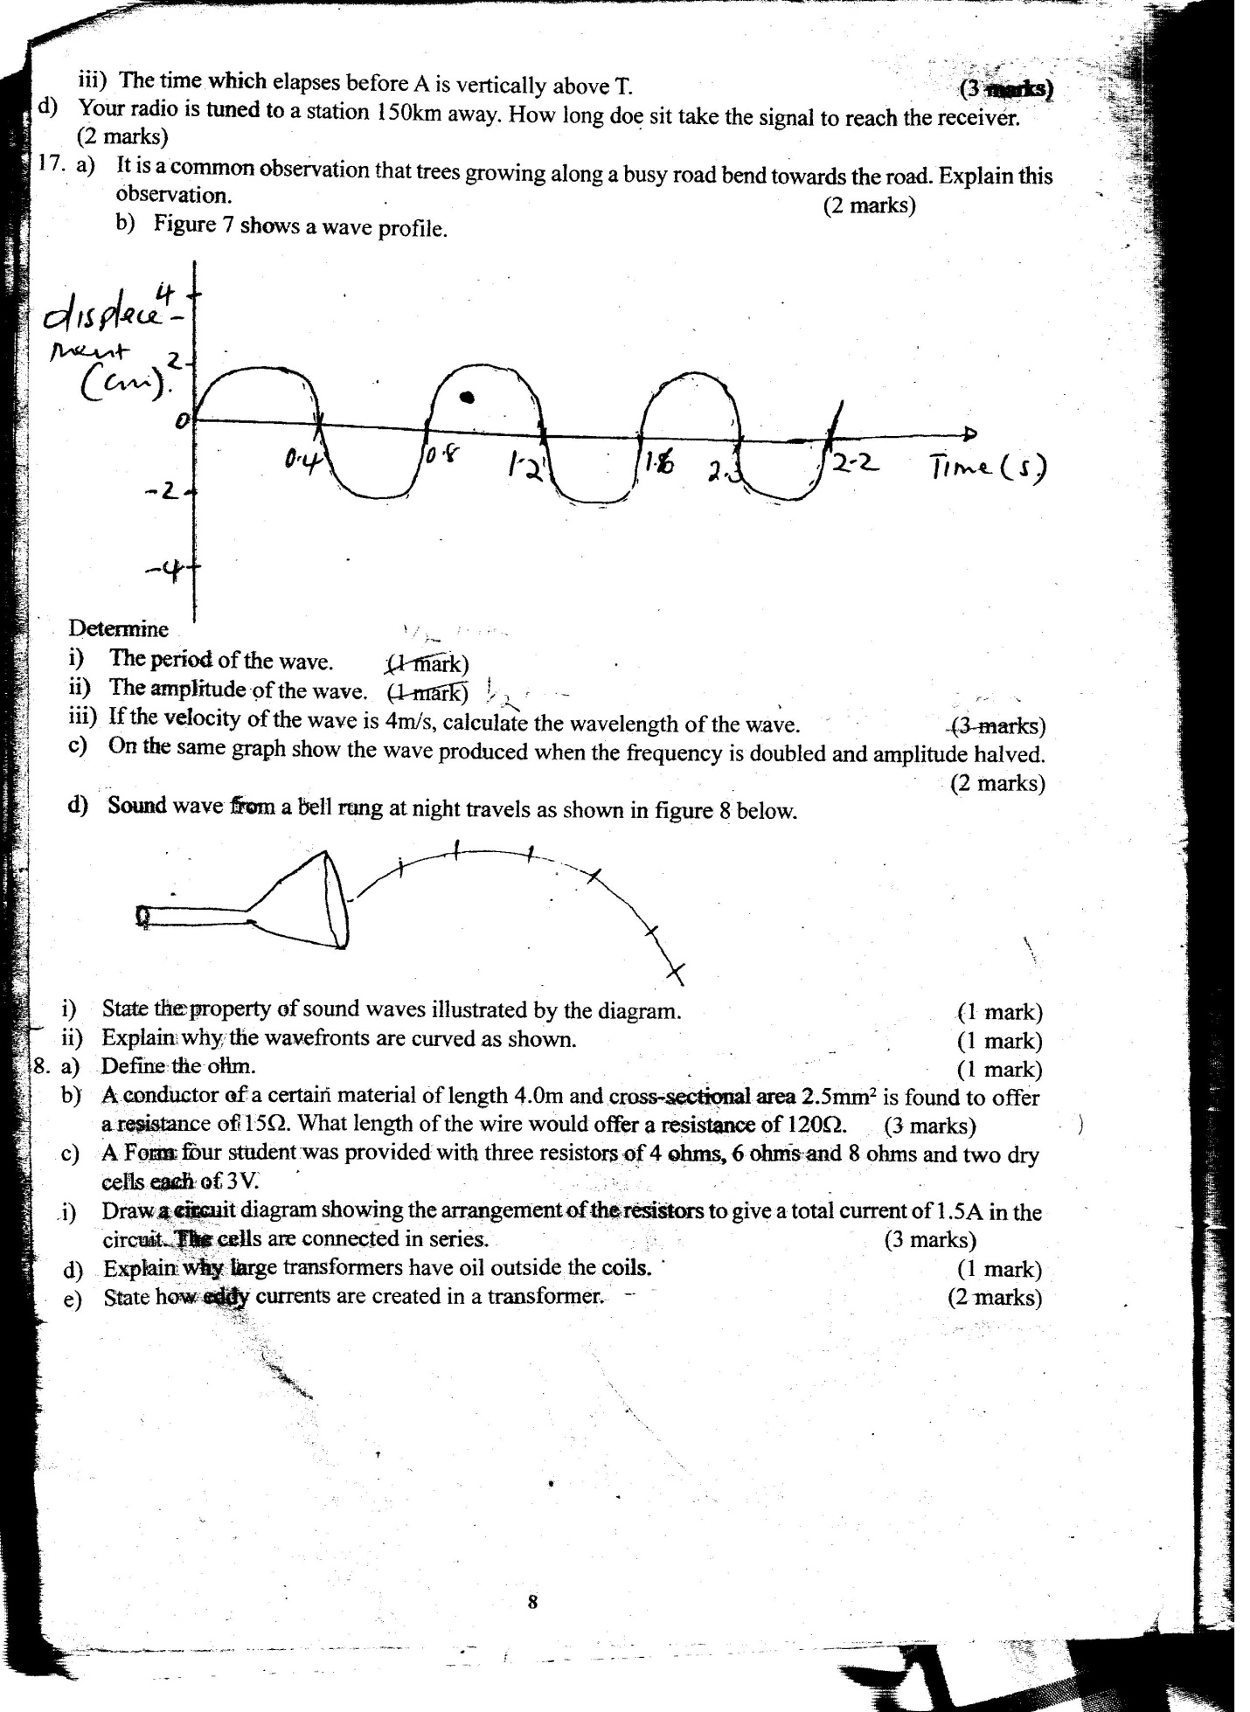
Determine
- The period of the wave ( ½ mk)

- The amplitude of the wave ( ½ mk)

- If the velocity of the wave is 4m/s, calculate the wavelength of the wav (2mks)

