**CROP PRODUCTION IV (FIELD MANAGEMENT PRACTICES)**

This topic entails the following:

* Crop rotation
* Reasons for crop rotations
* Crop rotation programme
* Terms used in crop farming
* Mulching
* Reasons for various field management practices
* Correct stage for harvesting crops
* Harvesting practices of various crops.

The following relevant questions and their answers in this topic will greatly motivate and help the user to comprehend and understand the required concepts and practices:

1. Distinguish between **staking** and **propping** as a field management practice on crops

2. Explain five advantages of crop rotation

3. State **four** factors which influence the stage at which the crops are harvested

4. The diagrams labelled **B** and **C** below are illustrations of coffee plants established using two

different formative pruning systems.

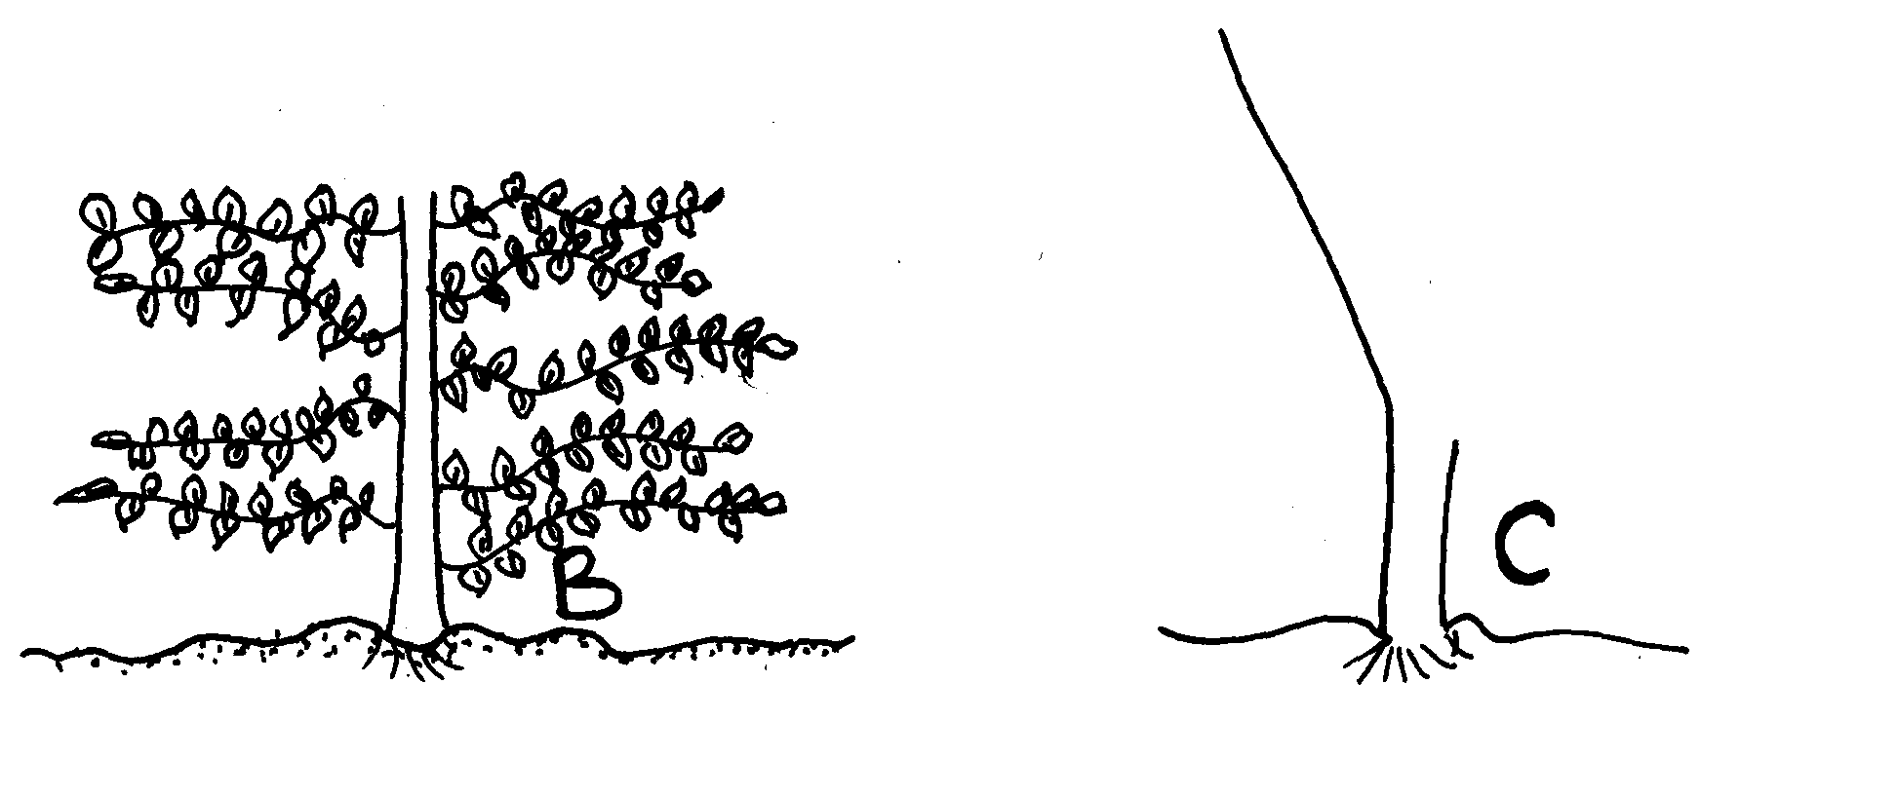 Examine the diagrams and answer the questions that follow:-

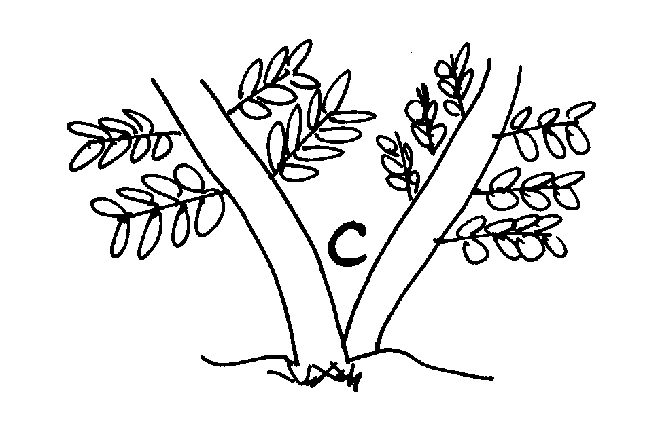

(a) Identify the system of pruning illustrated in **B**

(b) Identify the system of pruning in **C**

(c) Outline the procedure of how pruning in diagram **C** is carried out

5. Give **two** functions of earthing up in crop production

6. Describe the factors which determine the stage of harvesting of crops

7. Give **two** ways in which inorganic much helps to conserve water

8. State **four** factors that determine the spacing of annual crops

9. Explain the importance of each of the following practices: (i) Hardening off

(ii) Pricking out

(iii) Gapping

10. Outline **two** factors that determine the stage of harvesting crops

11. (a) List **four** factors that determine harvesting sage of a crop

(b) Give **four** practices that can be used to control storage pests

12. List **four** benefits of pruning in crop production

13. (a) What is winnowing?

(b) Give **one** importance of the following practices: (i) Mulching (ii) Threshing

(c) Which factors are considered when carrying out a crop rotation program?

14. What is frelishing?

15.Briefly explain how each of the factors listed below will determine the stage at which a crop is harvested

(a) Intended use of the crop

(b) Market demand

16. What is roguering in crop production?

17. What is meant by the term “changing the cycle” in coffee growing?

18. The diagram below shows a practice carried out on various crops on the farm. Study them

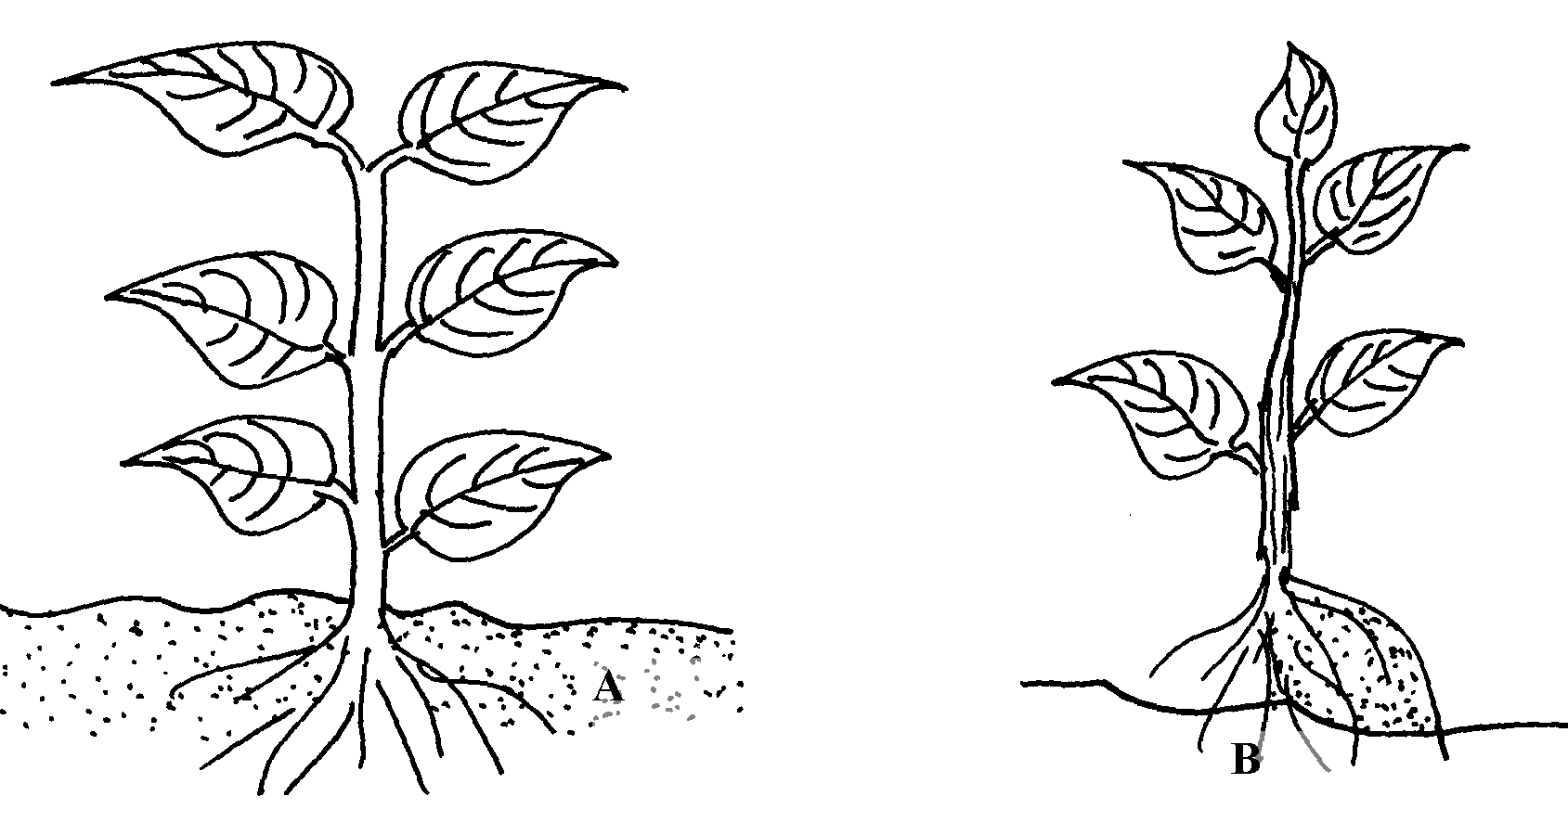 carefully and answer the questions that follow;

(a) Identify the farm practice represented by **B**

(b) State the importance of the above practice in the following crops;

(i) Maize

(ii) Irish potatoes

(c) At what stage of growth should the above practice be carried out in maize?

19. Mention **four** factors which determine the stage at which crops are harvested

20. State **two** limitation of using polythene sheets as mulching materials in a field of tomatoes

21. Give **two** management practices carried in a banana stool

23. State **two** functions of polythene sheet when used as mulch material

24. Give **four** crops requiring training