Name: …………….……………….…………….………….. Adm No: ……………………………
Class…………………………………………………………..Date: ………..……………………….

JOINT EVALUATION EXAMINATION
443/1
AGRICULTURE
Paper 1
Form Three 2023

Time: 2 Hours

INSTRUCTIONS TO CANDIDATES:
- Write your name and admission number in the space provided.
- Sign and write the date of examination in the space provided
- This paper consists of three section A, B and C.
- Answer all questions in section A and B.
- Answer any two questions in section C
- All the questions should be answered in the spaces provided.
- This paper consists of 11 pages

FOR EXAMINERS USE ONLY

SECTION | QUESTINS | MAX SCORE | CANDIDATES SCORE
A | 1-16 | 30
B | 17-20 | 20
C | 21 | 20
 | 22 | 20
 | 23 | 20
TOTAL |  | 90

SECTION A (30MARKS)
Answer all the questions in this section in the space provided.
- Give four characteristics of intensive farming system (2mks)
…………………………………………………………………………………………………………………………………………………………………………………………………………………………………………………………………………………………………………………………………………………………………………………………………………………..
- Give an example of a weed matching the following description
a) Causes poisoning to livestock and human (1mks)
…………………………………………………………………………………………………….......
………………………………………………………………………………………………………...
b) Alternate host of rust (½ mk) ………………………………………………………………………………………………….....
c) Aquatic weed (½ mk) …………………………………………………………………………………………….............
- Name the plant part used for vegetative propagation of each of the following plants.
- Sisal (½ mk)
………………………………………………………………………………………
- Pyrethrum (½ mk)
………………………………………………………………………………………
- Sweet potatoes (½ mk)
………………………………………………………………………………………
- Sugar cane (½ mk)
………………………………………………………………………………………

- State four cultural ways of controlling black jack weed. (2mks)
……………………………………………………………………………………………………………………………………………………………………………………………………………………………………………………………………………………………………………………………………………………………………………………………....
- Name three sources of underground water (1½mks)
………………………………………………………………………………………………………………………………………………………………………………………………………………………………………………………………………………………………
- State three causes of blossom end of rot in tomatoes (1½mks)
………………………………………………………………………………………………………………………………………………………………………………………………………………………………………………………………………………………………
- Give three characteristics of crops used to prepare green manure. (1½mks)
……………………………………………………………………………………………………………………………………………………………………………………………………………………………………………………………………………………………....
- State four reasons for practicing minimum tillage. (2mks)
………………………………………………………………………………………………………………………………………………………………………………………………………………………………………………………………………………………………………………………………………………………………………………………………
- Name four farm records that should be kept by a poultry farmer. (2mks)
……………………………………………………………………………………………………………………………………………………………………………………………………………………………………………………………………………………………………………………………………………………………………………………………………………………

- Give three ways in which pasture crops are classified (1½mks)
………………………………………………………………………………………………………………………………………………………………………………………………………………………………………………………………………………………………
- State four ways in which land reforms can be implemented in Kenya. (2mks)
……………………………………………………………………………………………………………………………………………………………………………………………………………………………………………………………………………………………………………………………………………………………………………………………………………………
- State four factors that determine the stage at which a crop is harvested. (2mks)
………………………………………………………………………………………………………………………………………………………………………………………………………………………………………………………………………………………………………………………………………………………………………………………………………….…………
- Give four beneficial effects of weeds to a farmer. (2mks)
…………………………………………………………………………………………………………………………………………………………………………………………………………………………………………………………………………………………………………………………………………………………………………………………….………………………
- Give four advantages of practicing crop rotation. (2mks)
……………………………………………………………………………………………………………………………………………………………………………………………………………………………………………………………………………………………………………………………………………………………………………………………………………………

- Name four classifications of pesticides according to the target pest (2marks) ……………………………………………………………………………………………………………………………………………………………………………………………………………………………………………………………………………………………………………………………………………………………………………………………………………………………….
16. Give four ways in which inorganic fertilizer can be classified (2mks)
…………………………………………………………………………………………………………………………………………………………………………………………………………………………………………………………………………………………………………………………………………………………………………………………………………………….

SECTION B (20 MARKS)
Answer all the questions in this section in the spaces provided.

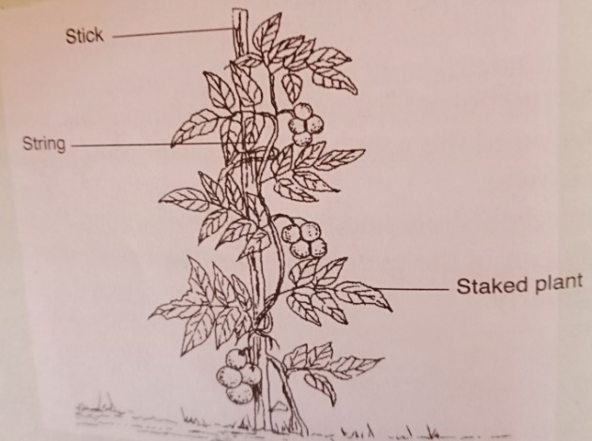

17. a) Identify the crop management practice shown above (1mks) ……………………………………………………………………………………………….
b) Name two example of crops on which the above can be practiced (2mks)
…………………………………………………………………………………………………………………………………………………………………………………………………………………………
c) State three reasons for carrying out the above practice (3mks)
………………………………………………………………………………………………………………………………………………………………………………………………………………………………………………………………………………………………………………………………………

18.The diagram below illustrate investigation on a property of soil using soil samples labeled A, B and C.

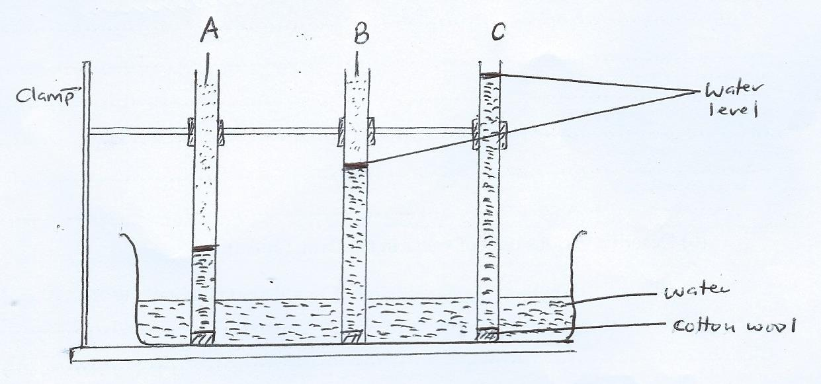

- Name the property of soil being investigated (1mk)
……………………………………………………………………………………………
- What is the relationship between the soil property above and the size of soil particles? (1mk)
……………………………………………………………………………………………………………………………………………………………………………………………..
- Which soil sample would be suitable for growing paddy rice? (1mk)
…………………………………..………………………………………………………
- Give a reason for your answer in (c) above (1mk)
…………………………………………………………………………………………..
19. The following is a list of nutrients: copper, calcium, nitrogen, molybdenum, zinc, phosphorus, carbon, Sulphur, iron and magnesium. Which of the above nutrients are;
- Macro – nutrients (1mk)
…………………………………………………………………………………………..
- Micro – nutrient (1mk)
…………………………………………………………………………………………..
- Fertilizer elements (1mk)
…………………………………………………………………………………………..
- Liming elements (1mk)
………………………………………………………………………………………….
- Primary macro nutrients (1mk)
…………………………………………………………………………………………

20. Study the diagrams below and answer the questions
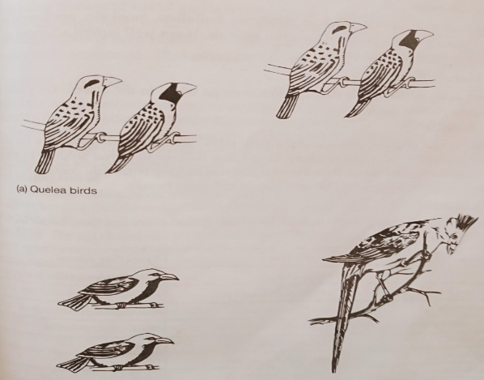

a) Name examples of crops damaged by crop pests above (2mks)
…………………………………………………………………………………………………………………………………………………………………………………………………………………………
b) Give three examples of rodent pests (3mks)
…………………………………………………………………………………………………………………………………………………………………………………………………………………………
…………………………………………………………………………………………………………………………………………………………………………………………………………………………

SECTION C
Answer any two questions in this section in the spaces provided after question.
21.a) Discuss sorghum production under the following sub heading
i) Ecological requirement (3mks)
ii) Varieties (2mks)
iii) Pests and their control (3mks)
iv) Harvesting (2mks)
b) Describe five physical method of pest control (5mks)
c) Explain five functions of a live fence in a farm. (5mks)

22. a) Explain five factors considered when siting farm structures (10mks)
b) Explain the different ways in which each of the following environmental factors influence crop production.
- Wind (5mks)
- Temperature (5mks)

23. a) Explain the cultural methods of controlling soil erosion (8mks)
b) State six roles of trees in soil and water conservation (6mks)
c) State six benefits of land consolidation (6mks)

……………………………………………………………………………………………………………………………………………………………………………………………………………………………………………………………………………………………………………………………………………………………………………………………………………………………………………………………………………………………………………………………………………………………………………………………………………………………………………………………………………………………………………………………………………………………………………………………………………………………………………………………………………………………………………………………………………………………………………………………………………………………………………………………………………………………………………………………………………………………………………………………………………………………………………………………………………………………………………………………………………………………………………………………………………………………………………………………………………………………………………………………………………………………………………………………………………………………………………………………………………………………………………………………………………………………………………………………………………………………………………………………………………………………………………………………………………………………………………………………………………………………………………………………………………………………………………………………………………………………………………………………………………………………………………………………………………………………………………………………………………………………………………………………………………………………………………………………………………………………………………………………………………………………………………………………………………………………………………………………………………………………………………………………………………………………………………………………………………………………………………………………………………………………………………………………………………………………………………………………………………………………………………………………………………………………………………………………………………………………………………………………………………………………………………………………………………………………………………………………………………………………………………………………………………………………………………………………………………………………………………………………………………………………………………………………………………………………………………………………………………………………………………………………………………………………………………………………………………………………………………………………………………………………………………………………………………………………………………………………………………………………………………………………………………………………………………………………………………………………………………………………………………………………………………………………………………………………………………………………………………………………………………………………………………………………………………………………………………………………………………………………………………………………………………………………………………………………………………………………………………………………………………………………………………………………………………………………………………………………………………………………………………………………………………………………………………………………………………………………………………………………………………………………………………………………………………………………………………………………………………………………………………………………………………………………………………………………………………………………………………………………………………………………………………………………………………………………………………………………………………………………………………………………………………………………………………………………………………………………………………………………………………………………………………………………………………………………………………………………………………………………………………………………………………………………………………………………………………………………………………………………………………………………………………………………………………………………………………………………………………………………………………………………………………………………………………………………………………………………………………………………………………………………………………………………………………………………………………………………………………………………………………………………………………………………….......

……………………………………………………………………………………………………………………………………………………………………………………………………………………………………………………………………………………………………………………………………………………………………………………………………………………………………………………………………………………………………………………………………………………………………………………………………………………………………………………………………………………………………………………………………………………………………………………………………………………………………………………………………………………………………………………………………………………………………………………………………………………………………………………………………………………………………………………………………………………………………………………………………………………………………………………………………………………………………………………………………………………………………………………………………………………………………………………………………………………………………………………………………………………………………………………………………………………………………………………………………………………………………………………………………………………………………………………………………………………………………………………………………………………………………………………………………………………………………………………………………………………………………………………………………………………………………………………………………………………………………………………………………………………………………………………………………………………………………………………………………………………………………………………………………………………………………………………………………………………………………………………………………………………………………………………………………………………………………………………………………………………………………………………………………………………………………………………………………………………………………………………………………………………………………………………………………………………………………………………………………………………………………………………………………………………………………………………………………………………………………………………

