NAME……………………………………….……………………………. ADM NO………….
CLASS……………………………………………………………..
JOINT EXAMINATION
443/2
AGRICULTURE FORM THREE PAPER 2
2 Hours
TERM 3: OCTOBER 2023
INSTRUCTIONS
(a) Write your name, admission number and class in the space provided above.
(b) This paper consists of three sections: A, B and C.
(c) Answer all questions in section A and B.
(d) Answer any two questions in section C
e) This paper consists of 13 printed pages
FOR EXAMINER’S USE ONLY
SECTION | QUESTION | MAXIMUM SCORE | CANDIDATES SCORE
A |  | 30
B |  | 20
C |  | 20
TOTAL |  | 90

SECTION A (30 MARKS)
Answer all the questions in the spaces provided.
- What is parasite. (1mk)
.

- Name any three general factors that influence agriculture (1 1/2mks)
.
- State four signs of ill-health in livestock. (2mks)
.
- Differentiate between wessex and Essex pig breeds (2mks)
.
- What is a disease predisposing factor. (1mk)
.
- Give five advantages of artificial insemination. (2 ½ mks)
.
- Differentiate between line breeding and upgrading. (1mk)
.
- Give four routes of administering vaccines in farm animals. (2mks)
.
- Give four functions of a rumen in a ruminant animal. (2mks)
.
- State four advantages of Kenya top bar hive. (2mks)
.
- State four important reasons for feeding livestock with roughages. (2mks)
.
- State four ways of identifying farm animals. (2mks)
.

- Give two examples of feed additives in feeding livestock. (2mks)
.
- Name two species of camel. (1mk)
.
- State four advantages of castrating male animals . (2mks)
.
- Give four ways of maintaining a fish pond. (2mks)
.
- State four functions of water in an animals body. (2mks)
.
- State four reasons for swarming in a bee colony. (2mks)
.

SECTION B (20MARKS)
Answer all the questions in the species provided
- The following diagram represents a poultry’s reproductive system.
Study it carefully and answer the questions that follows.
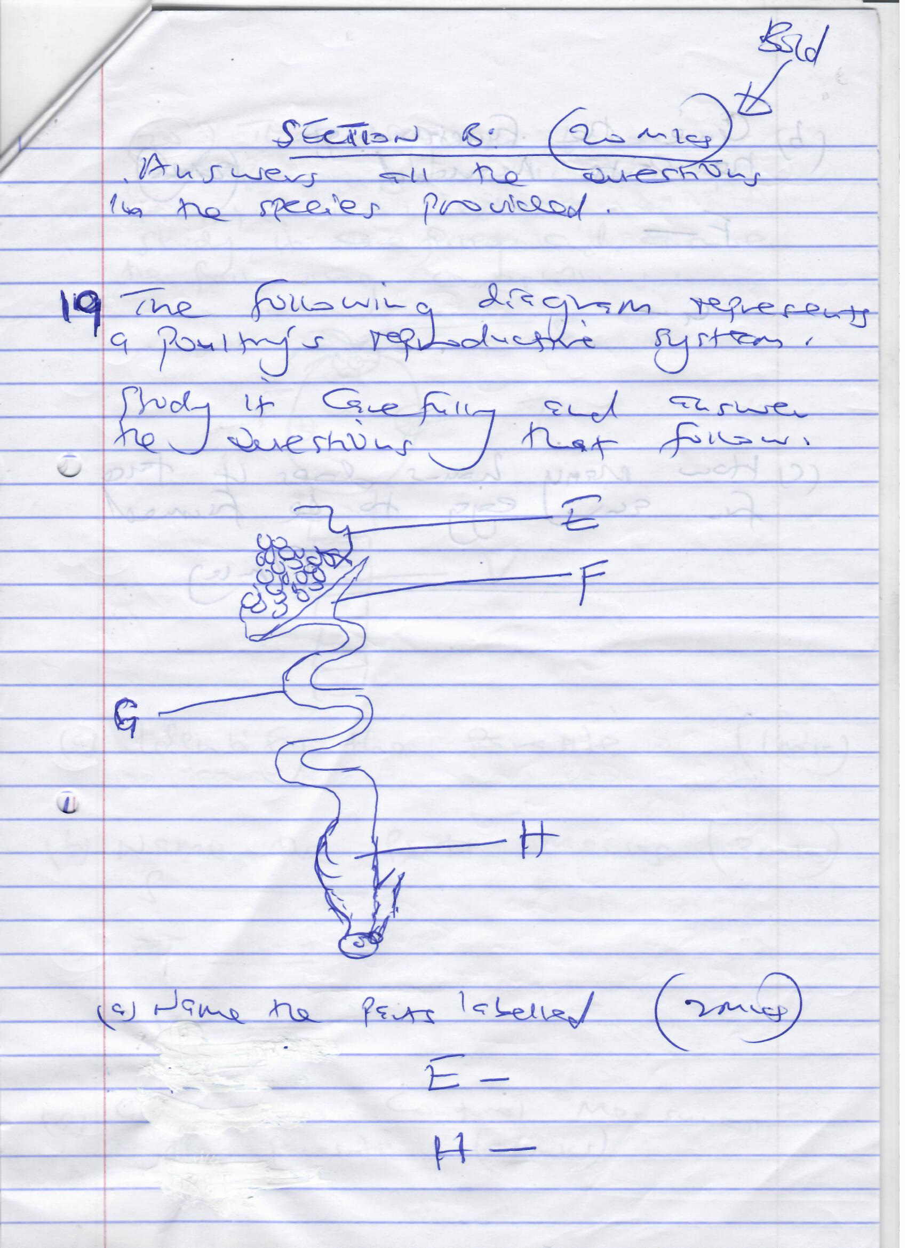

- Name the parts labeled ; (2mks)
E-

H-

- Give the functions of parts marked. (2mks)
F-

G-

- How many hours does it take for an egg to be formed. (1mk)
.
- The diagram below represents an internal parasite in livestock. Study it carefully and answer the following questions
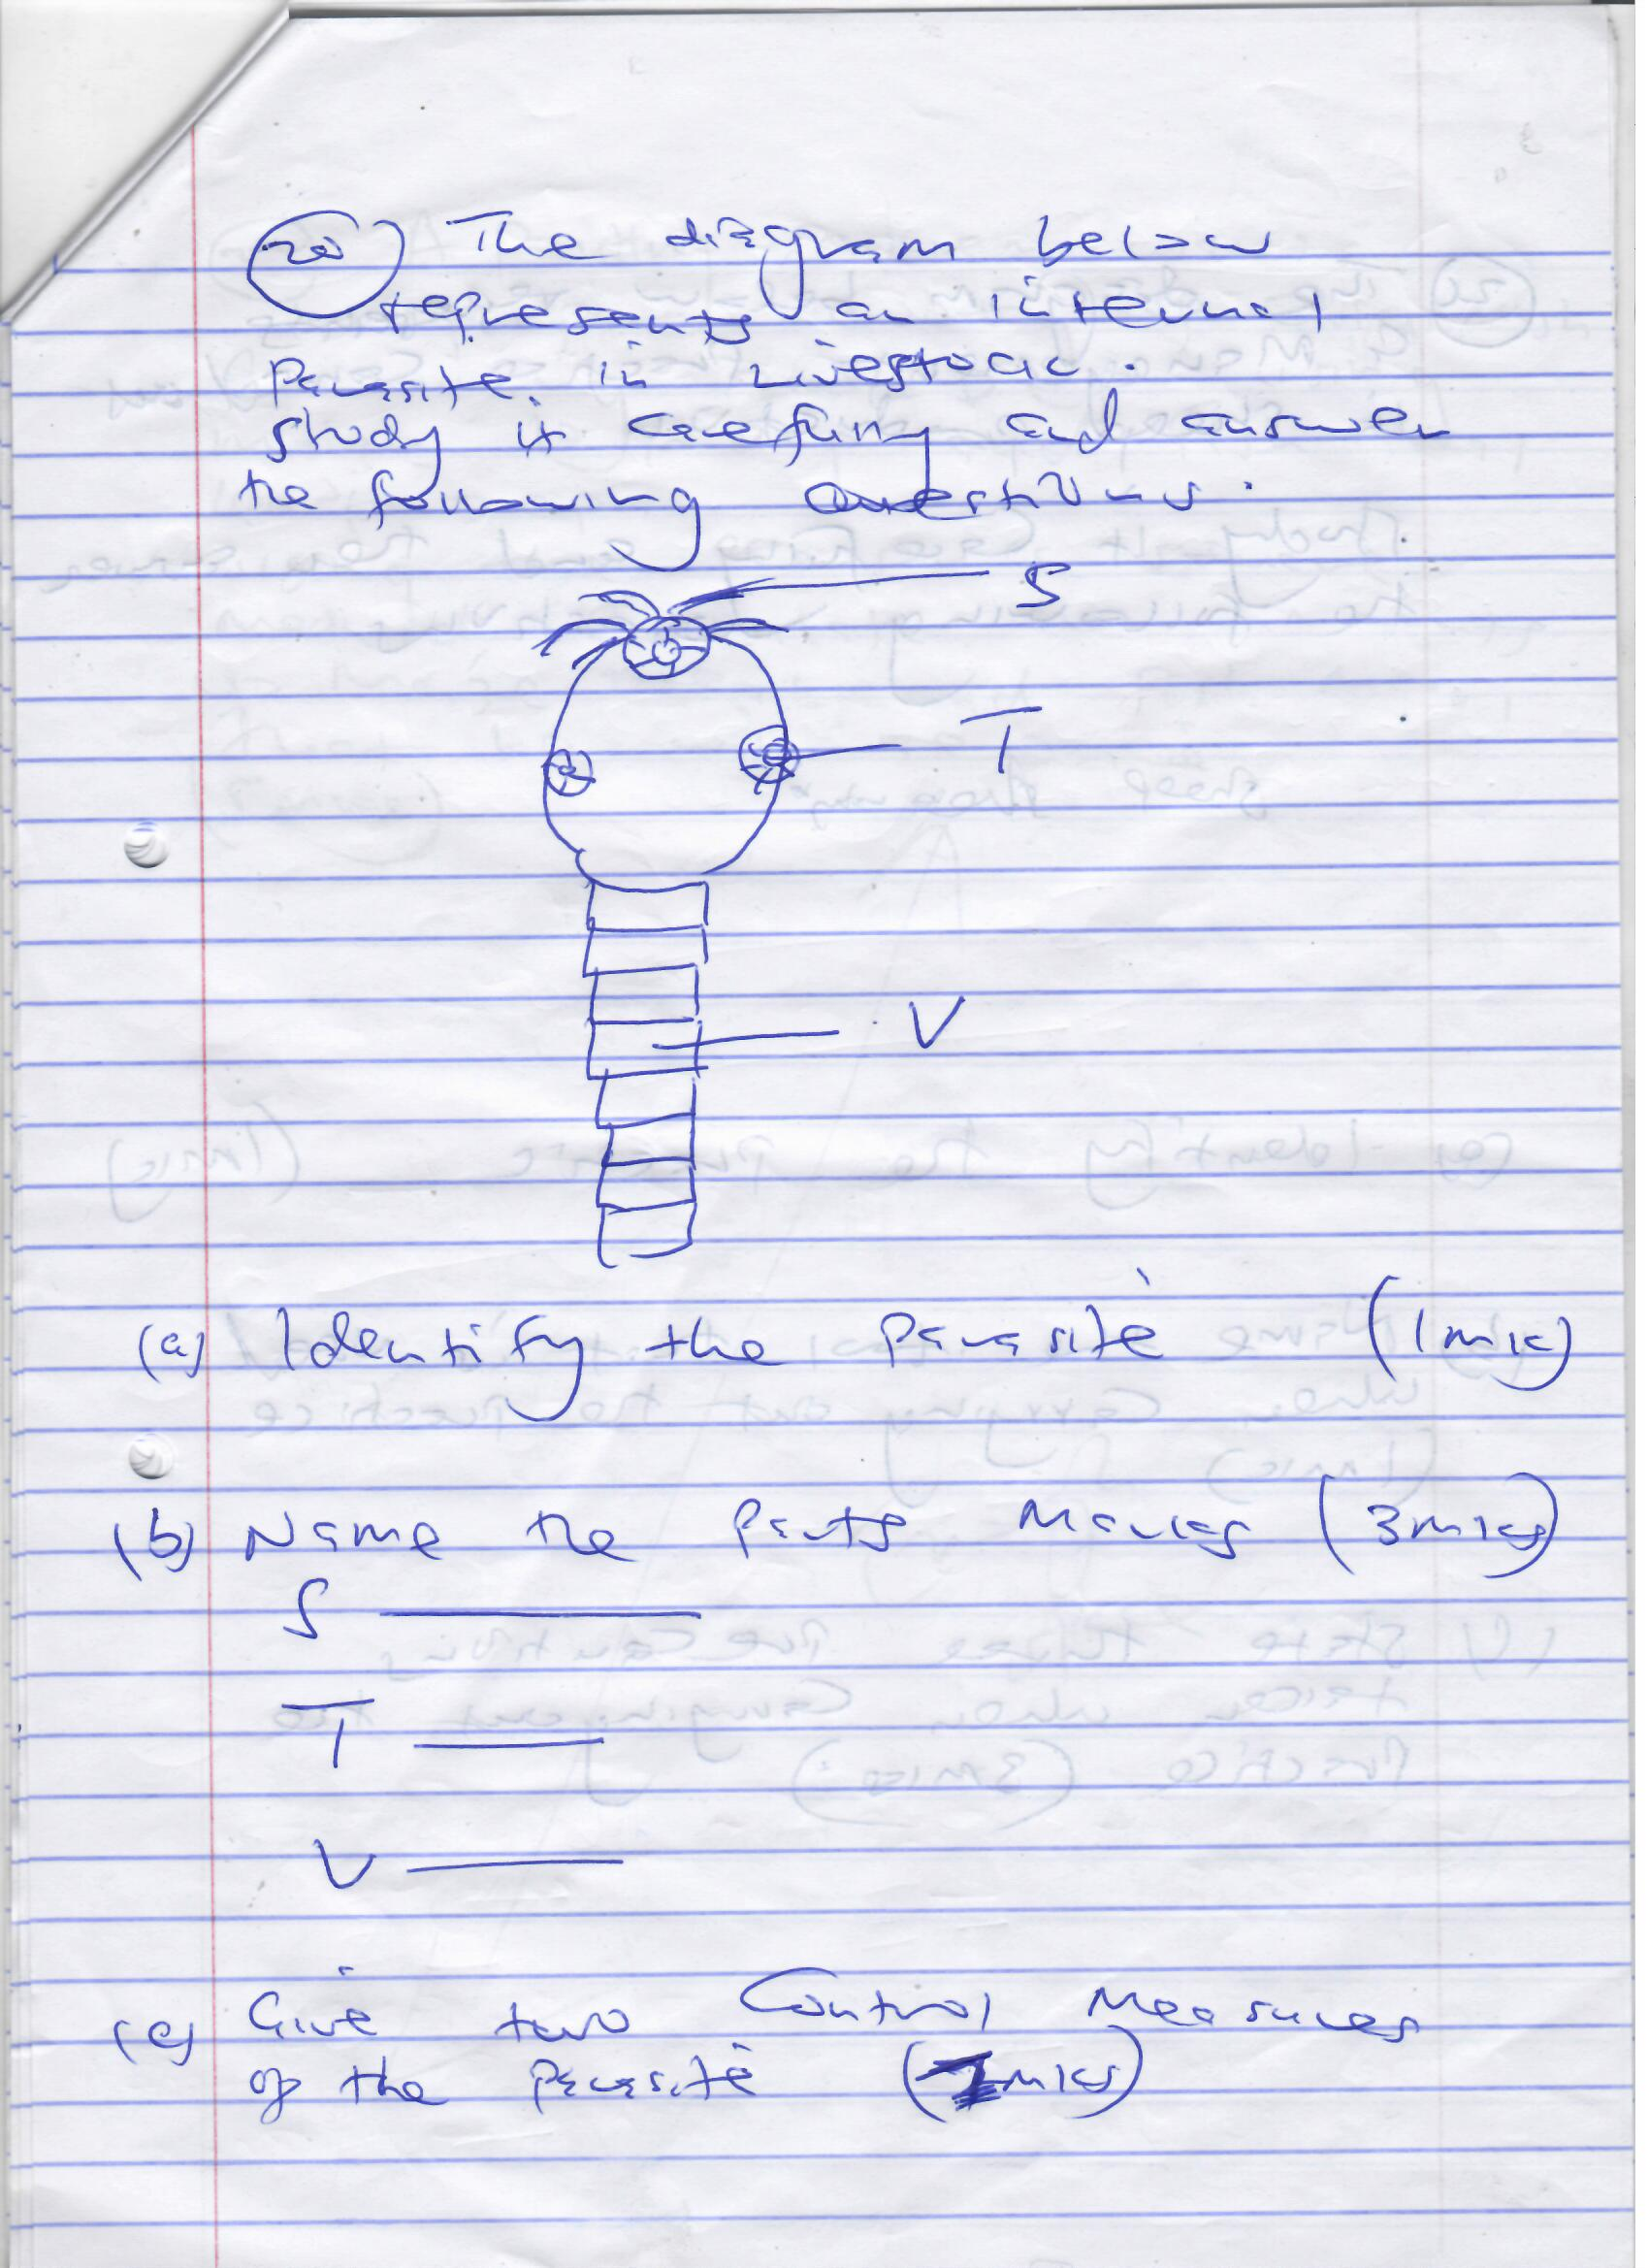
- Identify the parasite. (1mk)
.
- Name the parts marked T and V (2mks)
T-
V-
- Give two control measures of the parasite. (2mks)
.

- The diagram below represents a management practice carried out in sheep production. Study it carefully and then answer the following questions
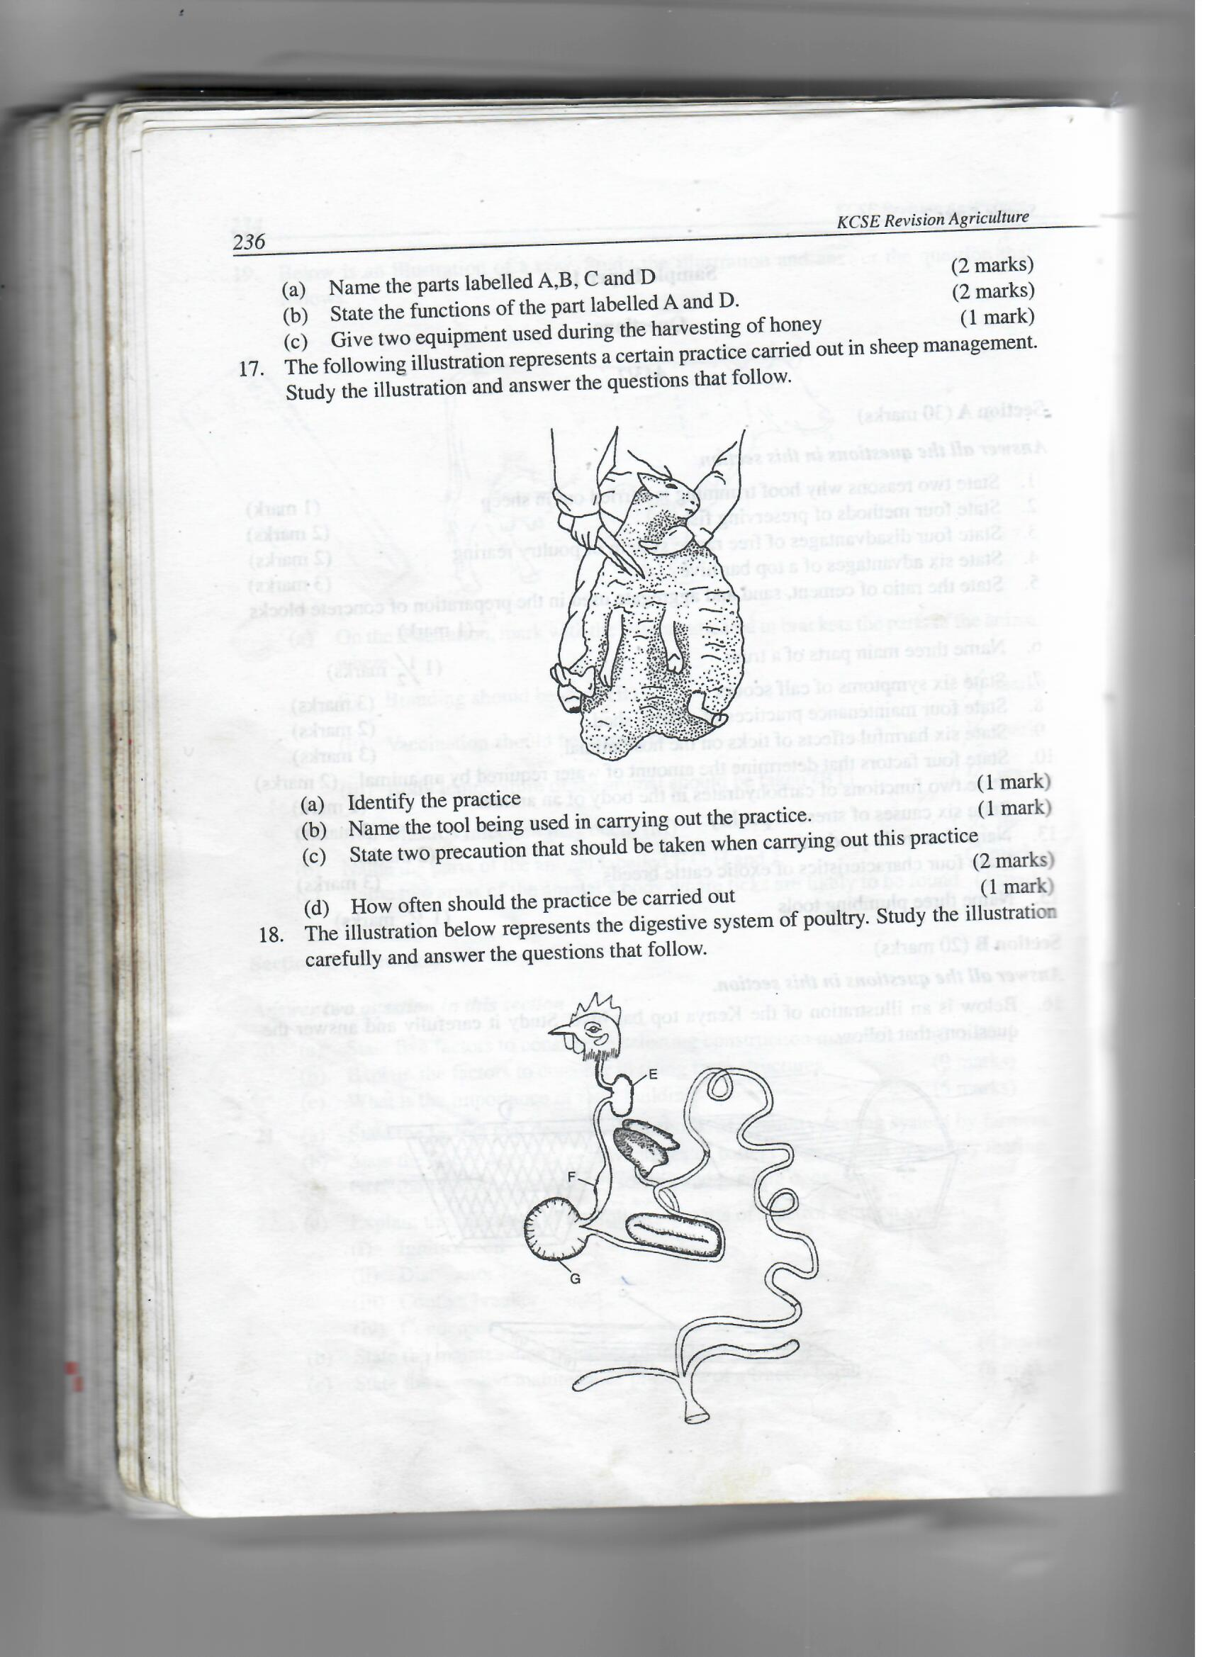
- Identify the practice. (1mk)
.
- Name the tool that is used when carrying out the practice . (1mk)
.
- State three precautions taken when carrying out the practice. (3mks)
.
- A poultry farmer wants to prepare 600kg of chick mash containing 20% DCP using maize 10% DCP and fish meal 40% DCP.
Using the Pearson’s square method, calculate the amounts of maize meal and fish meal that he will require. Show you working (5mks)

SECTION C (40MARKS)
This section consists of 3 questions. Answer only two question
- (a) State five signs of heat in a dairy cow. (5mks)
.
(b) State five advantages of cattle dip as compared to the spray race. (5mks)
.
(c) Give five reasons for maintaining livestock healthy. (5mks)
.

(d) State five factors affecting the digestibility of food eaten by livestock. (5mks)
.

- (a) Describe the body conformation features of a dairy heifer. (8mks)
.
(b) Describe coccidiosis under the following sub-headings.
I. causal agent. (1mk)
II. Symptoms. (6mks)
.
III. Control and treatment. (5mks)
.
- (a) Describe bee keeping under the following sub headings procedure of;
- Feeding bees. (4mks)
.
- Explain five factors to consider when siting an apiary. (5mks)
.
- Procedure of processing honey using the heat method. (6mks)
.
- Importance of keeping bees. (5mks)
.

