Name:…………………………………………………….............................Admission No. ………………
School:…………………………………………………….Signature…………………… Date: ………………..
231/3
PAPER 3
BIOLOGY PRACTICAL
OCTOBER 2023
TIME: 1 ¾ HOURS
JOINt EXAMS
Kenya Certificate of Secondary Education (K.C.S.E)
INSTRUCTIONS TO CANDIDATES:-
- Answer all the questions
- Write your name, admission number and school in the spaces provided above.
- Sign and write the date of examinationin the spaces provided above.
- You are required to spend the first 15 minutes of 1 ¾ hours allowed for this paper reading the whole paper carefully before commencing your work.
- Answers must be written in the spaces provided in the question paper.
- Additional pages must not be inserted
FOR EXAMINER’S USE ONLY:
Question | Maximum score | Candidate’s score
1 | 13
2 | 8
3 | 19
TOTAL | 40

This paper consists of 7 printed pages. Candidates should check to ascertain that all pages are printed as indicated and that no questions are missing.

1 Study the photographs below and answer the questions that follow:
PHOTOGRAPH J PHOTOGRAPH K
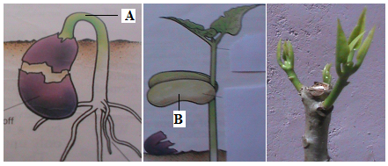
a)Photograph K illustrates the observations made two weeks after the plant was trimmed.
(i)Name the phenomenon that was experienced by the plant before it was trimmed (1mk)

(ii) Account for the observation made in the shoot after the practice (2mks)

(iii) Give one application of the practice in agriculture (1mks)

b) In photograph J
(i) Name the part labeled A (1mk)

(ii) State one functions of part B (1mk)

c) The photograph below shows the arrangements of different type of cells and tissues in a certain living organism. Study it and answer the questions that follow.
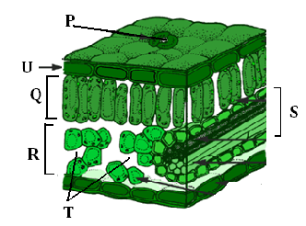

i) From what part of the plant was the photograph obtained. (1mk)

ii) Name the parts Labeled. R (1mk)

d) i) State the function of the part labeled Q. (1mk)

ii) State one adaptation of structure Q to its function. (1mk)

e) State one environmental factor which regulate the function of the part labeled P. (1mk)

f) Measure the length of one cell of region labeled Q on the photomicrograph whose magnification is X5000.What is the actual length of the cell in micrometer? Show yourworking. (2marks)

2. Study the kidney diagrams below
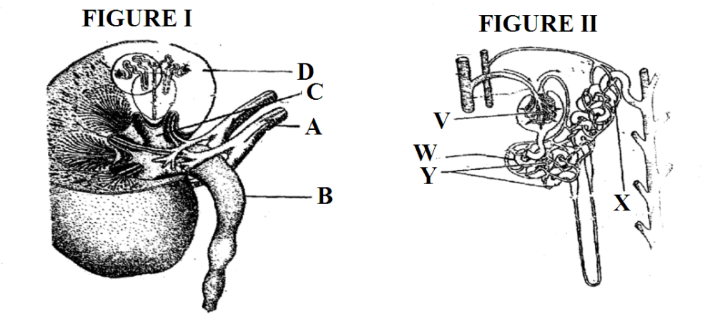
a)i) Name the parts labeled A in figure 1
(1mk)
A ………………………………………………

ii) Name the processes that take place in the parts labeled (1mk)
V ………………………………………………
b) State two adaptations of the part labeled W (2mks)

c) On the diagram name the part where counter current flow occurs (1mk)

d) State one homeostatic function of the organ in the diagram above (1mks)

e) Explain what will happen to the process of urine formation in absence of vasopressin (A.D.H)
hormone. (2mks)

3. You are provided with specimen Y, 0.01% DCPIP and 0.1% Ascorbic Acid.
Examine specimen Y.

a).i) What part of plant is specimen Y? (1mk)

ii) Give a reason for your answer for (a) (i) above. (1mk)

b) Cut a transverse section through specimen Y (3mks)
Draw and label one of the cut surface

c) i)To 1cm³ of DCPIP in a test-tube add 0.1% solution of ascorbic acid drop wise until the colour of DCPIP disappears. Shake the test tube after addition of each drop. Record the number of drops used (1mk)
…………………………
Squeeze the juice from one half of specimen Y in a l00mI beaker. Add l0mI of distilled water. Filter it in 50ml measuring cylinder provided.

ii. To another 1cm³ of DCPIP in a test tube, add the juice from specimen Y drop by drop. Shake the test tube after the addition of each drop until the colour of DCPIP disappears. Record the number of drops used (1mk)
………………………………………………
iii) From the results obtained in (c)(i) and (ii) above, calculate the % ascorbic acid in the juice obtained from specimen Y. show your working. (2mks)

d. Below are photographs labelled B and C of organs obtained from different animals . The organs perform similar functions. Examine them and answer the questions that follow.
B C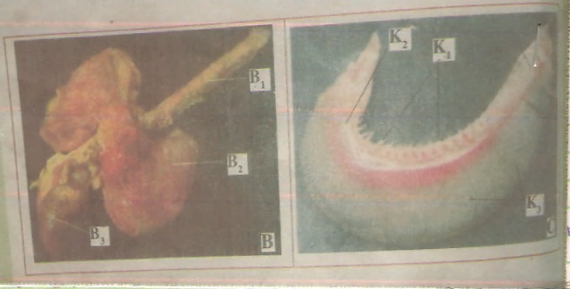
(i) Name the organ C (1mk)

(ii) Give one adaptation of the part marked B1 (1mk)

(b) State one common function performed by the organ stated in a (i) above. (1mk)

(c) Name the parts labelled B1and B2 in photographs B (2mks)

B1………………………………….
B2…………………………………

(d) (i)Identify the part labelled K2 in photograph C (1mk )

(ii) Using observable features, state how the parts labelled K1 and K3 are adapted to their functions. (4mks)

