**Name:** ………………………………………………. **Adm No**: ………

**school**…………………………………………………………………

**Class:** ………**Candidate’s Sign**: …………………**Date:** …………

**233/2**

**CHEMISTRY**

**PAPER 2**

**TERM 3 – OCT 2023**

**TIME: 2 HOURS**

**JOINT EXAMINATION**

**INSTRUCTIONS TO THE CANDIDATES:**

* Write your **name** and **admission** **number** in the spaces provided above
* **Sign** and write the **date** of examination in the spaces provided.
* Answer ***all*** the questions in the spaces provided.
* All working **must** be clearly shown where necessary.
* Mathematical tables and electronic calculators can be used.

***For Examiners Use Only***

|  |  |  |
| --- | --- | --- |
| **Question** | **Maximum score** | **Candidate’s score** |
| 1 | 13 |  |
| 2 | 12 |  |
| 3 | 11 |  |
| 4 | 12 |  |
| 5 | 11 |  |
| 6 | 12 |  |
| 7 | 9 |  |
| **Total** | **80** |  |

1. The grid below shows a section of the periodic

|  |  |  |  |  |  |  |  |  |
| --- | --- | --- | --- | --- | --- | --- | --- | --- |
|  |  |  |  |  |  |  |  |  |
| K | L |  |  | M |  | N | P |
|  | Q | R | S |  | T | V |  |
| W |  |  |  |  |  |  |  |  |
|  |  |  |  |  |  |  |  |  |

1. Name the family into which element P belongs to (1mk)

……………………………………………………………………………………………………………………………………………………………………………………………………

1. Which two elements forms the most soluble carbonates (1mk)

……………………………………………………………………………………………………………………………………………………………………………………………………

1. With a reason, identify elements in period 3 with the largest atomic radius (2mks )

……………………………………………………………………………………………………………………………………………………………………………………………………

1. Write the formula of the compound formed between Q and M (1mk )

……………………………………………………………………………………………………………………………………………………………………………………………………

1. State two uses of element R and for each use , state property of element R that makes lts possible for the use
2. Use (1mk)

……………………………………………………………………………………………………………………………………………………………………………………………………

Property (1mk)

……………………………………………………………………………………………………………………………………………………………………………………………………

1. Use (1mk)

…………………………………………………………………………………………………………………………………………………………………………………………………

Property (1mk)

……………………………………………………………………………………………………………………………………………………………………………………………………

1. Using dots and cross, show bonding in the compound formed between Q and oxygen (2mks )
2. In terms of structure and bonding explain why the oxides of element T has relatively low boiling points (2mks)

…………………………………………………………………………………………………………………………………………………………………………………………………..

…………………………………………………………………………………………………………………………………………………………………………………………………….

2. (a) Name the following compounds (3mks)

1. **CH3CH2CH2COOH**

…………………………………………………………………………………………………

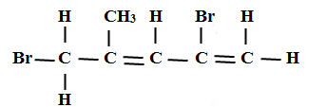

…………………………………………………………………………………………………

1. **CH3CH2OOCCH2CH3**

…………………………………………………………………………………………………

b) Two types of detergents P and Q can be represented as

**P: R $-$ COONa**



(i) Identify each type of the detergent (2mks)

……………………………………………………………………………………………………………………………………………………………………………………………………

(ii)Which of the two detergents is the best to use with hard water? Give a reason (2mks)

………………………………………………………………………………………………

………………………………………………………………………………………………

(iii) State one advantage of detergent P (1mk)

………………………………………………………………………………………………

………………………………………………………………………………………………

(iv) State one disadvantage of detergent Q (1mk)

…………………………………………………………………………………………………

…………………………………………………………………………………………………

(c) An hydrocarbon can be represented as follows

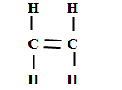

(i) Identify the hydrocarbon (1mk)

………………………………………………………………………………………………

(ii) Name two reagents that can reacted together to generate the hydrocarbon (2mks)

……………………………………………………………………………………………………………………………………………………………………………………………………

3.(a)Name two apparatus that can be used for determining mass in a laboratory (2mks)

…………………………………………………………………………………………………………………………………………………………………………………………………

(b) One of the flames produced by Bunsen burner is the luminous flame

i) Explain why this flame is very bright (1mk )

…………………………………………………………………………………………………

………………………………………………………………………………………………

ii) State two disadvantages of the luminous flame (2mks)

…………………………………………………………………………………………………………………………………………………………………………………………………….

(c) Air is usually one of the substances that is considered as a mixture

(i) Identify the two most abundant component of air (2mks )

……………………………………………………………………………………………………………………………………………………………………………………………………

(ii) Give two reasons why the air is considered as a mixture (2mks)

…………………………………………………………………………………………………………………………………………………………………………………………………

(iii) One of the components of air is carbon (iv) oxide. Describe an experiment that can be used to prove the presence of carbon (iv) oxide in the air (2mks)

…………………………………………………………………………………………………………………………………………………………………………………………………………………………………………………………………………………………………………………………………………………………………………………………………………………………………………………………………………………………………………..

4(a) The diagram below shows the process used to obtain Sulphur from underground deposits

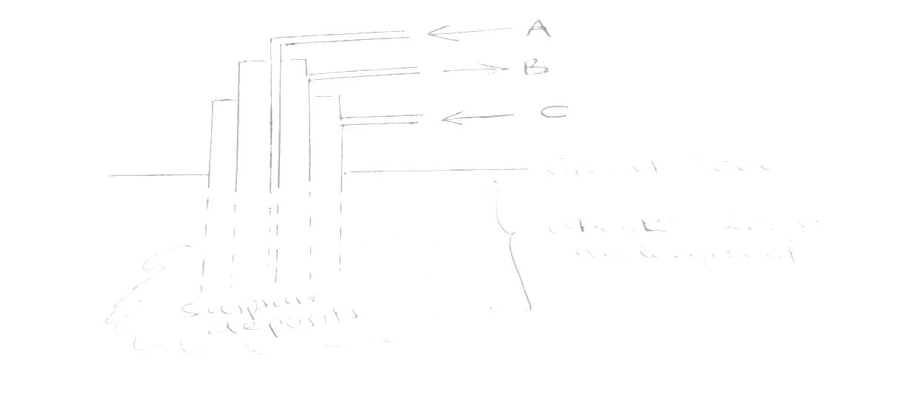

i) Name the above process used to obtain Sulphur from the underground deposits (1mk)

……………………………………………………………………………………………………………………………………………………………………………………………………

ii) Name the substance passed through pipe

**A**  (1mk)

…………………………………………………………………………………………………

**B** (1mk) …………………………………………………………………………………………………

iii) State two properties of Sulphur that makes it possible to extract using the above process (2mks)

………………………………………………………………………………………………………………………………………………………………………………………………………………………………………………………………………………………………………

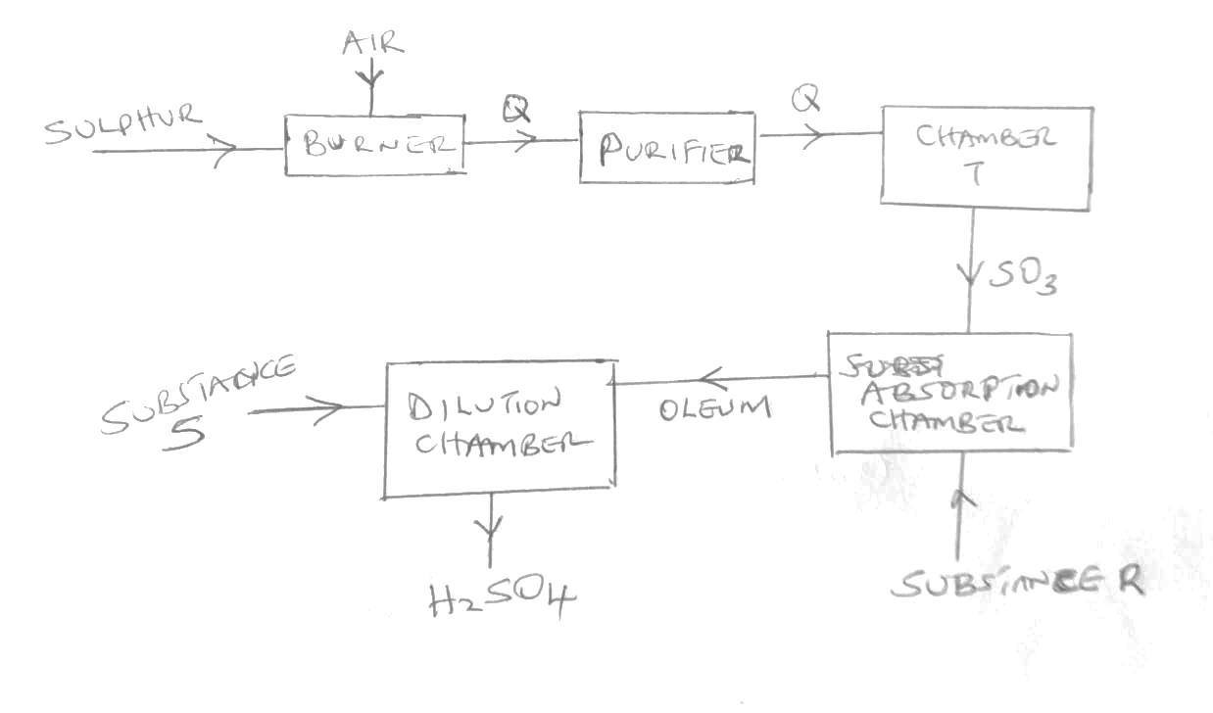b) The diagram below shows the contact process used in the manufacture of concentrated sulphuric(vi) acid

i)Identify the following:

a) Substance Q formed in the burner (1mk)

………………………………………………………………………………………………… b) Chamber T (1mk)

………………………………………………………………………………………………… c) Substance R (1mk)

…………………………………………………………………………………………………

d) Substance S (1mk)

………………………………………………………………………………………………… ii) Write the chemical equation occurring in the dilution chamber (1mk)

…………………………………………………………………………………………………………………………………………………………………………………………………….

iii) Why is it necessary to pass substance Q though a purifier (1mk)

……………………………………………………………………………………………………………………………………………………………………………………………………

]iv) State one use of sulphuric (VI) acid (1mk) …………………………………………………………………………………………………

5. (a) The diagram below represents a set-up that was used to obtain dry nitrogen from air. Study it and answer the questions that follow.



(i) ***Name*** solid ***Q***. (1mk)

………………………………………………………………………………………………

(ii) ***What is*** the purpose of sodium hydroxide ? (1mk)

…………………………………………………………………………………………………

(iii) ***Write*** an equation for the reaction which took place in tube ***P***. (1mk)

………………………………………………………………………………………………

………………………………………………………………………………………………

(iv) ***Give the name*** of one impurity in the nitrogen gas obtained. (1mk)

…………………………………………………………………………………………………

(v) ***Why is*** liquid nitrogen used for storage of semen for artificial insemination? (1mk)

………………………………………………………………………………………………

(b) The set-up below was used to prepare nitric acid.



I. ***Give*** the name of liquid ***R***. (1mk)

………………………………………………………………………………………………

II. ***Write an equation*** for the reaction which took place in the retort flask. (1mk) …………………………………………………………………………………………………

…………………………………………………………………………………………………

III. ***Explain*** why: -

(a) Nitric acid is not stored in clear/transparent glass. (2mks)

…………………………………………………………………………………………………

…………………………………………………………………………………………………

(b) The reaction between copper metal with 50% nitric acid *(one volume of acid added to an*

*equal volume of water)* in an open test tube produces brown fumes. (2mks)

…………………………………………………………………………………………………

…………………………………………………………………………………………………

6. The flow chart below shows some reactions starting with copper (II) nitrate. Study it and answer questions that follow.



i) State the condition necessary in step 1 (1mk)

………………………………………………………………………………………………….

ii) Identify: (4mks)

Reagent M

…………………………………………………………………………………………………..

Gas S

…………………………………………………………………………………………………..

Acidic products T

………………………………………………………………………………………………….

V

…………………………………………………………………………………………………..

iii) Write the formula of the complex ion formed in step 3. (1mk)

…………………………………………………………………………………………………………………………………………………………………………………………………….

iv) Write the equations for the reaction in (2 mks)

Step 1

………………………………………………………………………………………………

Step 2

…………………………………………………………………………………………………

7. The flow chart below shows industrial manufacture of sodium carbonate. Study it and answer the questions that follow.

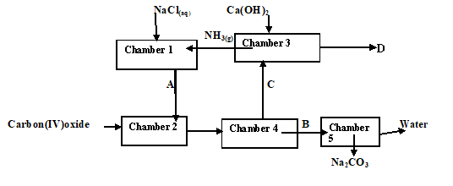

(a) Name substances **A**, **B**, **C** and **D**. (4mks)

**A**

……………………………………………………………………………………………….. **B**

………………………………………………………………………………………………..

**C**

………………………………………………………………………………………………………….

**D**

……………………………………………………………………………………………………………

(b) Write equation for the reactions taking place in chamber 2, 3 and 5. (3mks)

**Chamber 3**

…………………………………………………………………………………………………………………………………………………………………………………………………………………………

**Chamber 5**

………………………………………………………………………………………………………………………………………………………………………………………………………………………..

**Chamber 2**

…………………………………………………………………………………………………………………………………………………………………………………………………………………………

(c) Name the physical process in chamber 4 and 5. (2mks)

**Chamber 4**

……………………………………………………………………………………………………………

**Chamber 5**

……………………………………………………………………………………………………………

(d) Name **one** source of carbon (IV) oxide for Solvay process. (1mk)

……………………………………………………………………………………………………………………………………………………………………………………………………

(f) give 2 uses of sodium carbonate (1mk)

………………………………………………………………………………………………………………………………………………………………………………………………………………………………………………………………………………………………………