**Name___________________________________________ Index No.____________**

**Candidates signature ____________________ Date __________________**

**PHYSICS**

**PAPER 3**

**PRACTICAL**

**2 ½ HOURS**

**JOINT EXAMINATION TERM 3 2023**

**INSTRUCTIONS TO CANDIDATES**

* Answer all questions in both sections in the spaces provided in the question paper.
* Read the whole paper carefully before commencing your work.
* Marks are given for clear record of the observations actually made, their suitability and accuracy and the use of them.
* Mathematical tables and electronic calculators may be used.

**FOR EXAMINER’S USE ONLY**

|  |  |  |
| --- | --- | --- |
| **Question** | **Maximum Score** | **Candidate’s Score** |
| 1. | 20 |  |
| 2. | 20 |  |
| **TOTAL** | **40** |  |

**This paper consists of 7 printed pages. Learners should check to ensure that all pages are printed as indicated and that no questions are missing.**

**Question 1**

You are provided with the following;

* Masses; 10g, 20g(2), 50g and 100g
* A helical spring with a pointer
* Metre rule or half metre rule

Proceeds as follows;

1. a) Suspend the helical spring vertically, alongside the clamped half metre rule as shown in figure 1 below. Determine the length, L0 of the spring before loading it.

L0=________________________________(cm) (1mk)

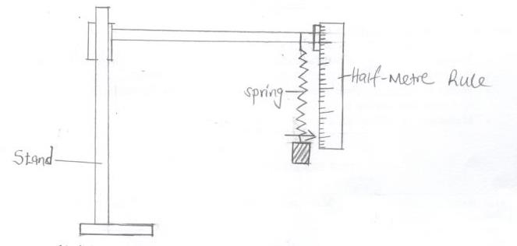

1. i) Load the spring with a mass of 20g and determine the new reading on the metre rule (L).

ii) Record this in the table below.

iii) Calculate the extension, e= L-L0 due to the mass of 20g and record the value in the table given below.

1. Repeat step b(i-iii) for other masses and complete the table. (8mks)

|  |  |  |  |  |  |  |  |  |  |  |
| --- | --- | --- | --- | --- | --- | --- | --- | --- | --- | --- |
| Mass (g) | 0 | 20 | 30 | 40 | 50 | 60 | 70 | 80 | 90 | 100 |
| Weight (N) (Force) |  |  |  |  |  |  |  |  |  |  |
| Reading L (cm) |  |  |  |  |  |  |  |  |  |  |
| Extension e (cm) |  |  |  |  |  |  |  |  |  |  |

1. Plot a graph of Force(N) against extension e (cm). (5mks)

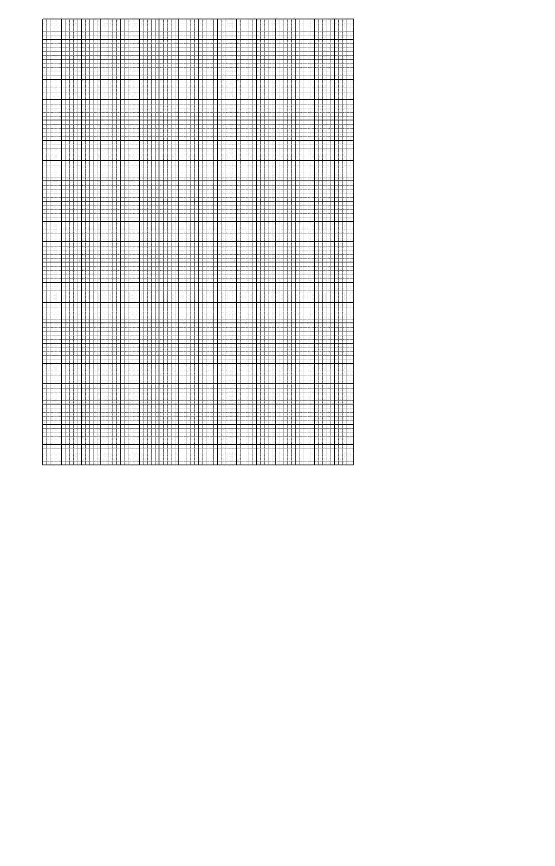

1. Determine the slope S of the graph. (3mks)
2. Given that K=Se, determine the value of K where S is the slope of the graph and e is the extension of the spring when loaded with a 50g mass. (3mks)

**Question 2**

You are provided with the following;

* A Nichrome wire mounted on a millimeter scale YZ.
* A carbon resistor R (10Ω)
* 8 connecting wires
* Ammeter
* Voltmeter
* 2 dry cells
* Cell holders
* Switch

1. (a) Set up the circuit as shown below.



1. Record the voltmeter reading when the switch is open.

E=_____________________________________ (1mk)

1. Close the switch and record the voltmeter and ammeter readings.

Voltmeter reading, V=_______________________________ (1mk)

Ammeter reading, I=________________________________ (1mk)

1. Explain why V is less than E. (2mk)

______________________________________________________________________________________________________________________________________________________________________________________________________

1. Now connect the voltmeter across the carbon resistor R and record voltmeter reading V1 when the switch is on. (1mk)

V1=

1. Determine R given that; R= $\frac{V_{1}}{I}$ (3mks)

(b)

1. Measure and record the diameter, d of the resistance wire (YZ) using a micrometer screw gauge.

d= ___________________________________mm

d=___________________________________m (2mks)

ii) Set-up the circuit as shown in figure;



1. Determine the current I flowing in the circuit.

I=__________________________________ (1mk)

1. Now connect the voltmeter across wire (YZ) and record the p.d, V2 across wire YZ.

V2= ________________________________ (1mk)

1. Determine the resistance R of the wire YZ. (3mks)
2. Determine k, the resistance per metre of wire YZ. (2mks)
3. Determine Q given that Q= $\frac{{πkd}^{2}}{4}$ (where d is in metres) (2mks)