**9 Asexual reproduction and cloning in plants**

Self-assessment questions 9.01

**1** In natural vegetative propagation, which of the following structures are most likely to give

rise to new individuals: (a) stems, (b) roots, (c) buds, (d) leaves, (e) flowers?

**2** The drawing shows a plant which reproduces vegetatively.

(a) What will need to happen before shoots A - C become independent plants?

(b) How might a gardener assist this process?

(c) What name is given to the horizontal stem in this kind of propagation?

(d) Name a commercially grown fruit whose plants are propagated in this way

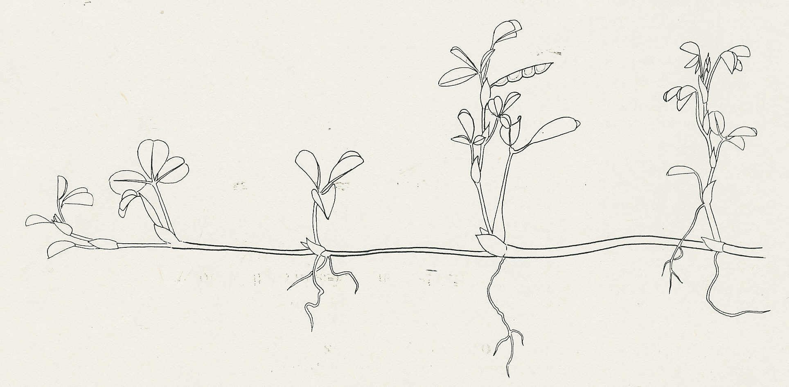

A

C

B

**3** Before stem cuttings are planted, the cut end of the stem is often dipped in a hormone

powder. What is the point of this?

**4** The following are thought to be some of the advantages of either vegetative reproduction or sexual reproduction:

produces greater variety in the offspring, good at colonising new areas, reduces competition

from other species, maintains desirable qualities in the offspring, good at colonising favourable

areas

Make a table with these qualities under the headings of 'Sexual reproduction' and 'Vegetative reproduction'.

**5** If a gardener wanted to propagate a useful variety of apple tree in a way which maintained all its desirable qualities, which of the following techniques would be used:

(a) planting stem cuttings in potting compost

(b) grafting stem cuttings onto a rootstock

(c) grafting buds on to a root stock

(d) growing the seeds produced from the useful variety

(e) cross-pollinating the variety with another good variety and growing the seeds

resulting from the cross?

**6** What name is given to the population of genetically identical offspring which result from a

process of asexual (vegetative) reproduction?

**7** Which structures of a flowering plant give rise to (a) potatoes, (b) the fleshy scales of an onion?

**8** In the process of tissue culture in plants, what is needed to induce the formation of a complete plant, in addition to a growth medium with nutrients?