**16 Human Reproduction**

Self-assessment questions 16.01

**1** Fertilisation occurs when the …..(A)….. of the sperm cell fuses with the…..(B) ….. of the

….. (C) ….. .

**2** State the differences between the male gametes and the female gametes with regard to

(a) their size; (b) their structure, (c) their relative numbers.

**3** Before fertilisation can occur, the sperms have to travel from the testes to meet an ovum in the female organs. Using the list below, name the organs, in the correct order, through which the sperms will have to pass.

*uterus, sperm duct, oviduct, urethra, cervix, vagina*

**4** (a) Explain what is meant by ovulation.

(b) How often does it occur in humans?

**5** Explain why the chance of fertilisation in humans is restricted to only a few days each

month.

**6** The diagram below represents the events leading up to fertilisation (v), implantation (vi) and development. In each case name the structures involved and, at the numbers, state briefly what is happening or what has happened previously.

(v)

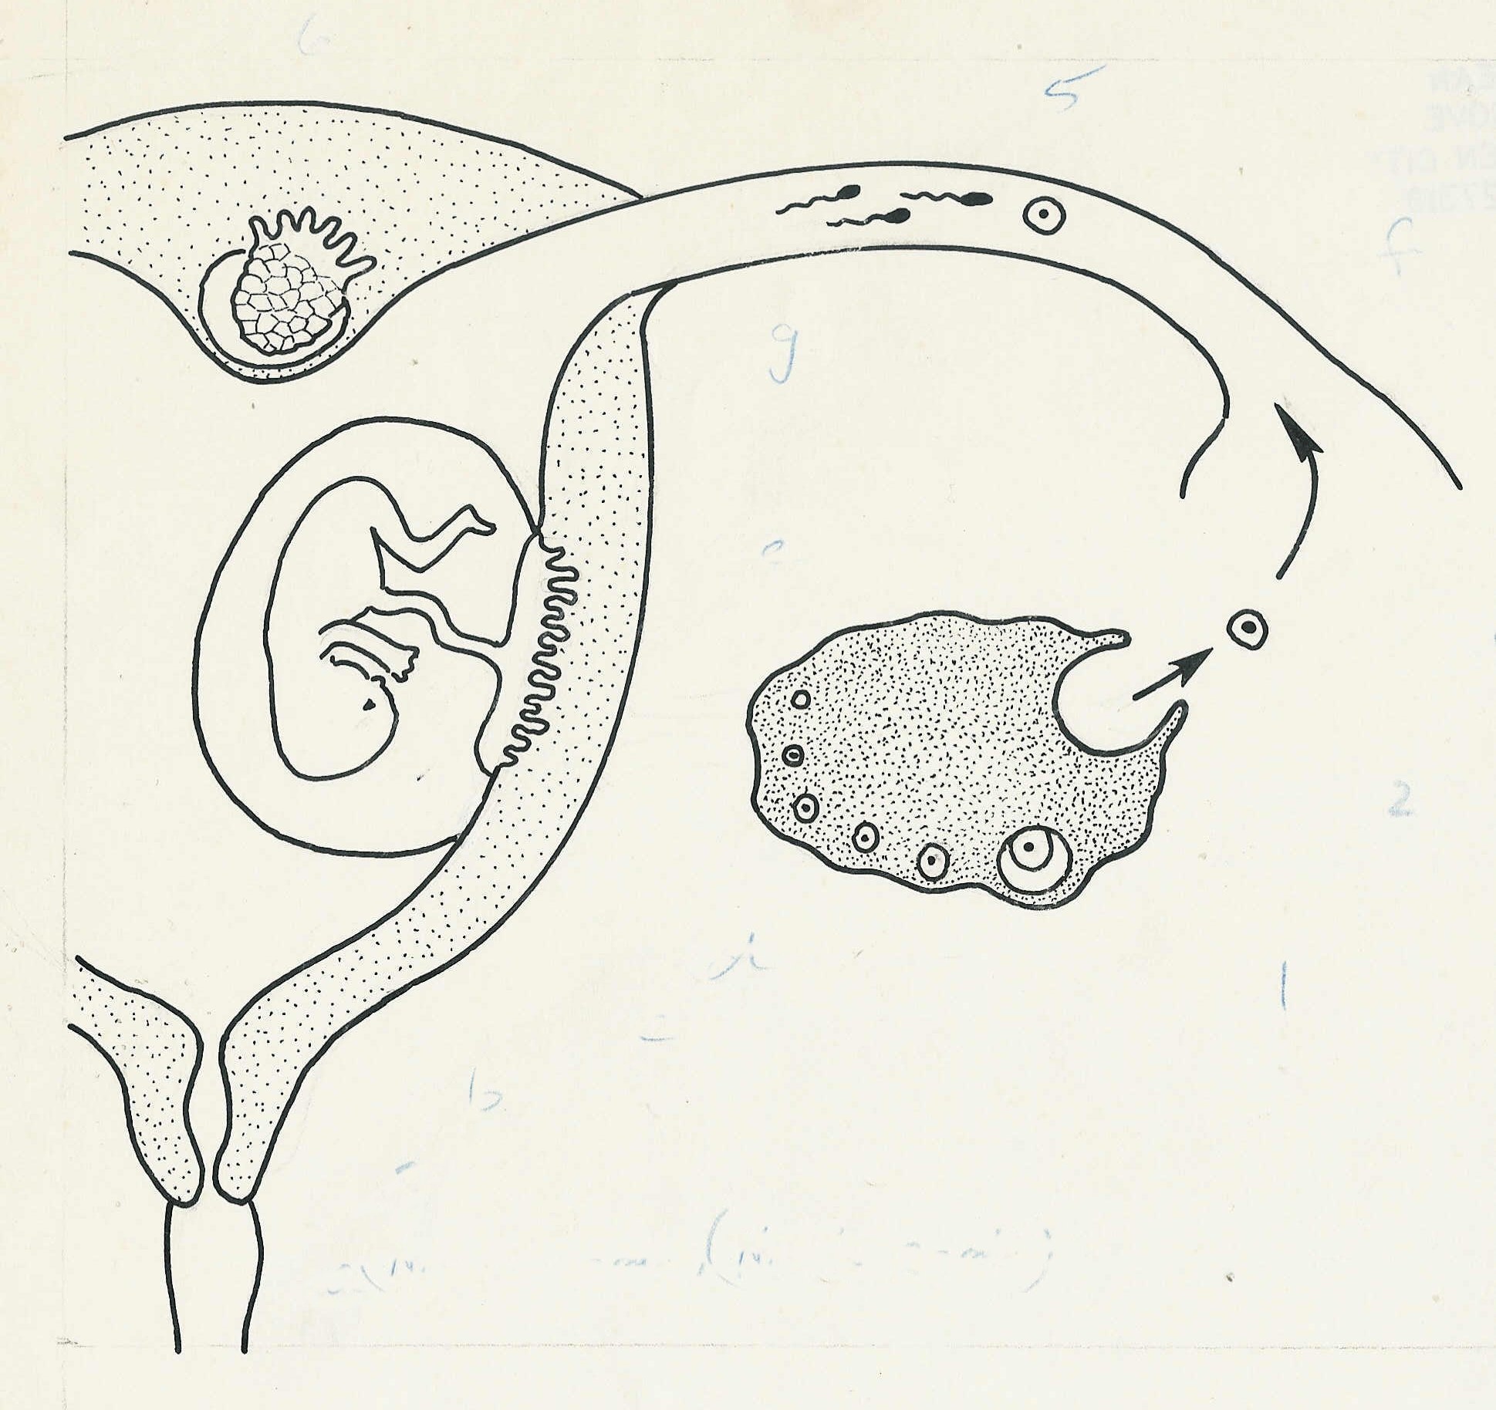

F

(vi)

E

G

(iv)

C

(ii)

(i)

D

B

(iii)

A

**7** Blood from the fetus circulates through the placenta.

(a) What substances pass (i) from the maternal to the fetal blood, (ii) from the fetal to the

maternal blood?

(b) By what means is the fetal blood circulated through the placenta?

**8** What is the function of the umbilical cord?

**9** What are the possible effects on the fetus if, during pregnancy, the mother (a) smokes,

(b) catches rubella?

**10** Describe the events which lead to the formation of (a) identical twins, (b) fraternal twins.

**11** At an ante-natal clinic what can (a) blood tests, (b) urine tests reveal?

**Human reproduction (continued)**

Self-assessment questions 16.02

**12** Place the following events in the correct order for natural childbirth.

*amniotic fluid expelled, placenta expelled from uterus, baby's feet emerge from vagina,*

*abdominal contractions begin, baby' head emerges from vagina, amnion breaks, cervix*

*dilates, contractions of the uterus begin .*

**13** (a) What are the advantages of human milk over cows' milk for feeding babies?

(b) Apart from the composition of the milk, what are the other advantages of breast-

feeding?

**14** Name (a) the male sex hormone and (b) the female sex hormone which help bring about

the changes at puberty .

**15** After ovulation (a) what structure replaces the Graafian follicle, (b) what hormone does it

produce?