**GENETICS**

1. a) - Ribonucleic acid

- Has the base ‘U’ uracil

b) -G- C –A – G

2. RNA DNA

a) Has ribose sugar Deoxyribose sugar

b) Has uracil as one Has thyamine of its bases

c) Single strand Double strand

3. Haemophilia (sickle cell anaemia)

4. Controls / regulates enzyme / synthesis for the material for inheritance.

5. Gametes form new offspring

6. Co-dominance / incomplete dominance

7. - High yielding Hybrid vigour

- Resistance to disease, early maturity.

Resistance to drought early maturity.

8. Y Chromosome – Hairy pinna, tuft and hair sprouting from the pinna, baldness.

X Chromosome – Colour blindness; Haemophilia

9. a) Smooth seed coat is dominant to wrinkled seed coat. Let R represent gene for

smooth and parental genotype RR x rr

R R r r

|  |  |  |
| --- | --- | --- |
|  | R | R |
| R | Rr | Rr |
| R | Rr | Rr |

All F1 are ………………….Rr

Parental genotypes Rr X Rr

Gamete

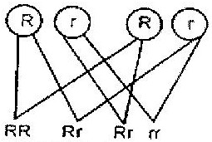

F2 genotypes

i) Genotypic ratio 1RR : 2Rr: 1rr

ii) Phenotype ratio 3 smooth: 1 wrinkled

iii) Wrinkled number ¼ x 7324 = 1831

10. a)

Parental genotypes RR x WW

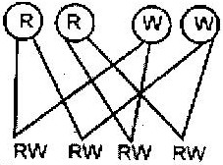 Gametes

F1 genotypes

b) 1:2:1 for ratio, 1 white: 2 pink: 1 red

c) Co-dominance / incomplete dominance / partial dominance / equal dominance.

11. a) White

- Fewer number / lower rates / absence of white in parent and its presence in offspring.

b) Heterozygous/ Rr

c) Homozygous / rr / double recessive.

12 a) i) Haemophilia

ii) Sickle cell anaemia

iii) Colour blindness

iv) Leukemia

v) Albinism

b) i) Inversion- A result of a chromosomal break up and rejoining with the

middle piece turned by 1800

ii) Translocation- A section of chromosome breaking and joining a

homologous chromosome.

c) Phenotype: Black mice x Brown mice

Genotype Bb x bb

Gametes B b b b

F1 genotype Bb Bb bb bb

Phenotype 2 black : 2 brown

13. a) It is alternative form of a chromosome been similar in structure but may have

different composition.

b) i) Occurs when the nucleotides of a gene break off and disappear

ii) Occurs when the nucleotides of a part of a gene become inverted by taking

a 1800 turn.

c) Testing the genotype of an individual by crossing with the recessive trait.

14. a) i) Parents Homozygous x Heterozygous phenotype purple grains purple

grains

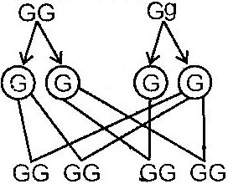 Genotype

Gametes

1st filial generation

(Off springs)

- The genotype ratio:

- 2 homozygous purple coloured grains

- 2 heterozygous purple coloured grains

ii) All purple coloured grained maize plants maize plants.

b) Deliberate modification of a characteristics are of an organism by manipulates genes and DNA by transferring genes from one organism to another.

c) It is when best characteristics are developed from both parents and offspring better than either parent.

15. i) Alleles are alternative forms of the same gene which control the inheritance of

contrasting features of the same position in homologous chromosomes.

ii) Genotype is the genetic makeup or composition of an organism.

iii) Phenotype is the outward appearance of an organism with reference to a particular trait.

16. a) The genes for dark red colour and white colour are co-dominant. Since the calf

is heterozygous it gets a coat colour that is intermediate between dark red and white

b) Let R represent the gene for dark red coat colour and W the gene for white coat colour. The light red bull must be heterozygous (RW) and the dark red cow must be homozygous (RR)

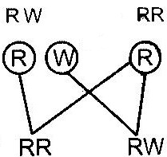 Parental phenotypes Light red x dark red

Parental genotype

Gametes

Offspring genotypes

Offspring phenotypes Dark Red Light red

17. a) Linked genes are those genes that are found in the same chromosomes. They

are usually inherited together.

b) These observation show that eye colour in fruit flies is a sex-linked trait. Since

it is well known that the Y chromosomes carries very few genes, we can assume that eye colour in fruit flies is an x-linked trait.

- When a true-breeding, red-eyed female is mated with a white-eyed male, all the

offspring received an X-chromosome carrying the dominant gene from the mother. Because of this, they all develop red eyed. This is illustrated below.

Parental phenotypes Red eyed female x white eyed m

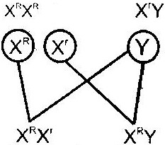 Parental genotype

Gametes

Offspring genotypes

Offspring phenotypes Red eyed Red eyed

females males

When a true breeding white eyed female is mated with a red-eyed male, the female offspring receive an X-chromosome carrying the dominant gene from the father and develop red eyed. The male offspring received an X-chromosome carrying the recessive gene from the mother. They also receive a Y chromosome contains no genes for eye colour the male offspring develop white eyes.

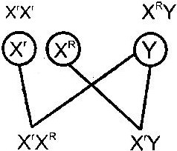i) Parental phenotypes White eyed female x Red eyed male

Parental genotype

Gametes

Offspring genotypes

Offspring phenotypes Red eyed White eyed

females males

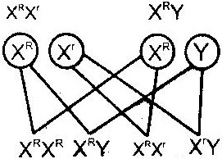ii) Parental phenotypes red eyed female x white eyed male

Parental genotype

Gametes

Offspring genotypes

Offspring phenotypes Red eyed White eyed Red eyed White eyed

Females Males females males

18. a) Variation refers to the difference in specific characteristics that exist between

members of a species e.g. in humans, characteristics that exist between members of a species e.g. in human, characteristics such as height, blood group.

b) Discontinuous variation refers to the existence of two or more distinct forms

between them e.g. pink or white flowers in pea plants

- Continuous variation refers to the existence of a characteristic in a continuous gradation between two extremes e.g. height, weight and fruit size in trees.

c) Genetic variation provides the raw materials for evolution by natural selection. It increases the chances of survival in an ever-changing environment. If a particular species is highly adapted to a specific habitat, it might find it difficult to survive in case there is a sudden change in the environmental conditions. In absence of variation, such a change may lead to death of all members have a variation that adapts them to the new conditions they will survive. They will reproduce and multiply rapidly in the absence of competition from other forms. Since the variation is genetic, the adaptation is passed on to subsequent generations.

d) When DDT was first used in the 1950’s it was very effective in killing mosquitoes. In areas where mosquito populations were previously large, their numbers were greatly reduced. However, in the 1960’s the number of mosquitoes in these areas began to rise again despite the continued application of DDT.

- It then became evident that a few mutant forms had a variation that made them resistant to DDT. In the absence of competition from other forms, the resistant forms reproduced and multiplied very fast. The result was that the number of mosquitoes started to arise again despite the continued application of DDT. Thus the presence of a variation in the few mutant forms saved mosquitoes from extinction.

19. a) They represent the bases guamine, thymine, cytosine, adenine

b) It is a DNA strand because it contains the base thymine which is absent in RNA.

c) C A A T C G A C T

d) C A A T C G A C U

20. Human females produce one type of egg containing an X chromosome. Males produce two types of sperms; half contains a X-chromosome and the other half contains a Y chromosome.

Fertilization of the egg by a sperm carrying an X chromosome gives rise to a baby girl.

Fertilization of the egg by a sperm carrying a Y-chromosome gives rise to a baby boy.

Parental phenotypes Man x Woman

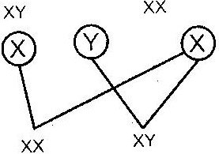 Parental genotype

Gametes

Offspring genotypes

Offspring phenotypes Girls Boys