**SUPPORT AND MOVEMENT IN PLANTS AND ANIMALS**

**PAST KCSE QUESTION ON THE TOPIC**

1. The diagram below represents in a mammalian bone

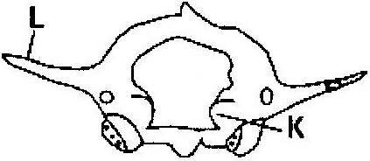

(a) State the function of the part labeled K and L ( 2 marks)

(b) State the region of the body in which the bone is found ( 1 mark)

1. State two ways in which skeletal muscle fibres are adapted to the function

( 2 marks)

1. The diagram below shows the arrangement of bones and muscles in a human arm.

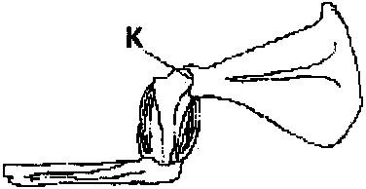

(i) Name the parts of the bone labeled K ( 1 mark)

(ii) How do the muscles work to extend the arm? ( 3 marks)

1. State three structural differences between biceps muscles and muscles of the gut

|  |  |  |
| --- | --- | --- |
|  | Biceps | Gut muscles |
| (i)  (ii)  (iii)  (iv) |  |  |

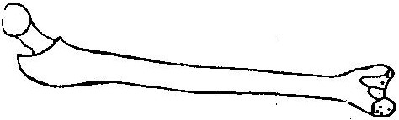

(a) Name the bone ( 1 mark)

(b) Name the type of joint formed by the bone at its anterior end with the adjacent bone ( 1 mark)

1. Give a reason why the lumbar vertebrae have long and abroad transverse processes ( 2 marks)
2. (a) Name the three types of skeletons found in multicellular animals

( 3 marks)

(b) Describe how the cervical, lumbar and sacral vertebrae are suited to their

functions ( 17 marks)

1. A bone obtained from a mammal is represented by the diagram below

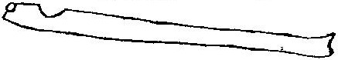

(a) Name the bone ( 1 mark)

(b) Which bones articulate with the bone shown in the diagram at the notch?

( 2 marks)

1. (a) Name the cartilage between the bones of the vertebral column

( 1 mark)]

(b) State the function of the cartilage in (a) above ( 1 mark)

1. How are xylem vessels adapted for support? ( 1 mark)
2. 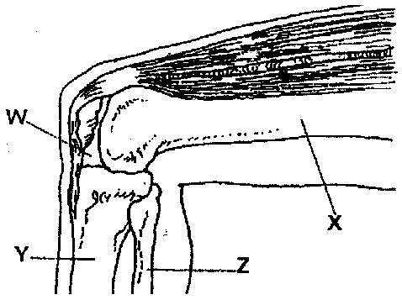The diagram below represents bones at a joint found in the hind limb of a mammal

(a) Name the bones labeled X, Y, and Z ( 3 marks)

X _______________________

Y _______________________

Z _______________________

(b) (i) Name the substance found in the place labeled W ( 1 mark)

(ii) State the function of the substance named in (b) (i) above

(c) Name the structure that joins the bones together at the joint ( 1 mark)

(d) State the differences between ball and socket joint and the one illustrated in the diagram above ( 1 mark)

(e) Name the structure at the elbow that performs the same functions as the patella ( 1 mark)

1. (a) State a characteristic that is common to all cervical vertebrae

(b) Name two tissues in plants that provide mechanical support ( 2 marks)

1. (a) Name the three types of muscles found in mammals and give an example

of where each on of them is found

(b) State the difference between ball and socket and hinge joint ( 1 mark)

1. State three functions of an insects exoskeleton (3 marks)
2. State the function of the following fins of a fish
   1. Dorsal fin ( 1 mark)

(b) Pectoral and pelvic fins ( 1 mark)

(c) Caudal fin ( 1 mark)

1. State the diagnostic features of the cardiac muscles ( 3 marks)

The following figure is a part of a pelvic girdle known as the innominate bone

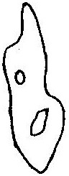

(a) Make a complete drawing of the girdle ( 1 mark)

(b) Name the bones that articulate with the pelvic girdle. In each case name the part that articulates with ( 2 marks)

1. Distinguish between tendons and ligaments ( 2 marks)
2. Explain what antagonistic muscles are and give an example ( 4 marks)
3. (a) Name three types of strengthening tissues found in plants ( 3 marks)

(b) Explain how the tissue in (a) above are adapted to their functions

( 3 marks)

1. (a) Name the three main types of joint ( 3 marks)

(b) Give an example of where each type of joint name in (a) above is found in the human body ( 3 marks)

1. What makes young herbaceous plant remain upright? ( 2 marks)]
2. Name three types of muscles found in the human body, state where each type is located and how each is adapted to its functions. ( 12 marks)