**24 Applied genetics - answers**

Self-assessment questions 24.03

**1** (a) The plant breeder would pollinate plant A with pollen from plant B (or vice versa).

The gametes would be (A) **HsHs**, (B) **hShS**.

When the gametes combined in the zygote, the seeds would all have the **HhSs** genotype.

Since **H** and **S** are the dominant alleles, the plants would all be high-yielding, short-

stemmed varieties (the F1 variety).

(b) When the **HhSs** variety produces gametes, these could be **HS**, **Hs**, **hS** or **hs** which, when

combined in the zygote, could produce four varieties of offspring; some of which might be

short-stemmed / high yield; short-stemmed / low yield; long-stemmed / low yield, or long-

stemmed / low yield.

**2** In genetic engineering, a *gene* (A) from one organism is introduced into the *genome* (B) of an unrelated organism.

**3** An enzyme which is used to cut DNA at specific sites is called a *restriction enzyme*.

**4** The cells structures in bacteria which carry genes intended for genetic engineering are called *plasmids*.

**5** Useful producs of genetic engineering are *chymosin, Alpha-anti-trypsin, hepatitis B vaccine,*

*and insulin* (any three)

**6** The gene for insulin is ‘cut’ from the appropriate strand of DNA using restriction enzymes. Plasmids are extracted from bacterial cells and ‘opened up’ using the same restriction enzymes and the insulin gene is inserted in the gap. The recombinant plasmids are inserted into bacteria which then produce insulin.

7 Genetic engineering of crop plants can improve resistance to pests, retard ripening, improve uptake of ions from the soil, increase the vitamin content of the crop. In the future, genetic engineering might improve drought resistance and salt tolerance.

**8** (a) DNA fragments, in solution, are placed at one end of a sheet of gel and an electric current

is applied which separates the fragments.

(b) The size of the fragments determines how rapidly they move through the gel. Smaller

fragments travel faster and further than larger fragments.

S3

S2

S1

CS

V

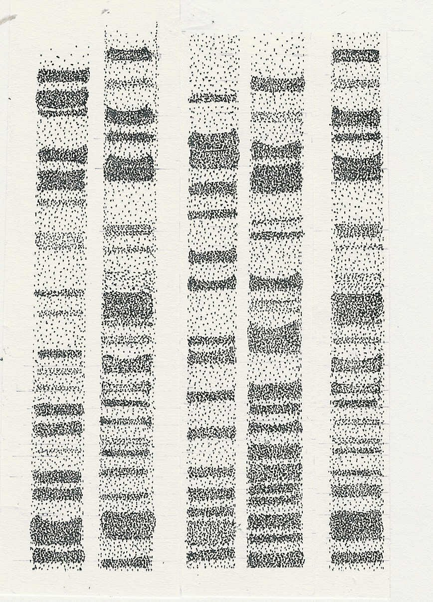

**9** (a) Suspect S3 is the most likely to be guilty

(b) The greatest correspondence in the position of

the bands at the crime scene is with those of suspect 3.

(not all the relevant lines are drawn here)

Self-assessment questions 24.04

**Applied genetics - answers (continued)**

**10** (a) Stem cells can continue to divide throughout their life.

(b)The special characteristic of embryonic stem cells is that they can develop into any kind of

cell and in some animals (e.g. amphibia) into complete organism.

**11** Embryonic stem cells can be derived from individual cells of an early embryo, from blood cells in the umbilical cord of mammals and from cultures of stem cells.

**12** The advantage of using stem cells from the patient being treated is that they will not be rejected by the patient’s immune system.