**21 Cell division and chromosomes**

Self-assessment questions 21.01

**1** A cell in the basal layer of the skin contains 46 chromosomes and divides by mitosis to produce new skin cells. After ten successive divisions, how many chromosomes will the

basal cell have?

**2** The drawings below depict stages in the mitotic division of a cell

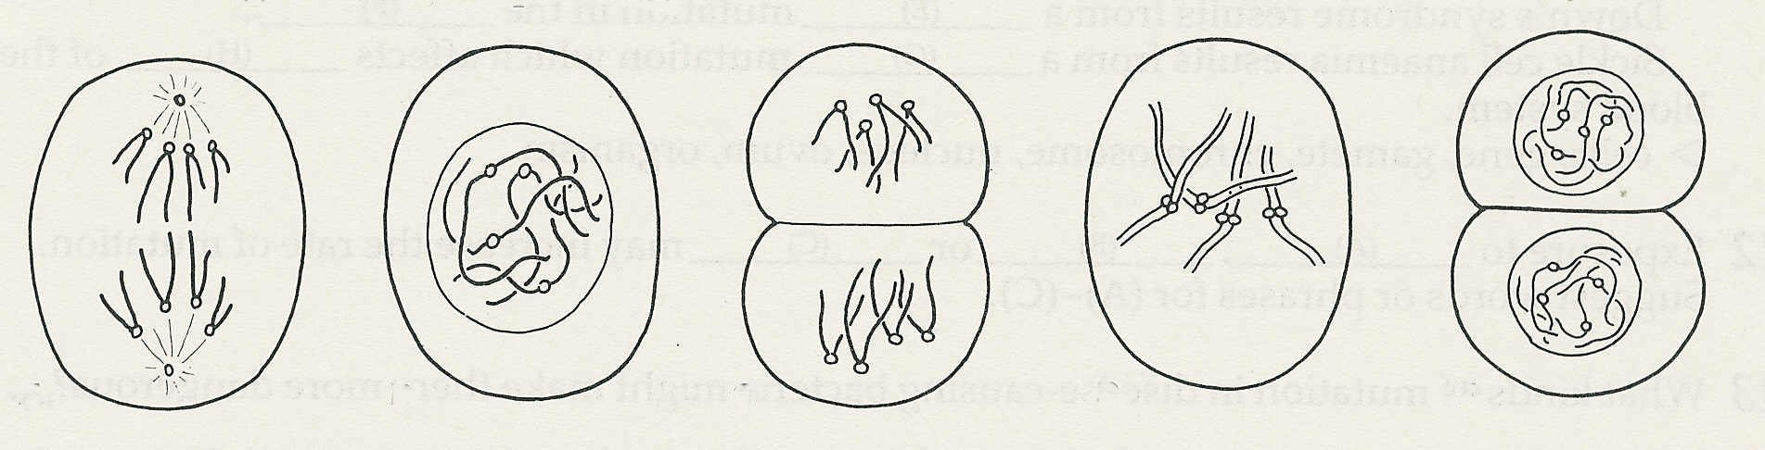

E

D

C

B

A

(a) Write the letters in the order in which these stages occur.

(b) How many pairs of chromosomes are there in the cell?

(c) What is the diploid number of chromosomes in these cells?

**3** Choose the most appropriate word to complete the sentence.

When chromosomes replicate, they produce ……...

*tissues, nuclei, chromatids, somatic cells*

**4** In which three of the following cells is mitosis unlikely to occur?

a sperm cell, an epithelial cell of a villus, a hair cell, a cell in the red bone marrow, a red blood

cell, a lymphocyte, a cell in the basal layer of the skin

**5** An animal has 36 chromosomes in each of its body cells. How many of these chromosomes came from its male parent?

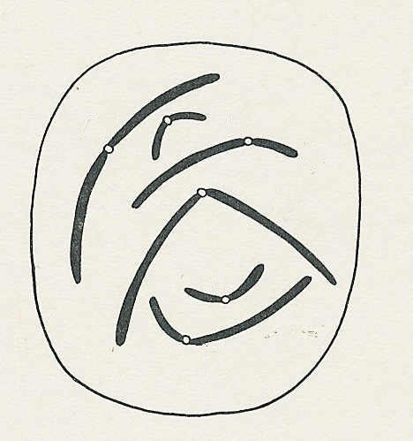

**6** Which pairs of chromosomes in the cell shown here

B

A

are homologous?

C

D

**7** Fill in the missing words.

E

The ….. A ….. of a cell contains a fixed number of

chromosomes. Before mitosis, each chromosome

F

….. B ….. to produce two ….. C …...

**8** The following drawings-show the sequence of events early in cell division.

(a) Is the division meiotic or mitotic?

(b) How do you know?

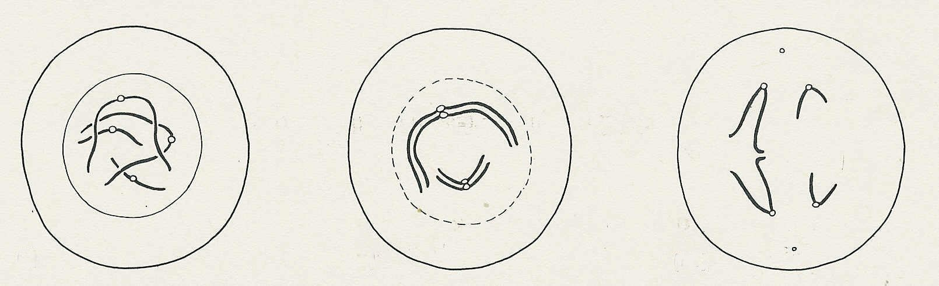

(iii)

(ii)

(i)

**9** Give two examples in each case of organs or tissues in which you would expect

(a) meiosis, (b) mitosis to be taking place.

**Cell division and chromosomes (continued)**

Self-assessment questions 21.02

**10** A fruit fly has four pairs of chromosomes in its cells. At meiosis, how many different

combinations of maternal and paternal chromosomes are possible in the gametes?

**11** From the list below, choose the most suitable words to complete the sentence.

Mutations are changes which occur in a ….. A …..or a ….. B …... If a mutation

occurs in a cell which is going to form a ….. C ….., the mutation may affect the whole

….. D ….. which develops.

Down's syndrome results from a ….. E ….. mutation In the ….. F…..

Sickle cell anaemia results from a ….. G ….. mutation which affects ….. H ….. of the

blood system.

*cells, gene, gamete, chromosome, nucleus, ovum, organism*

**12** Exposure to ….. A ….., ….. B ….. or ….. C ….. may increase the rate of mutation

Suggest words or phrases for A - C

**13** What kinds of mutation in disease-causing bacteria might make them more dangerous?