Introduction

INTRODUCTION TO NETWORKING AND DATA COMMUNICATION
Welcome!
Computers communicate to one another; however they should be interconnected (networked) in order for communication to take place. The best example where computers communicate to one another is through Internet or usage of mobile phones. A number of procedures and elements are needed in order for communication to take place. In this tutorial, we are going to learn the following topics:
- Definition of terms used in networking
- Types of computer networks
- Purpose and demerits of networking
- Elements of networking
- Network topologies and
- Network security
At the end of this topic therefore, you should accomplish the tasks listed above and be able to attempt assessments to clarify you understanding on logic

1.2 Definition of Terms Used in Networking

Definition of Terms Used in Networking

Network
A network is the infrastructure that supports electronic data exchange.Either, it can be defined as a collection of independent entities that are arranged to exchange data or resources

Computer Network
A computer network therefore can be defined as a collection of computers linked together using transmission media for the purpose of communication and resource sharing

Transmission Media
This is any physical or non-physical link between two or more computers and in which a signal can be made to flow from source to destination. These shared resources include:- application programs, printers, fax machines, modems, storage devices etc.
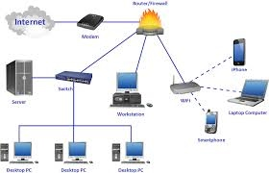

Data Communication
Data communication is a process of transmitting data signals from one point to another through the network.

Data Signal
A data signal is a voltage level in the circuit which represents the flow of data. data signal can either be digital or analogue

Modulation
This is a process by which the characteristics of electrical signals are transformed to represent information. Types of modulation include AM, FM, and PAM.i.e converting digital signal to analogue

Demodulation
This is a process of returning a modulated signal to its original form. Modems perform demodulation by taking an analog signal and returning it to its original (digital) form.

Multiplexing
This is the process of sending multiple data signals over the same medium

Demultiplexing
This is the process of separating the multiplexed signals at the receiving end

Bandwidth
This is the maximum amount of data that a transmission medium can carry at lany one time

Baseband Signal
This is a digital signal that is generated and applied tot he transmission medium directly without modulation

Broadband Transmission
An analogue signal is sent over the transmission medium using a particular frequency

Attenuation
This is a decrease in magnitude and energy as a signal progressively moves along a transmission medium

Repeater
A Physical Layer device which restores, amplifies, re-clocks or otherwise improves a network signal that it receives on one of its ports and transmits the improved signal without buffering or interpreting it.

Modes of data communication

Simplex
This is communication in only one direction e.g. radio broadcasting

Half Duplex
Refers to communication in both directions but one direction at a time e.g. using a walkie talkie

Full Duplex
This is communication that occurs in both directions simultaneously

1.3 Computer Network and Types

Computer Network
A computer network or data network is a telecommunications network that allows computers to exchange data.

Types of computer networks
There are different types of networks. Namely: Personal Area Network (PAN), Local Area Network (LAN), Metropolitan Area Network (MAN), Wide Area Network (WAN) and Internetwork
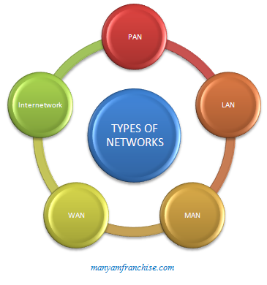
Note: KCSE Syllabus limits types of networks as LAN, MAN and WAN (students should stick with the syllabus)

Personal Area Network
A Personal Area Network or simply PAN, is smallest network which is very personal to a user. This may include Bluetooth enabled devices or infra-red enabled devices. PAN has connectivity range up to 10 meters. PAN may include wireless computer keyboard and mouse, Bluetooth enabled headphones, wireless printers and TV remotes for example. Piconet is an example Bluetooth enabled Personal Area Network which may contain up to 8 devices connected together in a master-slave fashion.
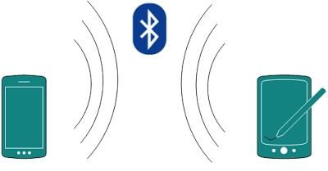

Local Area Network
A computer network spanned inside a building and operated under single administrative system is generally termed as Local Area Network. Usually, Local Area Network covers an organization’s offices, schools, college/universities etc. Number of systems may vary from
as least as two to as much as 16 million. LAN provides a useful way of sharing resources between end users. Resources like Printers, File Servers, Scanners and internet is easy sharable among computers.
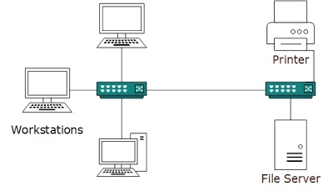

Metropolitan Area Network
MAN, generally expands throughout a city such as cable TV network. It can be in form of Ethernet, Token-ring, ATM or FDDI.
Metro Ethernet is a service which is provided by ISPs. This service enables its users to expand their Local Area Networks. For example, MAN can help an organization to connect all of its offices in a City.
Backbone of MAN is high-capacity and high-speed fiber optics. MAN is works in between Local Area Network and Wide Area Network. MAN provides uplink for LANs to WANs or Internet.
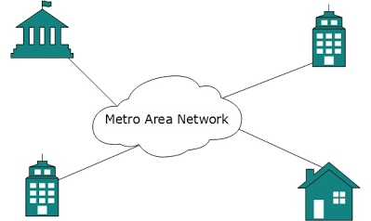

Wide Area Network
As name suggests, this network covers a wide area which may span across provinces and even a whole country. Generally, telecommunication networks are Wide Area Network. These networks provides connectivity to MANs and LANs.

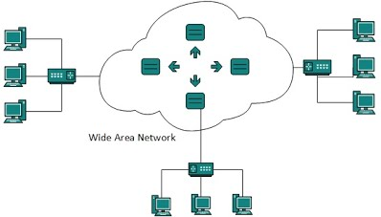

Internetwork
A network of networks is called internetwork, or simply Internet. It is the largest network in existence on this planet. Internet hugely connects all WANs and it can have connection to LANs and Home networks.
Internet enables its users to share and access enormous amount of information worldwide. It uses www, ftp, email services, audio and video streaming etc. At huge level, internet works on Client-Server model.
Internet uses very high speed backbone of fiber optics. To inter-connect various continents, fibers are laid under sea known to us as submarine communication cable.
Internet is widely deployed on World Wide Web services using HTML linked pages and is accessible by some client software known as Web Browsers. When a user requests a page using some web browser located on some Web Server anywhere in the world, the Web Server responds with the proper HTML page. The communication delay is very low.
Internet is serving many proposes and is involved in many aspects of life. Some of them are:
- Web sites
- E-mail
- Instant Messaging
- Blogging
- Social Media
- Marketing
- Networking
- Resource Sharing
- Audio and Video Streaming

1.4 Purpose and Limitations of Networking

Purpose and Limitations of Networking

Purpose of Networking
Computer networking has various purposes which include:
resource sharing, remote communication, distributed processing facilities, cost effectiveness and reliability.

Resource Sharing
Anything available on the same network environment is referred to as a resource this include: printers, fax machines, data/information, modems, files etc.
Resource sharing is the idea of computers sharing resources in a common network. For example: in a computer lab, all computers can be able to share the same printer or scanner. Also information can be shared in all computers
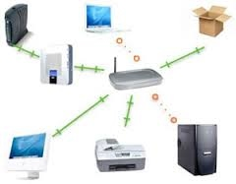

Remote Communication
Remote communication refers to the transmission of data signals between two communication devices located at different locations. A computer that tries to access resources from another computer on the network is called a remote client while the computer being accessed is called a remote host.
Remote communication has been made possible by use of wireless transmission media such as radio waves, microwave and satellite

Distributed Processing Facilities
Distributed data processing is a computer-networking method in which multiple computers across different locations share computer-processing capability. This is in contrast to a single, centralized server managing and providing processing capability to all connected systems. Computers that comprise the distributed data-processing network are located at different locations but interconnected by means of wireless or satellite links.
Files reside on the user's computer rather than on a central computer. Branch offices in a large organization have their own servers that store data, information and other resources required for the daily operations. This servers would periodically update the central computer.

Advantages of Distributed Processing
- The failure of the central computer does not affect the operations of the other terminals (reliability)
- processing load is shared equally hence no time wastage (improved performance and reduced time wasting)
- Relatively cheap -Distributed data processing considerably lowers the cost of data sharing and networking across an organization by comprising several minicomputers that cost significantly less than mainframe machines.
- The system is flexible in sharing of processing activities also in terms of increasing or decreasing processing power. For example, adding more nodes or computers to the network increases processing power and overall system capability, while reducing computers from the network decreases processing power.

Cost Effectiveness
Even though the initial cost is higher, the savings experienced and the value added to service delivery make them a ready choose for enterprising managers. Networks greatly increase the efficient use of scarce resources thus saving operational costs

Reliability
A computer network is reliable because:
- Data can be transferred with minimum error from source to destination
- In case one computer breaks down, a user can still access data and information from other computers on the same network.

Advantages of Computer Networking

1. Easy Communication
It is very easy to communicate through a network. People can communicate efficiently using a network with a group of people. They can enjoy the benefit of emails, instant messaging, telephony, video conferencing, chat rooms, etc.

2. Ability to Share Files, Data and Information
This is one of the major advantages of networking computers. People can find and share information and data because of networking. This is beneficial for large organizations to maintain their data in an organized manner and facilitate access for desired people.

3. Sharing of Resources
Another important advantage of networking is the ability to share hardware/software. For an example, a printer can be shared among the users in a network so that there’s no need to have individual printers for each and every computer in the company. This will significantly reduce the cost of purchasing hardware.

4. Speed
Sharing and transferring files within networks is very rapid, depending on the type of network. This will save time while maintaining the integrity of files.

Limitations (Disadvantages) of Networking

Security Issues
Data and information is more prone to illegal access than where there is no networking. Computer crimes like tapping of information is common

High Initial Costs
Initial costs of acquiring network resources like hardware and software is high

Moral and Cultural Effects
Large networks like the internet have chat rooms and messaging services that enable underage children to meet peers and adults on the net some of whom may have bad intentions. e.g access to drugs information and pornographic contents

Spread of Terrorism and Drug Trafficking
The easy flow of information keeps even those who are on the wrong side of the law communicating easily. Terrorists and drug traffickers use information networks for their business communications

Over - Reliance on networks
All businesses these days is dependent on computer networks. And if a network fails, businesses will halt to a standstill and bring enormous losses.

Bandwidth Issues
In a network there are users who consume a lot more bandwidth than others. Because of this some other people may experience difficulties.
summary

Advantages and disadvantages of networks

Advantages
- Sharing devices such as printers saves money.
- Site (software) licences are likely to be cheaper than buying several standalone licences.
- Files can easily be shared between users.
- Network users can communicate by email and instant messenger.
- Security is good - users cannot see other users' files unlike on stand-alone machines.
- Data is easy to backup as all the data is stored on the file server.

Disadvantages
- Purchasing the network cabling and file servers can be expensive.
- Managing a large network is complicated, requires training and a network manager usually needs to be employed.
- If the file server breaks down the files on the file server become inaccessible. Email might still work if it is on a separate server. The computers can still be used but are isolated.
- Viruses can spread to other computers throughout a computer network.
- There is a danger of hacking, particularly with wide area networks. Security procedures are needed to prevent such abuse, eg a firewall.

