312/1
GEOGRAPHY
Paper 1
Time: 2¾ hours

SMARTPASS EXAMINATION
Kenya Certificate of Secondary Education (KCSE)
MODEL ONE 2019
312/1
Paper 1
GEOGRAPHY

INSTRUCTIONS TO STUDENTS

- This paper has two sections A and B
- Answer ALL the questions in section A. In section B answer questions 6 and any other TWO questions.
- All answers must be written in the answer booklet provided.

This paper consists of 4 printed pages. Candidate should check the question paper to ascertain
that all the pages are printed as indicated and that no questions are missing.

SECTION A (25 MARKS)
Attempt all questions in this section
- (a) Name the temperate grasslands found in the following countries.
(i) Canada (1 mark)
(ii) Russia (1 mark)
(b) Explain three ways in which desert vegetation adapts to environmental conditions.
(3 marks)
2. (a) What is micro-climate? (1 mark)
(b) Discuss four consequences of climate change. (4 marks)
3. (a) Describe plucking as a process in glacial erosion. (3 marks)
(b) The diagram below shows types of moraines in a valley glacier.
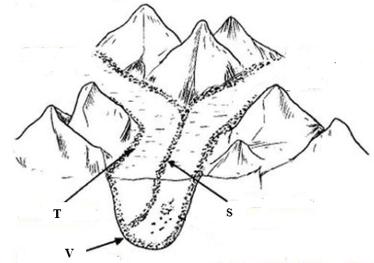
(i) Name the type of moraine marked S, T and V. (3 marks)
4. (a) Differentiate between magma and lava. (2 marks)
(b) Name two volcanic features found in the rift valley of Kenya. (2 marks)
5. (a) What is a karst scenery? (1 mark)
(b) Describe how a stalactite is formed in an underground feature in limestone areas. (4 marks)
SECTION B: Answer question six and another two
6. Use the map of Taita hills (sheet 189/4) provided and answer the questions below.
(a) Measure the length of dry weather road, D535, from the junction at grid 4028 to the east of the maps. (2 marks)
(b) What is the bearing of the pump house at grid 2918 from mwaturaje in grid 3215?
(2 marks)

(c) Calculate the area of the region below the all-weather road; bound surface A23 in
the South East of map . (2 marks)
(d) What is the magnetic declination of the map by the time the map was published?
(2 marks)
(e) Discuss the drainage of the area covered by map. (5 marks)
(f) Citing evidence from the map, state three social services offered in the area covered by the map. (3 marks)
(g) (i) Reduce the square by 2 within northings 26 and 31 and between eastings 37 and 42. (1 mark)
(ii) In it, indicate:-
-Ronge forest (1 mark)
-road D535 (1 mark)
-water reservoir (1 mark)
-out crop rock. (1 mark)
(iii) What is the new scale after reduction? (2 marks)
(h) Highlight two types of vegetation in the area covered by the map. (2 marks)

7. (a) Define the following terms:-
(i) Aridity (1 mark)
(ii) Desert (1 mark)
(b) (i) Name three descriptions of deserts based on the surface. (3 marks)
(ii) Give an example of a hot desert in Africa. (1 mark)
(c) Name and describe the three types of wind erosions in deserts. (6 marks)
(d) Explain three factors influencing wind deposition in deserts. (6 marks)
(e) (i) Name three features resulting due to action of water in desert areas. (4 marks)
(ii) What are the four positive significance of desert features to human activities?
(4 marks)
8. (a) (i) Define the term ‘solar system’. (2 marks)
(ii) Name four components of the solar system. (4 marks)
(b) (i) Which force is responsible for the flattening of the poles of the earth? (1 mark)
(ii) Give four proofs that the earth is spherical. (4 marks)
(c) (i) State four effects of revolution of the earth. (4 marks)
(ii) Supposing the local time at Greenwich meridian is noon (1200hrs). What is the
local time at a place A, 300E? (3 marks)
(iii) What is ‘equinox’? (1 mark)
(d) (i) Draw a well labeled diagram of the internal structure of the earth. (5 marks)
(ii) What is internal date line? (1 mark)

9. (a) (i) What is faulting? (2 marks)
(ii) Name three features resulting from faulting. (3 marks)
(b) With the aid of a well labelled diagrams, describe the formation of the rift valley by
tensional forces. (7 marks)
(c) (i) Give three ways in which faulting influences drainage. (3 marks)
(ii) Apart from tensional forces explain two other processes that may cause faulting.
(2 marks)
(iii) Name three types of faults. (3 marks)
(d) Discuss how features resulting from faulting is of significance to human activities.
(5 marks)
10. (a) (i) Differentiate between a watershed and a catchment area? (2 marks)
(ii) The diagram below shows a hydrological cycle.

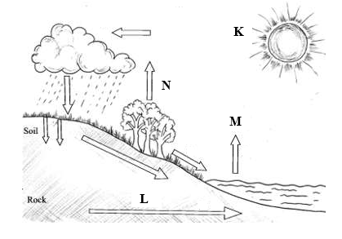
What processes do the arrows labelled K, L, M and N represent? (4 marks)
K
L
M
N
(b) (i) What is a lake? (2 marks)
(ii) Give three reasons why some lakes in Kenya are saline. (3 marks)
(c) (i) Apart from L. Magadi, name two other lakes within the rift valley in Kenya that have
a high level of salinity. (2 marks)
(ii) Highlight four man-made lakes in Kenya. (4 marks)
(d) (i) Describe the formation of a corrie lake. (5 marks)
(ii) Give three negative effects of lakes. (3 marks)

