312/1 SMARTPASS GEOGRAPHY PAPER 1 MARKING SCHEME MODEL ONE 2019
1 a) i) Canada – prairies. (1mk)
ii) Russia – steppes (1mk)
b) Some plants have long tap roots to enable them tap underground water.
- some plants have thick/fleshy leaves to enable them store water.
- some have thin/needle like leaves to reduce water loss.
- some plants have shining surfaces to reflect light.
- some plants have thorns to protect themselves from browsing animals.
- salt tolerant plants (halophytes) grow in areas with poor drainage, saline and alkaline soils.
- stomata of the leaves of some of these plants are protected from excessive exposure to evaporation by being sunken.
Any 3x1 = 3mks

- a) Refers to the climate experienced within a small or localized area which are slightly modified or different compared to the general climate of the region. (1mk)
b) Consequences of climate change include:-
- increased rainfall due to increased rates of evaporation.
- Global warming could result in the shifting of crop growing areas thus affecting agriculture.
- Disruption of natural ecosystem where some species of organisms would adapt to new conditions while others would become extinct.
- City environments becoming hotter due to increase .in levels of carbon dioxide.
- Abnormal fast growth of plants due to carbondioxide which is a natural plant fertilizer thus having a major increase in yields.
- Flooding due to rising sea level which is brought in the melting ice due to rise in temperature.
- Shifting of climatic and regeneration zone.
- Increased ultraviolet radiation which have a wide range of effects on human, animals and plant life. Eg destruction of paint, cause cancer.
Any 4 x 1 = 4mks

- a) Plucking as a process of glacial erosion. (3mks)
- Pressure from overlying mass of ice cause freeze and thus action.
- Melting water fills the cracks/joints in the bed rock.
- As water freezes it exerts pressure on the cracks enlarging them.
- The enlarged cracks lead to disintegration of the rock.
- The disintergrated rock eventually gets embedded within the mass of ice.
- As the ice moves it pulls/gouging out of the ice embedded rock from the parent rock.
3 x 1 = 3mks
b) S – Medial moraine
T – Lateral moraine
V- Terminal moraine

- a) Magma is molten rock material which originate from the interior of the earth and cools below the earth’s surface while lava is molten rock materials that has reached the earth and has lost the gaseous part. (2mks)
b) Lava plateau
crater/caldera
hotsprings/geysers. Any 2 x 1 = 2mks

- a) A karst scenery is a landscape in limestone areas that consist of both surface and underground features that have resulted from chemical weathering of limestone rocks. (1mk)
b) Carbon II Oxide dissolves in rain water to form weak carbonic acid. Weak carbonic acid reacts with limestone/chalk/dolomite rock on the surface of the earth to form calcium bicarbonate solution which pelolates into cave or caverns roof. On the roof of the underground cave evaporation takes place, water is lost and crystals of calcium carbonate are left behind hanging on the roof. Continuous percolation of calcium bicarbonate on the roof of cave, evaporation of water and formation of calcium carbonate crystals results in the elongation of the crystals hence forming a fertile called stalactite.
4 x 1 = 4mks

SECTION B
Q6. Use map of Taita hills (sheet 189/4) provided.
- 4.4km (4.3km – 4.5km) (2mks)
- 310 degrees+_1
c) Complete squares = 14
Incomplete squares=32/2 =16
--------
30
30 1 = 30
d) Magnetic declination (variation) (2mks)
e) Discuss drainage of the area covered by the map. (5mks)
- There has several/ a few rivers in the area covered by the map.
- The main river is river voi (goshi)
- Some rivers eg R.voi are forming dendritic drainage pattern.
- There are a few water reservoirs in the area covered by the map eg at grid 3926.
- Some rivers are short and disappearing.
- Swamp in the northern part of the map
any 5 x 1 mks

f) Social service evidence
- Educational service - presence of schools, youth polytechnic, technical school
- Water supply - presence of water supply and water pump at grid 2918 and 2919, water pipeline in N.W part of the map.
- Health/medical services - presence of dispensaries.
- Religious services - presence of churches
3x1 = 3 evidence must be present to score
g) i)
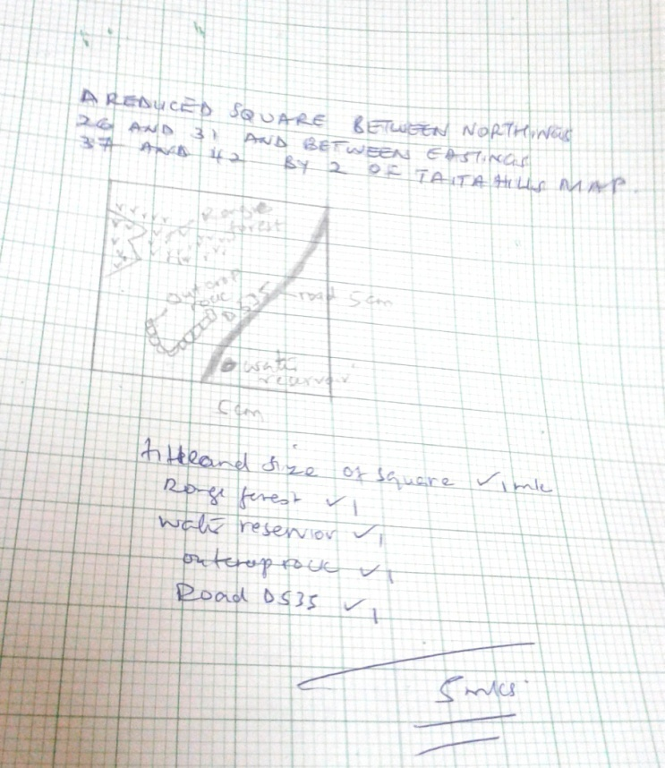
ii) new scale after reduction
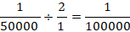

1:100000 2mks
h) types of vegetation in the area covered by the map.
- Scrub
- Scattered trees
- Thicket
- Forest
Any 2x1 = 2mks
7a) i) Aridity is the state of the land being deficient in moisture, leaching to scanity and consequently living conditions for plants and animals are hostile.
b) i) Sand deserts
- Stony deserts
- Rock deserts
- Bad lands
Any 3 x 1 = 3mks
ii) – namib
- Sahara
- Kalahari
Any 1 x 1 = 1mk
c) i) abrasion – world uses its load like samd particles to grind and polish the rock surfaces. Abrasion is effective near the ground.
ii) Deflation – The wind blows away any dry and unconsolidated materials like dust and fine sand particles by rolling them on the fround and then lifting them up in the air.
iii) Attrition – materials being transported by wind constantly collide against each other. This impact wears the materials out and reduce them in size.
2 x 3 = 6mks
d) – presence of obstacle such as rocks, bushes and shrubs in the path of wind creates friction as a result the wind drops some of its load.
- Strength and direction of wind – when wind slackens it begins to drop some of its load. When wind blowing from different direction meet collision occurs resulting in some of the load being dropped.
- Nature of desert surface – a desert surface made of bare rock allows wind to continue transporting its load while water surfaces in the desert impede transportation of materials close to the surface due to friction.
- Amount of load carried – if the wind is carrying too many particles they constantly collide among themselves causing some of them to be dropped.
State and explain 2 x 3 = 6mks
e) i) – inselbergs
- mesas and bultes
- Gorges
- wadis
- alluvial fans and bojadas
- playas and Salinas
- pediplans and pediments
any 3 x 1 = 3mks

ii) – some deflation hollows contain oases which are used as source of water for nomadic communities.
- Desert features such as rocks pedestal, yardangs, and sand dunes and tourist attraction.
- Desert landscape provide good sites for lesting military weaposeg nuclear bombs.
- The loss regions have fertile alluvial soils which are used for cultivation.
- Playas and sadines are economically and for salt production.
Any 4 x 1 = 4mks
8 a) i) solar system consists of the sun, the planets and other heavenly bodies such
as natural satellites, meteors and meteorites, asteroids (planetoids) and
comets. (2mks)
ii) – sun
- natural satellites
- asteroids (planetoids)
- comets-meteros and meteorites.
Any 4 x 1 = 4mks
b) i) centripetal force. (1mk)
ii) when on a plane or standing on a high ground the earth’s horizon appears curved.
- The areas in the east receive sunrise earlier than those in the west.
- When observed through a telescope, the planets and other heavenly bodies such as the natural satellites appear spherical and therefore since the earth is one of the planets it appears spherical.
- Photographs taken by satellites is far distances show that the earth is spherical.
- During the lunar eclipse, the eath’s shadow appears spherical only spherical/round objects give spherical or round shadows.
- When on a cliff at the harbor, an observer watching a ship moving to the port/harbor would first see the smoke and mast and as the ship nears the harbor the observer sees its whole body.
- When on a cliff at the harbor, an observer watching two ships approaching the harbor, one after the other, he sees the first one first and as the two ships are very close to the harbor, he sees the second ship.
Any 4 x 1 = 4mks
c) i) – causes four seasons.
- causes varying length of day and night.
Causes changes in position of midday sun at different times of the year.
- Causes the lunar eclipse.
Any 4 x 1 = 4mks
ii) 30
iii) Equinox – is a time during the year when the midday sun is overhead the equator on 21st March and 23rd September causing an equal length of day and night. (1mk)
d) i)

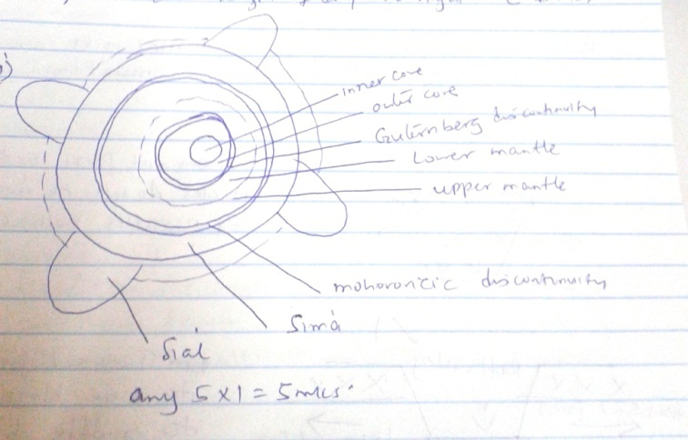
ii) An imaginary line drawn along longitude 1800 on a map avoiding water bodies upon crossing the line to the west a day is lost while a day is gained if crossed to the east. (1mk)

9. a) i) It is the fracturing or breaking of crystal rocks due to tectonic forces / earth
movements. (2mks)
ii) – Rift valley
- Horsts/block mountains
- Tilt blocks
- Fault steps
b) – crustal roks are subjected to tensional forces.
- tensional forces on the crustal rocks leads to development of parallel normal faults.
- tensional forces pulls the side blocks causing the middle block to subside forming a depression called the rift valley.
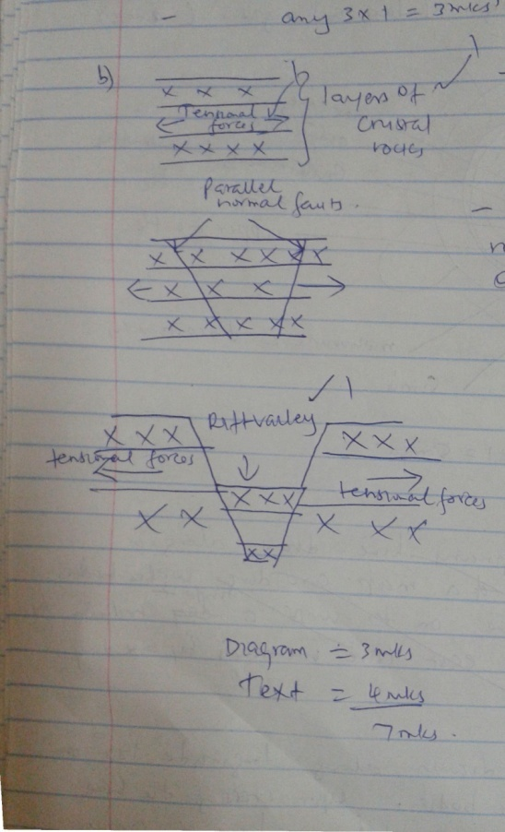

c) i) -vertical faulting across a river may cause a water fall
-when a fault occurs across a river, the river may disappear completely or change the direction of flow hence shortage of water down stream. -
-Leads to formation of lakes that are important fishing grounds, provide water for domestic use etc.
3 x 1 = 3mks

ii) – Faulting may occur due to vertical movements which may exert a strain in rocks making them to fracture
-faulting may occur where horizontal fores act parallel to each other in the opposite direction resulting in shearing.
-Faulting may be caused by compressional forces which causes rocks to squeeze hence rocks fracture causing faults.
2 x 1 = 2mks.
iii) – normal faults
- Reversed faults
- Shear/tear fault
- Anticlinal fault.
d) – block mountains formed through faulting experience relief rainfall on the windward side which favours agriculture, forestry and settlement.
- faulting leads to formation of features egriftvalley which forms beautiful sceneries which attract toursits earning country foreign exchange.
- rivers flowing over fault scarps may form waterfalls which may be suitable
sites for hydroelectric power production.
- faulting causes displacement of rocks which exposes minerals making mining easier.
- Faulting leadsto formation of lakes that are important fishing grounds/tourist sites/provide water for domestic use.
- subsidence of land as a result of faulting may lead to loss of life/property.
- faulting creates deep faults which are passage of steam jets which may be utilized for geothermal power production.
- when faulting occurs along a ridge it may provide a dep which could form a mountain pass where transport and communication lines could be constructed.
Any 5 x 1 = 5mks.
10. a) i) A watershed is a ridge line boundary separating drainage basins or rivers
systems while a catchment area is a wetland which a river draws its waters
from. 2 x 1 = 2 mks
ii) K- radiation/insolation/sun’s rays
L – Percolation
M – Evaporation
N – Evapotranspiration
4 x 1 = 4mks

b) i) A water body occupying a hollow/depression on the surface of the earth.
ii) Some lakes lack outlets which leads to accumulation of salt in waters.
- In hot and dry areas, the rate of evaporation is very high which increases the concentration and accumulation of the dissolved minerals salts in the lakes.
- Some lakes lack fresh water rivers emptying into dam and some are fed with underground water which contains a high concentration of salts which increases salinity.
- The rocks over which the lake water is in contact may contain mineral salts which add to salinity of the lake.
3 x 1 = 3mks
c)i) – L. Elementaita
- L.Bogoria
L. Nakuru
2 x 1 = 2mks

ii) – Masinga
- Kamburu
- Gitaru
- Kindaruma
- Kiambere
Any 4 x 1 = 4mks

d) i) A glacier occupy a preexisting hollow on the side of a mountain. Rocks from the glacier are embedded in the ice/glacier. Minimum rise in temperature or heavy weight causes the glacier to move gouging on the rocks. The embedded rock causes abrasion. The gouging causes compressing of the backward while abrasion causes deepening of the hollow. Continuous plucking and abrasion by the glacier leads to formation of a depression called corrie or carque.
Melt under or rain water occupies the depression and hence formation of a carrier lakes.
ii) overflooding of lakes causes destruction of property and loss of life.
Man-made or damaged lakes are transport barriers
Prevalence of water borne diseases to lakes eg malaria.
- Their construction eg human made lake leaders to displacement of people.

