312/2 SMARTPASS GEOGRAPHY PAPER 2 MARKING SCHEME MODEL ONE 2019
SECTION A
1. a) Horticulture is the practice of cultivating fruits, vegetables and flowers for sale mainly export while market gardening is the cultivation of fruits and vegetable for sale in the nearby town or urban centre. (2mks)
b) Characteristics of horticulture farming include:-
- Requires a lot of capital due to the high cost of input, labour and transport cost. (capital intensive)
- Intensively cultivated farms for maximum yields.
- Advanced scientific techniques are used to ensure high yields.
- It is labour intensive and most of work in the farm is done manually.
- Most farms are generally small in size and located near good and reliable routes which lead to markets of exporting centres.
Any 3 x 1 = 3mks
2. a) – Problems caused by floods include:-
- Floods create stagnant waters which form breeding places for vectors that spread water borne diseases eg mosquitoes and fresh water snail.
- Wash away crops leading to food shortage and famine.
- Cause loss of lives and destruction of property.
- Disrupt transport by carrying away bridges, roads etc.
- People are displaced or made homeless by floods.
- Floats pollute water sources with dirty water and silt.
Any 2 x 2 = 4mks
b) Environmental hazards include:-
- Floods
- pests and diseases
-fires
- pollution
- windstorms
- earthquakes
- volcanic eruptions
- ligtining
- drought
3. a) A polder is a low lying land reclaimed from the sea and enclosed by dykes.
b) – Fluctuation of River Perkerra due to water consumption and drought hence limited water for irrigating the lands.
- The cost of land preparation and inputs is high hence reduce the profit margin.
- Conflict between farmers and the pastoralists in which the livestock destroy crops and this leads to huge losses.
- Inter-ethnic conflicts between tugen and jemps which has led to tension in the area making it insecure to cultivate the land.
- The scheme is a tenant .scheme and the farmers do not own the land.
- Diversification into seed maize resulted in neglect of other crops.
Any 3 x 1 = 3mks
4. a) – African pencil/cedar
- podo
2 x 1 = 2mks
b) – Protect water sources/catchment areas. Hence waters in the rivers.
- Act as wind breakers hence reduce wind erosion.
- Provide humus to soil when leaves decompose which absorb most of the moisture.
- Control/reduce soil erosion by breaking force of failing rain/bird soil together.
- Protect and improve climate by preventing excessive evaporation from the bare ground.
Any 3 x 1 = 3mks
5. a) i) Veins and lodes – tin
- lead
- - Zinc
- Copper
- Silver
Any 1 x 1 = 1mk
ii) Alluvial/placer deposits
- Gold
- Tin
- Platinum
Any 1 x 1 = 1mk
b) Uses of soda ash include:-
- Making of glass
- Used as a water softener/water treatment
- Making detergents
- Used in paper industries/bleaching agent.
- Used in oil refining.
Any 3 x 1 = 3mk
SECTION B
6a)
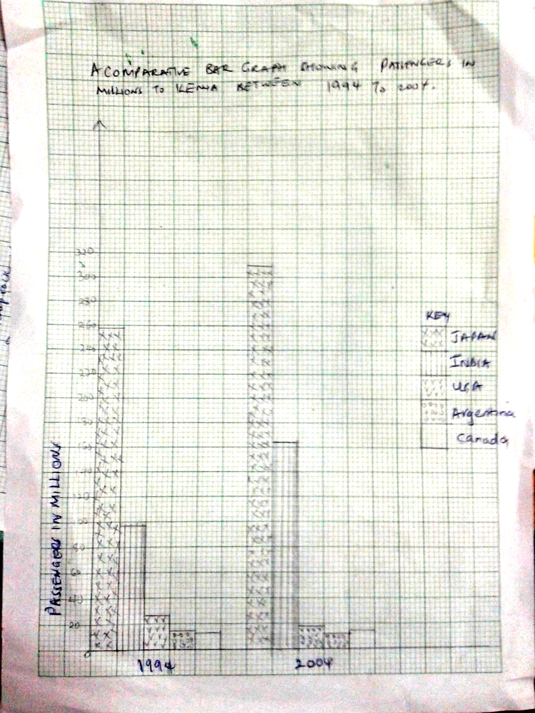
b)i)
163.8 67/96.8100=69.2 2mks
-96.0
-------
67.0
ii) Advantages of comparative bar graph include:-
- values in the same group can be compared easily.
- Individual contribution made by each variable in each group can be identified easily.
- It gives good visual impression.
- Can be used to present a wide range of data.
3 x 1 = 3mks
c) i)
- 500 canal
- Tent canal
- Welland canal
- Barge canal
- Rideau canal
Any 4 x 1 = 4mks
ii) – It has enabled the two continues to transport raw materials and finished products hence increased internal and international trade.
- Provides water for industrial use.
- The dams along the route provided hydroelectric power for industrial and domestic use.
- Source of foreign income.
- Creation of employment opportunities; those involved in the construction and modification of the sea way and those in different industries along the sea way.
- It formed a base for international relations.
- Development of lake ports and tours.
Any 3 x 1 = 3mks
d) – it has enhanced mobility of labour.
- it has promoted international understanding thus promote trade.
- Source of employment to many people eg. Broad casting, journalist etc.
- Communication has enabled exploitation of resources through opening of remote areas.
- It has enhanced implementation of government policies.
Any 4 x 1 = 4mks
7a) – It has led to rural-urban migration which has increased the urban population leading to congestion, increase in crime/shortage of houses.
- Industrial effluents pollutes water sources, polluting the water for human and animal use.
- Some industries have led to displacement of people therefore disrupting their social and economic life.
- Some industries emit toxic gases which are harmful to people and wildlife.
- Careless dispatch/dumping of industrial waste has led to degradation of land.
- Concentration of infrastructure and social services in industrial centres causes an imbalance in economic development.
Any 3 x 2 = 6mks

b) – leather tanning
- textile
- tobacco treatment
- creation of employment opportunities.
Any 2 x 1 = 2mks
c) i) Mombasa 1mk
ii) Webuye 1mk
iii) Nairobi/Thika/Mombasa 1mk
d) – Availability of coal, iron ore and limestone from the Rhine valley provided raw materials needed in the industry.
- The region is serviced by navigable river eg River ruh which provide cheap transport for bulky raw materials and finished products.
- River Rhire/Ruhr/R. Wupper provided water required for cooling machines in the industry/industrial use.
- The local population had acquired skills on iron working/availability of local skilled labour which formed the foundation of iron and steel industry.
- The dense population in Central and Western Europe, Germany provided ready market for iron and steel.
- Coal from Ruhr region/imported petroleum provided power required in the industry.
Any 3 x 2 = 6mks
e) i) – to be able to formulate appropriate objectives for the study.
- to establish the size of the workshop for proper planning.
- To determine the appropriate tools for study.
- To find out possible problems likely to be experienced during the field study.
- To seek permission for the visit.
- To familiarize with the area of study.
ii) – It makes learning real.
- It enables one to apply skills learnt (acquired skills.
- It makes learning interesting/breaks class monotony.
- It enables one to share information.
- One is able to retain information learnt.
f) – presence of large population with large domestic market for electronic goods/availability of external markets in other continents.
- Availability of adequate financial resources which have helped in setting and expansion of the industry.
- The highly developed sources of power encourages growth of electronic industries.
- Government policy on industrialization has led to rapid development of electronic industries.
- Japan has skilled/industrious workforce which enhances efficiency in production.
- The numerous sea ports ease the importation of raw materials and exportation of finished electronic products.
- Advanced technology/research has promoted efficient methods of production/high quality goods which are competitive in the world market.
Any 4 x 1 = 4mks.
8a) i) Eco-tourism in the practice of involving toursits and communities having around tourist attractions in order to minimize negative environmental influences and to maximize economic gains. (2mks)
ii) – Marine national parks (Malindi and kisite/mpunguti)……………….
- Sandy beaches
- Museums (Fort Jesus, Gedi ruins, Vasco da gama pillar).
- Water sports (fishing)
- Mashimoni caves
Any 4 x1 = 4mks

b) i) P – Ruwenzori/queen Elizabeth
Q – Serengeti
R – Tsavo (East/West)
ii) – Ban on hunting and trading in game trophies.
- Establishment of anti-poaching unit has helped curb poaching.
- Encouraging eco-tourism has helped reduce human-wildlife conflicts/negative impact on wildlife habitat.
- Construction of electric fences around game parks and reserves to reduce human-wildlife conflict.
- Isolation and treatment of sick animals/extending veterinary services to wild animals.
Any 4 x 1 = 4mks
c) – Climate plays a big role as a vital tourist attraction in both Kenya and Switzerland.
- In both Kenya and Switzerland wildlife is a major tourist attraction.
- Both Kenya and Switzerland are endowed with beautiful sceneries egsnow capped mountains.
- In both Kenya and Switzerland tourism is a major foreign exchange earner.
- In both Kenya and Switzerland tourists are offered package tours.
- In both Kenya and Switzerland toursist accommodation facilities are well developed.
- In both Kenya and Switzerland there is domestic and international toursits/tourism.
Any 4 x 2 = 8mks
d) – loss of jobs/retretchment for those in the tourism industry eg hotels hence loss of
income/low standards of living.
- low foreign exchange earning.
- related industries are affected eg curio shops and they may crumble.
- loss of revenue to the government with the machine related industries.
Any 4 x 1 4mks
9 a) i) – Presence of land basement rocks which provided a firm foundation for the
construction of the dams.
- Presence of large volumes of water from river Tana and its tributaries to turn the turbines.
- Presence of water falls/ rapids/ and steep gradient hence a great energy to turn the turbines.
- Presence of impervious rocks.
- Presence of narrow steep sided river valley/ deep gorges.
Any 3 x 1 = 3mks
ii) – Seasonal fluctuation of water levels in the rivers.
- Inadequate capital to expand the projects.
- High costs of maintainance of machines.
- Frequent silting of reservoirs/lakes which in expensive to dredge.
- High cost of transmission of power from remote areas
Any 2 x 1 = 2mks
b) i) – Natural gas
- Uranium
- Coal
Any 2 x 1 = 2mks
ii) Energy crisis refers to a situation where the prices of fossil fuels rise uncontrollably as a result of a short supply relative to demand. (2mks)
iii) – It has provided alternative source of energy.
- It has increased Kenya’s energy output.
- It has led to reduction of importation of hydro-electric power from Uganda has saved foreign exchange.
- It has helped in opening up formerly remote areas.
- It has increased in employment opportunities.
- It has stabilized the cost of electricity for consumers.
Any 4 x 2 = 8mks
ii) – Source of increased wealth hence improve per capital.
- Will save Kenya foreign exchange used and importing crude oil from the middle east.
- Wealth from oil will be used to expand and improve other sectors of the economy.
c) i) – A swam degradation – Egypt.
- Kariba dam – Zimbabwe
- Owen fall dam- (Uganda)
- Akasombo dam (Ghana)
- CabboraBasa (Mozambique)
ii) – Reduces employment by lack of enough money to pay extra people due to closure of some industries.
- Drainage of foreign exchange from importation of energy to cater for the shortage.
- Discourage foreign investors in the country because there is uncertainity of future growth investments.
- Reduces the government revenue which is got from the taxation of goods from industries and from payment of energy consumption.
Any 2 x 1 = 2mks)

- (a) – Clearing of vegetation in the area is done by burning.
- A virgin land especially in a hill slope is selected.
- When crop yields decline, the plot is abandoned and fresh one is cleared.
- the trees which fail to burn are ……..cut or left to rot slowly.
- Planting of crops is all year round to ensure a continuous supply of food.
- Simple tools like axes, hoes and digging sticks are used.
- Manual labour is used which is provided by family members.
- Little attention is given to the crops till maturity.
Any 4 x 1 = 4mks
b) i) – Kiambu
- Nyeri
- Muranga
- Kericho
Any 2 x 1 = 2mks
ii) – Undertaking marketing of tea on behalf of the farmer.
- Buying farm inputs in bulk and sells to farmers at low prices.
- Organizes farmer education day/provides extension services for the farmers at low prices.
- Providing credit facilities to the farmers to enable them purchase farm inputs.
- Improves feeders roads to ease transportation of green leaves.
- Conducts research on tea crop varieties/diseases/pest in order to produce high yielding tea/better quality tea.
- Establishing factories where green tea leaves are.
Any 4 x 2 = 8mks

c) i) – Kilifi
- Nakuru
- Kajiado
- Kwale
- Trans Nzoia
- Laikipia
Any 5 x 1 = 5mks
ii) – Rainfall is unreliable and, in some months, pasture is inadequate.
- Kenyan environment encourages the spread of nagana and ronder pest which are disastrous to animals.
- Pastoral tribes are for quantity rather than quality, large herds of poor animals
- Most Kenyan soils are prone to soil erosion and natural grass is poor and not good for quality animals.
- Temperature are high in most parts of Kenya making it difficult to raise cattle of high quality.
Any 2 x 1 = 2mks
iii) – Availability of refrigeration facilities.
- Planting pasture lands with better and nutritious grass.
- Better organization of ranches and better management of ranches which are fairly mechanized which has increased production.
- Well developed railway network which helps in transporting beef cattle in factories.
Any 4 x 1 = 4mks

